**PORT RECONNAISSANCE**

1. Port Reconnaissance:

Tool to detect open ports nmap

**Step-1:** Enter the domain name using commandnmap –sS –sV Domain name.

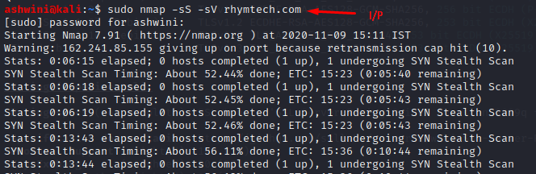

**Step-2:**

If open port sql found consider alert as **MEDIUM** with alert score **5**.

If open port sql not found consider as **IGNORE.**

If open MYSQL Database Port found consider alert as **MEDIUM** with alert score **6**.

If open MYSQL Database Port not found consider alert as **IGNORE.**

If open IMAP Port found consider alert as **MEDIUM** with alert score **6**.

If open IMAP Port not found consider as **IGNORE.**

If open SMB Version1 found consider alert as **CRITICAL** with alert score **10.**

If open SMB Version1 not found consider alert as **IGNORE**.

If open SMB Version2 found consider alert as **HIGH** with alert score **7.8.**

If open SMB Version1 not found consider alert as **IGNORE.**

If open SMB Version3 found consider alert as **CRITICAL** with alert score **10.**

If open SMB Version3 not found consider alert as **IGNORE.**

If open remote desktop protocol ports found consider alert as **HIGH** with alert score **7**.

If open remote desktop protocol ports not found consider alert as **MEDIUM** with alert score **5.**

If open virtual network computing ports found consider alert as **HIGH** with alert score **8.**

If open virtual network computing ports not found consider as **IGNORE**

If open smtp ports found consider alert as **MEDIUM** with alert score 5.

If open smtp ports not found consider as **IGNORE.**

If open Postgresql database ports found consider alert as **MEDIUM** with alert score **5.**

If open Postgresql database ports not found consider as **IGNORE.**

If open ftp ports found consider alert as **HIGH** with alert score **8**.

If open ftp ports not found consider as **IGNORE.**

If open telnet ports found consider alert as **CRITICAL** with alert score **9.8.**

If open telnet ports not found consider alert as **IGNORE.**

If open SSH Port Found consider alert as **MEDIUM** with alert score **5.**

If open SSH Port Not found consider as **IGNORE.**

If open pop3/email ports found consider alert as **MEDIUM** with alert score **5.**

If open pop3/email ports not found consider as **IGNORE.**