**REPUTATION MONITOR**

1. **Blacklisted:**

URL to check IP Blocklist **https://www.ipvoid.com/**

1. **IP Blocklist:**

**Step-1:** Enter the IP address in search field, click on check IP address consider IP address as input

**Step-2:** If the output shows IP address is blacklisted consider alert severity as **MEDIUM** with alert score **5**

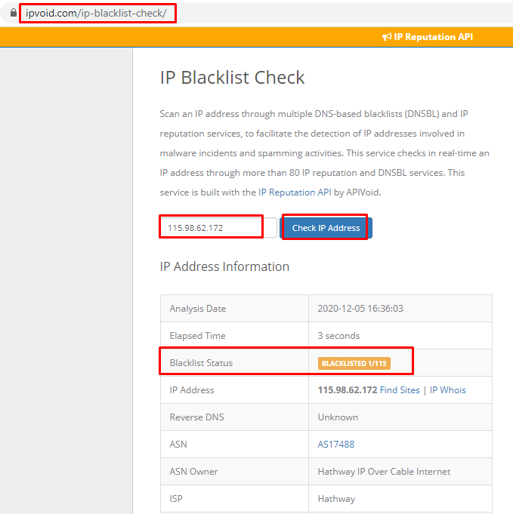

**Step-3:** If the output shows IP address is not Blocklist consider as **IGNORE**

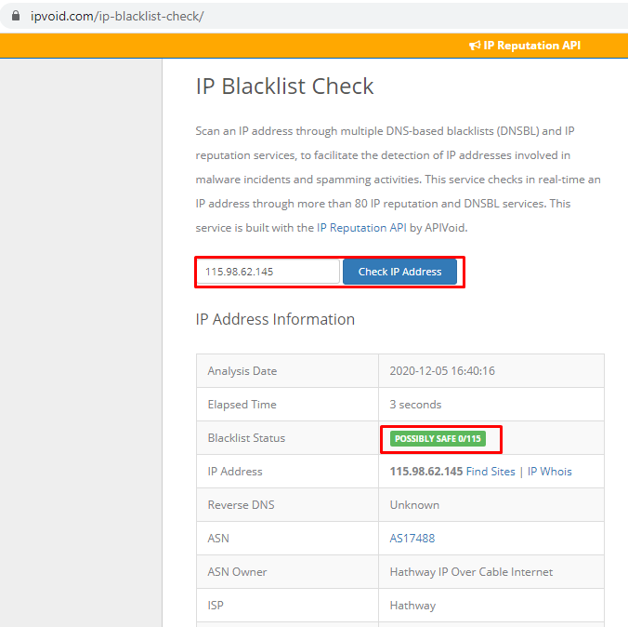

1. **DNSBL:**

Tool to check DNS Blacklist **https://mxtoolbox.com/blacklists.aspx**

**Step-1:** Enter the domain name in search field and click on the blacklist check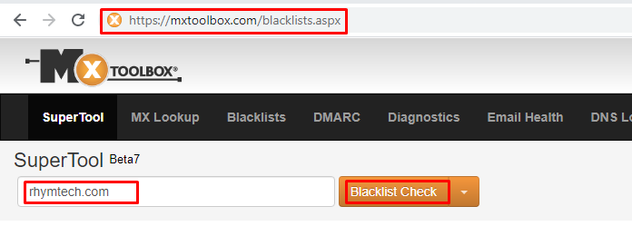

**Step-2:** If the output shows DNSBL is blacklisted consider alert severity as **MEDIUM** with alert score **5**

**Step-3:** If the output does not show any DNSBL Blacklisted consider as **IGNORE**

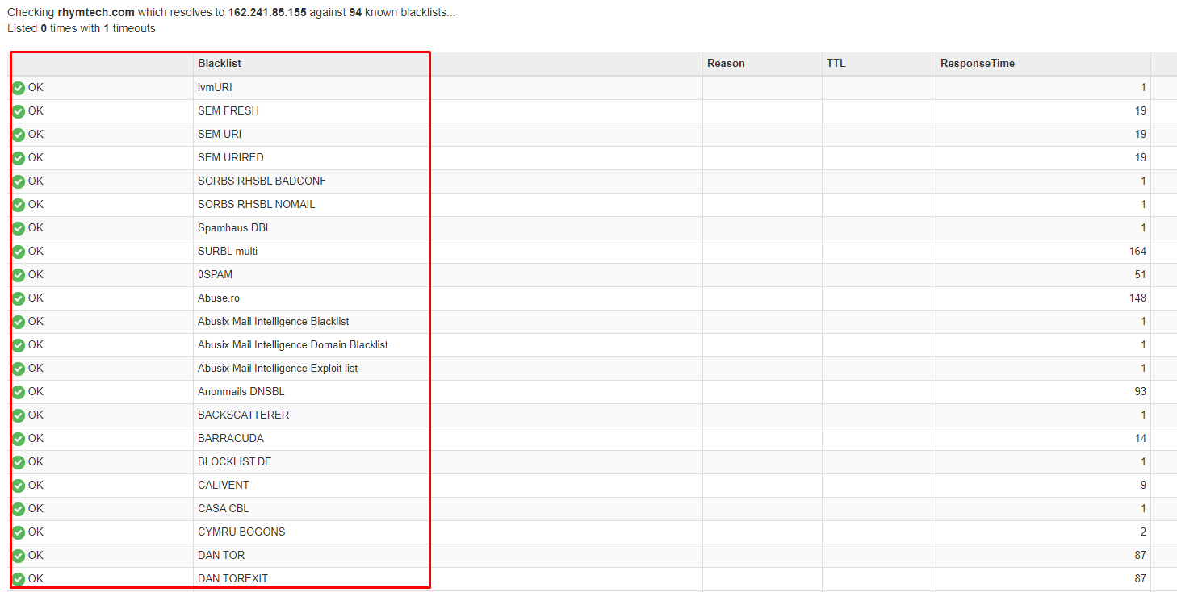

1. **Domain Trust Score:**

URL to check domain trust score **https://www.scamadviser.com**

**Step-1:** Enter the domain name in search field and consider domain name as input.

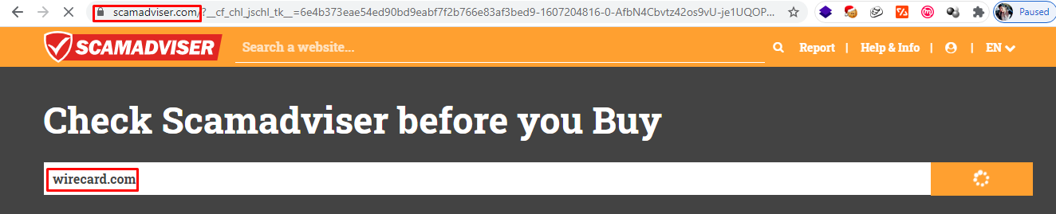

**Step-2:**If the output show domain trust score 100 consider alert severity as **INFORMATIONAL** with alert score **0**.

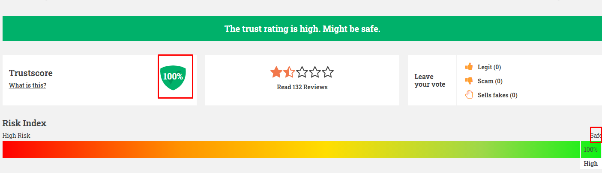

**Step-3:** If the output show domain trust score 80-90 consider alert severity as **INFORMATIONAL** with alert score **0**.

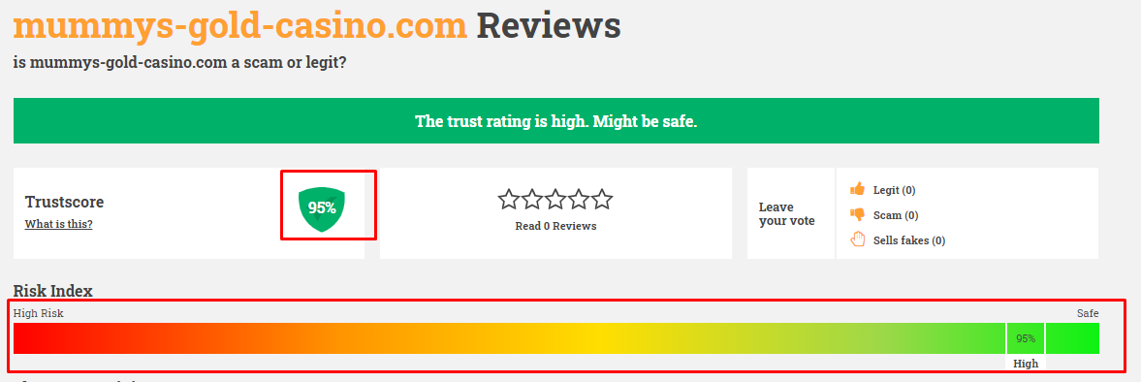

**Step-4:** If the output show domain trust score 60-79 consider alert severity as **INFORMATIONAL** with alert score **0**.

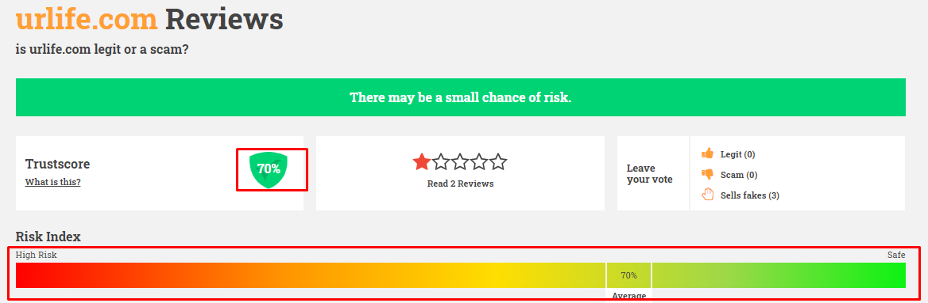

**Step-5:** If the output show domain trust score <60 consider alert severity as **MEDIUM** with alert score 5**.**

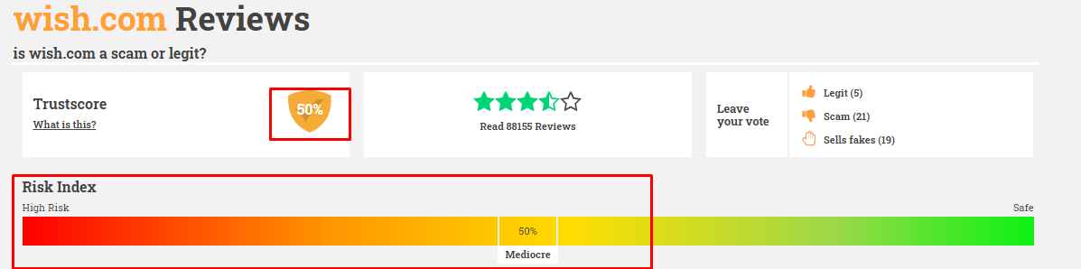

**Step-6:** If the output show domain trust score <30 consider alert severity as **MEDIUM** with alert score **6.**

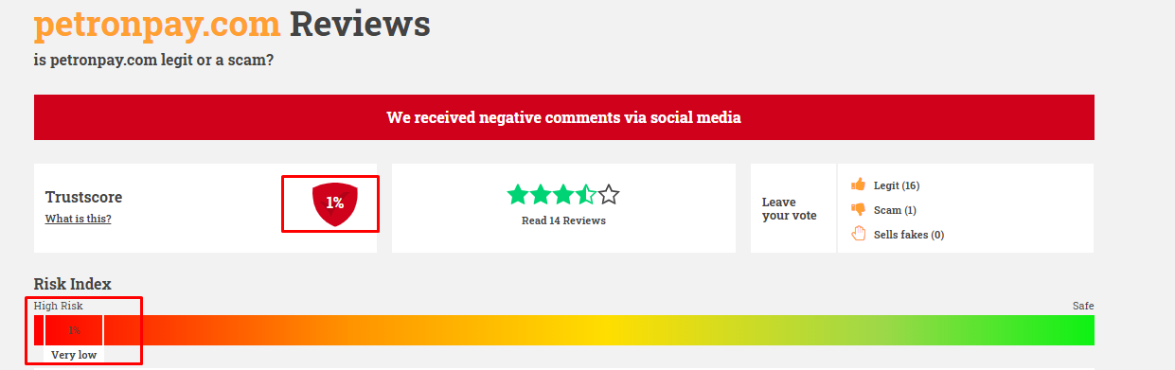

1. **IP Reputation:**

URL to check IP reputation **https://talosintelligence.com/**

**Step-1:** Eenter the domain name in search field consider domain name as input**.**

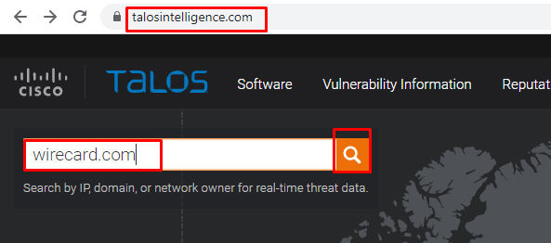

**Step-2:** If the output shows IP reputation Good consider alert severity as **INFORMATIONAL** with alert score **0**.

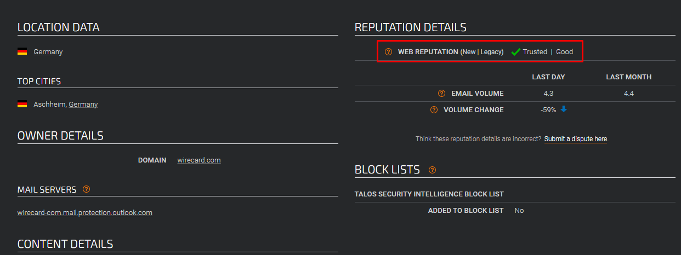

**Step-3:** If the output shows for IP reputation as bad/neutral/unknown then also consider alert severityas **INFORMATIONAL** with alert score **0.**

1. **Spam Level:**

URL to check the spam level **https://www.ipqualityscore.com/**

**Step-1:** Enter the IP address in search field and consider IP as input**.**

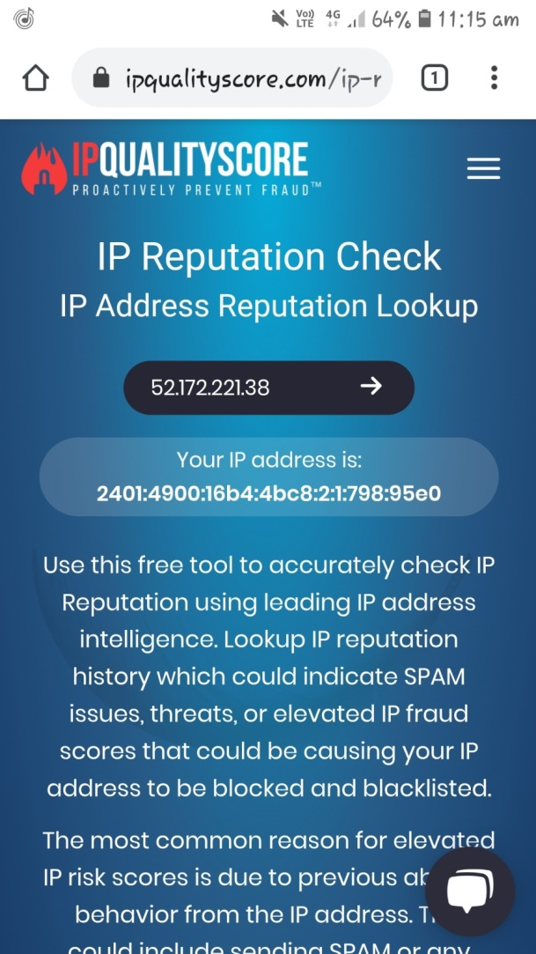

**Step-2:** If the IP spam level is between 61-100 consider alert severity as **CRITICAL** with alert score **9**

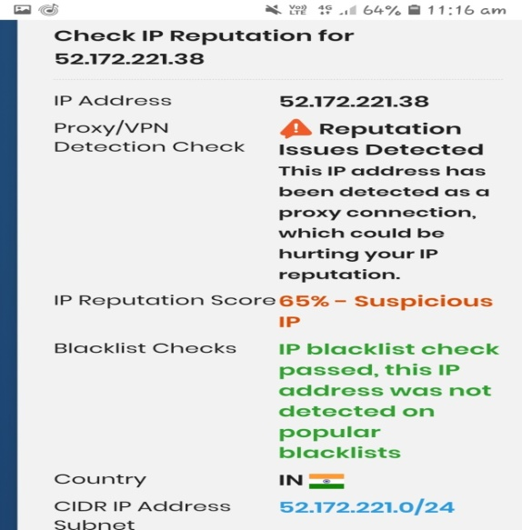

**Step-3:** If spam level is 0 consider as alert severity **Low** with alert score **3.**

**Step-4:** If the IP spam level is between 1-30 consider alert severity as **MEDIUM** with alert score **5.**

**Step-5:** If IP spam level is between 31-60 consider alert severity as **HIGH** with alert score **7.**

1. **Website name in malicious list**

Tool to check website name is in malicious List **https://github.com/mitchellkrogza/The-Big-List-of-Hacked-Malware-Web-Sites/blob/master/hacked-domains.list.**

**Step 1:** Check the IP address/ domain name using the keyword CTRL+F if the desired IP address or Domain name is in Malicious List Consider alert severity as **HIGH** with alert score **7.**

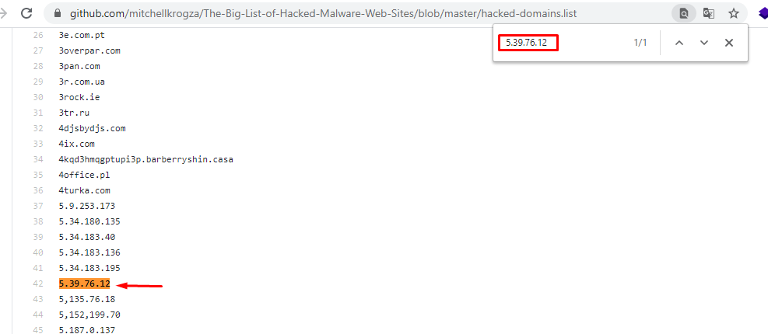

**Step 2:** If the website name is not detected in malicious list consider as **IGNORE.**