**SOCIAL ENGINEERING**

1. **Cybersquatting:**

Tool to check Cybersquatting and Typosquatting domains immuneweb **https://www.immuniweb.com/radar/**

**Step-1:** Enter the domain name in search field and consider domain name as Input

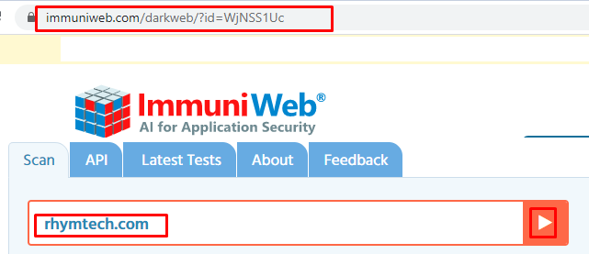

**Step-2:** Consider below are the cybersquatting domains

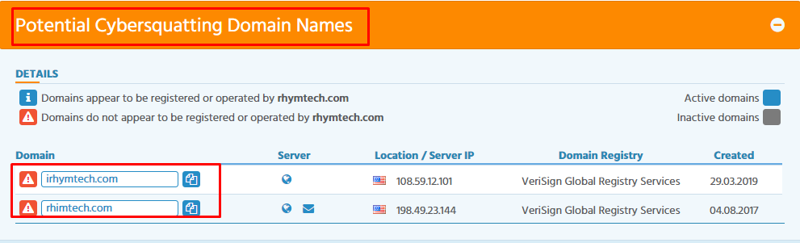

**Step-3:** Open each cybersquatting domains manually and if the page is open or accessible consider alert as **MEDIUM** with alert score **6**

**So below image is Cybersquatting domain for RHYMTECH**

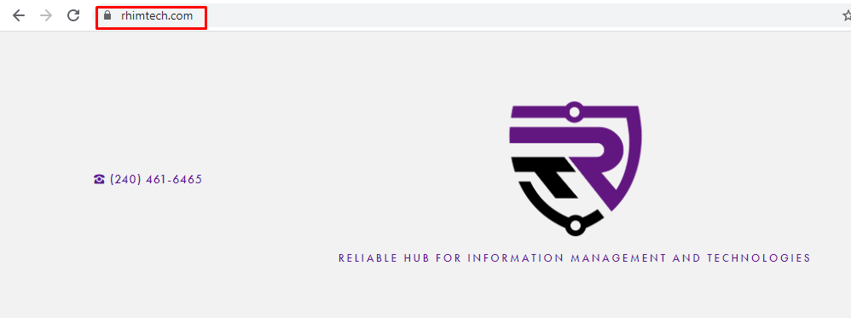

**Step-4 :** Open this Cybersquatting domain by using tool **https://whois.domaintools.com**

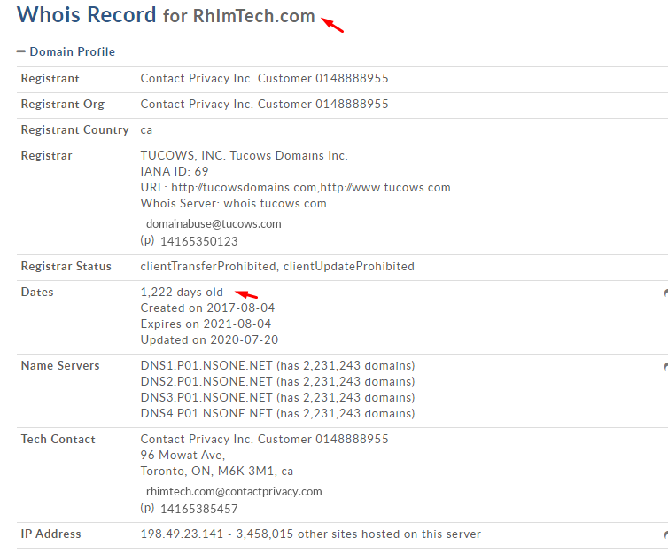

**Step-5:** If the Cybersquatting domain page is not accessible or blank consider as I**GNORE**

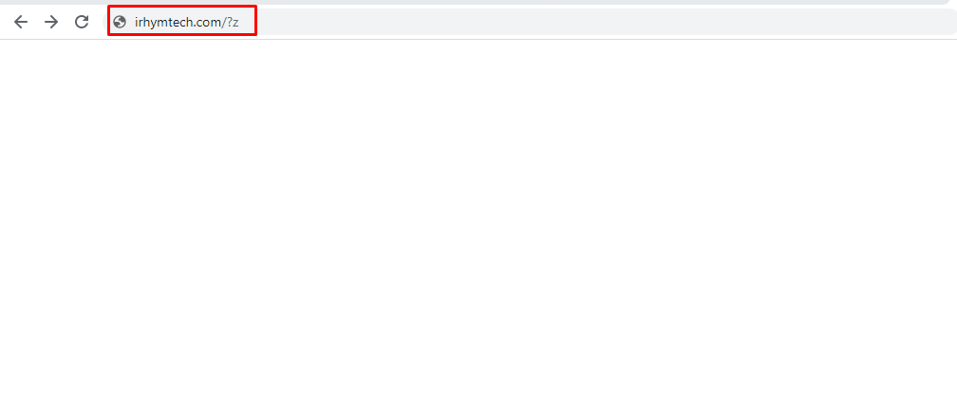

**Step-6:** If No cybersquatting threats Detected consider as **IGNORE**

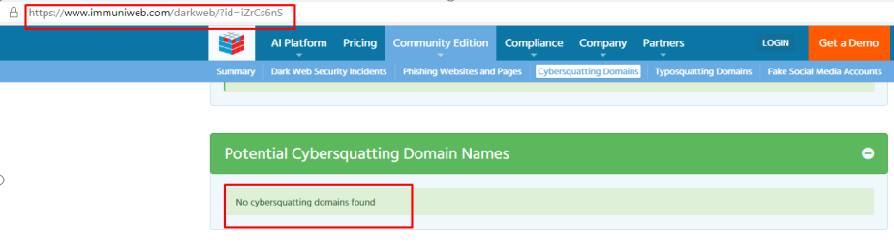

1. **Typosquatting:**

**Step-1:** Enter the domain name in search field and consider domain name as Input



**Step-2:** Consider below are the Typosquatting domains

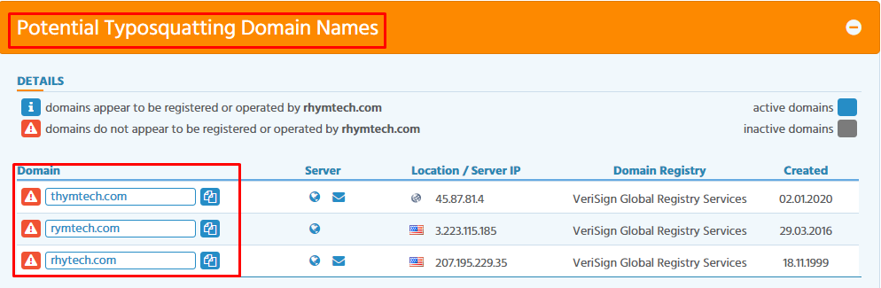

**Step-3:** Open each Typosquatting domains manually and if the page is open or accessible consider alert as **MEDIUM** with alert score **6**

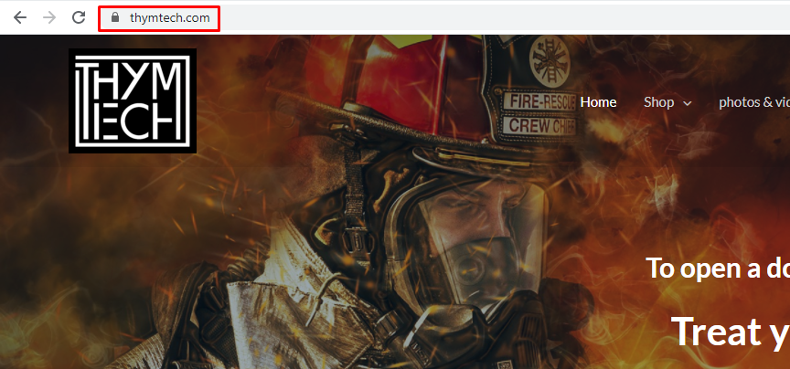

**Step-4:** Open this Typosquatting domain by using tool **https://whois.domaintools.com**

Open this Typosquatting domain and check for registrant details

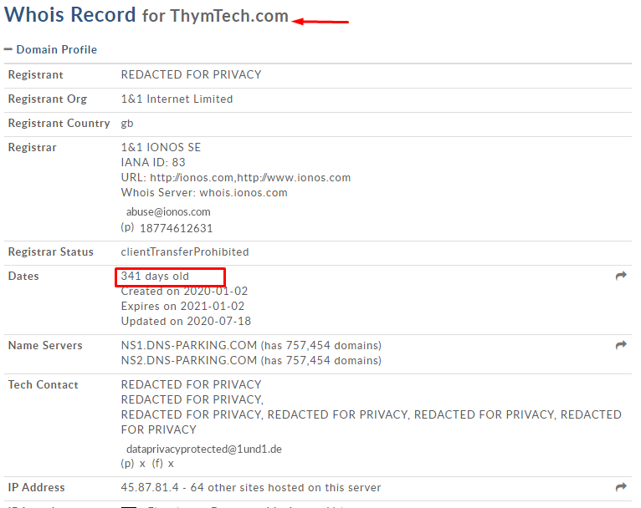

**Step-5:** If the Typosquatting domain page is not accessible or blank consider as I**GNORE**

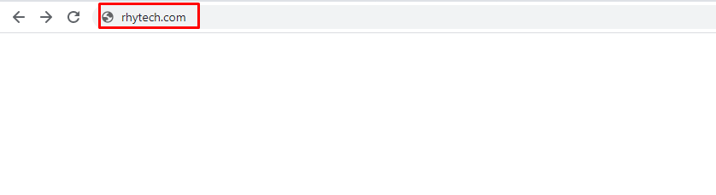

**Step-6:** If No Typosquatting threats Detected consider as **IGNORE**

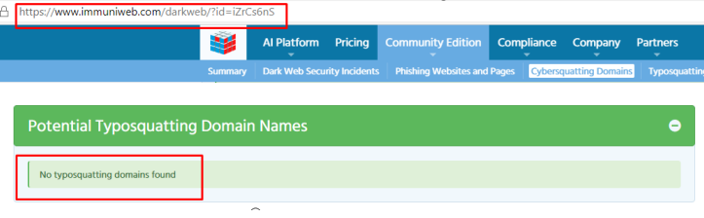

1. **Potential Phishing:**

URL to check the potential phishing https://www.phishtank.com/

**Step-1:** Enter the URL in search field and click on the Is It a Phish consider URL as a Input

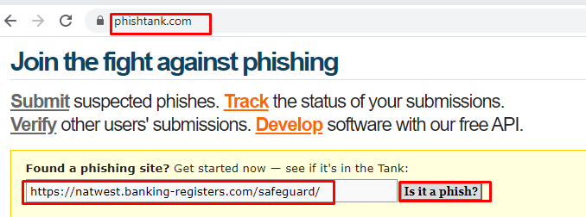

**Step-2:** After Clicking on the Is it a phish it will show as below

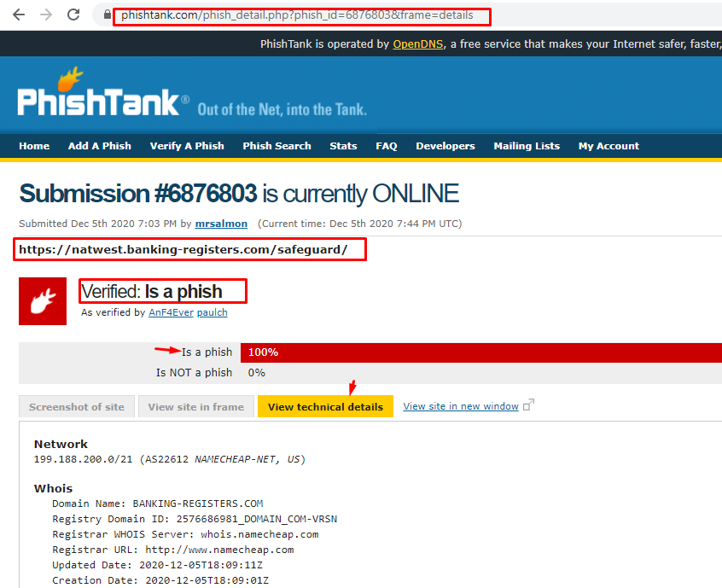

**Step-3:** After finding it as a phish open it in another tab if the page is accessible or it showing deceptive site consider alert severity as **MEDIUM** with alert score **5**

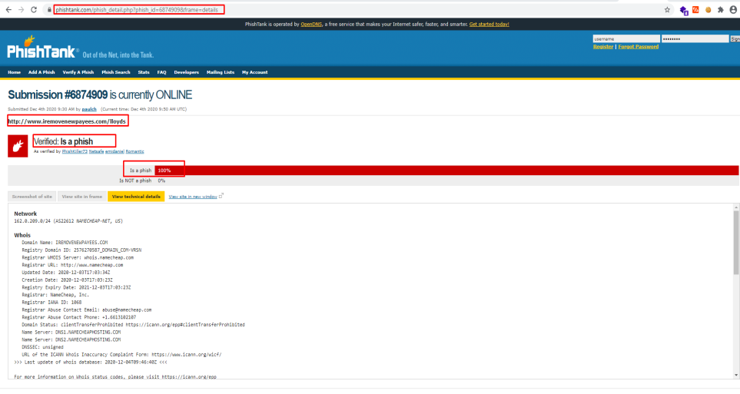

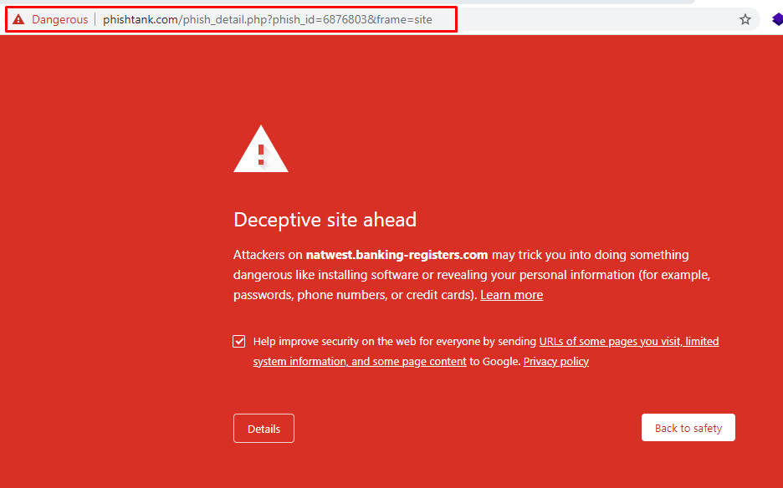

**Step-4:** If Potentials Phishing Links Found (If the Page is not open) consider as **IGNORE**

**Step-5:** If No Potential Threats Detected consider as **IGNORE**

