**STRESS RESISTENCE**

Tool to check Load Balancers lbd which is default in Kali Linux

1. **HTTP Load balancer detection**

**Step-1:** Enter the domain name using command lbd domain name consider domain name as Input

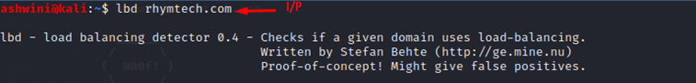

**Step-2:** If the output shows HTTP Loadbalancing NOT FOUND Consider alert as **MEDIUM** with alert score **5**



**Step-3:** If the Output shows HTTP Loadbalancing FOUND consider alert as **INFORMATIONAL** with alert Score **0**

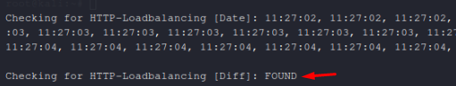

1. **DNS Load Balancer detections**

**Step-1:** Enter the domain name using command lbd domain name consider domain name as Input



**Step-2:** If the output shows HTTP Load Balancer NOT FOUND Consider alert as **LOW** with alert score **3**

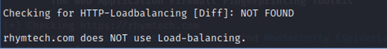

**Step-3:** If the Output shows HTTP Loadbalancing FOUND consider alert as **INFORMATIONAL** with alert Score **0**

