IT 230 Coding Activity Submission Template

Submit your work on the coding activities for Modules One, Two, Three, Four, and Six in this document. In addition to this document, you should submit a ZIP file containing all your Visual Studio project files and source code that can be run in Visual Studio on a different computer.

For each coding activity, complete the following steps:

- Download and rename this document to meet the file naming conventions requested in the assignment instructions.
- Fill in the required information below by replacing the bracketed text with the relevant information.
- Submit this document and your ZIP file for grading and feedback. Your ZIP file should follow the same naming conventions.

Document your work in the coding activity by completing each of the following items:

- Provide a screenshot of the output that resulted from running your program successfully in Visual Studio. See the coding assignment instructions for an example of what should be included in the screenshot. Your screenshot must include the following elements:
  - Your last name as the first printed text on the screen
  - Verification that the program is fully functioning and data results are accurate for the given problem

[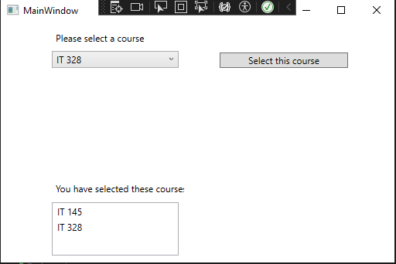]

- Copy and paste the source code text you wrote for this assignment from the *.cs file into the space below. Only providing the *.cs files or a screenshot does not meet the requirements for this part of the assignment. Code should be logically organized. It should also follow proper syntax and conventions noted in the Coding Activity Guidelines and Rubric.

[using System;

namespace CreateClassesObjs
{
public class Course
{
// Field to store the course name
private string name;

// Setter method used in your MainWindow code
public void setName(string courseName)
{
this.name = courseName;
}

// Getter method (optional, but good practice)
public string getName()
{
return this.name;
}

// Overriding ToString tells the ComboBox/ListBox what text to display
public override string ToString()
{
return this.name;
}
}
}]

- Show that you understand the task by explaining the design of your program in the space below. Include the process and steps you took to write your code. Explain how you arrived at the solution to the problem and completed the activity.

[Encapsulation: The name field is private, meaning it can't be changed directly from outside the class. You have to use the setName method to update it.
The this Keyword: In this.name = courseName;, this refers to the specific instance of the class you are currently working with.
UI Compatibility: The public override string ToString() is the most important part for your UI. When you add a Course object to a ListBox or ComboBox, the control calls ToString() to figure out what text to show the user. Without this, you’d just see the technical name of the class (like CreateClassesObjs.Course) instead of the actual course name.]

- Reflect on your learning experience and what you learned from completing the activity.

[This took me a few tries to pull off but just like every single problem a quick research session helped me fix what I messed up and solve this challenge. Also doing this while having a headache is not a good idea won’t be doing that next week hopefully.]

