AUTHORIZATION: William L. Nesmith, Fire Chief

1. Hillsborough County Fire Rescue recognizes that no organization with such a diverse and ever changing responsibility can effectively manage all of its operations without well thought-out, pre-set, and regularly reviewed and maintained rules and/or action plans to guide its members during both routine and extraordinary operations.
   1. It must be remembered by all members that no policy or procedure manual is capable of providing direction for every possible scenario that may be encountered and that all members shall be expected to use the same prudent judgment in the exercise of their duty that an equally trained and equipped individual would.
2. The purpose of this policy is to create and implement a Policy and Procedures Development and Review process within the Department so that all policies, procedures, rules, regulations, guidelines, or protocols set forth by the Department are applicable, usable, and comprehensive enough to effectively guide its members in their daily operations.
   1. Also it shall be a goal of the Policy and Procedure Development and Review (PPDR) process to assist the Department and its members in achieving a level of operational readiness and capability that adheres to and optimizes compliance with applicable Federal, State, and Local laws, regulations, ordinances, collective bargaining agreements, and widely accepted national consensus standards.
   2. It shall also be a goal of the PPDR process to include as many stakeholders as possible within the process so that a comprehensive needs assessment, development, implementation process, and ongoing review may be created yielding an ever evolving and relevant set of policies.
      1. This representation may take many forms (i.e. committees, work groups, questionnaires, policy suggestion, collective bargaining, task forces, etc.) in order to efficiently coordinate the free flow of information and input.
3. While it is intended that a multitude of stakeholders have input into the development and review process, the Fire Chief shall be responsible for approving, in their final version, ALL POLICIES & PROCEDRUES implemented by Hillsborough County Fire Rescue.
   1. Further, in conjunction with the goals and objectives of Hillsborough County Fire Rescue, as determined and approved by the Fire Chief, the Department Medical Director shall approve, by signature, ALL Treatment Protocols, Policies, and/or Standing Orders as they pertain to the treatment of persons suffering a medical emergency.
   2. In establishing an ongoing development and review process; this policy does not, nor is it intended to, supersede the authority and/or responsibility of the Fire Chief and/or the Medical Director (under the authority and direction of the Fire Chief) to develop, review, or institute any policy or procedure they feel is necessary for the safe, efficient, and quality delivery of service to the citizens of Hillsborough County.
4. The scope of the Development and Review process will cover all policies, procedures, rules, regulations, guidelines, or protocols as set forth in the Department's Policies and Procedures Manuals.
5. The Hillsborough County Fire Rescue Policies and Procedures Manuals are as follows:
   1. Manual #1 - Rules and Regulations
      1. This manual will be responsible for communicating the Department policy on the day to day functions within facilities and by members outside the realm of specific incident procedures.
      2. Examples would include but are not limited to duty status, disciplinary procedures, maintenance requirements, facility operations, routine operation of vehicles, etc.
   2. Manual #2 - Suppression Operations
      1. This manual will be used to communicate to members the standard response to request for assistance that do not include as their primary and specific mission emergency medical treatment of individuals or groups.
      2. Examples would include but are not limited to structure fires, car fires, hazardous materials incidents, technical rescue incidents, brush fires, illegal burns, etc.
   3. Manual #3 - Medical Operations
      1. This manual will be used to communicate to members the standard response to and treatment of individuals or groups experiencing a medical emergency independent of the nature or cause.
      2. Examples include but are not limited to ALS treatment protocols, BLS treatment protocols, MedEvac operations, medical documentation, medical exposure plan, etc.
   4. Manual #4 - Manual of Collective Bargaining Agreements
      1. The Manual of Collective Bargaining Agreements (CBAs) is included as a policies manual so that all members and supervisors are aware of its contents and mandates involved in our daily operations.
      2. The Manual of CBAs is not included in the Policy Development and Review process as these contractual agreements have their own implementation and review process through contract negotiations and labor management meetings.
6. In order to effectively fulfill the purpose of this policy, the Hillsborough County Fire Rescue Policy and Procedure Development and Review process shall mirror the following basic design:



* 1. Fire Chief: has the authority and responsibility for the FINAL approval of ALL policies and procedures.
  2. HCFR Medical Director: has the authority and responsibility of approving ALL treatment protocols and procedures as they pertain to the care of persons suffering from a medical emergency.
  3. Executive Staff Review (Executive Staff I Review Staff): responsible for reviewing and assembling all submitted new, revised, and / or reviewed policies from the Rescue Chief and/or PPO to the Fire Chief and/or the Medical Director in finalized form for consideration of implementation.
  4. Division Chief of Rescue (Rescue Chief I Chief Medical Officer - CMO):
     1. He/She shall:
        1. Oversee the ongoing development and review of HCFR Policies & Procedures Manuals #3 (Medical Operating Guidelines).
        2. Assign and maintain Committees and/or Work Groups as necessary to ensure that all policies within Manual #3 are reviewed and revised on an ongoing regular basis.
           1. Committees/Work Groups, under the direction of the CMO, will work as necessary to ensure that all policies within Manual #3 are reviewed and/or revised within a three (3) year period from the policy's original issue, previous review, or revision date.
        3. Ensure that all policies being submitted to the Executive Staff have already been approved by the Medical Director when applicable.
        4. Ensures that all policies covered by any CBA are provided to the affected Collective Bargaining Unit within the proper time frame prior to distribution.
        5. Ensure that any new or revised policy signed by the Fire Chief, and Medical Director when necessary, is forwarded to the Policies Officer for distribution to every member and updating of the online copy of Manual #3.
        6. Work with the Training Division to ensure that adequate training is provided to all affected members with regards to any new or revised policy.
  5. Policies & Procedures Officer (PPOIPolicies Officer): shall be appointed by the Fire Chief and is responsible for the overall coordination of the Departmental policies & procedures development & review process as outlined in this policy.
     1. He/She shall:
        1. Oversee the ongoing development and review of HCFR Policies & Procedures Manuals #1 (Rules & Regulations) and #2 (Suppression Operating Guidelines).
        2. Ensure that all policies and procedures within Manuals #1 & #2 are kept up to date with changing laws, CBAs, nationally accepted consensus standards, etc.
        3. Assign and coordinate Committees and/or Work Groups as necessary to ensure that all policies within Manuals #1 & #2 are reviewed and revised on an ongoing regular basis.
           1. Committees/Work Groups, under the direction of the PPO, will work as necessary to ensure that every policy & procedure issued within:

Manual #1 is reviewed and/or revised within a three (3) year period from the policy's original issue, previous review, or revision date.

Manual #2 is reviewed and/or revised within a three (3) year period from the policy's original issue, previous review, or revision date.

* + - 1. Ensures that all policies covered by any CBA are provided to the affected Collective Bargaining Unit within the proper time frame prior to distribution.
      2. Ensure that any new or revised policy, once signed off on by the Fire Chief, is distributed to every member and that the online copies of ALL manuals are up to date.
      3. Work with the Training Division to ensure that adequate training is provided to all affected members with regards to any new or revised policy.
      4. Maintain a file for every policy and procedure within each of the four manuals that documents the policy's development, review, and/or revision as well as supporting documentation for actions taken affecting the policy.
      5. Be responsible for coordinating and maintaining ALL forms created for internal use by Hillsborough County Fire Rescue members.
         1. Responsibility will include developing an updated numbering system for all forms and for the inclusion of all new forms developed for use by staff.
         2. Also, the maintaining of such forms for online access of members shall be included.
  1. Policies & Procedures Development & Review CommitteesIWork Groups: Under the direction of their appointing Officer (i.e. the CMO or PPO) shall constitute the assembled working body of this policy.
     1. Committees/Work Groups shall be established as necessary to assist the CMO and PPO to ensure that every policy & procedure issued within an HCFR Policy & Procedure Manual is reviewed and/or revised within the guidelines established within sections 6(d)(i)(2)(a) and 6(e)(i)(3)(a) of this policy.
     2. Members may also be assigned, as necessary, to individual Committees/Work Groups for the development of new policies & procedures as determined by the Executive Staff, or as otherwise directed by the Fire Chief.
        1. Executive Staff or Fire Chief appointed groups shall work with the either the CMO or PPO in order to accomplish the objectives outlined by Staff and/or the Fire Chief.
     3. Members who are selected/appointed to a Committee/Work Groups shall be expected to remain actively involved until the Committee's/Work Group's designated task are completed.
        1. The CMO/PPO shall have the authority to relieve any member of an established Committee, or Work Group, if it is deemed in the best interest of group effectiveness.
           1. The Assistant Chief of Operations shall be consulted for the removal of any member of an Executive Staff/Fire Chief directed Committee/Work Group.
     4. Committees/Work Groups may request the appointment of ancillary members to assist in policy development or review as needed.
        1. Persons falling into this category may be members of a specific job class or persons who have expertise or extraordinary knowledge in a specific area.
        2. Persons chosen to assist the group will be called upon as needed to perform specific reviews or functions.

1. Existing Policies
   1. Hillsborough County Fire Rescue will have a standardized Policies & Procedures Review Period (PPRP) that begins on the 1st of February each calendar year and runs to the 31st of January the following calendar year on a continuing cycle.
      1. This timeline shall pertain to the review and/or revision of existing policies/procedures.
   2. CMO and PPO responsibilities:
      1. They shall have from the 1st of February until the 31st of October to review existing policies for submission to the Executive Staff.
      2. During this nine (9) month period, the CMO/PPO shall:
         1. Conduct a review of the Policies & Procedures Manuals for polices that need review or revision.
         2. Each policy shall be revised/reviewed with a recommendation made to the Executive as to whether the policy should be kept as is, revised, or discarded.
            1. Complex policies and/or those needing extensive revision may have a Committee / Work Group assigned.
         3. Any recommendation for revision or deletion will be submitted with accompanying documentation as to the reason for change or deletion.
         4. All material for review, revision, or deletion shall be submitted to the Executive Staff for consideration no later than 1 November of each PPRP.
   3. Executive Staff responsibilities:
      1. The Executive Staff shall review each submission and either submits the policy to the Fire Chief as a Final Draft for his/her consideration or they may resubmit to the policy to the CMO/PPO for revision with recommended/necessary changes.
      2. During the period from the 1st of February to the 31st of October Executive Staff shall meet at least once every sixty (60) for the specific purpose of reviewing submitted policies.
      3. During the period from the 1st of November to the 31st of December Executive Staff shall review any submitted policies at the end of each weekly Staff meeting as necessary to ensure that all policies submitted by the CMO/PPO are ready for final draft submission to the Fire Chief no later than the 1st of January each year.
   4. The Fire Chief's responsibilities:
      1. The Fire Chief will ensure that policies submitted to him/her for consideration are either:
         1. Authorized as submitted,
         2. Returned to the Executive Staff for further consideration or alteration (comments or changes shall be attached), - or -
         3. Authorized and continued "as is" without any recommended changes, additions, or omissions.
2. New Policies
   1. New policies shall follow a similar path as the existing policies but are not limited to the time constraints listed in the above sections.
      1. Development of new policies may be initiated by the Fire Chief, Executive Staff, or the CMO/PPO in response to departmental needs, changes in Federal, State, or Local laws, National Consensus Standards, or any other situation in which the need for a guideline for members is noted.
   2. The CMO/PPO may establish such committees/work groups as is necessary in order to develop new policies.
   3. Submission of ideas or recommendations of members.
      1. In order to facilitate an opportunity for all members to have a say in how their department functions, any member may submit via electronic mail any recommendation for a new policy, or change to an existing policy, to the Fire_Rescue_Policies_&_Procedures electronic mail box.
      2. Suggestions in this box will be reviewed by a Committee established by the CMO/PPO as appropriate.
         1. The Committee will strive to reply to each recommendation with a notice of receipt and information as to the disposition of the suggestion once it has been reviewed by Committee members.
3. Implementation Dates of Policies
   1. It shall be a goal for all new policies and procedures to have an effective, revised, or review date of 1 February each year with concurrent implementation.
      1. A 1 February implementation date allows for consistency that will enhance dissemination of new or revised material and will meet contractual obligations for any material added to any promotional testing process.
      2. It is recognized due to the importance of some policy additions or changes (either for life safety or other equally pressing concerns) that immediate implementation may be necessary outside of the time frames listed in the above sections.
         1. If it is deemed necessary to implement a revised or new policy any time after 1 February and prior to any promotional testing for that same calendar year, it shall be the responsibility of the Training Division to ensure that no such policy or procedure appears in any form on any promotional test during said year.
4. Nothing in this policy precludes Hillsborough County or Hillsborough County Fire Rescue from implementing policies & procedures outside of this process that it deems necessary to the welfare of the public, the organization, and/or its members.

AUTHORIZATION: William L. Nesmith, Fire Chief

1. As It is widely recognized in the fire service community that the evaluation of past events and practices is an invaluable tool for the improvement of skills, knowledge, and safety in emergency service delivery, Hillsborough County Fire Rescue supports and encourages the use of Post Incident Analysis within all levels of the organization.
2. These PIAs, or "critiques", can be formal or informal and may take on many levels of simplicity or complexity, each one having its own purpose and place within the organizational structure.
3. PIAs should always, no matter what the format, be conducted with the idea of learning and the improvement of the department, company, and/or member in mind.
   1. Discussions and reviews of the involved events should not be conducted in an accusatory or hostile manner.
   2. A calm and rational progression of events should be employed so that maximization of the learning potential may be realized.
   3. All PIAs shall include a review of the conditions present, the actions taken, and the effect of the conditions and actions on the safety and health of members.
4. Informal PIAs
   1. Informal PIAs are more common and more easily conducted. They are most often used on our day to day operations and are critical to the development of our companies and members.
   2. Examples of informal PIAs:
      1. The "Hot Wash" or "Tail Board" critique. These types of venues allow for the companies involved to gather together immediately following an incident to discuss actions and/or concerns while events are still very fresh in everyone's minds. These meetings should not be long and drawn out, but rather they should simply hit the highlights of events.
      2. Dinner time discussions. Dinner time is an excellent opportunity for open and meaningful discussions within crews about different calls of the day.
      3. Mentoring review. The mentoring review would be a one on one discussion of events, tactics, strategies or other concerns between Company Officers or veteran members and newer members.
5. Formal PIAs
   1. Formal PIAs tend to occur on larger events and take on a much more rigid structure.
   2. These generally will be conducted at the Battalion Chief level and higher, well after the incident, and when some initial information gathering has occurred.
   3. Examples of formal PIAs:
      1. "Operational Reviews": Formal and occurring at different levels. (i.e. Shift Commander, or Asst. Chief of Operations, leading a review at weekly or quarterly Battalion meetings; Battalion Chiefs leading a review of involved fire companies at an organized location)
      2. "Department Wide Analysis". These will usually be proctored by a "Division Level Chief" and they will be conducted in a large forum allowing as many involved members to participate as possible.
      3. "Interagency Analysis". Conducted by the Asst. Chief of Operations, or his designee, for large scale incidents that required the assistance of and/or are of interest to other agencies.
6. Mandated PIAs
   1. The Incident Commander shall submit a formal written post incident analysis within three calendar days from the termination of operations to the appropriate Shift Commander in the event of all:
      1. 3rd Alarm and greater fires
      2. Level II or higher hazardous material incidents
      3. Fires involving serious injury and/or death of a civilian or firefighter
      4. Heavy Rescue Incidents (excluding normal motor vehicle collisions unless other criteria are met)
      5. Any alarm or incident that the Incident Commander feels is of sufficient interest or importance
   2. All reports will be reviewed by the Shift Commanders with a final summation presented to the Assistant Chief of Operations.
   3. Information gathered will be used to review practices and procedures implemented with special attention paid to possible training points that may be used to enhance member safety and/or improve public service.
   4. The Shift Commanders, in communication with the Assistant Chief of Operations, will determine the need for any expanded forums that may be needed or desired in order to better understand the incident or to improve the quality and quantity of information for the purposes of improving service delivery.
   5. If during any mandated PIA it is determined that any action or lack of action, condition, policy/procedure or lack of policy/procedure contributed to the injury/death or potentially exposed any member to injury/death an action plan shall be developed to ensure that the same event does not occur it again.
      1. Such action plan shall be reduced to writing and include:
         1. Specifically what actions, policies, or procedures are to be changed.
         2. Who will be responsible for implementation of the change.
         3. What training or other special considerations that will be necessary to implement the change.
         4. A time frame for the implementation of the change.

AUTHORIZATION: William L. Nesmith, Fire Chief

1. Each Suppression Company Officer shall be responsible for, and each Battalion Chief will ensure that, a minimum of one pre- incident plan for his/her first alarm territory is completed monthly following the guidelines as set forth in this policy:
   1. Identify " Target Hazards" in the company's primary response area:
      1. Emphasis should be given to apartment complexes, hotels/motels, nursing homes, hospitals, theaters, shopping centers, warehouses, high rise buildings, extremely hazardous substance (EHS) facilities, and bulk fuel/oil storage facilities.
   2. The quick Access Pre-Plan format should be followed.
      1. Variations to this format are permitted for extremely large complexes such as Malls, EHS facilities, high-rises, etc.
   3. Once completed, plans shall be turned into the Battalion Chief and he/she shall:
      1. Review each plan with first alarm companies focusing on tactical & strategical considerations in the event of a fire or emergency.
      2. Distribute the plan to all 1st and 2nd alarm companies.
   4. All EHS pre-plans will be forwarded to the Special Operations Chief at Headquarters for inclusion into Command Operations response.
2. EHS sites are documented by the Hillsborough County Emergency Planning Operations staff and can be verified by contacting the Hazardous Incidents Team on duty Company Officer.
3. Extremely Hazardous Substance (EHS) plans will be copied on goldenrod paper for quick recognition.
   1. Upon receipt of a Quick Access Plan, the Company Officers will review the plan with their crew so as to familiarize them with the building or complex and possible tactical scenarios.
      1. The Officer will then insure that the plan is placed on the apparatus for easy access in an emergency.
   2. Each structure that has a Quick Access Pre-Plan will be rechecked ANNUALLY and an updated plan submitted.
      1. A recheck will be done more frequently than once yearly when it is known that a change in accessibility, building construction, hazards or occupancy has occurred.
      2. Updated plans will be marked as such in UPPERCASE LETTERS in the lower right-hand corner, next to the date to insure that the out dated plans are replaced when distributed to the 1st and 2nd alarm companies. (i.e., 5/12/98 UPDATED)
   3. Company Officers are encouraged to utilize the process of completing pre-incident plans to train with their crew members on possible tactical scenarios, pumping and water supply operations, identification of construction types, possible means of forcible entry, ventilation, etc.
      1. All personnel should be included in the actual drawing of the plan and completion of the forms.
4. A Pre-Plan Log will be maintained in each station in a three-ring binder marked "Pre-Incident Plans."
   1. The notebook will be divided into sections by the primary box number assignments for the station (i.e. Box 0906).
   2. A unique number will be assigned to each pre-plan using the correlating box number as the leading digits and it shall be printed in the top right-hand corner of the pre-plan (i.e. Plan # 0906-01).
      1. Once the Company Officer has assigned a number to the plan, it will be legibly written or typed in the top right-hand corner of the pre-plan.
      2. As new plans are completed, the next available number in sequence is assigned (i.e. Plan # 0906-01, 0906-

02. etc.).

* 1. For quick reference, the pre-plan log shall have an index page such as in section 6 below.

1. Company Officers will complete a Pre-Plan Notification Form F-220 (example in § 7 below) and submit it with the Pre-Plan to their Battalion Chiefs.
   1. The Battalion Chief shall forward the F-220 to EDC for input into the computer data base and inclusion on the dispatch report.
   2. When the F-220 is returned from EDC to the Initiating Officer, the appropriate box on the index form can be checked thus assuring the process has been completed.
   3. Company Officers will review the existing Pre-Plans for his/her assigned primary boxes and retroactively assign and record plan numbers as outlined above and submit the F-220's for each.
2. To prevent a duplication of pre-plan numbers, the following guideline will be used when a primary box assignment is split between two officers:
   1. Initially, any existing pre-plan numbers that have already been assigned for the box in question must be listed and shared between the officers.
   2. If a primary box is divided between two officers, the officers will ensure that the sub-box designation is used so as not to duplicate numbers (i.e. plan # 1527n-005 instead of just 1527-005).
   3. If the sub-box designation is divided between two officers in the same station, the Pre-Plan Notebook will be used by both officers to coordinate pre-plan number assignments.
3. Battalion Chiefs will coordinate the Primary Box Assignments between shifts and stations to prevent a duplication of efforts.
4. Pre-plan Index Page Example:

# Box Number 2201

Plan # Business Name Address Completing Officer Date of Plan / Rev

|  |  |  |  |  |
| --- | --- | --- | --- | --- |
| 2201-01 | Sunshine Daycare | 2208 Orangewalk Dr. | M. McClamma 7 / C | 25 Sept. 06 |
| 2201-02 | Almand Center Day Care | 2512 Brooker Rd. | M. McClamma 7 / C | 1 Jan. 07 UPDATED |
| 2201-03 | Bloomingdale Pub. Library | 1307 E. Bloomingdale Ave. | W. Riley 7 / B | 24 Jul. 07 UPDATED |
| 2201-04 | Bell Shoals Church of God | 2289 Bell Shoals Rd. | F. Perez 7 / A | 2 Feb. 08 |
| 2201-05 | Blooomingdale High Sch. | 1101 E. Bloomingdale Ave. | W. Riley 7 / B | 15 Feb. 08 UPDATED |

1. Pre-plan Notification Form (F-220) Example:

# Hillsborough County Fire Rescue

Pre-Incident Plan Notification Form

Date: 15 Feb 2008 UPDATED Box Number: 2201 Plan Number: 2201-05

Address: 1101 Bloomingdale Ave E Occupancy Name: Bloomingdale Senior High School Plan Completed By: Capt. W. Riley 7/ C Entered Into CAD By: A. Potenziano

X

X

X

Form Completed:

X

Forwarded to EDC:

Entered Into CAD:

Returned to Initiating Officer:

1. Pre-Incident Plan Front Page Example:

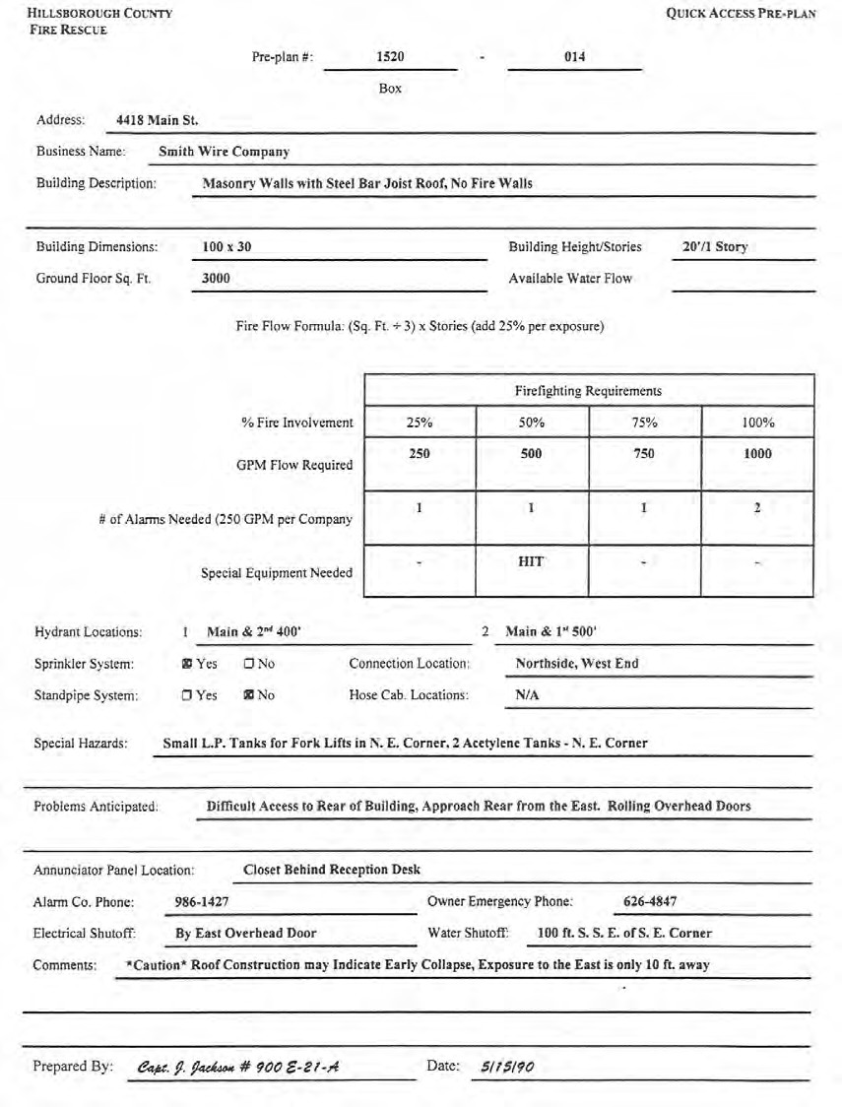

|  |  |  |
| --- | --- | --- |
| POLICY TITLE: | Pre-Incident Plans | REVIEW DATE: |
| POLICY NUMBER | 101.03 | Page 4 of 4 |

Pre-Incident Plan Back Page Example:

BUILILI DINIING LAYOUT

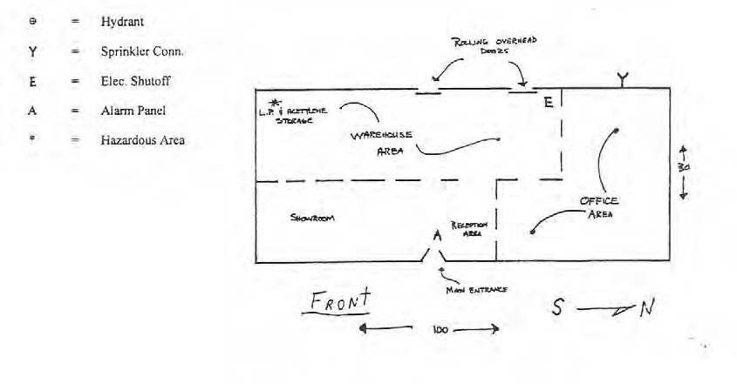

SIITITE LAYOUT

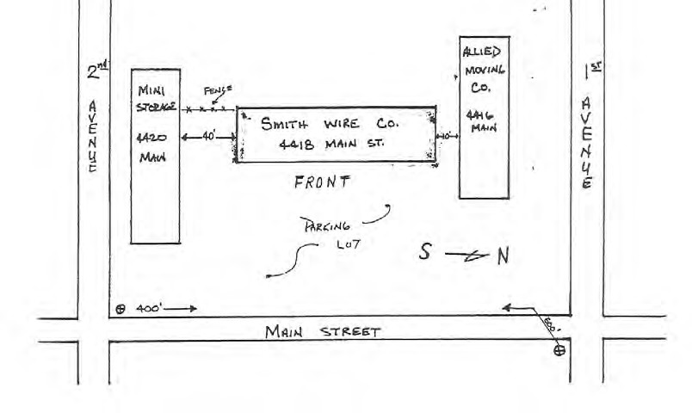

AUTHORIZATION: William L. Nesmith, Fire Chief

1. General:
   1. C-Platoon Battalion Chiefs/Shift Commanders shall ensure that each station has a coordinated schedule for the updating of emergency response box maps that is equally divided up between the company officers on each of the shifts.
      1. Every box map shall be updated at least annually.
         1. Also, the Company Officer who is assigned a specific box shall regularly survey their area of responsibility and ensure that an updated box is completed any time there is a change to an existing street, a new street is added, hydrant changes occur, or any other time in which a significant change to a response area occurs.
         2. During surveys, any unnamed road (paved or dirt) that has three (3) or more occupancies on it shall be reported to E-911 administration either via telephone (744-5911) or by email (preferred by E-911) at [king@hillsboroughcounty.org.](mailto:king@hillsboroughcounty.org)
   2. Hillsborough County Fire Rescue has placed a licensed copy of Microsoft Visio in every station for the purpose of creating legible and standardized box maps by suppression companies.
      1. All box maps created for use by and for Hillsborough County Fire Rescue shall be either created in or converted to the Microsoft Visio format.
   3. In addition to map books kept in apparatus, each station shall maintain a separate station map book for use by other companies who may be temporarily relocated.
      1. The station map book should be kept in a labeled red binder next to the Tear-n-Go printer.
      2. This book should contain maps of the station's first due area and the area of stations immediately surrounding.
2. Distribution & Storage:
   1. The Company Officer completing a map or update shall:
      1. Save a copy of the map to the station computer (C-drive) in a file titled Station "XX" Box Maps.
      2. Save a copy of the updated map to the Fire Rescue G-drive so that it will be available to all companies.
         1. With the map open in Visio select File: select Save As.
         2. When the Save As window appears: select My Computer.
         3. Under My Computer: select "Groups on 'fire-rescue.hcbocc.ad/'(G:)".
         4. Under the G-drive: select the file Box Maps - HCFR All.
         5. In the Box Maps - HCFR All file: select the appropriate box maps file.
         6. Once in the appropriate box maps file: choose Save.
            1. Files shall be titled and saved in the following format Box 0307.vsd.
      3. Send an email to all HCFR members at "Fire_Res" noting the box map that has been updated and that it has been placed on the G-drive.
         1. When a Company Officer receives such notification, he/she shall check the G-drive and ensure that a printed copy of the new or updated map is placed in each unit in the station.
      4. Send an email, with an attached copy of the update, to EDC at [GEO_EDC@hillsboroughcounty.org](mailto:GEO_EDC@hillsboroughcounty.org) or [potenzianoa@hillsboroughcounty.org](mailto:potenzianoa@hillsboroughcounty.org) for saving in the EDC database.
3. Map Drawing Guidelines:
   1. Maps will be oriented on an 8½" x 11" sheet of paper so that the boundaries of the emergency response box equal 8" vertically and 7" horizontally. (using 7" horizontally allows for extension lines into adjoining boxes)
      1. The northern boundary of the box shall be set 2" from the top of the page.
      2. The southern boundary of the box shall be 1" from the bottom of the page.
      3. The western boundary of the box shall be ¾" from the left edge of the page.
      4. The eastern boundary of the box shall be ¾" from the right edge of the page.
   2. Each box map should be drawn so that adjoining boxes align street to street.
   3. The Arial font should be selected for text.
   4. The box number should appear in the right upper corner (no closer than ¼" from the top and ¾" to the right edge) using 48 pt. bold text.
   5. The Station, Shift, Officer and Date of completion should appear immediately below the box number in 14 pt. bold text. (i.e. E. Wargo 6/C 1-22-08)
   6. Indicating arrows and abbreviations should be placed on the top left corner (no closer than ¼" from the top and ¾" to the left edge) to show direction (N,S,E,W) and adjoining boxes.
   7. Hydrants must be place in their exact location using a 1/16" open circle and when possible should have an address placed next to them.
   8. Streets that continue into an adjoining box should be ended with an arrow to indicate the continuation.
      1. The arrow and continuation should extend ½" past the border (i.e. ¼" in from the edge of the page).
   9. Railroad lines should be indicated as on the example.
   10. Whenever possible (it might not always be in dense areas) place hundred blocks and / or actual addresses to assist with orientation and location.
   11. Do Not outline the boundary of the map.
   12. ALL named streets and possible paths of travel should be included.
       1. If an apartment or other type of complex has internal street names and hydrants, make sure they are included.
       2. If a complex name is used make sure the address is labeled as well since names may change.
   13. The labeling of streets should correspond to the streets direction. (east/west - horizontally, north/south - vertically)
   14. Dirt roads should be indicated the same as other streets with (dirt) following the street name.
   15. Special considerations:
       1. Make sure maps are as clear and concise as possible. (remember, people have to been able to see them at night in low light and when tired)
       2. Maps can get very crowded depending on the density of the response area.
       3. Do not overcrowd the map with information that is not essential to locating the call.
       4. Extra content may be added (i.e. target hazard info, LZs, etc.) but not at the expense of being able to read the map.
       5. Do Not use colors or fill in hydrants as some stations do not have color printers and it will affect their ability to print a quality copy.
4. Example map:

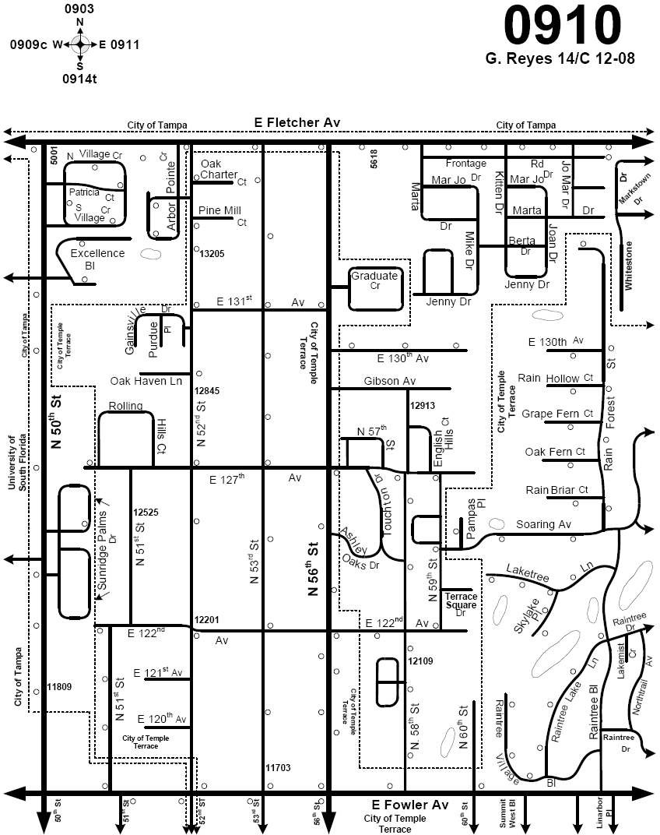

AUTHORIZATION: William L. Nesmith, Fire Chief

1. COMPANY OFFICER STATION INSPECTIONS
   1. On the first Saturday of each month, the captain or senior officer is responsible for conducting a station readiness and safety survey. This survey should include, but not be limited to the following:
      1. Station Appearance: The station and grounds will be inspected for appearance and any sign of disrepair. Any items needing attention will be noted and the proper paperwork filed for correction.
      2. Smoke Detectors:
         1. Location: one just outside each dormitory entrance, one inside each dormitory, one in each separate work area, one in or adjacent to the kitchen (this detector should be placed so as not to be activated during normal cooking activities), and one each general storage area.
         2. Check batteries and proper operation.
         3. When activated, detectors should activate throughout the fire station.
      3. Carbon Monoxide Detectors:
         1. One each in each sleeping and living areas (day room, kitchen, etc.).
         2. Check batteries and proper operation.
      4. Fire Extinguishers: Check for the service date, one year from date of last service. Location: one at entrance leading to kitchen area (wall mount). An extinguisher will be located in a wall mount just inside the closest doorway leading to the fuel island at stations with fuel pumps. Must be accessible for use in an emergency.
      5. Signs:
         1. EXIT locations: a sign will be on or above a door used as an exit that is NOT immediately visible or recognizable by occupants to be an exit. Doors in hallways or foyers that lead to an exit, but are not a means of exiting, will have a sign indicating "Not an Exit." Hallways leading to an exit, but the door is not visible, must have a sign indicating direction of the exit. Openings leading to other rooms or areas that are not provided an exit must have a sign indicating "Not an Exit."
         2. NO SMOKING: signs will be posted at the fuel pump station and near any LP tank.
         3. EMERGENCY FUEL SHUTOFF SWITCHES: This shutoff switch will be easily accessible during fueling operations. Wall switch plates or outside switch boxes will be painted red and marked accordingly. The breaker switch inside the breaker box will also be labeled and marked. Station doors leading to the shutoff switch will be left unlocked or open for easy access in the event of an emergency.
      6. Electrical:
         1. All circuit breakers will be properly identified and marked.
         2. All electrical cords will be properly spliced.
         3. All receptacles must be grounded and all appliances having three pin plugs must have a grounding pin in place.
         4. Any receptacle located near a water sink must be equipped with Ground Fault.
         5. All wall switches or outlets must have cover plates intact.
         6. Emergency lighting will be checked for proper function.
      7. Housekeeping:
         1. All areas of the station will be kept clear of any tripping hazards such as telephone or electrical extension cords. Apparatus floors will be maintained free of any slippery substances, i.e., water, oil, hydraulic fluids, etc., or any other obstructions.

|  |  |  |  |
| --- | --- | --- | --- |
| SECTION: | Administrative Policies | EFFECTIVE DATE: | 1 March 2010 |
| SUB-SECTION: | Organizational Planning & Readiness | REVISION DATE: |  |
| POLICY TITLE: | Station Inspections | REVIEW DATE: |  |

POLICY NUMBER 101.05 Page 2 of 2

* + 1. PPE:

1. All combustible or flammable materials used for normal station maintenance will be sorted on a shelf or in a cabinet designed solely for that purpose (located preferably in the apparatus bay area).
2. Monthly inspections should also include bunker gear and uniforms of all personnel to insure that it is clean and meets all minimum standards for appearance and safety.
3. BATTALION CHIEF INSPECTIONS
   1. The Battalion Chief will conduct quarterly station inspections and as he/she deems necessary to insure proper compliance with all applicable safety regulations, grooming and uniform standards, and general housekeeping of the station and grounds.
   2. The Battalion Chief will provide instructions for improvements to the company officer(s) as needed.
4. SHIFT COMMANDER INSPECTIONS
   1. The Shift Commander may conduct inspections as he/she deems necessary at any fire station.
   2. This would normally be conducted with reasonable notice during normal business hours unless circumstances warrant and unannounced inspection.
5. FIRE PREVENTION INSPECTIONS
   1. The Fire Prevention Bureau shall schedule and conduct Fire Safety Inspections of each fire station annually.
   2. Results of all inspections will be forwarded to the Assistant Chiefs of Operations and Administration so that any items needing to be addressed may be remedied.
6. ANNUAL INSPECTIONS
   1. Annual Inspections will be conducted by the Executive Staff as directed by the Fire Chief or his/her designee.
   2. The scope of the inspection will be determined by the Fire Chief.
   3. Annual Inspections for safety and compliance of all policies and standards shall be documented and kept on file in accordance with NFPA 1500.

|  |  |  |  |
| --- | --- | --- | --- |
| SECTION: | Administrative Policies | EFFECTIVE DATE: | 1 Martin 2010 |
| SUB-SECTION: | Organizational Planning & Readiness | REVISION DATE: |  |
| POLICY TITLE: | Fire Hose Annual Service Testing | REVIEW DATE: |  |

POLICY NUMBER 101.06 Page 1 of 3

AUTHORIZATION: William L. Nesmith, Fire Chief

1. All fire hose in use on Hillsborough County Fire Rescue apparatus (both front line and reserve) shall be tested annually in accordance with the most current edition of NFPA 1962, "Standard for the Care, Use, and Service Testing of Fire Hose Including Couplings and Nozzles".
   1. Testing shall be done in conjunction with the annual pump test for each apparatus as scheduled and conducted by Fleet Management Services.
      1. This process may be done on a contractual basis via a qualified private provider.
      2. Should Hillsborough County Fire Rescue not have an existing contract with a vendor for the purpose of conducting the annual hose test, designated members and/or Fleet Management Services shall be provided with training in the safe operation and procedures for conducting hose testing in accordance with NFPA 1962 and this policy.
   2. Service Test (Annual Hose Testing) shall be done using a "Hose Testing Machine / Pump" that is specifically designed for this purpose.
2. Should HCFR choose not to use a private provider for the purpose of annual service testing of hose, it shall be the responsibility of each Battalion Chief/Shift Commander to ensure that all tests are carried out for each company within his/her Battalion and to coordinate the testing of companies in accordance with the schedule as established by Fleet Management/HCFR Staff.
3. All fire hose in use by HCFR shall be tested using the below minimum guidelines regardless of the person(s) who are employed to conduct such testing:
   1. General Testing Guidelines:
      1. All hose shall be service tested (supply lines, attack lines, booster, and hard/soft sections).
      2. Each length of hose shall be pre-inspected prior to testing.
         1. All couplings shall be inspected for damage, slipping, and to insure that the gasket is in place and not dry rotted or otherwise damaged.
            1. If a gasket is deemed unserviceable it shall be replaced.
            2. If a coupling is damaged or show signs or slipping the section shall be either repaired or condemned and replaced.
         2. The jacket shall be inspected for damage, rotting, excessive wear, and for signs that the outer jacket may be separating from the inner liner.
            1. Should an external jacket be found to be unacceptable or suspect, the hose shall be either repaired or condemned and replaced.
            2. Should a hose show signs of delamination (separation of liner from jacket) the hose shall be condemned and destroyed.
      3. The length of any hose to be tested shall not exceed 300 feet in length (single section or multiple sections) and shall be maintained in as straight a line as is practicable.
      4. All 4" & 5" hose (LOH) shall be tested with a short section of smaller diameter hose (2.5" / 3") that has a service test pressure greater than or equal to that of the LOH.
         1. The smaller hose shall be connected to the discharge and the LOH attached in-line from the smaller hose.

|  |  |  |  |
| --- | --- | --- | --- |
| SECTION: | Administrative Policies | EFFECTIVE DATE: | 1 Martin 2010 |
| SUB-SECTION: | Organizational Planning & Readiness | REVISION DATE: |  |
| POLICY TITLE: | Fire Hose Annual Service Testing | REVIEW DATE: |  |

POLICY NUMBER 101.06 Page 2 of 3

* 1. Hose Testing Machine Guidelines:
     1. The condition of the hose testing machine shall be thoroughly checked daily, prior to any testing.
        1. Also, the machine shall be tested again should the testing site change during that same day.
     2. The machine shall be inspected for any damaged parts.
        1. Should any damage be discovered, it shall be repaired or replaced prior to use.
     3. A pressure leak integrity test shall be performed on the machine to ensure the pressurized outlet side is leak- free.
        1. The hose outlet connection shall be capped or otherwise closed.
        2. Pressure shall be applied to a level ten percent (10%) higher than the highest service test pressure.
        3. With the pump turned off, this pressure shall be maintained for a period of three (3) minutes.
        4. If leaks are detected, the machine shall not be used until repaired or replaced.
        5. The test gauge used must have been calibrated within the previous twelve (12) months.
  2. Conducting the Test:
     1. The test layout shall be connected to the outlet side of the water supply valve of the machine.
        1. A test cap with a bleeder valve shall be attached to the end of the test layout.
           1. A nozzle with a non-twist shutoff is acceptable.
     2. With the test cap open, the pressure shall be gradually raised to 45 psi ( 5 psi) and the discharge end shall be raised above the highest point in system to remove all air.
     3. The test cap shall be closed slowly, followed by closing the outlet water supply valve slowly.
     4. The hose shall be secured just behind the test cap to avoid any violent whipping or movement in the event of a burst line or other failure.
     5. The test layout shall be charged to between 40 - 50 psi and shall be walked and all couplings tightened to secure any leaks as necessary.
        1. Each coupling shall be marked with a line at the point the coupling is joined to the hose so that after the hose is drained slipping that may have occurred will be evident.
     6. All personnel not required to perform the remainder of the procedure shall leave the immediate area.
     7. The pressure shall be raised at a rate not to exceed 15 psi per second until the service test pressure is attained.
        1. This pressure shall be maintained (by pressure boost if necessary) for the duration of the stabilization period.
           1. The stabilization period is not less than 1 minute for each section of hose in the layout.
     8. After the stabilization period, the layout shall maintain the service test pressure (without further pressure boost) for a period of 3 minutes.
        1. Ouring this period the layout shall be inspected for leaks by personnel maintaining at least 15 feet of distance walking the left side of the hose layout.
           1. The left side is determined by facing the free end of the layout away from the pressure source.

|  |  |  |  |
| --- | --- | --- | --- |
| SECTION: | Administrative Policies | EFFECTIVE DATE: | 1 Martin 2010 |
| SUB-SECTION: | Organizational Planning & Readiness | REVISION DATE: |  |
| POLICY TITLE: | Fire Hose Annual Service Testing | REVIEW DATE: |  |

POLICY NUMBER 101.06 Page 3 of 3

* + 1. Personnel shall never stand at the free-end of the hose, on the right side of the hose, closer than 15 feet to the hose, or straddle the hose at anytime when the pump has been raised above the 45 psi level.
    2. If the service test pressure is not maintained during the 3 minute period, the test shall be terminated.
       1. The length of hose that leak shall have failed the test and it shall be drained and removed from service.
       2. The test shall be restarted beginning again at the procedure listed in § 101.06 (3)(c).
    3. Once the 3 minute duration has been reached, with no reduction in pressure or evidence of leaks, the test shall be concluded and the layout drained using the test cap valve.
    4. After the hose has been drained, the couplings shall be examined and if any sign of slippage is noted the hose shall have failed the test.

1. Hose Records:
   1. Should a private vendor be used, the vendor shall be required to provide a Hose Inventory System that will allow HCFR to fully comply with the intent of the most current addition NFPA 1962, "Standard for the Care, Use, and Service Testing of Fire Hose Including Couplings and Nozzles".
   2. If HCFR / Fleet Management is used the following system of documentation shall be used.
      1. All hose information and test results will be recorded on the ISO Hose Inventory Form F-223 (rev. 08').
         1. Once the annual testing is complete and data for the test are recorded, the F-223 (rev. 08') shall be filed as follows:
            1. Original: stored in the station file cabinet in a folder marked "Annual Hose Inventory/Test".
            2. Copy #1: forwarded to headquarters for electronic scanning and filing.
            3. Copy #2: forwarded to the A-platoon Battalion Chief/Shift Commander for filing at the Battalion Office in a folder marked "Battalion Annual Hose Inventory/Test".

Each A-platoon Battalion Chief shall notify his/her Shift Commander in writing once every unit under his/her command has completed the annual test for the calendar year.

* + - 1. Once the A-platoon shift commander has received conformation that every unit has been appropriately tested, he/she shall notify the Assistant Chief of Operations in writing.

|  |  |  |  |
| --- | --- | --- | --- |
| SECTION: | Administrative Policies | EFFECTIVE DATE: | 1 March 2010 |
| SUB-SECTION: | Organizational Planning & Readiness | REVISION DATE: |  |
| POLICY TITLE: | Standbys | REVIEW DATE: |  |

POLICY NUMBER 101.07 Page 1 of 1

AUTHORIZATION: William L. Nesmith, Fire Chief

1. Sometimes it is necessary to use an on-duty crew(s) to standby at large or out of the ordinary community events or other significant occurrences on a "calls permitting" basis.
   1. Normally these events shall be ones in which Hillsborough County Fire Rescue is not already providing standby personnel through a previously established arrangement that would pay off-duty members for their time and thereby not creating an impact our regularly provided emergency service.
2. Standbys shall not be accepted within the city limits of Tampa, Plant City, or Temple Terrace unless approved by the Fire Chief.
3. Battalion Chiefs are authorized to pull standby units for emergency calls when in the best interest of public safety.

|  |  |  |  |
| --- | --- | --- | --- |
| SECTION: | Administrative Policies | EFFECTIVE DATE: | 1 March 2010 |
| SUB-SECTION: | Organizational Planning & Readiness | REVISION DATE: |  |
| POLICY TITLE: | Fire Hydrant Use and Repair Reporting | REVIEW DATE: |  |

POLICY NUMBER 101.08 Page 1 of 1

AUTHORIZATION: William L. Nesmith, Fire Chief

1. The following procedure will be utilized for reporting fire hydrants found to be in need of repair.
   1. Municipality owned and maintained hydrant:
      1. The Company Officer shall complete a form F-173 (Fire Hydrant Repair Request) and fax it to the Fire Prevention Office.
   2. Privately owned and maintained hydrant:
      1. The Company Officer shall complete form FP-220 (Company Officer Inspection Request) and fax it to the Fire Prevention Office.
   3. A proper entry should be made in the station log book indicating the hydrant location, hydrant number, and the action taken.
2. Whenever a Hillsborough County Fire Rescue unit uses a fire hydrant (i.e. training, suppression ops, testing, etc.) the Company Officer shall upon returning to the station:
   1. Log onto the computer network, go to the following below listed website, and fill out the Fire Hydrant Use Survey.
      1. <http://hcbocc.websurveyor.net/wsb.dll/31/Hydrant-Use-Form.htm>
   2. Information collected in the survey shall reflect:
      1. Hydrant ID Tag # or location.
      2. Date.
      3. Approximated amount of water used in whole gallons.
      4. Member submitting the report.
      5. Station #.

AUTHORIZATION: William L. Nesmith, Fire Chief

1. With regards to Line-of-Duty Injuries / Illnesses / Exposures (i.e. Workers Compensation claims), all members shall adhere to the procedures contained in this policy and policy 122.08 (Workers Compensation: Light Duty).
2. All actual or suspected Line-of-Duty injuries, illnesses, and/or exposures shall be reported the day of the event and recorded in the Station log book.

# Line of Duty lnjury I lllness

* 1. Injuries Requiring Emergency Care:
     1. St. Joseph's and Tampa General Hospitals shall be the preferred transport destination for job related injuries that require emergency treatment.
        1. Tampa General shall be the destination choice for any member suffering from actual or potential burns and/or inhalation injuries.
        2. At the discretion of the Charge Medic, the member may be taken to another medical facility if the member's medical condition warrants immediate intervention and the facility is capable of providing the appropriate level and type of care.
     2. The Company Officer, or another member of the crew should the Company Officer require transport, shall immediately notify of the Battalion Chief or Senior Volunteer Officer.
     3. The Battalion Chief or Senior Volunteer Officer shall notify the Shift Commander that a member of HCFR has been transported for treatment as soon as practicable.
     4. In the case of serious or life threatening injury or illness, the Shift Commander shall ensure that the Assistant Chief of Operations, the Chief of Personnel Services, and the President of the member's Collective Bargaining Unit are notified as soon as is practicable.
     5. The Company Officer, or the Battalion Chief should the Company Officer require transport, shall ensure that all appropriate paperwork (First Report of Injury Packet - "yellow packet") is completed and faxed to headquarters ASAP.
  2. Injuries Requiring Non-Emergency Care - During Normal Working Hours:
     1. DURING NORMAL WORKING HOURS, any request for non-emergency medical care for job related injuries shall be coordinated through the Personnel Division at Headquarters.
        1. Procedure:
           1. All visits for medical non-emergency examination or follow up care must be authorized by the Office of Risk Management, through Headquarters.
           2. The Battalion Chief, or Company Officer at the direction of the Battalion Chief, shall contact the Personnel Division and report the injury and need for care.
           3. Members shall be referred to an authorized Medical Provider for treatment.
           4. Injured personnel will submit paperwork the same day to Headquarters unless incapacitated.
           5. All follow up appointments shall be coordinated between the member and the County's Worker's Compensation Administrator.

All paperwork from follow-up appointments shall be submitted to the Personnel Division the same day.

* 1. Injuries Requiring Non-Emergency Care - After Regular Working Hours:
     1. AFTER REGULAR WORKING HOURS, any minor injury sustained on duty may be attended to at the nearest walk-in clinic and / or emergency room.
        1. All follow up treatment will be coordinated through Headquarters by the Battalion Chief.
  2. * Special Note* - Members of I.A.F.F. Local 2294 shall, at the member's option, retain the right to have any initial injury/illness treatment provided at a local emergency room. (Local 2294 CBA 14.1)

# Line of Duty Exposure

* 1. Members shall notify their supervisor as soon as any exposure occurs or is suspected.
  2. The Company Officer shall:
     1. Contact the Infection Control Specialist (as provided by either the Department Infection Control Officer or contracted medical care provider) immediately.
        1. The pager number for Infection Control is currently (813) 268-3888.
     2. The Company Officer will ensure that and/or assist the exposed member in completing the First Report of Exposure Packet - "the blue packet".
     3. Follow the instructions in the exposure packet and those of the Infection Control Specialist.
  3. The Battalion Chief or Senior Volunteer Officer shall:
     1. Make sure that all appropriate paperwork is completed and faxed to Headquarters ASAP.
     2. Assist in making sure that timely medical care is provided in conjunction with the Infection Control Specialist.

1. On-Duty Injury and Exposure Packets:
   1. For On-Duty Injury: follow the instructions and complete the INJURY PACKET which has the yellow cover sheet and fax to the HCFR Personnel Division ASAP.
   2. For Exposures: follow the instructions and complete the EXPOSURE PACKET which has the blue cover sheet and fax to the HCFR Personnel Division ASAP.
      1. *Do Not Forget* - Report any exposure immediately to the Fire Rescue Infection Control Specialist.
2. Upon completion of initial medical treatment:
   1. Deliver all medical paperwork, completed Hillsborough County Fit for Duty medical release, and any billing paperwork to the HCFR Personnel Division at Headquarters.
   2. If after hours, fax any of the above paperwork to the HCFR Personnel Division at 272-7039.
   3. *NOTE* - Please ensure that the treating medical practitioner indicates on the doctor's note if the member is to:
      1. Remain in a non-duty status.
      2. Be placed on light duty (be sure that any restrictions are listed)
      3. Be released full duty without restrictions but with further follow-up required.
      4. Be released to full-duty without restrictions and has reached Maximum Medical Improvement (MMI).
         1. A listing of MMI indicates that the claim for this event has been closed and that any further treatment of the member for this event by a Worker's Compensation provider shall require the member to make a co-payment for services rendered.
      5. One of the four release types must be listed on all releases for the initial visit and on each follow-up visit.
3. Follow-up Medical Treatment:
   1. After the initial medical treatment has been completed, some injuries will require follow-up treatment through authorized Worker's Compensation medical practitioners.
   2. All follow-up medical treatment must be coordinated between the member and the County's Worker's Compensation administrator.
      1. A coordinator shall be assigned to each member by Worker's Compensation administrator for follow-up care appointments.
4. Relapse of a prior injury:
   1. If a member suffers a relapse of a prior injury/illness and does not feel that he/she can work their normal full duty work assignment, the member must notify their Battalion Chief/Senior Volunteer Officer and the HCFR Personnel Division immediately.
   2. The member must be seen by a County Worker's Compensation Medical Practitioner on or prior to his/her regularly scheduled duty day.
      1. It is not necessary to be seen by the original practitioner. If a member does not have this medical documentation, then the member shall be charged leave time or will be in an unpaid status.
      2. A relapse of a prior injury must be coordinated through the County's Worker's Compensation administrator for authorized treatment.
5. Annual Follow-Up Medical Assessments:
   1. Some members may have sustained injuries, illnesses, or exposures in which the member feels may need annual reassessment by a Worker's Compensation medical practitioner.
      1. Requests for these type visits must be made by the member through the County's Worker's Compensation administrator.
   2. A member who has been released back to full duty for more than one (1) year without continued care by a County Worker's Compensation medical practitioner cannot schedule a checkup for that injury.
   3. A relapse that occurs past the one year period is considered to be a new injury.
6. A member may be required to participate in the Physical Agility Test prior to returning to active duty.
7. If you have any questions, concerns, or have any difficulties with any aspect of a Worker's Compensation injury, illness, exposure, claim, or subsequent care please contact the Personnel Division at Headquarters.
8. * Note * - the current administrating company for all Hillsborough County Worker's Compensation claims is John's Eastern Insurance Company.
   1. The current contact information for John's Eastern Insurance Company is:
      1. Johns Eastern Company, Inc.

P.O. Box 110279

Lakewood Ranch, FL 34211-0004 (800) 749-3044

* 1. The current administrator and / or their contact information are subject to change.
     1. Should a member have problems contacting the current listed provider they should contact the HCFR Personnel Division for further assistance.

 

## POLICIES AND PROCEDURES MANUALS RULES & REGULATIONS

|  |  |  |  |
| --- | --- | --- | --- |
| SECTION: | Member Development and Well Being | EFFECTIVE DATE: | 1 March 2010 |
| SUB-SECTION: | Training and Education | REVISION DATE: |  |
| POLICY TITLE: | Employee Assistance Program (EAP) | REVIEW DATE: |  |

POLICY NUMBER 141.02 Page 1 of 1

AUTHORIZATION: William L. Nesmith, Fire Chief

1. Occasionally, situations arise in one's professional or personal life that can be difficult for the individual member to cope with. Hillsborough County has established an Employee Assistance Program to assist those employees who face such a circumstance.
2. Professional & discreet counseling services are available through the Hillsborough County Employee Assistance Program (EAP) at no cost to the employee or eligible dependent.
3. The contracted coordinator of the EAP for employees of Hillsborough County is Humana LifeSync and they can be contacted directly for confidential assistance by dialing 1-866-440-6556.
   1. This number can be used 24 hours-a-day/7 days-a-week, whenever the employee feels he/she needs assistance.
   2. Online information is also available for the EAP by going to <http://coin.hillsboroughcounty.org/departments/hr/home.cfm> and/or [www.lifesync.com](http://www.lifesync.com/) .
4. The EAP offers the employee and their eligible dependents access to face-to-face counseling services to help resolve personal problems which may be affecting one's work and/or home life.
   1. Some of the issues the EAP can help with include, but are not limited to:
      1. Marital and Family
      2. Parenting
      3. Alcohol and/or Substance Problems
      4. Aging Parents and Elder Care
      5. Relationships
      6. Anxiety/Depression
      7. Legal and Financial Problems
      8. Stress Management
5. Remember, all contact with EAP is strictly confidential and the employer is not notified about your use of the program.
6. Additional information may be obtained on COIN or by contacting the Benefits Section of the Department of Human Resources at 276-2720.