**Lab 2**

**57117112 吴泽辉**

Task 1 : Running Shellcode

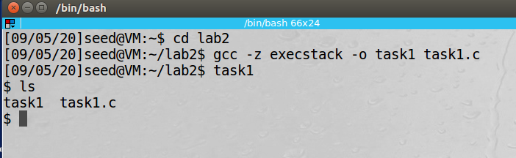

Task2: Exploiting the Vulnerability

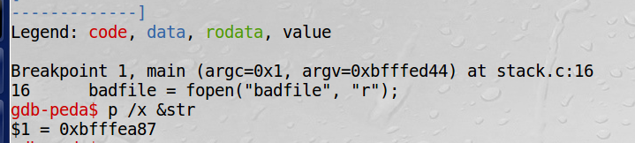

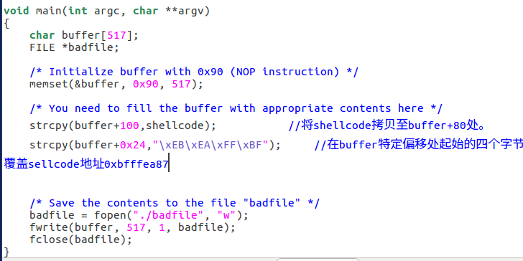

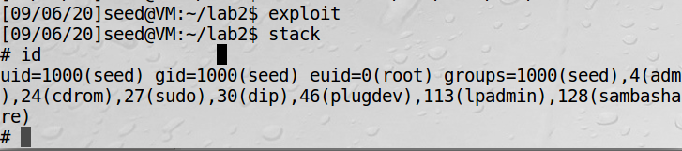

通过缓冲区溢出，成功获得root权限

Task3: Defeating dash’s Countermeasure

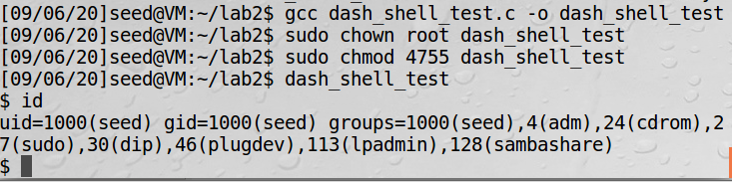 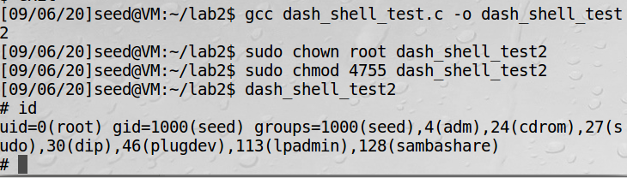

取消注释后能拥有root权限

Task4: Defeating Address Randomization

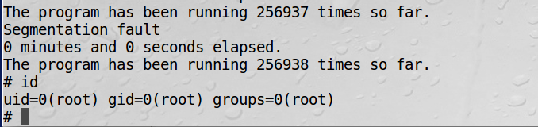

运行了256938次之后获得了root权限

Task5: Turn on the Stack Guard Protection

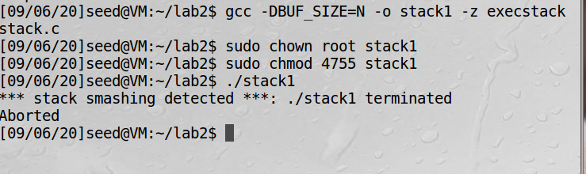

Task6: Turn on the Non-executable Stack Protection

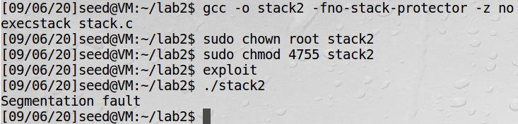

Task1: Finding out the addresses of libc functions

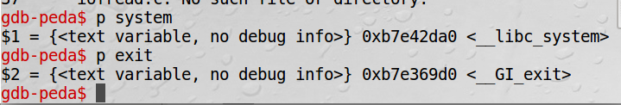

Task2: Putting the shell string in the memory

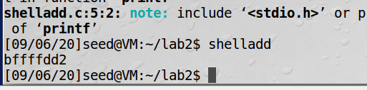

地址为0xbffffdd2

Task3: Exploiting the buffer-overﬂow vulnerability

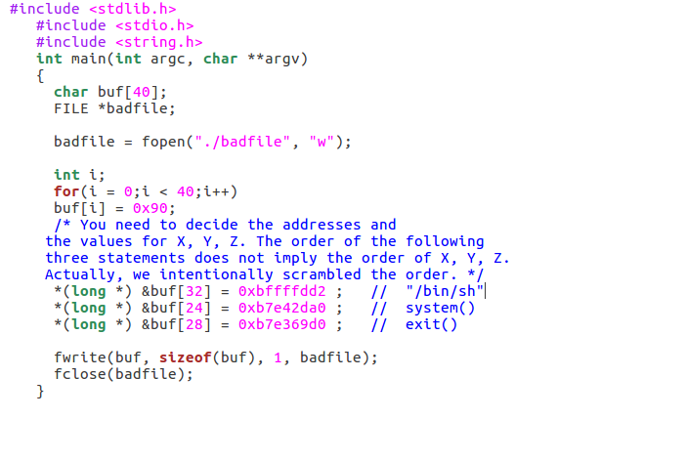

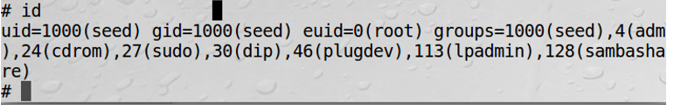

运行之后获得root权限

Task4: Turning on address randomization

