DEPARTMENT OF COMPUTER STUDIES

**(Applications Development and Emerging Technologies)**

**TECHNICAL-SUMMATIVE ASSESSMENT**

**4**

**USER PRIVILEGES, MANAGEMENT AND FILE UPLOAD**

|  |  |
| --- | --- |
| **Student Name / Group Name:** | Darla David and Dana Huang |
| **Members (if Group):** | |  |  | | --- | --- | | **Name** | **Role** | |  |  | |  |  | |  |  | |
| **Section:** | AN31 |
| **Professor:** | Sir Michael Ricafrente |

1. **PROGRAM OUTCOME/S (PO) ADDRESSED BY THE LABORATORY EXERCISE**

* Design, implement and evaluate computer-based systems or applications to meet desired needs and requirements.

1. **COURSE LEARNING OUTCOME/S (CLO) ADDRESSED BY THE LABORATORY EXERCISE**

* Understand and apply best practices and standards in the development of website.

1. **INTENDED LEARNING OUTCOME/S (ILO) OF THE LABORATORY EXERCISE**

At the end of this exercise, students must be able to:

* To provide a good background of Relational Database using MySQL.
* To know the importance of Database in Web Application using MySQL.
* To Identify the importance of Database Structure in constructing tables.
* To be familiar with the syntax in managing users and database.
* To define a good structure of tables in a given database for data storage.
* To be familiar in the common syntax of creating database and tables and the correct data type to be used for each field.

1. **BACKGROUND INFORMATION**

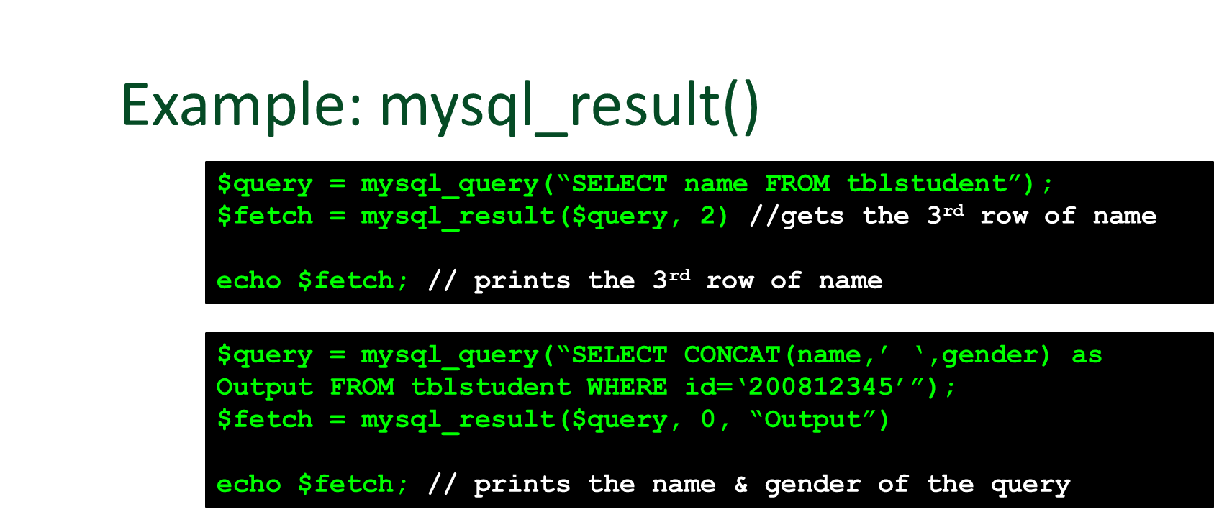

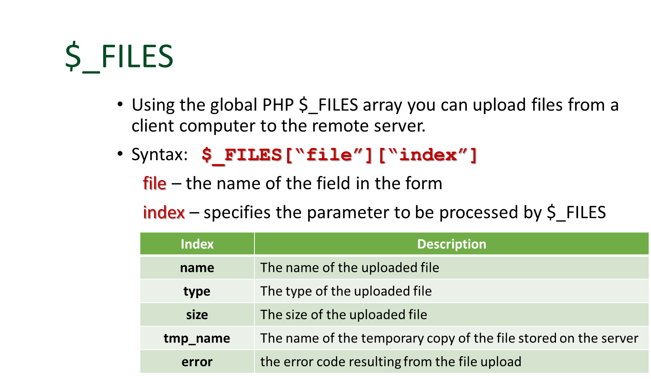

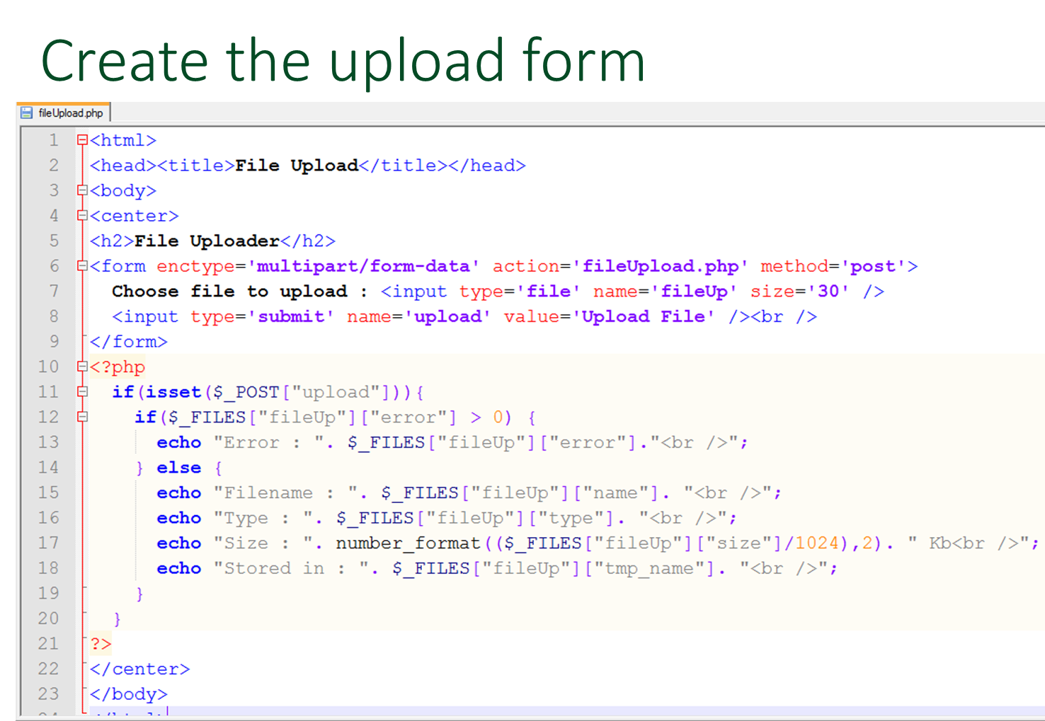

1. **GRADING SYSTEM / RUBRIC (please see separate sheet)**
2. **LABORATORY ACTIVITY**
3. Create a database using the following fields [ID, Firstname, Lastname, Middlename, Contactno, Email,Birthday, username, password, accesslevel, status. image]. incorporate the user access levels such as user and administrator. Integrate HTML, CSS and Sessions. Refer to the image below:

Admin panel (Admin_home.php):

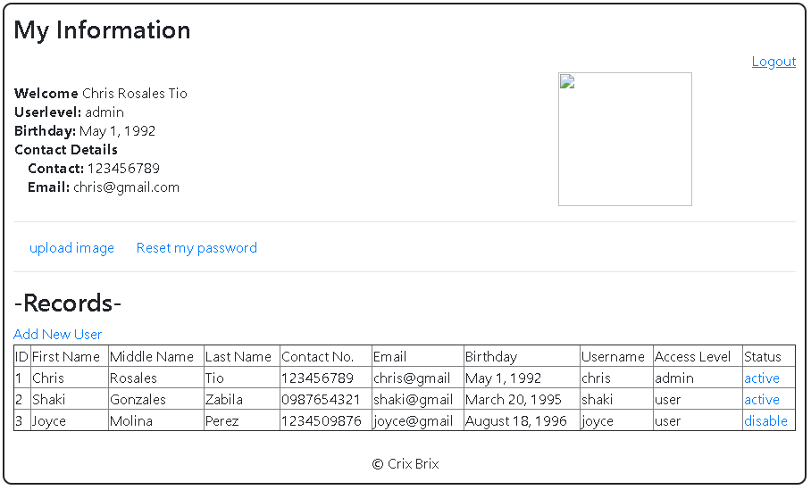

Admin panel - Add user link (Admin_adduser.php):

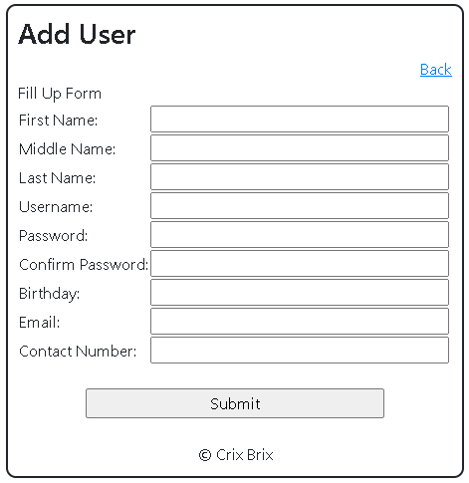

Upload Image (Admin_image.php):

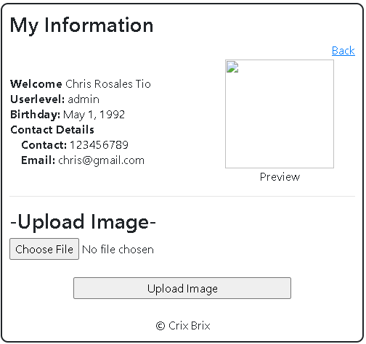

Reset my password (Admin_changepass.php):

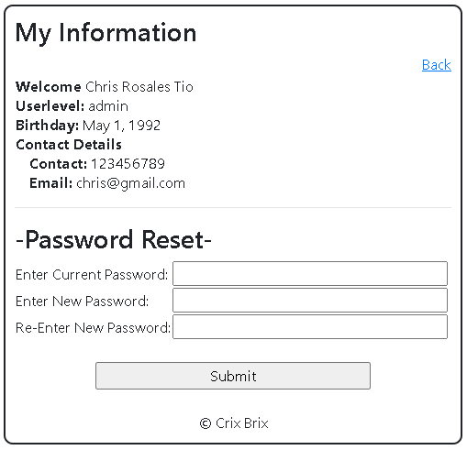

*Back link will go to Admin_home.php

1. Create a login form.

Example of Login form (login.php)

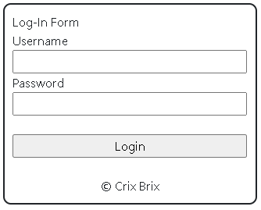

Notes:

* Depends on the user level where the webpage will be redirect
  + Admin ->Admin_home.php
  + User -> User_home.php
* Check if the user is active or disable, if disable show a message “This account is disabled please contact the administrator” otherwise proceed to Admin_home.php or User_home.php. Please see example below:

Example:

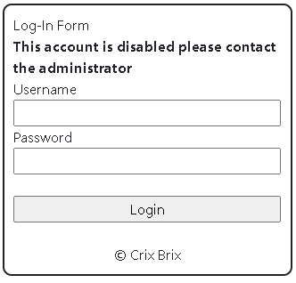

1. Create a homepage for the user. Please see the example below:

Homepage(user_home.php)

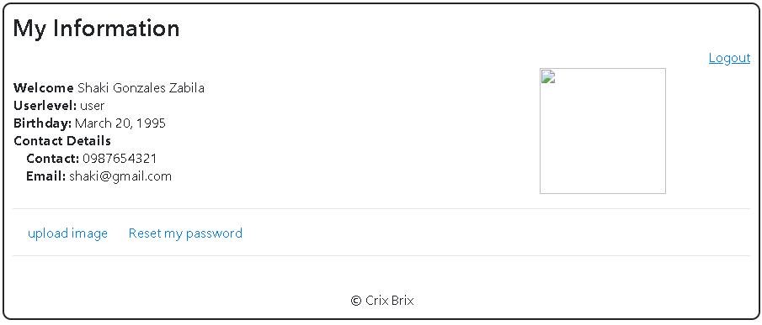

Change password (user_changepass.php):

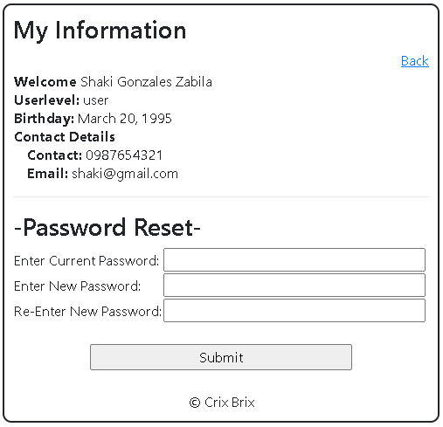

Change/upload picture(user_image.php)

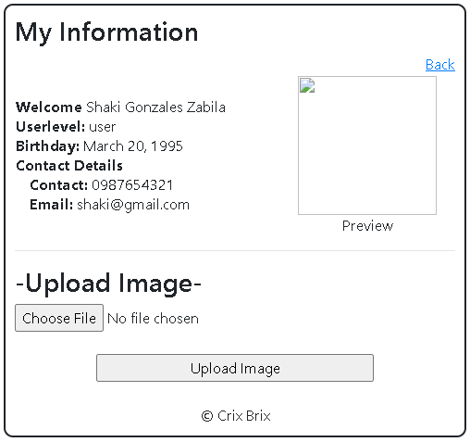

*Back link will go to user_home.php

1. Create 10 different records.
2. Screenshot your database with all the records form the XAMPP.

***Snip and paste your source codes here. Snip it directly from the IDE so that colors of the codes are preserved for readability. Include additional pages if necessary.***

1. **QUESTION AND ANSWER**
2. What are the different user levels in accessing a website?
3. What is the importance of Database in Web Application using MySQL.?
4. What are the different syntaxes in managing users and database?
5. What are the different types of file?
6. What are the different types of validation of file?
7. What are the syntaxes on creating and deleting a file?

**VIII. REFERENCES**

1. <https://www.w3schools.com/css/>
2. <https://www.w3schools.com/html/>
3. <https://www.w3schools.com/php/php_variables.asp>
4. <https://www.w3schools.com/php/php_mysql_intro.asp>
5. <https://www.w3schools.com/php/php_mysql_connect.asp>
6. <https://www.w3schools.com/php/php_mysql_create.asp>
7. <https://www.w3schools.com/php/php_mysql_create_table.asp>
8. <https://www.w3schools.com/php/php_mysql_insert.asp>
9. <https://www.w3schools.com/php/php_mysql_insert_multiple.asp>
10. <https://www.w3schools.com/php/php_mysql_select.asp>
11. <https://www.w3schools.com/php/php_mysql_select_where.asp>
12. <https://www.w3schools.com/php/php_mysql_select_orderby.asp>
13. <https://www.w3schools.com/php/php_mysql_delete.asp>
14. <https://www.w3schools.com/php/php_mysql_update.asp>
15. <https://skillforge.com/how-to-create-a-database-using-phpmyadmin-xampp/>
16. <https://www.w3schools.com/php/php_file_upload.asp>

**Note: The following rubrics/metrics will be used to grade students’ output.**

|  |  |  |  |  |
| --- | --- | --- | --- | --- |
| **Program (100 pts.)** | **(Excellent)** | **(Good)** | **(Fair)** | **(Poor)** |
| **Program execution (20pts)** | Program executes correctly with no syntax or runtime errors **(18-20pts)** | Program executes with less than 3 errors **(15-17pts)** | Program executes with more than 3 errors **(12-14pts)** | Program does not execute **(10-11pts)** |
| **Correct output**  **(20pts)** | Program displays correct output with no errors **(18-20pts)** | Output has minor errors **(15-17pts)** | Output has multiple errors **(12-14pts)** | Output is incorrect **(10-11pts)** |
| **Design of output**  **(10pts)** | Program displays more than expected **(10pts)** | Program displays minimally expected output **(8-9pts)** | Program does not display the required output (**6-7pts)** | Output is poorly designed **(5pts)** |
| **Design of logic**  **(20pts)** | Program is logically well designed **(18-20pts)** | Program has slight logic errors that do no significantly affect the results **(15-17pts)** | Program has significant logic errors **(3-5pts)** | Program is incorrect **(10-11pts)** |
| **Standards**  **(20pts)** | Program code is stylistically well designed **(18-20pts)** | Few inappropriate design choices (i.e. poor variable names, improper indentation) **(15-17pts)** | Several inappropriate design choices (i.e. poor variable names, improper indentation) **(12-14pts)** | Program is poorly written **(10-11pts)** |
| **Delivery**  **(10pts)** | The program was delivered on time. **(10pts)** | The program was delivered a day after the deadline. **(8-9pts)** | The program was delivered two days after the deadline. **(6-7pts)** | The program was delivered more than two days after the deadline. **(5pts)** |