What is Scrum?

**S**crum is a type of agile methodology that helps teams work together. In Scrum, projects move forward using incremental, iterative work sequences called sprints, rather than a singular finish line to measure project completion.

What is Trello?

**T**rello is an easy-to-use collaboration tool that enables you to organize projects, and everything related to them into boards. You can set deadlines, leave notes on projects and tasks, and assign tasks to other project collaborators.

Use Trello for Scrum to help with teamwork!

**S**crum and Trello can help get your project off the ground. As Trello uses movable, flexible, and visible features for [work management](https://blog.trello.com/beginner-tips-for-using-trello) and [project management](https://trello.com/use-cases/project-management), running Scrum on a Trello board helps give work more direction, ensures you’re focused on tasks that add value, and tracks your progress week over week.

**QAP 3 Trello Board Progress**

June 7, 2022

June 11, 2022

June 15, 2022

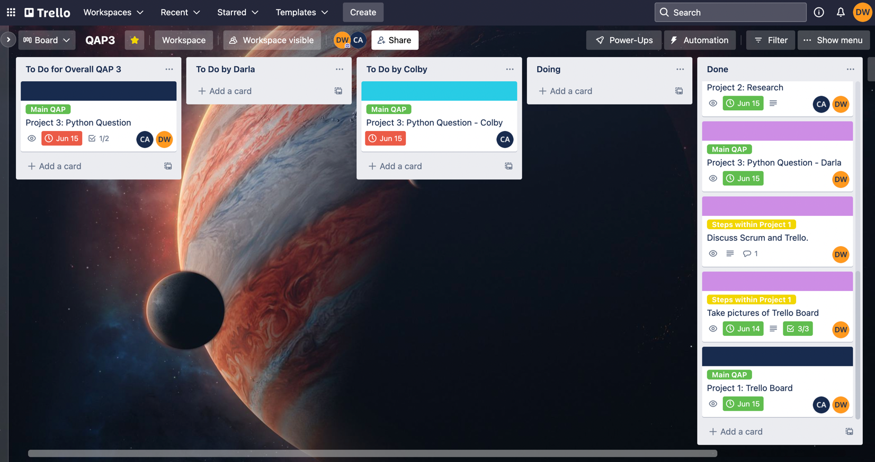

QAP 3 Completed: June 16, 2022