Deeb Armaly

ECE 4310

Lab 1

6 September 2022

C17525380

For this lab, three different smoothing algorithms were to be implemented. The output of the first algorithm is smoothed1.ppm, and the same naming follows for the second and third algorithms. As shown in the screenshot below, when compared, no differences appear in all three algorithms. This means the smoothed output images of all three algorithms are the same.

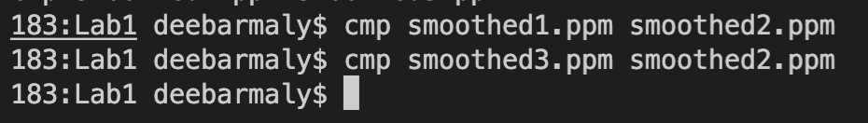

The chart below shows the run times of each of the sorting algorithms. Each algorithm was run 10 times and the average of the ten runs are calculated below. Run times are shown in nano-seconds.

|  |  |  |
| --- | --- | --- |
| Basic 2D Convolution | Separable Filters | Separable Filters and Sliding Window |
| 35215000  35268000  35456000  35416000  35336000  35392000  35316000  35402000  35505000  35410000 | 14621000  14648000  14812000  14546000  14728000  14696000  14835000  14759000  14594000  14932000 | 7562000  7484000  7325000  7637000  7576000  7631000  7632000  7552000  7741000  7528000 |
|  |  |  |
| AVG: 35371600 | AVG: 14717100 | AVG: 7566800 |

As can be seen from the chart, utilizing the smoothing algorithm with separable filters lowered the average runtime by 20654500 nsec compared to basic 2D convolution. Utilizing separable filters along with a sliding window further lowered the average runtime by 27804800 nsec compared to basic 2D convolution and 7150300 nsec from just using separable filters alone.