**Pertemuan 9 : FRAMEWORK I**

**Tugas 9 : SI Mobil Listrik**

|  |  |
| --- | --- |
| **Nama / Nim** | **: Darmawansyah (1918028)** |
| **Kelas** | **: I** |
| **Pengajar** | **:** |

* 1. **Tujuan**

1. Praktikan Mampu memahami konsep MVC pada framework Laravel.
2. Praktikan Mampu mengkofiguransi framework Laravel.
   1. **Alat dan Bahan**
3. Laptop/pc
4. Modul Praktikum Web 2024
5. TextEditor (Visual Studio Code / Sublime Text)
   1. **Langkah-langkah**
6. Buka cmd atau gitbash kemudian masuk ke directori untuk menyimpan project laravel kita, kemudian create-project via composer seperti gambar dibawah ini. Tunggu hingga selesai menginstal laravelnya

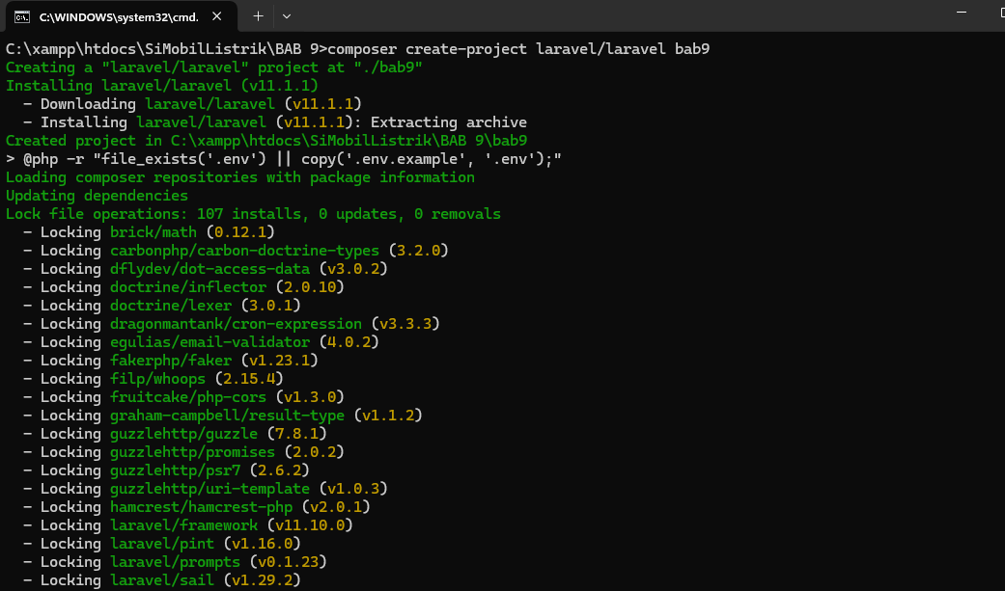

Gambar 9.1 Tampilan create project

1. Buka project Laravel yang sudah dibuat pada text editor. Kemudian silahkan buka file .env lalu cari baris code berikut

*Source code :*

|  |
| --- |
| DB_DATABASE=laravel  DB_USERNAME=root  DB_PASSWORD= |

Jika sudah menemukan baris code diatas ubah menjadi seperti berikut

|  |
| --- |
| DB_DATABASE=db_simobillistrik_laravel  DB_USERNAME=root  DB_PASSWORD= |

1. Buka database phpMyAdmin anda, lalu buat database baru dengan nama db_laravel_catshop.

Tampilan :

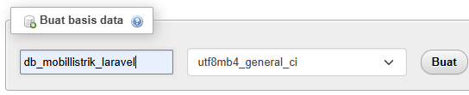

Gambar 9.2 Tampilan create database

1. Buat model dan migration untuk table categories dengan menggunakan perintah artisan berikut

|  |
| --- |
| php artisan make:model Category -m |

Setelah perintah di atas dijalankan maka kita akan mendapatkan 2 buah file baru yaitu file model yang terletak di app/Models/Category.php dan juga file migration yang terletak di database\migrations/ 2024_06_02_125842_create_categories_table.php.

1. Buka file migration dari table categories kemudian isikan source code berikut pada function up

|  |
| --- |
| Schema::create('categories', function (Blueprint $table) {  $table->id('id_categories');  $table->string('nama',50);  $table->string('harga',50);  $table->text('deskripsi');  $table->string('gambar', 100);  $table->timestamps();  }); |

Setelah itu jalankan perintah migrate supaya table categories diambahkan ke database kita

|  |
| --- |
| Php artisan migrate |

1. Buka file model Category.php kemudian tambahkan source code berikut

|  |
| --- |
| class Category extends Model  {  use HasFactory;  protected $table = 'categories';  protected $primaryKey = 'id_categories';  public $incrementing = true;  protected $fillable = ['nama', 'harga', 'deskripsi','gambar'];  public $timestamps = false;  } |

1. Buat controller baru dengan menggunakan perintah artisan berikut

|  |
| --- |
| php artisan make:controller CategoryController |

Setelah berhasil menjalankan perintah di atas kita akan mendapatkan file baru dengan nama CategoryController.php di dalam folder app/http/controllers. Buka file tersebut kemudian isikan fungsi fungsi berikut

|  |
| --- |
| <?php  namespace App\Http\Controllers;  use App\Models\Category;  use Illuminate\Http\Request;  use Illuminate\Support\Facades\File;  class CategoryController extends Controller  {  public function index()  {  $categories = Category::all();  return view('categories.categories', compact('categories'));  }  public function create()  {  return view('categories.categories-entry');  }  public function store(Request $request)  {  $request->validate([  'nama' => 'required',  'harga' => 'required',  'deskripsi' => 'required',  'gambar' => 'required|file|mimes:png,jpg,jpeg|max:2048',  ]);  $gambar = $request->file('gambar');  $nama_gambar = time() . '_' . $gambar->getClientOriginalName();  $tujuan_upload = 'img_categories';  $gambar->move($tujuan_upload, $nama_gambar);  Category::create([  'nama' => $request->nama,  'harga' => $request->harga,  'deskripsi' => $request->deskripsi,  'gambar' => $nama_gambar,  ]);  return redirect('/category');  }  public function edit($id_categories)  {  $category = Category::find($id_categories);  return view('categories.categories-edit', compact('category'));  }  public function update(Request $request, $id_categories)  {  $request->validate([  'nama' => 'required',  'harga' => 'required',  'deskripsi' => 'required',  'gambar' => 'file|mimes:png,jpg,jpeg|max:2048',  ]);  $category = Category::find($id_categories);  if($request->hasFile('gambar')){  File::delete('img_categories/'.$category->gambar);  $gambar = $request->file('gambar');  $nama_gambar = time() . '_' . $gambar->getClientOriginalName();  $tujuan_upload = 'img_categories';  $gambar->move($tujuan_upload, $nama_gambar);  $category->gambar = $nama_gambar;  }  $category->update([  'nama' => $request->nama,  'harga' => $request->harga,  'deskripsi' => $request->deskripsi,  ]);  return redirect('/category');  }  public function delete($id_categories)  {  $category = Category::find($id_categories);  return view('categories.categories-hapus', compact('category'));  }  public function destroy($id_categories)  {  $category = Category::find($id_categories);  File::delete('img_categories/'.$category->gambar);  $category->delete();  return redirect('/category');  }  } |

1. Buka file web.php pada folder routes lalu tambahkan route baru untuk mengakses halaman halaman category

|  |
| --- |
| <?php  use App\Http\Controllers\CategoryController;  use Illuminate\Support\Facades\Route;  Route::get('/', function () {  return view('welcome');  });  Route::get('/category', [CategoryController::class, 'index']);  Route::get('/category/tambah', [CategoryController::class, 'create']);  Route::post('/category/store', [CategoryController::class, 'store']);  Route::get('/category/edit/{id}', [CategoryController::class, 'edit']);  Route::put('/category/update/{id}', [CategoryController::class, 'update']);  Route::get('/category/hapus/{id}', [CategoryController::class, 'delete']);  Route::get('/category/destroy/{id}', [CategoryController::class, 'destroy']); |

1. Copy kan folder assets dan css pada project catshop ke dalam folder public di project Laravel kita.

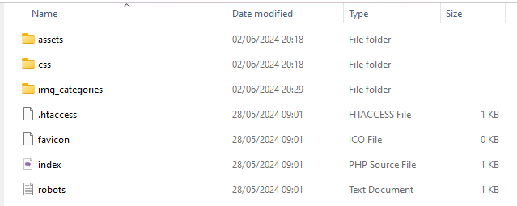

Gamabr 9.3 tampilan assets dan css

1. Buat folder layouts, partials, dan categories pada folder resources/views

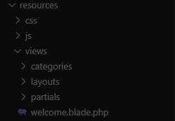

Gamabr 9.4 tampilan resources

1. Buat file sidebar.blade.php di dalam folder partials. Kemudian tambahkan source code berikut

|  |
| --- |
| <div class="sidebar">  <div class="logo-details">  <i class="bx bx-category"></i>  <span class="logo_name">Electric Car</span>  </div>  <ul class="nav-links">  <li>  <a href="#">  <i class="bx bx-grid-alt"></i>  <span class="links_name">Dashboard</span>  </a>  </li>  <li>  <a href="/category" class="{{ request()->Is('category*') ? 'active' : '' }}">  <i class="bx bx-box"></i>  <span class="links_name">Categories</span>  </a>  </li>  <li>  <a href="/transaction" class="{{ request()->Is('transaction*') ? 'active' : '' }}">  <i class="bx bx-list-ul"></i>  <span class="links_name">Transaction</span>  </a>  </li>  <li>  <a href="#">  <i class="bx bx-log-out"></i>  <span class="links_name">Log out</span>  </a>  </li>  </ul>  </div> |

1. Buat file app.blade.php pada folder layouts dan tambahkan source code berikut

|  |
| --- |
| <!DOCTYPE html>  <html lang="en">  <head>  <meta charset="UTF-8" />  <link rel="icon" href="{{ asset('assets/logo.jpg') }}" />  <link rel="stylesheet" href="{{ asset('css/admin.css') }}" />  <link href="https://unpkg.com/boxicons@2.0.7/css/boxicons.min.css" rel="stylesheet" />  <meta name="viewport" content="width=device-width, initial-scale=1.0" />  <title>@yield('title')</title>  </head>  <body>  @include('partials.sidebar')  <section class="home-section">  <nav>  <div class="sidebar-button">  <i class="bx bx-menu sidebarBtn"></i>  </div>  <div class="profile-details">  <span class="admin_name">Electric Car Admin</span>  </div>  </nav>  <div class="home-content">  @yield('content')  </div>  </section>  <script>  let sidebar = document.querySelector(".sidebar");  let sidebarBtn = document.querySelector(".sidebarBtn");  sidebarBtn.onclick = function () {  sidebar.classList.toggle("active");  if (sidebar.classList.contains("active")) {  sidebarBtn.classList.replace("bx-menu", "bx-menu-alt-right");  } else sidebarBtn.classList.replace("bx-menu-alt-right", "bx-menu");  };  </script>  </body>  </html> |

1. Buat file categories.blade.php di dalam folder categories dan tambahkan source code berikut.

|  |
| --- |
| @extends('layouts.app')  @section('title')  Categories | Electric Car Admin  @endsection  @section('content')  <h3>Categories</h3>  <button type="button" class="btn btn-tambah">  <a href="/category/tambah">Tambah Data</a>  </button>  <table class="table-data">  <thead>  <tr>  <th scope="col" style="width: 20%">Photo</th>  <th>Categories</th>  <th scope="col" style="width: 15%">Price</th>  <th scope="col" style="width: 30%">Description</th>  <th scope="col" style="width: 20%">Action</th>  </tr>  </thead>  <tbody>  @forelse ($categories as $category)  <tr>  <td><img src="{{ asset('img_categories/' . $category->gambar) }}" alt="" width="300px"></td>  <td>{{ $category->nama }}</td>  <td>Rp. {{ number_format($category->harga) }}</td>  <td>{{ $category->deskripsi }}</td>  <td>  <a class='btn-edit' href="/category/edit/{{ $category->id_categories }}">Edit</a>  |  <a class='btn-delete' href="/category/hapus/{{ $category->id_categories }}">Hapus</a>  </td>  </tr>  @empty  <tr>  <td colspan="5" align="center">Tidak ada data</td>  </tr>  @endforelse  </tbody>  </table>  @endsection |

1. Buat file categories-entry.blade.php di dalam folder categories dan tambahkan source code berikut

|  |
| --- |
| @extends('layouts.app')  @section('title')  Tambah Category | Electric Car Admin  @endsection  @section('content')  <h3>Input Categories</h3>  <div class="form-login">  <form action="{{ url('/category/store') }}" method="post" enctype="multipart/form-data">  @csrf  <label for="categories">Categories</label>  <input class="input" type="text" name="nama" id="categories" placeholder="Categories" value="{{ old('nama') }}" />  @error('nama')  <p style="font-size: 10px; color: red">{{ $message }}</p>  @enderror  <label for="price">Price</label>  <input class="input" type="text" name="harga" id="price" placeholder="Price" value="{{ old('harga') }}" />  @error('harga')  <p style="font-size: 10px; color: red">{{ $message }}</p>  @enderror  <label for="description">Description</label>  <textarea class="input" name="deskripsi" id="description" placeholder="Description">{{ old('deskripsi') }}</textarea>  @error('deskripsi')  <p style="font-size: 10px; color: red">{{ $message }}</p>  @enderror  <label for="photo">Photo</label>  <input type="file" name="gambar" id="photo" />  @error('gambar')  <p style="font-size: 10px; color: red">{{ $message }}</p>  @enderror  <button type="submit" class="btn btn-simpan" name="simpan" style="margin-top: 50px">  Simpan  </button>  </form>  </div>  @endsection |

1. Buat file categories-edit.blade.php di dalam folder categories dan tambahkan source code berikut

|  |
| --- |
| @extends('layouts.app')  @section('title')  Edit Category | Electric Car Admin  @endsection  @section('content')  <h3>Edit Categories</h3>  <div class="form-login">  <form action="{{ url('/category/update/' . $category->id_categories) }}" method="post" enctype="multipart/form-data">  @csrf  @method('put')  <label for="categories">Categories</label>  <input class="input" type="text" name="nama" id="categories" placeholder="Categories"  value="{{ old('nama', $category->nama) }}" />  @error('nama')  <p style="font-size: 10px; color: red">{{ $message }}</p>  @enderror  <label for="price">Price</label>  <input class="input" type="text" name="harga" id="price" placeholder="Price"  value="{{ old('harga', $category->harga) }}" />  @error('harga')  <p style="font-size: 10px; color: red">{{ $message }}</p>  @enderror  <label for="description">Description</label>  <textarea class="input" name="deskripsi" id="description"  placeholder="Description">{{ old('deskripsi', $category->deskripsi) }}</textarea>  @error('deskripsi')  <p style="font-size: 10px; color: red">{{ $message }}</p>  @enderror  <label for="photo">Photo</label>  <img src="{{ asset('img_categories/' . $category->gambar) }}" alt="" width="200px">  <input type="file" name="gambar" id="photo" />  @error('gambar')  <p style="font-size: 10px; color: red">{{ $message }}</p>  @enderror  <button type="submit" class="btn btn-simpan" name="edit" style="margin-top: 50px">  Edit  </button>  </form>  </div>  @endsection |

1. Buat file categories-hapus.blade.php di dalam folder categories dan tambahkan source code berikut

|  |
| --- |
| @extends('layouts.app')  @section('title')  Hapus Category | Electric Car Admin  @endsection  @section('content')  <h3>Hapus Categories</h3>  <div class="form-login">  <h4>Ingin Menghapus Data ?</h4>  <button type="submit" class="btn btn-simpan" name="hapus" style="width: 40%; margin: 20px auto;">  <a href={{ url('/category/destroy/' . $category->id_categories ) }}>  Yes  </a>  </button>  <button type="submit" class="btn btn-simpan" name="tidak" style="width: 40%; margin: 20px auto;">  <a href="/category">  No  </a>  </button>  </div>  @endsection |

Tampilan hasil

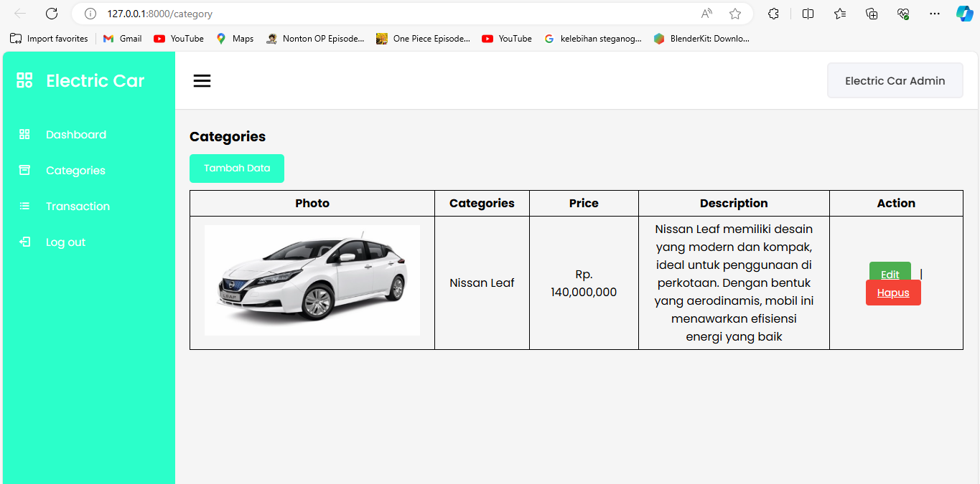

Gamabr 9.4 tampilan hasil category

Analisa :

Kode sumber yang diberikan adalah template Blade untuk aplikasi Laravel. Template ini memperluas file layout layouts.app dan mendefinisikan konten untuk bagian seperti title dan content. Pada bagian title, template ini mengatur judul halaman menjadi "Categories | Electric Car Admin". Pada bagian content, template ini menampilkan heading "Categories" diikuti dengan tombol yang mengarah ke formulir untuk menambah data kategori baru. Di bawah tombol tersebut, terdapat tabel untuk menampilkan informasi kategori. Tabel ini memiliki header untuk Foto, Kategori, Harga, Deskripsi, dan Aksi. Bagian tubuh tabel mengiterasi koleksi $categories menggunakan loop Blade @forelse. Untuk setiap kategori, ditampilkan gambar kategori, nama, harga (diformat sebagai Rupiah Indonesia), dan deskripsi. Pada kolom Aksi, disediakan tautan untuk mengedit dan menghapus kategori. Jika tidak ada kategori, direktif @empty akan menampilkan pesan yang menunjukkan bahwa tidak ada data yang tersedia.