**Militante, Dariel M. September 16, 2023**

**CAS-05-501A**

**Frequency Distribution Tables**

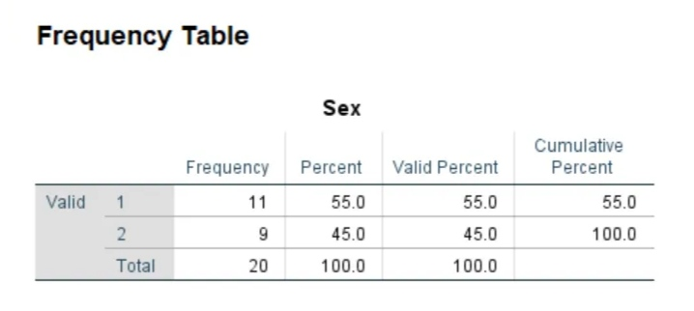

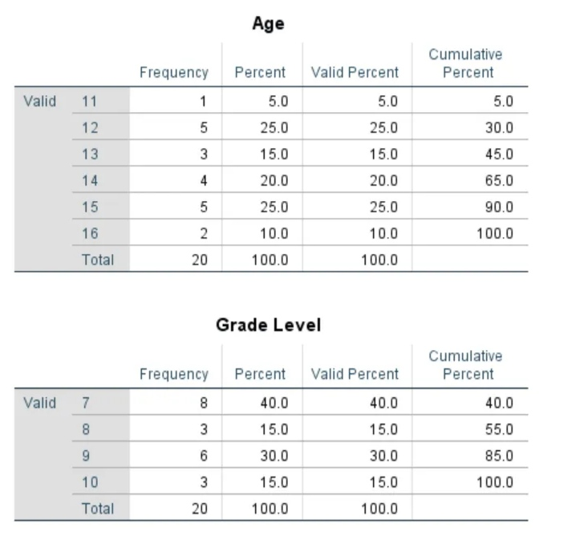

**Summary Statistics**

