Militante, Dariel M. CAS-05-501A OCTOBER 7,2023

Hypothesis: There is no significant difference between research attitude and number of research activities.

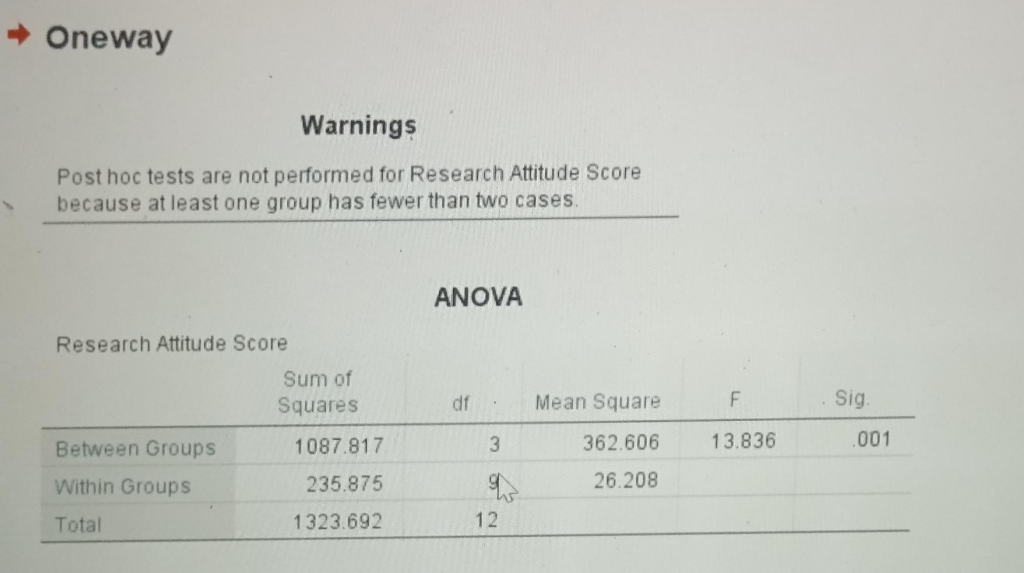

Question:  
1) Is there a significant difference between the research attitude of the respondents if grouped according to number of Research Activities?

An ANOVA Test was conducted to examine the relationship of the number of research activities to the research attitude among 13 selected students from various ages and research grades. Analysis shows that there is a significant difference between research attitude and number of activities in research, as demonstrated on the computed alpha of 0.001 which is lower than the critical value of 0.05.

The results suggest that students enjoy the subject based on the number of activities in research. It can be deduced that the number of research activities is associated with research attitude.