Team -
This is the comment you have gave for the before request
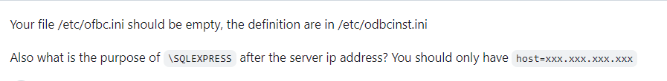
We have renamed the (server=xxx.xxx.x.xxx/SQLEXPRESS) to (server=xxx.xxx.x.xxx) in both the odbcinst -j and odbcinst.ini. After making the changes we once again ranned the ora2pg -t SHOW_VERSION --conf /home/ora2pg240/ext/ora2pg-master/ora2pg.conf and got the error message stating
DBI connect('driver=msodbcsql18;server= xxx.xxx.x.xx;database=AdventureWorks2022;TrustServerCertificate=yes','sa',...) failed: [Microsoft][ODBC Driver 18 for SQL Server]Login timeout expired (SQL-HYT00) [state was HYT00 now 08001]
[Microsoft][ODBC Driver 18 for SQL Server]TCP Provider: Error code 0x2749 (SQL-08001)
[Microsoft][ODBC Driver 18 for SQL Server]A network-related or instance-specific error has occurred while establishing a connection to xxx.xxx.x.xx. Server is not found or not accessible. Check if instance name is correct and if SQL Server is configured to allow remote connections. For more information see SQL Server Books Online. (SQL-08001) at /usr/local/share/perl5/Ora2Pg/MSSQL.pm line 76.
With this I have attached the snapshort of the odbcinst -j, odbcinst.ini and error message

odbcinst -j
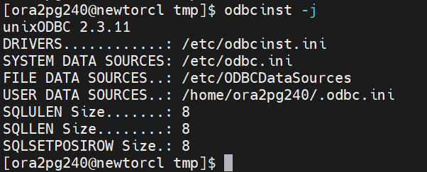

odbcinst.ini
In this snapshort I have masked the server name
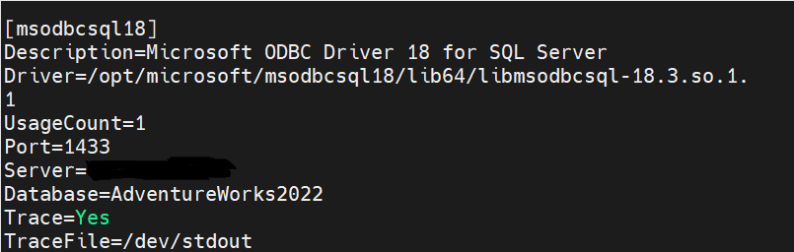

Error message
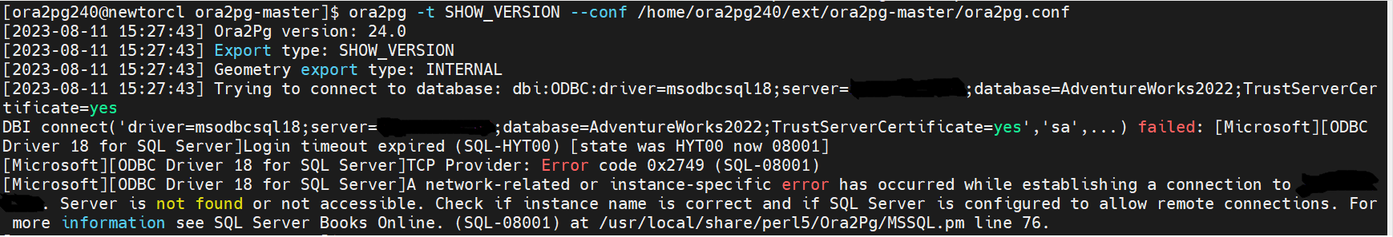
We have searched in google regarding the error and how to fix the error, we had gone through some link which as suggested to use isql -v msodbcaql18 sa “xxxxxxx”. After giving this command we got an error message that – Could not SQLConnect

Additionally I have checked for the login timed out issue ([Microsoft][ODBC Driver 18 for SQL Server]Login timeout expired), For this I have pinged my ip in another machine which is able to connect my ip address
