BBN IMMoRTALS Phase 1 Challenge Problem Announcement

Platform Overview
[[Short overview of the platform and DAS technologies to set context for the challenge problem and platform adaption. This section should clearly define any assumptions there are for your given platform (i.e. focused on challenges within the embedded real-time processing regime) and the overall approach (i.e. TA3 using machine learning to develop complex models of system state-space, TA2 using different refinement techniques to ensure they meet runtime goals).
This section should also make clear what components will be available for evaluation within the current program phase and their anticipated complexity (i.e. "only offline adaption will be possible for X", or "we anticipated online adaption for this particular subset of perturbations", etc.).
It would be helpful to provide a picture (you likely already have one from the proposal or kickoff presentation) to discuss the different aspects of your system. ]]
Tactical situation awareness is the domain chosen by IMMoRTALS. The IMMoRTALS platform is a collection of hardware and software that supports domain operation, e.g., a tactical SA missions. The IMMoRTALS platform consists of Android based clients and a Marti server that facilitates interaction among the Android clients. The client produces a self-location message periodically, and subscribes to position reports sent by other clients. The server’s most basic functionality takes position reports and forwards them to all connected clients. Variations on the client and server include sending other data besides position reports, such as images or other sensor data.
As such, the development/build view of the baseline (i.e., without any IMMoRTALS technology) platform consists of the client and server code base, and build and test tools (Fig 1(a)), and the runtime view of the baseline consists of the Android client(s) connecting to the Marti server over a network (Fig 1(b)).
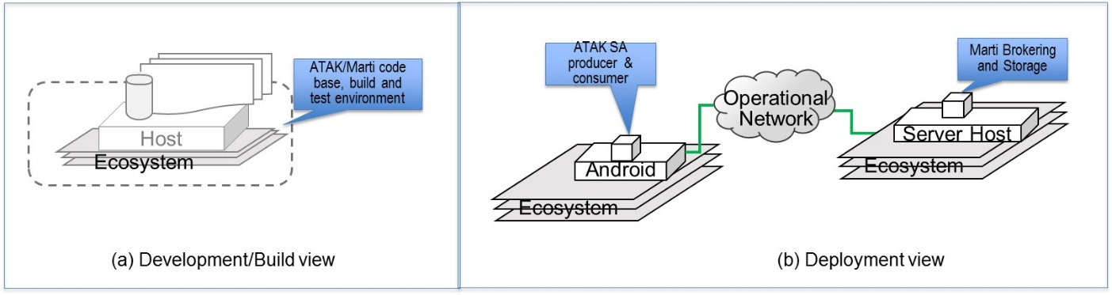
The ecosystem includes “resources” that the SA applications – the Android client app and the Linux server side application- rely on to function, including both SW and HW resources. That is the ecosystem includes systems resources such as CPU/memory/network, software elements such as libraries and packages, as well as other services that must be running.
The IMMoRTALS DAS is the baseline platform + all our technologies to detect and respond to changes + an interface/instrumentation to inject change and observe our response (see Fig 2 below).
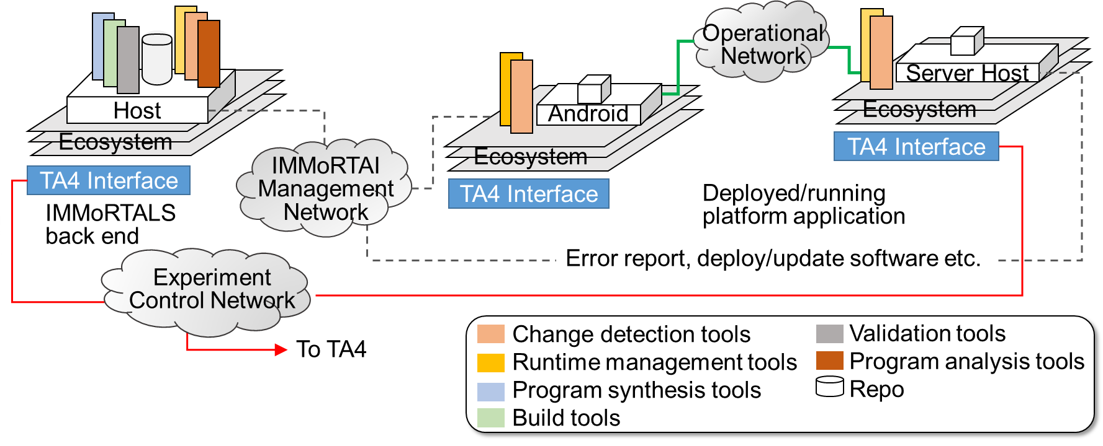
As the legends in the figure above shows, IMMoRTALS technology, in the form of software tools and services, will be used in both the development platform and the deployment platform to support effective and efficient resource-aware program adaptation.
The Fig 3 below shows the end to end operation of the IMMoRTALS DAS covering both the development platform and the deployment platform. “Offline” changes—e.g., changes in mission requirement, a new library update are mostly handled in the development side. Changes in systems systems resources can be both “online”/runtime as well as “offlne”. For example, CPU, memory or network resources may diminish in the deployment environment due to failures, load, attacks, contention with other applications etc. At the same time, the build platform can be used to adapt an existing version of the application for a new deployment environment with different systems resource profile.
The “repository” element is a logical entity, but our current implementation plan is that a SPARQL server will be at the core.
Our intent is to have the end-to-end “offline” workflow in place for the initial evaluation.

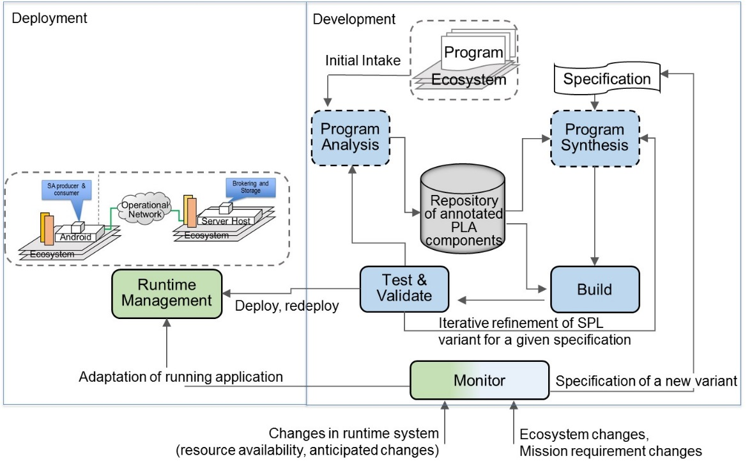
Platform for Evaluation
[[The platform for evaluation section will provide an overview of those components being developed which will be directly evaluated by Lincoln. For example, if model generation is a run-once static process that generates models which are then used to refine system behavior during runtime it is possible that this component may not be directly integrated with the test infrastructure that Lincoln is designing. Lincoln may start with the output of that process in order to apply the appropriate runtime ecosystem states for evaluating the dynamic adaption of your DAS. It would be helpful to provide a notional picture of this scenario in order to highlight all potential interfaces to be defined prior to the PI meeting.]]
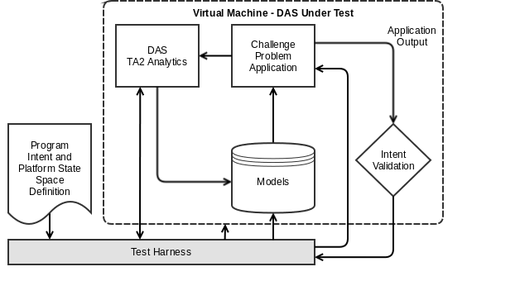
IMMoRTALS DAS generally fits into the above structure—except that it may not be a single VM.
The runtime components of the IMMoRTALS platform (i.e., the Android client and the Marti server) will be on their own VM. A separate VM (Linux Router?) may be needed to emulate the operational network and offer the TA4 interface to effect changes.
The models, analytics and the discovery machinery will be in the build environment/development platform. Some runtime change detection and runtime managers may be instrumented into the runtime VMs (i.e., the VMs hosting the Android clients and the Marti server).

Challenge Problems

Challenge Problem 1: Mission Requirement of Location Collection Changes
[[Provide a description of the first challenge problem.
- List any ecosystem perturbations and adaptations which will be built into your systems.
- State whether the challenge problem will test online/offline/or both types of adaptive responses.
- Add as much other information as you have available.
These descriptions will enable Lincoln and your team to begin discussing work to be performed in the current program phase. This description, including more technical details, will be further refined and documented on the Wiki as part of the Platform and Challenge Problem Description during the first half of each program phase.]]

Overview
Tactical situational awareness spans a large variety of missions. Such missions might have very different requirements for location collection. Some deployments may be satisfied with the GPS built-in to a given Android device. Other deployments might require GPS providers of a very specific nature (e.g. SAASM). Still other deployments might have to assume a GPS-denied environment, where the only options are dead-reckoning and potentially inertial sensors.

The accuracy and trustworthiness of the source of a location report come into play in a variety of ways from a mission requirements perspective. For instance, some use-cases by get by with only lat/lon values. Other mechanisms, such as dead-reckoning, can be augmented with a database of elevation data (DTED), at the cost of significant local disk space. Some of the potential mission requirements imply specific hardware being available. Even then, there can be multiple ways to get access to that hardware, for instance wired/USB vs. Bluetooth for accessing an external GPS.
This is primarily an “offline” adaptation scenario in its initial incarnation, although later iterations of this CP could easily be extended to have some “online” aspects. For instance, a mission requirement could be that the application use GPS when available, but be able to dead-reckon if there is no GPS. A further evolution might specify all possible location sources be built-in, and a preference-ordering is supplied as a mission requirement.
This CP can be extended to demonstrate handling of both anticipated and unanticipated changes. The following elaborates:
Let us assume that the current version of the product is built to use GPS location.
- Offline, anticipated change : mission requirement to use a different location comes in, IMMoRTALS happens to find a location provider that satisfies the mission need in the existing ecosystem
- Offline unanticipated change: mission requirement to use a different location comes in, but there is no location provider that satisfies the mission need -- may be the semantics do not match, maybe the resource profile of the available provider does not match with what is available in the deployment target
- Online, anticipated change: GPS signals became unavailable during mission, but the deployed program or the deployment environment includes an alternate provider and the system adapts to use the alternate provider
- Online, unanticipated change: GPS signal became unavailable during mission, but the deployment set up did not include any alternatives to fall back on, a failure report is provided to IMMoRTALS
  - At this point, this could be treated as the beginning of an “offline” change handling scenario—which could either be framed as anticipated or unanticipated change
Our initial goal is support offline and anticipated changes. And then adapt the existing product to support online anticipated changes, and finally support offline unanticipated changes. Note that adapting to unanticipated changes may not be fully automated, IMMoRTALS will likely provide a set of change directives that a human programmer will have to encode. In later phases we will look into automating this step using program rewriting.

System Perturbations
There are two system perturbations that this challenge problem exposes. First is the mission requirement for a given source of location data. Second is the execution environment, which will dictate availability of specific hardware or external services (e.g. GPS satellites).

Mission requirements
We envision a set of possible mission requirement-based location collection techniques such as
- Dead-reckoning
- Inertial tracking
- Consumer-grade GPS
- Commercial-grade GPS
- SAASM GPS
- DTED (elevation only; assumes another mechanism to find lat/lon)

A given deployment might specify that some options are required. We anticipate this will be input to the DAS as a checkbox or property file (see evaluation API section below).

Execution environment
The set of possible execution environment properties might include:
- GPS satellite availability
- GPS chipset type (e.g. SAASM)
- External GPS connectivity (wired/Bluetooth)
- Availability of sensors appropriate for inertial tracking

These could be set over the TA4 interface the IMMoTALS DAS will provide.

Software Requirements
Android SDK and build environment
Java JDK 1.8

Evaluation API
The mechanisms for perturbing the system for this problem consist of constructing a new set of mission requirements or execution environment descriptions. We will provide a set of properties and their possible values in each of those categories. We will also provide a pre-populated repository of code fragments.

Having actual SAASM hardware as part of the evaluation is infeasible, as well as strictly controlling GPS availability. So we will provide drivers that simulate some of the notional code fragments described above. An evaluator will be able to tell both by looking at the code for the final application (e.g. the application instantiates SaasmGpsLocationProvider), and by some markers we will put in the output data, which location provider was chosen.
Challenge Problem 2: Handling the impact of changes in deployment scale and other factors that impact resource consumption

Overview
Tactical SA can vary in scope from small-squad (<10 participants) missions to major National Security Events (>500 participants). Along with the number of participants, other variables might refer to expectations of the mission, such as report rate or additional data beyond basic Position Location Information (PLI) (e.g. pictures). All these factors have an impact on the resource usage of every node in the system, but in most cases the limiting factor is bandwidth. In many cases the cause for limited bandwidth is purely technological, but in other cases bandwidth may have outsized cost (e.g. SATCOM) such that users want to voluntarily limit usage even though the technology would support more bandwidth.

The goal of this challenge problem is to see whether IMMoRTALS can evolve the client and server applications in response to such variations. Like CP1, this CP is also a family of challenge problems. We outline a number of possibilities, and indicate what we propose to achieve in Phase 1.

- Offline, anticipated change: The change request comes in, the code to use exist in the current ecosystem or the current system is amenable to changing/tuning the contributing parameter
  - Obvious boundary cases—the deployment environment can only accommodate a certain scale. For example, for a given bandwidth limit, it is easy to set number of client, rate and size in such a way that no solution can exist—IMMoRTALS should indicate these impossibilities
- Offline, unanticipated change: same as above except the code to use is not available, and there is no way to tune the offending parameters
  - The goal here is to eventually generate new code that fits and adapt existing code to allow parameter tuning. Initially, IMMoRTALS will just prescribe the changes. We will try automated handling of this case in later program phases
- Online, anticipated change: rate or number of clients changed during mission and the deployed system is able to accommodate the changes
  - Same caveat about boundary cases—it will be easy to set parameters that the deployment environment cannot sustain
- Online, unanticipated change: changes happen during mission, the deployed system cannot deal with it. This could be thought of as a precursor to an offline scenario

Initially, our plan to start with the offline handling of anticipated changes.

System Perturbations
There are several system perturbations that this challenge problem exposes. The resource constraint that is most prominent is bandwidth. As mentioned in the overview, a bandwidth limit might be hard or soft.

Mission requirements
We envision a set of possible mission requirement variables
- Number of clients
- PLI Report Rate
- Image Report Rate
- Image property requirements (e.g. resolution, color vs. grayscale)

Some deployments may not have a requirement for images. The PLI report rate and number of clients will be in every scenario description

Execution environment
The most critical aspect of the execution environment for this CP is bandwidth availability. For the first iteration, we will be considering a simplified network model where we only consider the “most constrained link”. This is sufficient to describe most deployments, especially where the actual network topology may be opaque (e.g. commercial cellular). Later iteration may expand on the network definition to allow more complex topology descriptions.

Software Requirements
Android SDK and build environment
Java JDK 1.8

Evaluation API
The mechanisms for perturbing the system for this problem consist of constructing a new set of mission requirements and execution environment descriptions. The number of clients, PLI report rate, and Image Report Rate are integer values that can be set to any positive value. Likewise the bandwidth availability will be given as an integer value (likely kbps). We will provide a set of image properties and their possible values. We will also provide a pre-populated repository of code fragments.

The evaluation system must be able to limit bandwidth for at least one link (typically will be the link to/from the server). Multiple android “clients” will need to be deployed according to the mission plan.

Challenge Problem 3 (for Program Phases 2 and 3)
The CPs we described actually are families of CPs of wide ranging complexity.
We have additional candidates that we have been considering (no details—just a hint):
- Changes in library
- Other examples (if any)

**Same type of content as CP1**

Platform Integration & Test
Software Requirements
- What is the anticipated platform processing architecture (i.e. multi-core x86, GPU, ARM, etc.)?
- What OS will the DAS and CP utilize (please specify both type and version (i.e. Ubuntu 14.04, Windows 95, etc.)?
- Any specific packages or code that the platform will rely on (this doesn't have to include common packages like gcc or Python but should call out any specific (i.e. Robot Operating System version 2.x, Android Emulator, etc.) or supporting packages that your team is planning on developing and how Lincoln can obtain these)?
- Any specific interfaces or communication protocols that your system will rely on (i.e. multicast network capability, etc.), particularly for interaction with the TA4 test platform

