IMMoRTALS Challenge Problem 2

Cross-Application Dependencies

# Introduction

Modern software systems seldom operate in isolation. For example, Service-Oriented Architectures (SOAs) distribute distinct system functionality across discrete (and typically remote) processes that communicate using a network. Designers of these systems often bake assumptions about the availability and mechanics of interacting with other architecture components into their application logic, making these systems fragile over time.

A specialized class of software, called *middleware* is often used to bridge different parts of an application. In general, middleware handles data format differences between the interacting parts, and offers specific idioms (protocols) for using it. Even when a middleware is used, dependencies across interacting components cannot be eliminated. Changing the interaction pattern or properties on one side is likely to require changes on the other side of the interacting parties. Upgrading middleware versions or changing from one middleware to another will also require changes on both sides. The goal of this CP is to begin exploring how to adapt software in response to changes in the middleware space.

For example, consider the client-server interaction in the IMMoTRALS tactical SA application. The ATAK Lite clients use a socket-based middleware that uses COT messages to periodically transmit SA location information (and other SA data) to the MARTI server. Now suppose a new requirement is asserted specifying that all messages traversing networks must be encrypted. It is not enough to simply add encryption logic on the client side. The server must also be adapted to properly decrypt the information before using it. Additionally, the client and server implementers must agree upon and utilize a secure key exchange procedure.

# Challenge Problem Description

Challenge Problem 2 (CP2) will investigate the change drivers in the middleware space. In the context of the IMMoRTALS platform application, this CP will address changes in how SA data is shared between the ATAK Lite clients and the MARTI server, including properties of data, send and receive mechanisms, adding new data types etc. One common aspect of the resulting adaptations is that they require simultaneous/correlated modification of ATAK Lite and MARTI. As in Phase 1, most of these changes come from mission requirements, and the resulting adaptations will lead to new application binaries.

We will now describe some examples that we are considering initially in more detail. These focus on properties of SA Data being exchanged between the ATAK client and MARTI:

1. Data compression
   1. **Historical justification for adaptation**: There is a rich history of the emergence of new lossless compression algorithms over time. For example, gzip was released in 1993, bzip2 was released in 1996, and LZMA was released in 1998, and LZMA2 was released in 2009. Long-lived software should be able to benefit from compression algorithms that have not yet been created.
   2. **Technical challenges**:
      1. There exist time/space tradeoffs between various algorithms and configurations. For example, using a larger dictionary often (but not always) achieves better compression ratios at the cost of more CPU time.
      2. Certain types of data are more amenable to compression than others. For example, a list of random numbers will compress poorly whereas a human-readable text document will compress nicely.
      3. Lossless compression is an invertible transformation. If we compress data in ComponentX and transmit that data to ComponentY, ComponentY must subsequently decompress it before it can be used.
2. Data encryption
   1. **Historical justification for adaptation**: There is a rich history of the emergence of new cryptographic standards and best practices over time. For example, DES became a FIPS standard in 1975 but was easily brute forced by the late 1990s; DES3 became a standard in 1999 but was subsequently superseded by AES in 2001. Similarly, the recommended RSA key strength has increased from 512 bits at inception to 2048 bits as of 2016 (with a target key durability of 2030).
   2. **Technical challenges**:
      1. Encryption is another invertible transformation. If we encrypt data in ComponentX and transmit that data to ComponentY, ComponentY must subsequently decrypt it before it can be used. Additionally, the cipher configurations for both components must be compatible.
      2. Introducing cryptographic techniques into an application may require synthesizing multiple new dataflows. For example, symmetric encryption necessitates the use of key management procedures.

A simplification of our CP2 system architecture is provided in Figure 1 below. In this simplified architecture, ATAK interacts with MARTI by transmitting Cursor-on-Target (CoT) messages across network. MARTI then responds to ATAK with an ACK message (indicating success) or NACK (indicating the encounter of an unspecified failure condition while processing the client’s request). Under correct operation, ATAK should never receive a NACK from the server.

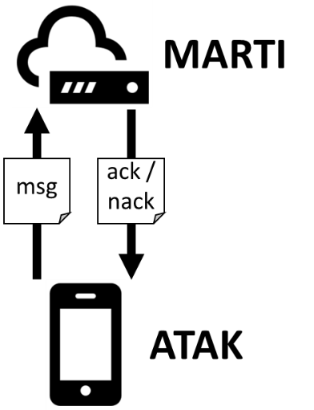

Figure : CP2 client server architecture

# Adaptation scenarios

The following scenarios can occur at various points in the lifetime of the MARTI/ATAK system. For each we describe the adaptation stimuli and verification procedures:

1. MARTI/ATAK are initially coded using a simple event driven protocol.. However, at some point in the future, a new requirement is put in place such that MARTI/ATAK must now encrypt their communications at the application layer. IMMoRTALS detects the constraint violation regarding unencrypted network traffic, and adds application-layer data encryption wherever messages are transmitted across the network. IMMoRTALS must also add decryption code wherever messages are received from the network.
2. Validation is achieved by monitoring the messages transmitted from ATAK to MARTI.
3. After adaptation, the message should contain an unencrypted frame and an encrypted payload.
4. A monitor aware of the symmetric key and cipher configuration used by the client and server should be able to inspect the messages and verify the integrity of their content.
5. After adaptation, no NACK messages should be observed.
6. Validation can also be achieved by inspecting the synthesized code
7. After adaptation, new encryption code regions should be injected into ATAK and MARTI.
8. The mission intends to deploy in a bandwidth restricted environment, and dictates that ATAK Clients should send compressed data to reduce network consumption. IMMoRTALS analyzes the system and determines that there is a dataflow relationship between that now-compressed data and a corresponding code unit in MARTI. It then selects the appropriate lossless compression code block and injects it the ATAK Lite code and injects similarly configured decompressor block in the appropriate place in MARTI.
9. Validation is again achieved by monitoring the messages transmitted from ATAK to MARTI.
10. After adaptation, the messages should be compressed.
11. After adaptation, the messages should be much smaller than before.
12. After adaptation, no NACK messages should be observed.
13. Validation can also be achieved by inspecting the synthesized code
14. After adaptation, new compression code regions should be injected in both MARTI and ATAK.
15. At some point in the future a new compression algorithm is discovered with much better time/space behavior than an algorithm currently used by MARTI/ATAK. We will call the old algorithm BogoCompress and the new algorithm LZMA-3. Mission commanders warrant that their applications must take advantage of the improvement. IMMoRTALS detects the use of BogoCompress in MARTI and ATAK, then replaces the appropriate client/server code regions with LZMA-3 code.
    1. Validation is achieved by monitoring the messages transmitted from ATAK to MARTI.
       1. After adaptation, the messages should be compressed using the new algorithm.
       2. After adaptation, the messages should be much smaller than before.
       3. After adaptation, no NACK messages should be observed.
    2. Validation can also be achieved by inspecting the synthesized code
       1. After adaptation, the BogoCompress code regions should be replaced with LZMA-3 code in both MARTI and ATAK.
16. At some point in the future, AES-128 is determined to be insufficiently secure due to the release of new brute forcing hardware. Instead, AES with 256-bit keys is recommended. Mission commanders require that AES-128 now should be deprecated and recommend use of AES-256.
17. Validation is achieved by monitoring the messages transmitted from ATAK to MARTI.
18. After adaptation, the data should be encrypted using a 256-bit key. This is difficult to verify generally, but could be validated under the assumption that ATAK transmits a single message repeatedly to MARTI and that the key is known to the monitor.
19. After adaptation, no NACK messages should be observed. See the point above about encryption of messages.
20. Validation can also be achieved by inspecting the synthesized code
21. After adaptation, the encryption code regions in ATAK and MARTI should be configured using a 256-bit key.

# Analysis supporting CP2 adaptation

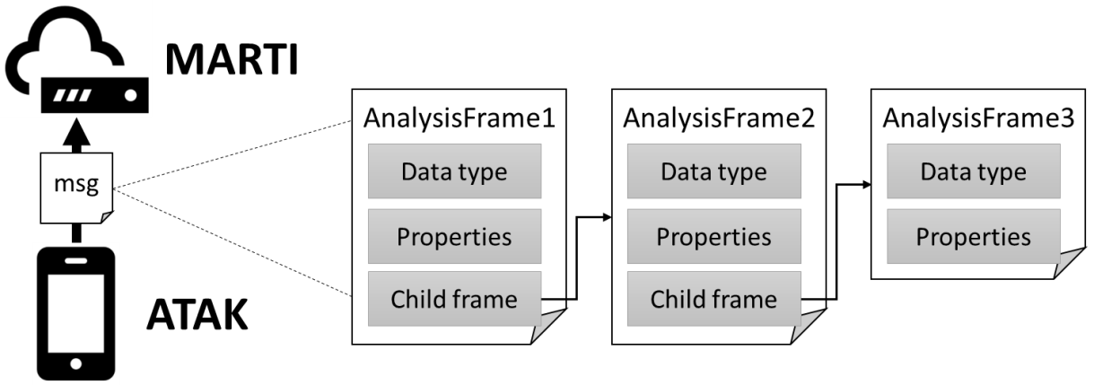

Figure : CP2 architecture

During the dataflow analysis of the ATAK/MARTI system, we will detect that messages are transmitted across the network from ATAK to MARTI. To capture details about this interaction, our dataflow analysis emits an abstraction called an *analysis frame*, a recursive structure which carries an abstract datatype and properties assumed to hold for the message. These analysis frames are depicted at a high level above in Figure 2 and a more detailed example is provided below in Figure 3.

We have thus far modeled DFUs as having property-modifying side effects on the dataflows with which their functional aspects intersect. For example, the *compress* aspect of a *compressor* DFU adds the *compressed* property to a dataflow analysis frame whereas the *deflate* aspect of that DFU removes that property. The analysis frames in Figure 3 are consistent in that the *compress* aspect of the *compressor* DFU in ATAK emits a data frame with the same properties expected by the *decompress* aspect in MARTI.

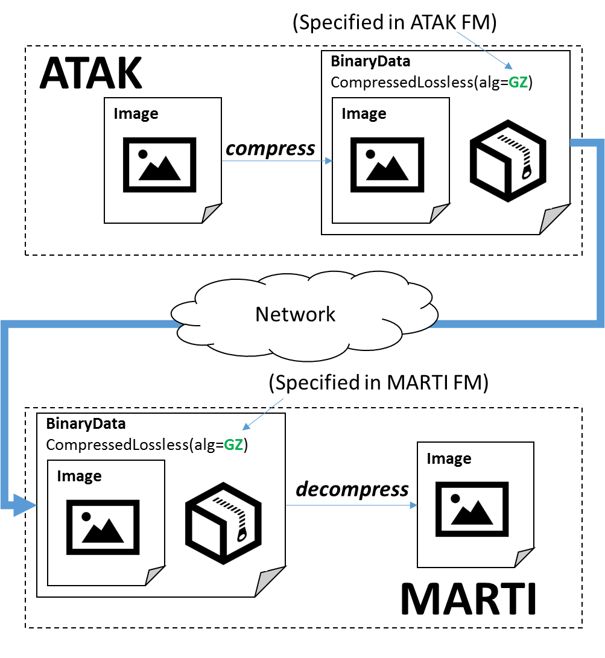

Figure : Dataflow analysis for a simple ATAK/MARTI architecture

The consistency between expected and actual properties shown in Figure 3 is serendipitous—it is by no means guaranteed. IMMoRTALS must be able to detect and repair inconsistencies detected through this analysis. For example, if MARTI is modified to use bzip2 compression instead of gzip, there is an inconsistency between the client and server and ATAK must also be modified. This scenario is shown below in Figure 4. We anticipate that inconsistency is a common occurrence and a useful change driver.

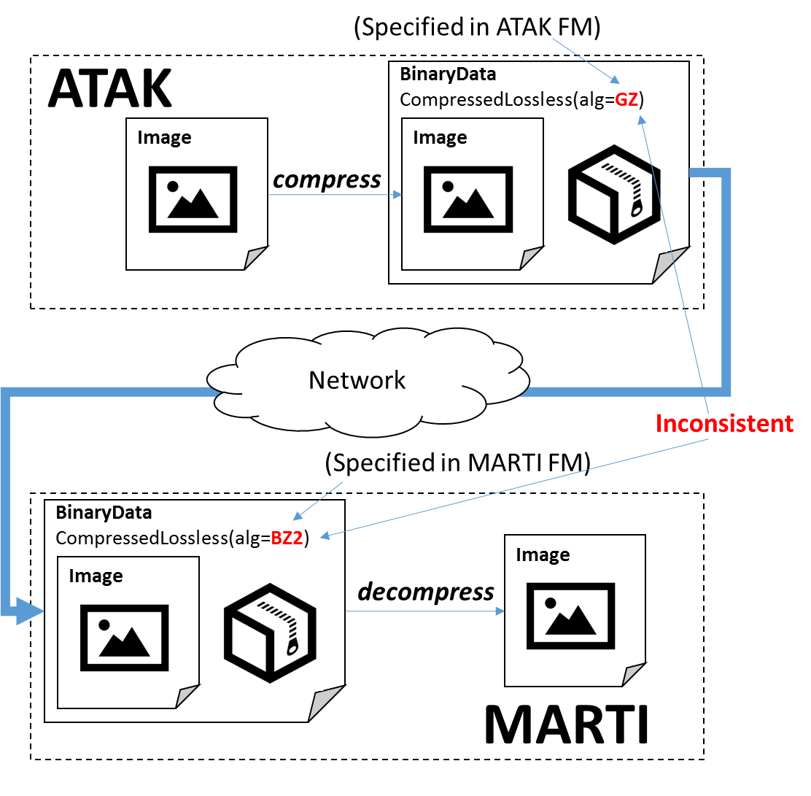

Figure : Illustration of a scenario with inconsistent analysis frames

A more complex example in which ATAK captures an image, compresses it using the gzip algorithm, then transmits it to MARTI (which then does the inverse) is shown below in Figure 5.

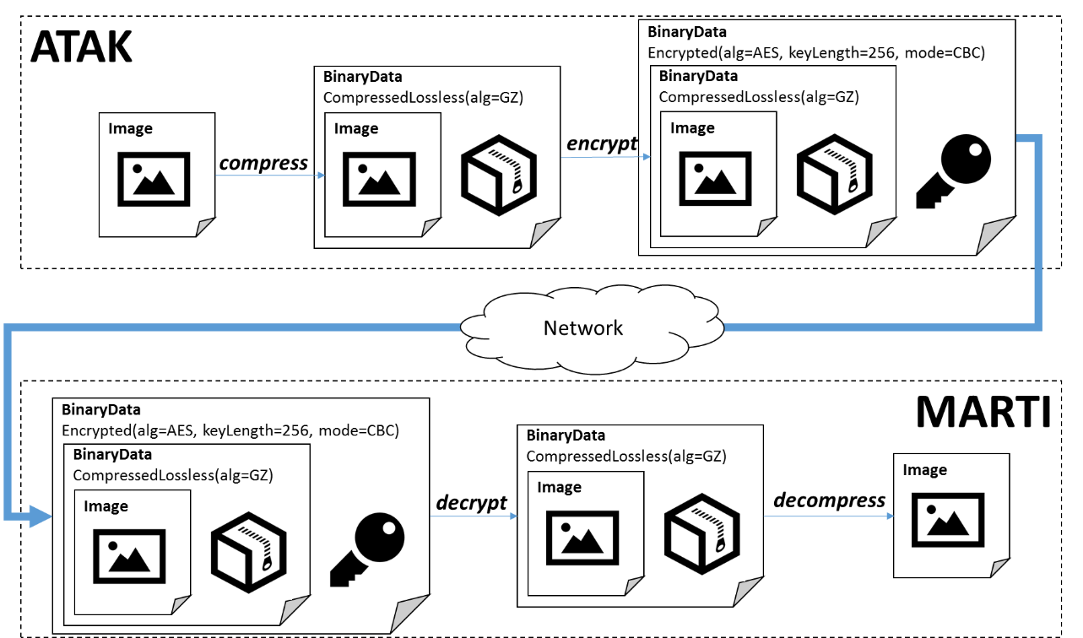

Figure : Complete analysis of hypothetical scenario involving correct transmission of a compressed, encrypted message containing an image from ATAK to MARTI

# CP2 Test Parameters

## Formalisms

* We will define a specification format for several popular symmetric key encryption algorithms (DES, 3DES, AES, Blowfish). This format will account for the following:
  + *KeyLength* is an algorithm-dependent enumeration of valid key lengths
  + *InitializationVector* is an algorithm-dependent number of bytes to use as an initialization vector
  + *PaddingScheme* is an enumeration of several common padding schemes. E.g., PKCS7, ANSI X.923, ISO 10126.
  + *CipherMode* is an enumeration of several common chaining modes. E.g., ECB, CBC, PCBC.
* We will define a specification for several lossless compression algorithms (gzip, bzip2, lzma). Similar to encryption, we will enumerate various configuration options that must be consistent between the compressor and decompressor.
* We will create feature vocabulary powerful enough to describe ATAK and MARTI with variation points into which features for performing encryption and compression of the data transmitted across the wire can be injected. These variation points will also accept a configuration specification.
* We will provide a vocabulary for expressing constraints on algorithms/configurations. E.g., a SME may want to mandate increased key length for symmetric ciphers to account for the development of more powerful ASICs for key brute forcing. This vocabulary will contain links to components in the feature model.

## Instantiations of formalisms

* We will provide feature models for ATAK and MARTI
  + The ATAK feature model will include variation points for injecting an optional BinaryTransformer DFU just before the data is transmitted across network. Compressor and Encryptor are subtypes of the BinaryTransformer functionality.
  + The MARTI feature model will also include a variation point for injecting a BinaryTransformer DFU.
* We will provide at least two example configurations for symmetric key encryption. One of these will be weak by modern standards (DES) and another will be strong (AES-256).
* We will provide at least two example configurations for compression. One of these will use a dated algorithm (gzip) and another will use the more modern one (lzma).
* We will provide an assertion mandating the use of application-level encryption. This assertion can be bound to feature models for ATAK/MARTI

## Software

* We will provide ATAK and MARTI code, build scripts, and a virtual testing environment
* We will provide the ATAK and MARTI unit and integration test suites required for dynamic analysis of the system
* We will provide an ATAK driver that periodically transmits messages to MARTI and verifies the correct ACK responses. The driver treat as a failure any NACK response returned by MARTI.

# Intent Specification and Evaluation Metrics

## Intent specification

Intent within IMMoRTALS takes the form of assertions that bind to the feature model. We will provide an easy-to-use knob-based convenience mechanic for manipulating these assertions. The resultant assertions emitted after modifying a knob will be visible in the triple store. The explicit knobs associated with this scenario are listed below:

* MIT-LL will be able to specify whether the client/server should use application-level encryption to protect data that crosses the network. Knob type: *Boolean value*
* MIT-LL will be able to specify that SymmetricCipher algorithm configuration X should be replaced with SymmetricCipher algorithm configuration Y. X and Y are elements in a predefined enumeration provided to MIT-LL. Knob type: *select from enumeration*
* MIT-LL will be able to specify that LosslessCompression algorithm configuration X should be replaced with LosslessCompression algorithm configuration Y. X and Y are elements in a predefined enumeration provided to MIT-LL. Knob type: *select from enumeration*

## Evaluation metrics

The following metrics are gathered as the automated ATAK driver program executes:

* NACK count
  + Type: integer
  + Interpretation: any number greater than zero indicates that a malformed message was sent to the server
* EncryptionConfiguration
  + Type: String
  + Interpretation: represents the encryption configuration of a message intercepted as it traverses the network. E.g.,
    - AES-128(initializationVector= umTQJoM6XqFQUh,key=Fy4z6EZLsVu8kc)
* CompressionConfiguration
  + Type:String
  + Interpretation: represents the

The following metrics are gathered once, just after adaptation:

* Code diff
  + Type: textual (human-readable)
  + Interpretation: highlights code regions modified by the IMMoRTALS analysis process
* ATAK/MARTI compressor/cipher count
  + Type: Integer
  + Interpretation: the # of compression or cipher DFUs included in the ATAK/MARTI software

# Expected results

## Expected runtime behavior of baseline software system before perturbation

|  |  |
| --- | --- |
| **Metric** | **Nominal value** |
| NACK count | 0 |
| EncryptionConfiguration | No EncryptionConfiguration metrics should be received (the application does not initially utilize application-level encryption |
| CompressionConfiguration | No CompressionConfiguration metrics should be received (the application does not initially utilize compression) |
| Assertion describing the preference of one lossless compression algorithm over another | IMMoRTALS replaces all uses of the less preferential lossless algorithm with the more preferred one |

## Expected runtime behavior after perturbation

|  |  |
| --- | --- |
| **Change driver** | **Expected application behavior after adaptation** |
| Assertion mandating use of DES application-level encryption | * All EncryptionConfiguration metrics received should match the expected DES configuration * NACK count = 0 |
| Assertion mandating the replacement any DES cipher with an AES implementation | * All EncryptionConfiguration metrics received should match the expected AES configuration * NACK count = 0 |
| Large messages transmitted across network; assert a prescriptive adaptation strategy for large messages based on the injection of a LosslessCompressor DFU | * Should observe CompressionConfiguration metrics * NACK count = 0 |
| Assertion describing the preference of one lossless compression algorithm over another | * Should observe CompressionConfiguration metrics for the preferred algorithm * NACK count = 0 |

## Expected IMMoRTALS response to perturbation

|  |  |
| --- | --- |
| **Change driver** | **Expected adaptation response** |
| Assertion mandating use of application-level encryption | IMMoRTALS injects cipher DFUs at all code regions with dataflows that transcend the network boundary |
| Assertion mandating the replacement any DES cipher with an AES implementation | IMMoRTALS replaces all DES cipher logic with AES implementations |
| Large messages transmitted across network; assert a prescriptive adaptation strategy for large messages based on the injection of a LosslessCompressor DFU | IMMoRTALS injects a LosslessCompression DFU at all code regions with dataflows that transcend the network boundary |
| Assertion describing the preference of one lossless compression algorithm over another | IMMoRTALS replaces all uses of the less preferential lossless algorithm with the more preferred one |

# Test Procedure

## The test harness will provide mission requirements by selecting change drivers as described in the “Intent specification” section. Tests will execute much as they did in our Phase-1 challenge problems: After the Test Harness provides the parameters, the TA and DAS will produce compliant versions of the client (ATAK) and server applications, then execute intent tests.

# Interface to the Test Harness (API)

[TODO]

