Dr.Listner: catching what the visit missed
Oct 15, 2026 · @himanshi
AI scribes record what was said; Dr.Listner flags what was never asked or answered, and hands the patient a plain-language plan they can actually follow. IEEE Hack for Humanity, Track 2: AI for Accessibility and Disability Inclusion.

The problem
Roughly 1 in 20 US adults is misdiagnosed in outpatient care each year, and the people least able to catch a gap in the visit are the ones most exposed to it.
- Diagnostic error is common. About 12 million US adults a year, around half potentially harmful (BMJ Quality & Safety, 2014). The Institute of Medicine's 2015 report puts the rate at 5% of US adults who seek outpatient care each year and links errors in part to inadequate communication among clinicians, patients and families (National Academies, 2015).
- Hearing loss is the norm in older patients. Disabling hearing loss affects 22% of US adults aged 65 to 74 and 55% of those 75 and older, and only about 30% of adults 70+ who could benefit from hearing aids have ever used them (NIDCD, NIH). Fewer than a quarter of studies on physician communication with older patients even mention hearing loss (Cohen et al., JAGS).
- Low health literacy is the majority. In the 2003 national survey, only 12% of US adults had proficient health literacy and 36% were at basic or below basic (NCES, U.S. Department of Education, 2006). These are the latest figures we found for this survey; they are 2003 data.
- Patients forget the plan. 40% to 80% of the medical information clinicians give is forgotten immediately, and almost half of what is remembered is incorrect (Kessels, Journal of the Royal Society of Medicine, 2003).
- Hearing loss lowers rated communication quality in a nationally representative US sample (study in PMC).

Market gap
Ambient scribes are built to document the conversation; nobody is checking the conversation itself for what is missing, and no one is writing for the patient.
 | Ambient AI scribes today | Dr.Listner
Core job | Draft the visit note from what was said | Flag what was not said or not resolved
Known failure | Omissions and made-up content in the note; omissions were the top error in a 356-note audit (64 notes, 18%) (JMIR Med Inform, 2026) | Misses are surfaced with the transcript line that triggered them, so the clinician can verify in seconds
Clinician experience | Note to review and edit | One quiet end-of-visit gaps list; no live pop-ups, to avoid alert fatigue
Patient experience | Notes written for clinicians | Plain-language care summary, captions, read-aloud, questions to ask next time
Who it helps most | Clinician workload | Patients with hearing loss, low health literacy or cognitive impairment
Caveat: this compares the category as described in published audits; we have not audited individual vendors. Scribe omissions (things said but dropped from the note) are a different problem from visit omissions (things that should have been asked); Dr.Listner targets the second.

Goal
Build a working prototype for one visit type (outpatient chest pain) that shows, with measured numbers, it finds missed questions, unanswered concerns and chart contradictions, and gives the patient a summary they can follow.
Draft targets, to be confirmed against the first eval run:
- Recall of at least 80% on planted gaps across all three gap types
- Precision of at least 80%, and no more than 1 false flag per visit on average
- Patient summary at or below a 6th-grade reading level, checked automatically
- Every flag cites the transcript line or chart entry behind it

Solution
Dr.Listner reads a visit transcript against a published checklist and the patient's chart, then produces two outputs after the visit ends.
Three gap types
- Red-flag questions not asked. Chest-pain checklist items (onset, exertional pattern, radiation, sweating, shortness of breath, fainting, family history, risk factors) with no matching question in the transcript.
- Patient concerns left unanswered. Worries the patient voiced that the clinician never addressed.
- Statements that contradict the chart. For example, the patient says no heart history while the chart lists a prior stent.
Checklist source: the 2021 AHA/ACC Guideline for the Evaluation and Diagnosis of Chest Pain (Gulati et al., J Am Coll Cardiol, 2021). The red-flag items above are our working draft; each must be confirmed against the guideline's history section (Section 2.1, Table 3) before the eval.
Two outputs
- Clinician gaps list. Quiet, end-of-visit, each item with its evidence line and a one-tap dismiss. Documentation completeness only; it never suggests a diagnosis.
- Patient summary. Plain-language plan, key warning signs, and questions to ask next time, with captions and read-aloud for patients with hearing loss.

How it works
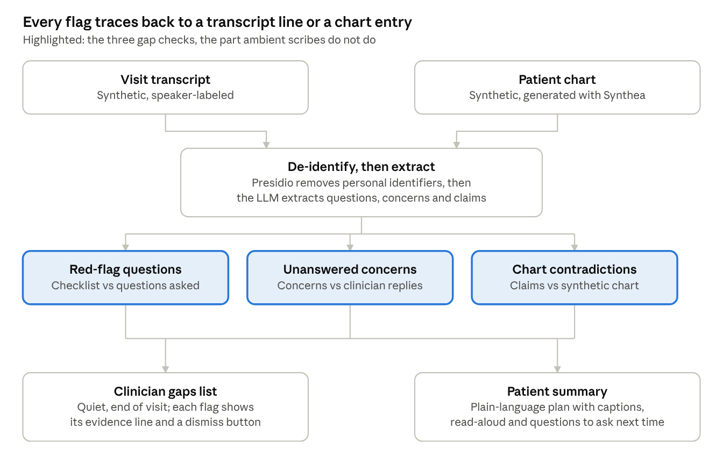
Dr.Listner pipeline · 2 inputs, 3 gap checks, 2 outputs
Gap checks run on de-identified text only. Every flag links to the transcript line or chart entry that triggered it, and the patient summary reuses the flags as questions to ask next time.

Tech stack
Python end to end, free or open-source pieces only, chosen so a two-person team can have a demo running in a day. Free-tier limits change, so check them before the build.
Layer | Pick | Why
UI | Streamlit | A clinician view and a patient view in one Python file; no frontend build
Transcript input | Synthetic transcripts as JSON, speaker-labeled | Removes audio risk; the eval depends on controlled input
Speech to text (stretch) | faster-whisper, local | Free, runs offline, adds a live-audio demo if time allows
Extraction and gap reasoning | Google Gemini API free tier with JSON output, Ollama (Llama or Qwen) as offline fallback | Structured output keeps results parseable; fallback guards against rate limits; free-tier content may be used to improve Google products, so send synthetic text only
Schemas | Pydantic | Validates every model response before it reaches the UI
Checklist matching | sentence-transformers (all-MiniLM-L6-v2) plus an LLM check for borderline cases | Cheap first pass, so the LLM runs only where it is unsure; heavy PyTorch install, so keep it out of the hosted app and ship precomputed embeddings
De-identification | Microsoft Presidio | Open-source PII scrubbing before any text leaves the machine
Synthetic charts | Synthea (FHIR output) and fhir.resources | Realistic fake patient histories, no real PHI
Reference dialogues | ACI-Bench, MTS-Dialog, PriMock57 | Public doctor-patient conversations for style; check each license
Patient readability | textstat | Automatic grade-level score on every summary
Read-aloud and captions | Browser SpeechSynthesis API, Web Speech API | No install, works in the demo browser
Evaluation | pandas, scikit-learn | Precision, recall and F1 per gap type in a few lines
Hosting and repo | Streamlit Community Cloud, GitHub | Free public demo link for judges

Evaluation plan
The proof is a number: how many planted gaps Dr.Listner finds, and how many false flags it raises per visit.
- Write 20 to 30 synthetic chest-pain transcripts, each paired with a synthetic chart.
- Plant known gaps in each (missed red-flag question, ignored concern, chart contradiction) and record them in a separate answer key.
- Run Dr.Listner and compare against the key. Report precision, recall and F1 per gap type, plus false flags per visit.
- Compare against a baseline of a plain scribe-style summary with no gap check.
- Score every patient summary for reading grade level and check that it covers the care plan items in the key.
- If we can get a clinician to review the checklist and a sample of transcripts, say so on the results slide and note what they changed.

Privacy and safety
The prototype never touches real patient data, and we do not claim HIPAA compliance.
- Synthetic and public data only; no transcript storage.
- De-identification runs before any text is sent to a hosted model.
- The tool checks documentation completeness. It does not diagnose or recommend treatment, and a clinician decides what to do with every flag.
- Production path, stated as a roadmap item: a HIPAA-eligible deployment with a signed business associate agreement, audit logging and patient consent for recording.
- Known limits, said up front: single visit type, synthetic data, no clinician validation unless we secure it.

Deployment and cost
Target spend is $0: the app runs on Streamlit Community Cloud from a GitHub repo, model calls use Gemini's free tier, and every other component is open source and runs inside the app.
Piece | Where it runs | Cost | Watch-out
Web app (clinician and patient views) | Streamlit Community Cloud, deployed from GitHub | Free (Streamlit docs) | RAM is 690 MB minimum and 2.7 GB maximum per the docs (February 2024 figures, subject to change); apps with no traffic for 12 hours go to sleep and wake with one click (Streamlit docs)
LLM extraction and gap reasoning | Gemini API free tier | $0 on the listed Flash and Flash-Lite models (Google AI pricing) | Free-tier content is used to improve Google products, so send only synthetic, de-identified text; the page lists no numeric rate limits, so check AI Studio for yours
De-identification, matching, readability, eval | Presidio, sentence-transformers, textstat, scikit-learn, inside the app process | $0, open source | sentence-transformers pulls in PyTorch, which would crowd the 690 MB RAM minimum; run it offline, ship precomputed embeddings, and let the LLM do matching in Live mode
Synthetic charts, transcripts, answer key | Generated offline on a laptop, committed to the repo as JSON | $0 | No real data, keep files small
Backup demo | Laptop with Ollama and the same code, plus a screen recording | $0 | Covers wifi, rate-limit and sleeping-app failures on demo day
Hugging Face Spaces is not the plan: its docs say Gradio and Docker Spaces need a paid plan to create, with only static Spaces free (Hugging Face docs).
- Keep one repo: app.py, requirements.txt, and a data/ folder holding the synthetic transcripts, charts, answer key and cached results.
- Add a Demo mode that reads cached results with no API calls, and a Live mode that calls Gemini.
- Store the Gemini key in the platform's secrets settings, never in the repo.
- Connect the GitHub repo in Streamlit Community Cloud and deploy; changes pushed to GitHub generally show up in the app right away (Streamlit docs).
- Within 12 hours before presenting, open the live link (a sleeping app needs a one-click wake), run one visit end to end, and keep the recording ready.
Expected spend is $0 if the free tiers hold; the unconfirmed limits above are the only way that changes.

Sources
Opened and checked against the page: NIDCD, NCES, Kessels, National Academies brief, Google AI pricing, Streamlit docs, Hugging Face docs. Taken from search excerpts only, so open before submitting: BMJ abstract, JAGS review, the PMC hearing study, the JMIR audit. The chest-pain item list is not yet checked against the guideline. Targets in the Goal section are our own drafts.
- Frequency of diagnostic errors in outpatient care, BMJ Quality & Safety (2014)
- Improving Diagnosis in Health Care, Institute of Medicine (2015)
- Quick Statistics About Hearing, NIDCD, NIH
- Hearing loss in physician-patient communication research, JAGS systematic review
- Hearing loss and ratings of patient-physician communication, PMC
- The Health Literacy of America's Adults, NCES 2006-483, U.S. Department of Education
- Patients' memory for medical information, Kessels, J R Soc Med (2003)
- AI scribe quality audit, JMIR Medical Informatics (2026)
- 2021 AHA/ACC Guideline for the Evaluation and Diagnosis of Chest Pain, J Am Coll Cardiol
- Gemini API pricing, Google AI for Developers
- Streamlit Community Cloud docs
- Manage your app, Streamlit Community Cloud resource limits and sleep
- Spaces overview, Hugging Face docs

