

MÜHENDİSLİK FAKÜLTESİ

BİLGİSAYAR MÜHENDİSLİĞİ

LİSANS DÖNEM PROJESİ – GERÇEKLEŞTİRİM RAPORU

KURS YÖNETİM SİSTEMİ

HAZIRLAYAN

Zeynep Rüveyda SALMAN

DANIŞMAN ÖĞRETİM ÜYESİ

Dr. Öğr. Üyesi Bayram GÖKBULUT

2021

İçindekiler

1. Giriş 3

1.1. Özet 3

1.2. Gerçekleştirim Amacı 3

2. Karşılaşılan sorunlar ve Çözümler 3

3. Gerçekleştirme Çalışması 4

3.1. Yazılım Geliştirme Ortamı 4

3.2. Katmanlar ve Sınıflar 4

4. Veritabanı 7

4.1. Veri Yapıları 8

5. Geliştirilebilirlik Açısından İnceleme 12

6. API 13

7. Proje Github Linki 15

# Giriş

## Özet

Bu raporda; “Kurs Yönetim Sistemi” projemizin uygulanması gerçekleştirilirken yapılan çalışmalar yer almakta; Projenin yapısından, bileşenlerinden, genel çalışma mantığından bahsedilmektedir.

## Gerçekleştirim Amacı

Proje gerçekleştirim çalışmamızla; tasarım aşamasında ortaya koyduğumuz mantıksal yapıyı ya da sistemi; fiziksel olarak çalışan bir sistem haline getirmeyi, veritabanı ve içerik kısımlarını aktif hale getirmeyi, veritabanı ve içerik arasındaki ilişkinin kusursuz olmasını sağlamayı ve karşılaşılan problemlere çözüm aramayı amaçladık.

# Karşılaşılan sorunlar ve Çözümler

Projeyi yaparken; uygulamanın kapsamının belirlediğimden daha ayrıntılı olduğunu fark ettim. Analiz raporunda belirlediğim ihtiyaçları gerçekleştirebilmek için Veritabanı tasarımımı düzenledim. İlişkiler ve tablolar ekledim, olan ilişkileri ve tabloları düzenledim. Kodda ilgili konfigürasyonları sağladım.

Veritabanında, alanları "not null" olarak vermiştim ama kodda da değerlerin null olup olmadığını kontrol edince sorun çıktı. Veritabanından "null olamaz" kuralını kaldırdım. Kod ile kontrolü sağladım, sorun çözüldü.

Projenin ilerleyen aşamalarında, constructor injection kullandığım için, “Dairesel Bağımlılık- Circular Dependencies” sorunuyla karşılaştım.

Coursemanager sınıfım StudentManager sınıfıma bağımlıyken, StudentManager da Coursemanager’a bağımlıydı.

Yani bir tasarım sorununun olduğunu ve sorumlulukları iyi ayıramadığımı fark ettim. Hiyerarşileri ve bileşenleri yeniden tasarladım.

StudentManager Sınıfında yaptığım “register” işlemi içerisinde CourseManager’a ihtiyaç duyuluyordu. StudentManager’da ki “register” ve InstructorManager Sınıfında da bulunan “register” işlemini AuthManager Sınıfına aldım. Sorunu çözmüş oldum.

API’den herhangi bir dosya girişi alamıyordum. Stack Overflow sitesinde bulduğum bir çözümü uyguladım. Sorun çözüldü.

# Gerçekleştirme Çalışması

## Yazılım Geliştirme Ortamı

Projeyi nesne yönelimli programlama dillerinden biri olan Java (JDK 11) ile gerçekleştirdim.

Proje; java programlama dili ile geliştirildiği için, bilgisayar mimarisine bağlı olmadan herhangi bir Java Sanal Makinesi (JVM) üzerinde çalışabilir.

Yazılım geliştirme ortamı olarak Eclipse IDE kullandım

## Katmanlar ve Sınıflar

Projenin karışmaması ve düzenli olması amacıyla ilgili kodları ilgili paketlerde topladım. Bu paketler projemin daha sonrada düzenlenebilmesi geliştirilebilmesi için kolaylık sağlayacaktır.

Projede farklı amaçlara hizmet eden sınıflar kullandım ve bu sınıflardan birbiri ile ilgili olanları ilişkilendirdim.

* [***Entities***](https://github.com/zeynepsl/CourseManagementSystem/tree/master/courseManagementSystem/src/main/java/project/courseManagementSystem/entities)
  + [*concretes*](https://github.com/zeynepsl/CourseManagementSystem/tree/master/courseManagementSystem/src/main/java/project/courseManagementSystem/entities/concretes) - Veritabanındaki tablolarımız, programdaki nesnelerimiz:
    - [Course.java](https://github.com/zeynepsl/CourseManagementSystem/blob/master/courseManagementSystem/src/main/java/project/courseManagementSystem/entities/concretes/Course.java)
    - [Homework.java](https://github.com/zeynepsl/CourseManagementSystem/blob/master/courseManagementSystem/src/main/java/project/courseManagementSystem/entities/concretes/Homework.java)
    - [Instructor.java](https://github.com/zeynepsl/CourseManagementSystem/blob/master/courseManagementSystem/src/main/java/project/courseManagementSystem/entities/concretes/Instructor.java)
    - [Lesson.java](https://github.com/zeynepsl/CourseManagementSystem/blob/master/courseManagementSystem/src/main/java/project/courseManagementSystem/entities/concretes/Lesson.java)
    - [Point.java](https://github.com/zeynepsl/CourseManagementSystem/blob/master/courseManagementSystem/src/main/java/project/courseManagementSystem/entities/concretes/Point.java)
    - [Student.java](https://github.com/zeynepsl/CourseManagementSystem/blob/master/courseManagementSystem/src/main/java/project/courseManagementSystem/entities/concretes/Student.java)
  + [*dtos*](https://github.com/zeynepsl/CourseManagementSystem/tree/master/courseManagementSystem/src/main/java/project/courseManagementSystem/entities/dtos) - İlişkisel dataların önüne geçebilmek için dto’lar:
    - [CourseDto.java](https://github.com/zeynepsl/CourseManagementSystem/blob/master/courseManagementSystem/src/main/java/project/courseManagementSystem/entities/dtos/CourseDto.java)
    - [InstructorDto.java](https://github.com/zeynepsl/CourseManagementSystem/blob/master/courseManagementSystem/src/main/java/project/courseManagementSystem/entities/dtos/InstructorDto.java)
    - [LoginDto.java](https://github.com/zeynepsl/CourseManagementSystem/blob/master/courseManagementSystem/src/main/java/project/courseManagementSystem/entities/dtos/LoginDto.java)
    - [PointDto.java](https://github.com/zeynepsl/CourseManagementSystem/blob/master/courseManagementSystem/src/main/java/project/courseManagementSystem/entities/dtos/PointDto.java)
    - [RegisterDto.java](https://github.com/zeynepsl/CourseManagementSystem/blob/master/courseManagementSystem/src/main/java/project/courseManagementSystem/entities/dtos/RegisterDto.java)
    - [StudentDto.java](https://github.com/zeynepsl/CourseManagementSystem/blob/master/courseManagementSystem/src/main/java/project/courseManagementSystem/entities/dtos/StudentDto.java)
* [***DataAccess***](https://github.com/zeynepsl/CourseManagementSystem/tree/master/courseManagementSystem/src/main/java/project/courseManagementSystem/dataAccess/abstracts) **- *Veritabanına erişim yaptığımız katman:***
  + [CourseDao.java](https://github.com/zeynepsl/CourseManagementSystem/blob/master/courseManagementSystem/src/main/java/project/courseManagementSystem/dataAccess/abstracts/CourseDao.java)
  + [HomeworkDao.java](https://github.com/zeynepsl/CourseManagementSystem/blob/master/courseManagementSystem/src/main/java/project/courseManagementSystem/dataAccess/abstracts/HomeworkDao.java)
  + [InstructorDao.java](https://github.com/zeynepsl/CourseManagementSystem/blob/master/courseManagementSystem/src/main/java/project/courseManagementSystem/dataAccess/abstracts/InstructorDao.java)
  + [LessonDao.java](https://github.com/zeynepsl/CourseManagementSystem/blob/master/courseManagementSystem/src/main/java/project/courseManagementSystem/dataAccess/abstracts/LessonDao.java)
  + [PointDao.java](https://github.com/zeynepsl/CourseManagementSystem/blob/master/courseManagementSystem/src/main/java/project/courseManagementSystem/dataAccess/abstracts/PointDao.java)
  + [RoleDao.java](https://github.com/zeynepsl/CourseManagementSystem/blob/master/courseManagementSystem/src/main/java/project/courseManagementSystem/dataAccess/abstracts/RoleDao.java)
  + [StudentDao.java](https://github.com/zeynepsl/CourseManagementSystem/blob/master/courseManagementSystem/src/main/java/project/courseManagementSystem/dataAccess/abstracts/StudentDao.java)
  + [UserDao.java](https://github.com/zeynepsl/CourseManagementSystem/blob/master/courseManagementSystem/src/main/java/project/courseManagementSystem/dataAccess/abstracts/UserDao.java)
* [***Core***](https://github.com/zeynepsl/CourseManagementSystem/tree/master/courseManagementSystem/src/main/java/project/courseManagementSystem/core) **- *Neredeyse her projede kullanılan servisler, paketler vb. :***
  + [*adapters*](https://github.com/zeynepsl/CourseManagementSystem/tree/master/courseManagementSystem/src/main/java/project/courseManagementSystem/core/adapters/mernis) - Dışarıdan kendi projemize adapte ettiğimiz paketler:
    - [MernisServiceAdapter.java](https://github.com/zeynepsl/CourseManagementSystem/blob/master/courseManagementSystem/src/main/java/project/courseManagementSystem/core/adapters/mernis/MernisServiceAdapter.java)
    - [UserCheckService.java](https://github.com/zeynepsl/CourseManagementSystem/blob/master/courseManagementSystem/src/main/java/project/courseManagementSystem/core/adapters/mernis/UserCheckService.java)
  + [*business*](https://github.com/zeynepsl/CourseManagementSystem/tree/master/courseManagementSystem/src/main/java/project/courseManagementSystem/core/business) - Her iş sınıfı ekleme, silme, güncelleme, tüm nesneleri listele, id alanına göre getir vb. işlemleri yapar. Bu yüzden, bu işlemleri, ortak bir Interface altında, generic yapıda oluşturdum:
    - [BaseService.java](https://github.com/zeynepsl/CourseManagementSystem/blob/master/courseManagementSystem/src/main/java/project/courseManagementSystem/core/business/BaseService.java)
  + [*email*](https://github.com/zeynepsl/CourseManagementSystem/tree/master/courseManagementSystem/src/main/java/project/courseManagementSystem/core/email) - Kullanıcınn geçerli bir email girip girmediğini kontrol eder:
    - [EmailCheckService.java](https://github.com/zeynepsl/CourseManagementSystem/blob/master/courseManagementSystem/src/main/java/project/courseManagementSystem/core/email/EmailCheckService.java)
    - [EmailCheckManager.java](https://github.com/zeynepsl/CourseManagementSystem/blob/master/courseManagementSystem/src/main/java/project/courseManagementSystem/core/email/EmailCheckManager.java)
  + [*entities*](https://github.com/zeynepsl/CourseManagementSystem/tree/master/courseManagementSystem/src/main/java/project/courseManagementSystem/core/entities) - Her projede olacak Varlıklar:
    - [User.java](https://github.com/zeynepsl/CourseManagementSystem/blob/master/courseManagementSystem/src/main/java/project/courseManagementSystem/core/entities/User.java)
    - [Role.java](https://github.com/zeynepsl/CourseManagementSystem/blob/master/courseManagementSystem/src/main/java/project/courseManagementSystem/core/entities/Role.java)
  + [*security*](https://github.com/zeynepsl/CourseManagementSystem/tree/master/courseManagementSystem/src/main/java/project/courseManagementSystem/core/security) - Sistem güvenliğini sağlamak için:
    - [CustomUserDetailsService.java](https://github.com/zeynepsl/CourseManagementSystem/blob/master/courseManagementSystem/src/main/java/project/courseManagementSystem/core/security/CustomUserDetailsService.java)
    - [SecurityConfig.java](https://github.com/zeynepsl/CourseManagementSystem/blob/master/courseManagementSystem/src/main/java/project/courseManagementSystem/core/security/SecurityConfig.java)
  + [*utilities*](https://github.com/zeynepsl/CourseManagementSystem/tree/master/courseManagementSystem/src/main/java/project/courseManagementSystem/core/utilities) - Yardımcı araçlar
    - [*fileUpload*](https://github.com/zeynepsl/CourseManagementSystem/tree/master/courseManagementSystem/src/main/java/project/courseManagementSystem/core/utilities/fileUpload) - API’den dosya yükleme yapabilmek için:
      * [*exception*](https://github.com/zeynepsl/CourseManagementSystem/tree/master/courseManagementSystem/src/main/java/project/courseManagementSystem/core/utilities/fileUpload/exception)
      * [*payload*](https://github.com/zeynepsl/CourseManagementSystem/tree/master/courseManagementSystem/src/main/java/project/courseManagementSystem/core/utilities/fileUpload/payload)
      * [*service*](https://github.com/zeynepsl/CourseManagementSystem/tree/master/courseManagementSystem/src/main/java/project/courseManagementSystem/core/utilities/fileUpload/service)
      * [FileStorageProperties.java](https://github.com/zeynepsl/CourseManagementSystem/blob/master/courseManagementSystem/src/main/java/project/courseManagementSystem/core/utilities/fileUpload/FileStorageProperties.java)
    - [*imageUpload*](https://github.com/zeynepsl/CourseManagementSystem/tree/master/courseManagementSystem/src/main/java/project/courseManagementSystem/core/utilities/imageUpload) - API’den resim dosyası yükleme yapabilmek için:
    - [*results*](https://github.com/zeynepsl/CourseManagementSystem/tree/master/courseManagementSystem/src/main/java/project/courseManagementSystem/core/utilities/results) – Metotları çalıştırırken doğru çalışıp çalışmadığını konrol edebilmek için
* [***Business***](https://github.com/zeynepsl/CourseManagementSystem/tree/master/courseManagementSystem/src/main/java/project/courseManagementSystem/business) ***– iş kurallarını yazdığımız katman***
  + [*abstracts*](https://github.com/zeynepsl/CourseManagementSystem/tree/master/courseManagementSystem/src/main/java/project/courseManagementSystem/business/abstracts) – İş yapan Class’ların Interface’leri
    - [AuthService.java](https://github.com/zeynepsl/CourseManagementSystem/blob/master/courseManagementSystem/src/main/java/project/courseManagementSystem/business/abstracts/AuthService.java)
    - [CourseService.java](https://github.com/zeynepsl/CourseManagementSystem/blob/master/courseManagementSystem/src/main/java/project/courseManagementSystem/business/abstracts/CourseService.java)
    - [HomeworkService.java](https://github.com/zeynepsl/CourseManagementSystem/blob/master/courseManagementSystem/src/main/java/project/courseManagementSystem/business/abstracts/HomeworkService.java)
    - [InstructorService.java](https://github.com/zeynepsl/CourseManagementSystem/blob/master/courseManagementSystem/src/main/java/project/courseManagementSystem/business/abstracts/InstructorService.java)
    - [LessonService.java](https://github.com/zeynepsl/CourseManagementSystem/blob/master/courseManagementSystem/src/main/java/project/courseManagementSystem/business/abstracts/LessonService.java)
    - [PointService.java](https://github.com/zeynepsl/CourseManagementSystem/blob/master/courseManagementSystem/src/main/java/project/courseManagementSystem/business/abstracts/PointService.java)
    - [RoleService.java](https://github.com/zeynepsl/CourseManagementSystem/blob/master/courseManagementSystem/src/main/java/project/courseManagementSystem/business/abstracts/RoleService.java)
    - [StudentService.java](https://github.com/zeynepsl/CourseManagementSystem/blob/master/courseManagementSystem/src/main/java/project/courseManagementSystem/business/abstracts/StudentService.java)
    - [UserService.java](https://github.com/zeynepsl/CourseManagementSystem/blob/master/courseManagementSystem/src/main/java/project/courseManagementSystem/business/abstracts/UserService.java)
  + [*concretes*](https://github.com/zeynepsl/CourseManagementSystem/tree/master/courseManagementSystem/src/main/java/project/courseManagementSystem/business/concretes) – İş yapan somut Class’lar
    - [AuthManager.java](https://github.com/zeynepsl/CourseManagementSystem/blob/master/courseManagementSystem/src/main/java/project/courseManagementSystem/business/concretes/AuthManager.java) – register, login işlemleri
    - [CourseManager.java](https://github.com/zeynepsl/CourseManagementSystem/blob/master/courseManagementSystem/src/main/java/project/courseManagementSystem/business/concretes/CourseManager.java)
    - [HomeworkManager.java](https://github.com/zeynepsl/CourseManagementSystem/blob/master/courseManagementSystem/src/main/java/project/courseManagementSystem/business/concretes/HomeworkManager.java)
    - [InstructorManager.java](https://github.com/zeynepsl/CourseManagementSystem/blob/master/courseManagementSystem/src/main/java/project/courseManagementSystem/business/concretes/InstructorManager.java)
    - [LessonManager.java](https://github.com/zeynepsl/CourseManagementSystem/blob/master/courseManagementSystem/src/main/java/project/courseManagementSystem/business/concretes/LessonManager.java)
    - [PointManager.java](https://github.com/zeynepsl/CourseManagementSystem/blob/master/courseManagementSystem/src/main/java/project/courseManagementSystem/business/concretes/PointManager.java)
    - [RoleManager.java](https://github.com/zeynepsl/CourseManagementSystem/blob/master/courseManagementSystem/src/main/java/project/courseManagementSystem/business/concretes/RoleManager.java)
    - [StudentManager.java](https://github.com/zeynepsl/CourseManagementSystem/blob/master/courseManagementSystem/src/main/java/project/courseManagementSystem/business/concretes/StudentManager.java)
    - [UserManager.java](https://github.com/zeynepsl/CourseManagementSystem/blob/master/courseManagementSystem/src/main/java/project/courseManagementSystem/business/concretes/UserManager.java)
  + [*validation rules*](https://github.com/zeynepsl/CourseManagementSystem/tree/master/courseManagementSystem/src/main/java/project/courseManagementSystem/business/validationRules) – doğrulama kurallarını yazdığımız Class’lar:
    - [CourseValidator.java](https://github.com/zeynepsl/CourseManagementSystem/blob/master/courseManagementSystem/src/main/java/project/courseManagementSystem/business/validationRules/CourseValidator.java)
    - [CourseValidatorService.java](https://github.com/zeynepsl/CourseManagementSystem/blob/master/courseManagementSystem/src/main/java/project/courseManagementSystem/business/validationRules/CourseValidatorService.java)
    - [InstructorValidator.java](https://github.com/zeynepsl/CourseManagementSystem/blob/master/courseManagementSystem/src/main/java/project/courseManagementSystem/business/validationRules/InstructorValidator.java)
    - [InstructorValidatorService.java](https://github.com/zeynepsl/CourseManagementSystem/blob/master/courseManagementSystem/src/main/java/project/courseManagementSystem/business/validationRules/InstructorValidatorService.java)
    - [StudentValidator.java](https://github.com/zeynepsl/CourseManagementSystem/blob/master/courseManagementSystem/src/main/java/project/courseManagementSystem/business/validationRules/StudentValidator.java)
    - [StudentValidatorService.java](https://github.com/zeynepsl/CourseManagementSystem/blob/master/courseManagementSystem/src/main/java/project/courseManagementSystem/business/validationRules/StudentValidatorService.java)
    - [UserValidator.java](https://github.com/zeynepsl/CourseManagementSystem/blob/master/courseManagementSystem/src/main/java/project/courseManagementSystem/business/validationRules/UserValidator.java)
* [***API***](https://github.com/zeynepsl/CourseManagementSystem/tree/master/courseManagementSystem/src/main/java/project/courseManagementSystem/api/controllers) ***– Dış dünyaya erişim sağlayabilecek yapıyı kurduğumuz katman, bir yazılımın başka bir yazılımda tanımlanmış işlevleri kullanabilmesi için oluşturulur:***
  + [AuthController.java](https://github.com/zeynepsl/CourseManagementSystem/blob/master/courseManagementSystem/src/main/java/project/courseManagementSystem/api/controllers/AuthController.java)
  + [CourseController.java](https://github.com/zeynepsl/CourseManagementSystem/blob/master/courseManagementSystem/src/main/java/project/courseManagementSystem/api/controllers/CourseController.java)
  + [HomeworkController.java](https://github.com/zeynepsl/CourseManagementSystem/blob/master/courseManagementSystem/src/main/java/project/courseManagementSystem/api/controllers/HomeworkController.java)
  + [InstructorsController.java](https://github.com/zeynepsl/CourseManagementSystem/blob/master/courseManagementSystem/src/main/java/project/courseManagementSystem/api/controllers/InstructorsController.java)
  + [LessonController.java](https://github.com/zeynepsl/CourseManagementSystem/blob/master/courseManagementSystem/src/main/java/project/courseManagementSystem/api/controllers/LessonController.java)
  + [PointController.java](https://github.com/zeynepsl/CourseManagementSystem/blob/master/courseManagementSystem/src/main/java/project/courseManagementSystem/api/controllers/PointController.java)
  + [RoleController.java](https://github.com/zeynepsl/CourseManagementSystem/blob/master/courseManagementSystem/src/main/java/project/courseManagementSystem/api/controllers/RoleController.java)
  + [StudentsController.java](https://github.com/zeynepsl/CourseManagementSystem/blob/master/courseManagementSystem/src/main/java/project/courseManagementSystem/api/controllers/StudentsController.java)
  + [UsersController.java](https://github.com/zeynepsl/CourseManagementSystem/blob/master/courseManagementSystem/src/main/java/project/courseManagementSystem/api/controllers/UsersController.java)

# Veritabanı

Veritabanı tasarımı için PostgreSQL kullandım.

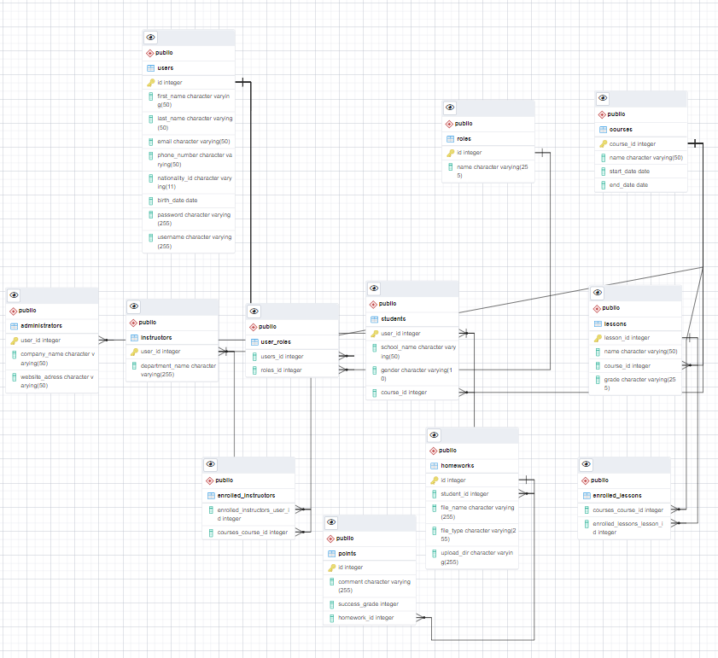

## Veri Yapıları

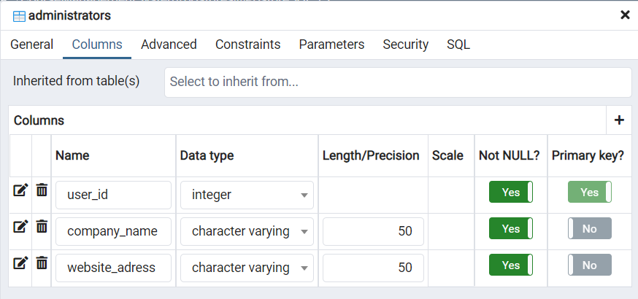

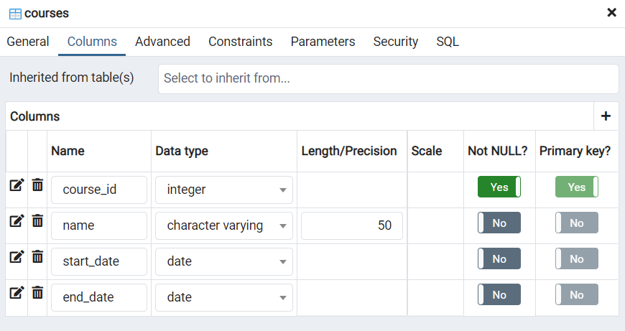 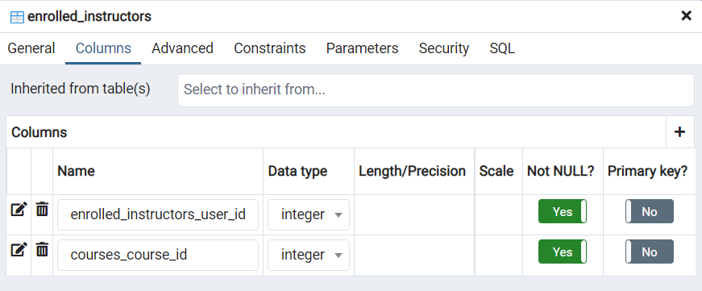 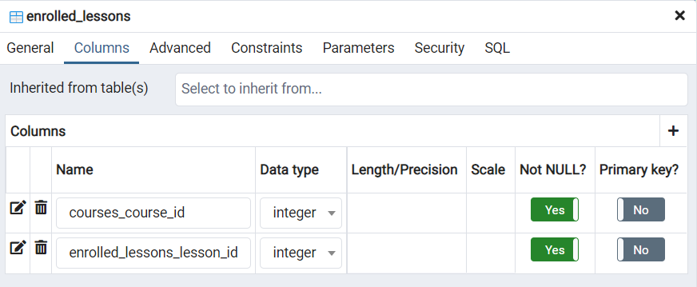 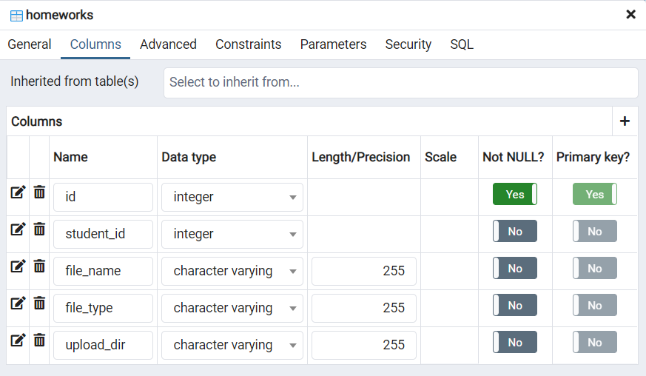 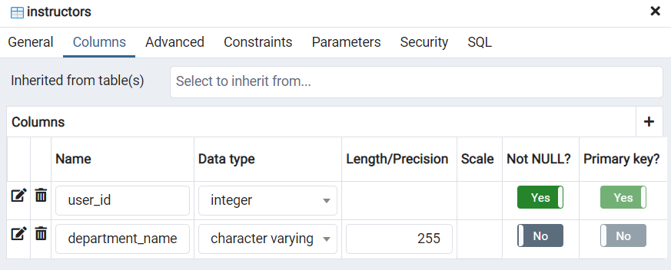 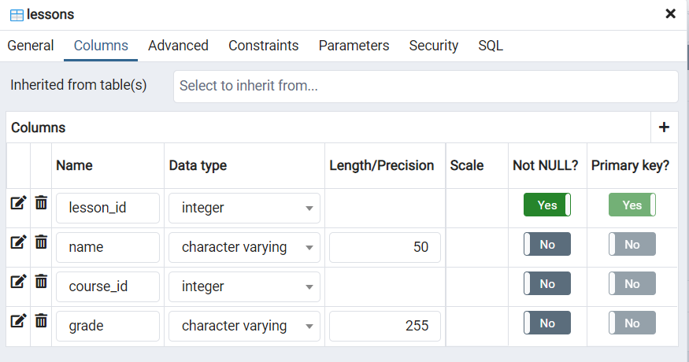 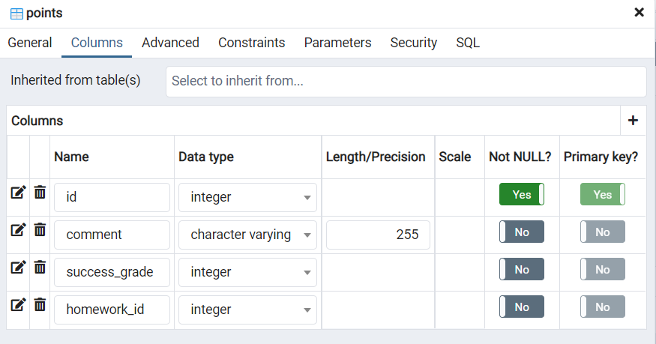 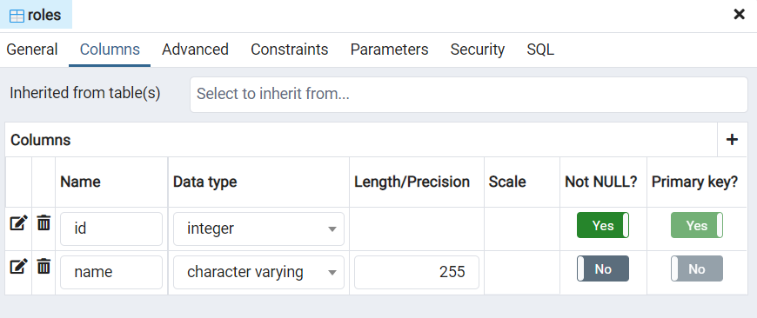 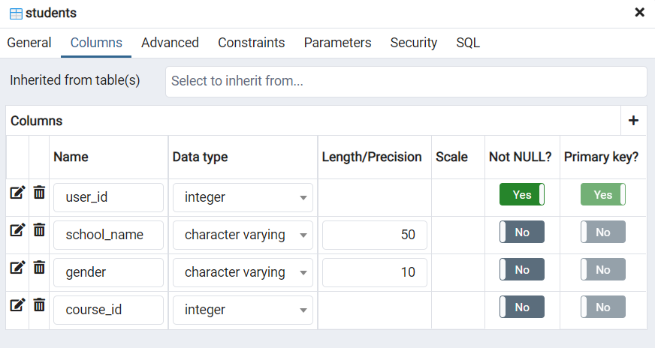 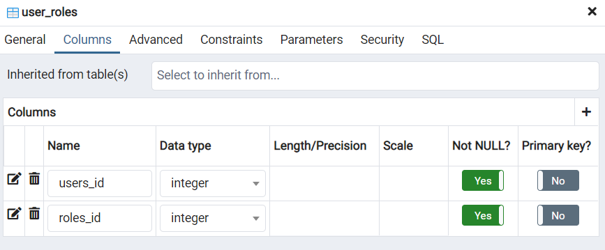 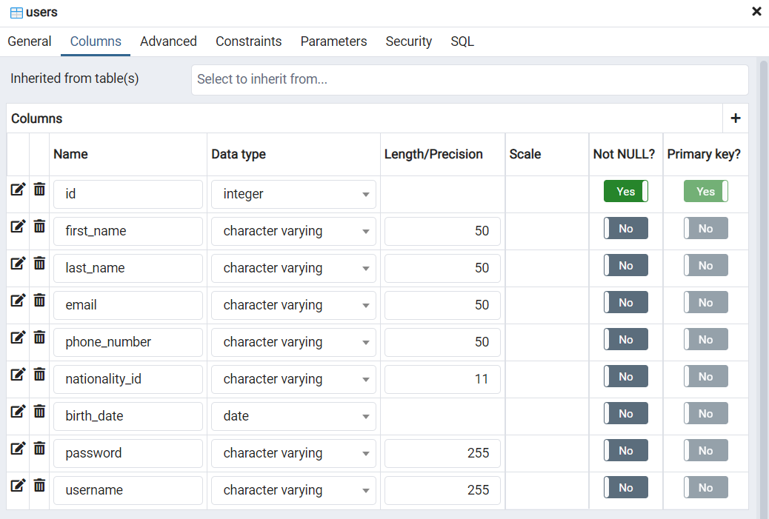

# Geliştirilebilirlik Açısından İnceleme

Yazılıma, “Öğrenci Veli” nesnesi, veliye öğrenci durumu hakkında mesaj gönderme özelliği, ödeme sistemi eklenebilir. Yazılımın mobil uygulaması yapılabilir.

# API

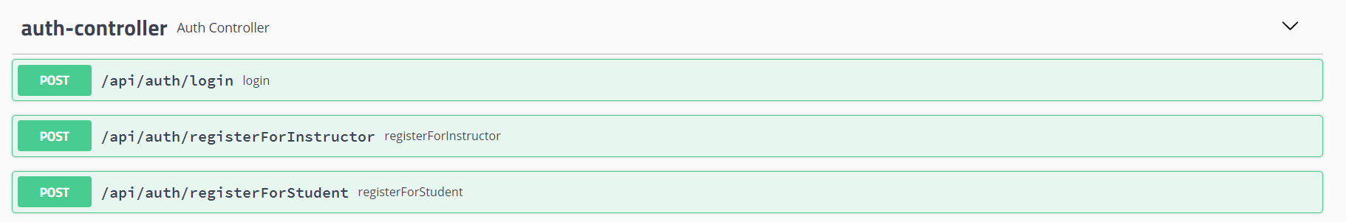

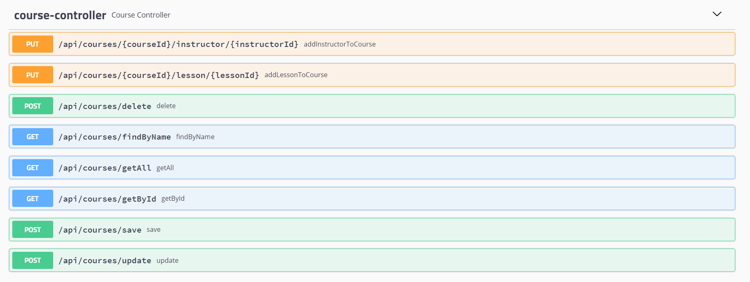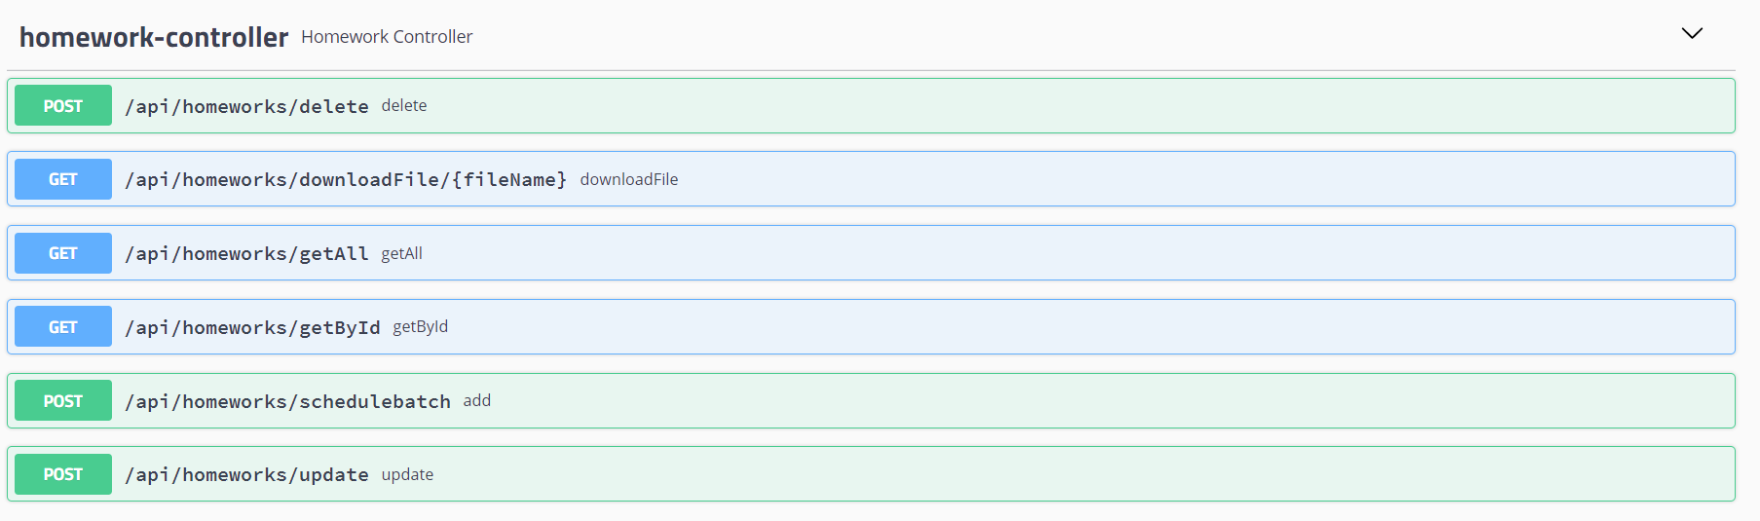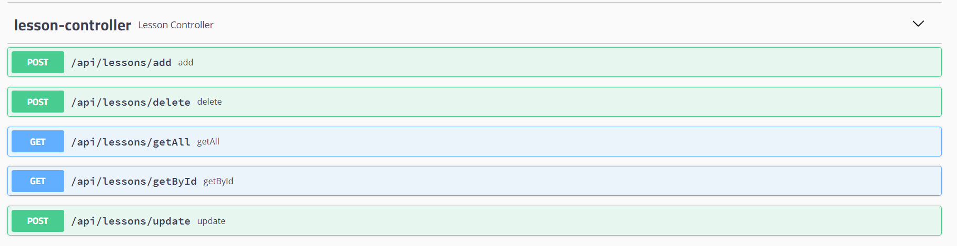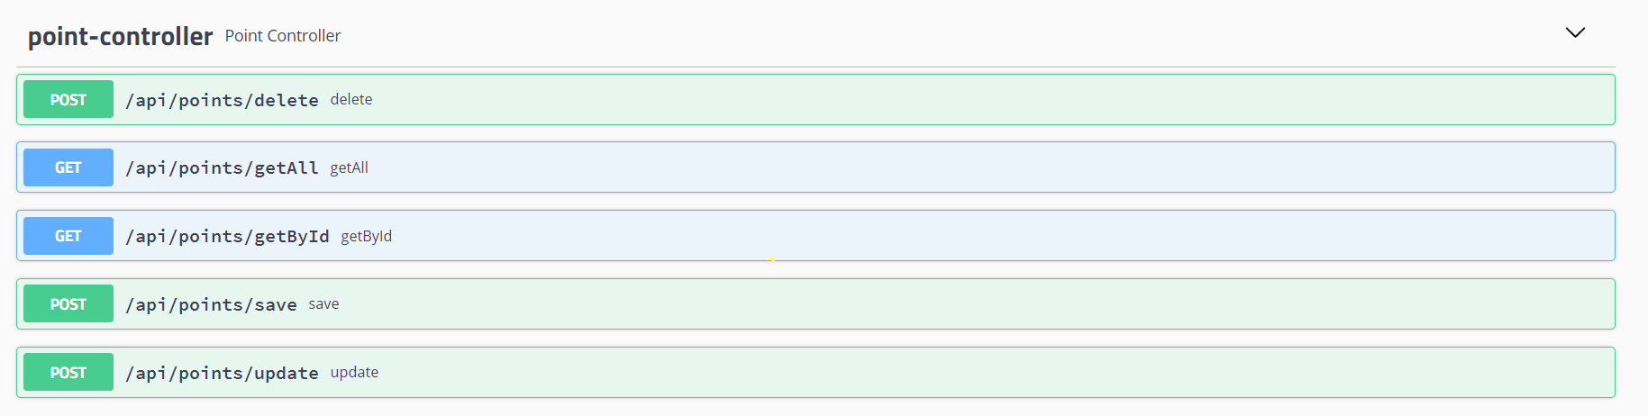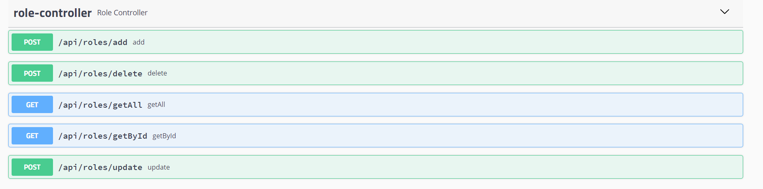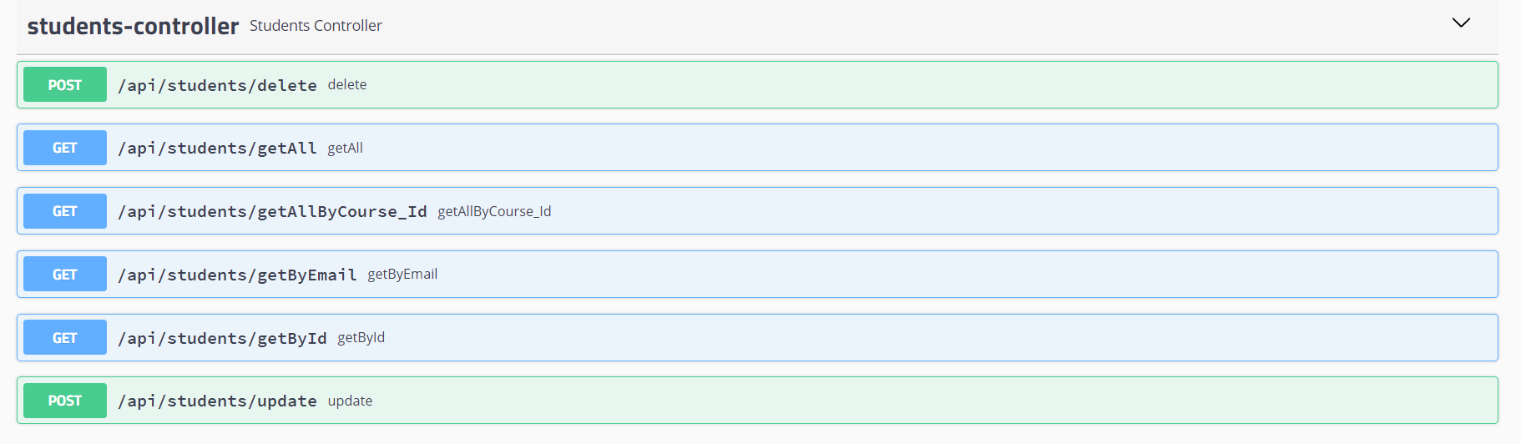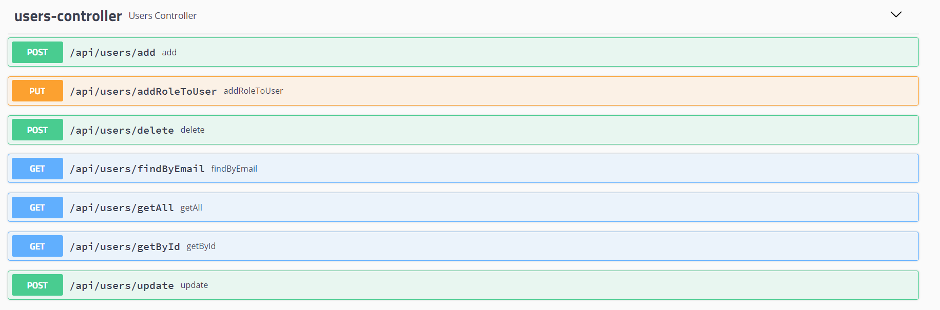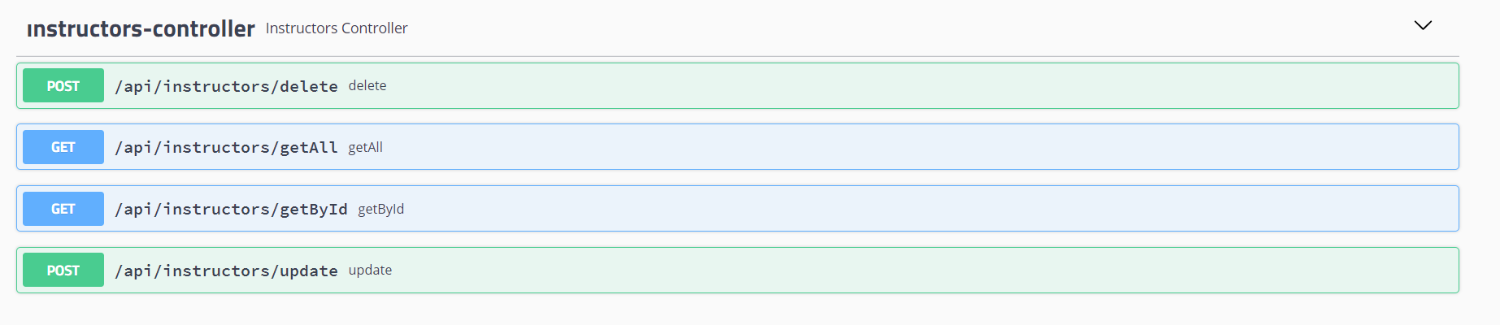

# Proje Github Linki

<https://github.com/zeynepsl/CourseManagementSystem>