

**A MINI PROJECT REPORT ON**

**EPILEPTIC SEIZURE DETECTION USING CNN**

**COURSE: COS6038B-OPEN-SOURCE TECHNOLOGIES**

**BY**

|  |  |
| --- | --- |
| Yash Tajanpure | PRN No: 1132220426 |
| Tanmay Bankhele | PRN No: 1132220710 |
| Pratik Khandake | PRN No: 1132220111 |
| Tanisq chhabada | PRN No: 1132220593 |

**IN PARTIAL FULFILLMENT OF**

**MASTER OF COMPUTER APPLICATION (SCIENCE)**

**Submitted Through**

**Department of Computer Science and Applications**

**To**

**DR. VISHWANATH KARAD MIT WORLD PEACE UNIVERSITY, PUNE, MAHARASHTRA, INDIA -411038**



**DEPARTMENT OF COMPUTER SCIENCE AND APPLICATIONS**

Certificate

This is to certify that**, ________________________** studentsof MCA (Science) Semester III has/have successfully / partially completed COS6038B - Mini Project on Open-source Technologies in partial fulfilment of MCA (Science) Sem III under Dr. Vishwanath Karad MIT World Peace University, for the academic year 2023-2024.

______________ ______________

Dr. Anuradha Kanade Prof. Swapnil Goje

**Internal Guide 1 Internal Guide 2**

Dr. Jalindar Gandal Dr. Rajeshree Khande

**Program Head Program Director**

Date: ___/___/______

External Examiners:

1. ____________________________ 2.____________________________

**Acknowledgement**

It gives us pleasure in presenting the partial project report on **‘Epileptic Seizures Detection using CNN’**.

Firstly, we would like to express our indebtedness appreciation to our internal guide **Mr. JALINDAR GANDAL.** His constant guidance and advice played very important role in making the execution of the report. He always gave us his suggestions, that were crucial in making this report as flawless as possible.

We would like to express our gratitude towards **Prof. Mr. JALINDAR GANDAL** Head of Master of Computer Application Department, Maharastra institute of technology for his kind co-operation and encouragement which helped us during the completion of this report.

Last but not the least, the backbone of our success and confidence lies solely on blessings of dear parents and lovely friends.

Yash Tajanpure

Pratik Khandake

Tanmay Bankhele

Tanishq Chhabda

**Abstract**

People with epilepsy frequently experience seizures, which reduce their quality of life. When electroencephalograph (EEG) recordings of these individuals are categorized precisely between seizurefree and seizure-based segments, it is possible to look into previous seizures and forecast upcoming ones. Modeling an EEG signal can help with the extraction of discriminate characteristics. In this study, a wavelet-based approach is used to break down EEG signals into detailed and approximate coefficients up to the fourth level of decomposition. For the purpose of distinguishing between normal EEG data and signals recorded from epileptic patients, several statistical features have been derived from the wavelet coefficients and fed to various classifiers. The simulation results showed that the suggested model, when applied to the neurology and sleep centre EEG database, New Delhi, attained the maximum classification accuracy of 100 Percent between healthy and epileptic EEG

**INDEX**

|  |  |  |
| --- | --- | --- |
| **SR. NO** | **TOPIC** | **PAGE NO.** |
| **1** | Introduction | 4 |
| **2** | Literature Survey | 4 |
| **3** | Software Requirements | 5 |
| **4** | System Design | 6 |
| **5** | Project Plan | 8 |
| **6** | Project Implementation | 9 |
| **7** | Result | 9 |
| **8** | Future Work | 17 |
| **9** | Conclusion | 29 |
| **10** | References | 30 |

**List of Abbreviations**

Convolutional Neural Network

Electroencephalogram

Data Flow Diagram

## 1 INTRODUCTION

## Overview

During an epileptic seizure, the interactions between nerve cells temporarily go haywire. As a result, certain areas of the brain or all areas of the brain become overly active and fire off too many signals. The resulting ”storm in the brain” has noticeable effects, such as convulsions, in the rest of the body.

### Motivation

Electroencephalogram (EEG) is an important diagnostic test that physicians use to record brain activity and detect seizures by monitoring the signals.There have been several attempts to detect seizures and abnormalities in EEG signals with modern deep learning models to reduce the clinical burden. However, they cannot be fairly compared against each other as they were tested in distinct experimental settings. Also, some of them are not trained in real-time seizure detection tasks, making it hard for on device applications. In this work, for the first time, we extensively compare multiple state-of-the-art models and signal feature extractors in a real-time seizure detection framework suitable for real world application, using various evaluation metrics including a new one we propose to evaluate more practical aspects of seizure detection models.

### 1.3 Problem Definition and Objectives

#### Problem Definition

To improve the timeliness of the seizure detection and reduce the burden of clinicians, we need a machine that accurately detects the seizure signal in real time to help physicians diagnose and prescribe.

**Objectives**

* The objective of the system is to reveal, analyze and detect Epilepsy.
* Identify the occurrence of Epilepsy which helps the doctors to take preventive measures.
* Also generate a report which contains the details of Epilepsy, and to keep track of count which helps in treatment of patient.

Epileptic Seizure Detection using CNN

### Project Scope Limitations

#### Scope

* Since Human nature is dynamic more focus must be on usage of unsupervised machine learning techniques.
* Future work can target on usage of these machine learning techniques for precise detection of Epilepsy.
* We will develop a system by applying different machine learning methods to better predict Epilepsy and improve performance.

#### Limitations

A seizure is a sudden, uncontrolled electrical disturbance in the brain. It can cause changes in your behavior, movements or feelings, and in levels of consciousness. Having two or more seizures at least 24 hours apart that aren’t brought on by an identifiable cause is generally considered to be epilepsy. There are various complications of seizure ; Breathing in food or saliva into the lungs during a seizure, which can cause aspiration pneumonia. Injury from falls, bumps,self-inflicted bites, driving or operating machinery during a seizure. Permanent brain damage (stroke or other damage).

### 1.5 Methodologies for Problem Solving

Here are some methodologies for problem-solving in an epilepsy seizure detection

:

* **Defining the problem :** Clearly define the problem statement and the objectives of an epilepsy seizure detection project. This includes identifying the type of data set to be used and the evaluation metrics to be used.
* **Data collection:** Collect a large and diverse dataset of EEG . It is essential to ensure that the dataset is of high quality, well-annotated, and balanced.
* **Preprocessing:** Preprocess the dataset by resizing the images, normalizing the pixel values, and tokenizing the captions. This step also involves splitting the data into training, validation, and testing sets.
* **Feature extraction:** Use a pre-trained convolutional neural network ( CNN ) such as ResNet or Inception to extract features from the images. This step involves freezing the CNN layers and using the features as input to the caption generator model.
* **Sequence** modeling: Use a recurrent neural network (RNN) such as LSTM or GRU to generate captions for the images. The RNN takes the image features as input and generates a sequence of words that form the caption.
* **Training:** Train the caption generator model on the preprocessed dataset using a combination of loss functions such as cross-entropy loss and mean squared error. The training process involves optimizing the model’s weights using backpropagation.
* **Evaluation:** Evaluate the performance of the model using metrics like BLEU score, ROUGE-L, and CIDEr. These metrics are used to measure the quality of the generated captions.
* **Deployment:** Deploy the trained model on a web or mobile application to generate captions for new images. This step involves integrating the model into the application and optimizing it for performance and scalability.

Overall, these methodologies involve a systematic approach to problem-solving for an image caption generator project, from defining the problem to deployment and maintenance.

## 2 LITERATURE SURVEY

### 2.1 Literature Survey

|  |  |  |  |  |  |
| --- | --- | --- | --- | --- | --- |
| **Sr** |  |  | |  |  |
| **No.** | **Paper Name** | **Author** |  | **Publication** | **Description** |
| 1 | A Deep Learning Approach for Automatic Seizure Detection in Children with Epilepsy | Magdy oumi,Ahmed delhameed | Bay-  Ab- | NEURAL NET-  WORKS,CNN,L | Proposes a novel deep learning approach for  STMdetecting seizures |
| 2 | Epileptic  Seizures  Prediction Using Machine Learning Metho | Syed Muhammad Usman, Muhamad Usman, and Simon Fong | | NUERAL NETWORKS, CNN,  RNN | Classification of the ictal state with rest of states of seizure |
| 3 | Detection  of Epileptic Seizures using  EEG Signals | S. Gupta, S. Bagga and M.P. S. Bhatia | | EEG,Epilepsy | The Goal of project to help patients with disorder to prevent injuries |
| 4 | Epileptic  Seizures Detection Using Deep Learning  Techniques | Shoeibi A. Khodatars, M. Ghassemi, N. Ja-  fari | | CNN,RNN | This study presents an effective method for classifying EEG signals as either normal or those recorded during epileptic seizure activity |

Table 2.1: Literature Survey

## 3 SOFTWARE REQUIREMENTS

## SPECIFICATION

### 3.1 Introduction

Epilepsy exists one of the furthermost common neurological and chronic diseases in childhood. Epilepsy patients understanding challenges in life due to protections they have to take in order to cope with this condition. When an attack occurs, it force cause injuries or expose the life of the patients or others, especially while they are using heavy machinery, e.g., driving cars. It needs a technique that can constantly monitor and evaluation the alertness level of drivers. Electroencephalogram (EEG) is one of the most useful and real useful tools in understanding and treatment of epilepsy. In this paper we presents a novel approach of seizure detection and predict the problem using Discrete Wavelet transform with 4- level transformation to find out whether the human body is normal or abnormal. A system is presented for detecting seizures from Electroencephalogram (EEG) data recorded from regular subjects and epileptic patients. The system is based on discrete wavelet transform with 4-level transformation analysis and approximate entropy (ApEn) of EEG signals. Seizure detection is accomplished in two steps. In the first step, EEG signals are decomposed by DWT to calculate estimate and detail constants.In the second stage, ApEn values of the estimate and detail coefficients are calculated using mat lab.The accuracy of seizure detection reached in this system is more than 90.

#### 3.1.1 User Classes and Characteristics

**User classes :**

* User – Person or user can select the input as image and upload it.
* External Organization.
* Group – Members of the group.

**Characteristics :**

* A trusted directory of patient data in EEGs which guarantees access as well as the integrity of the data itself.
* Lower your risk of traumatic brain injury.
* Low risk of stroke.

### 3.2 Functional Requirements

* CNN
* Data Cleaning
* Feature Extraction
* Training the model
* Classification

### 3.3 System Requirements

#### 3.3.1 Software Requirements(Platform Choice)

**Tensor-flow** : Tensor-Flow is an end-to-end open source platform for machine learning. Tensor-flow is developed by Google and has integrated the most common units in deep learning frameworks. It supports many up-to-date networks such as CNN and RNN with different settings. Tensor-flow is designed for remarkable flexibility, portability, and high efficiency of equipped hardware.

* **Miniconda** : Miniconda is a light version of the Anaconda Python distribution that includes only the necessary packages and libraries for scientific computing and data analysis. It allows users to create and manage virtual environments, install packages and dependencies, and run Python scripts and applications.
* **Flask** : Flask is a micro web framework written in Python. It is classified as a microframework because it does not require particular tools or libraries. It has no database abstraction layer, form validation, or any other components where pre-existing third-party libraries provide common functions. However, Flask supports extensions that can add application features as if they were implemented in Flask itself. Extensions exist for object-relational mappers, form validation, upload handling, various open authentication technologies and several common framework related tools.

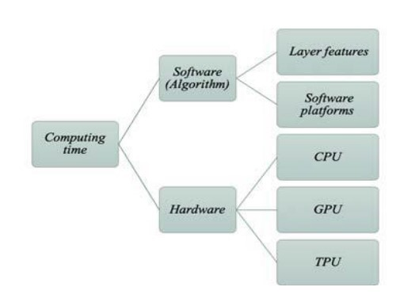

Figure 3.1: Software requirements

#### 3.3.2 Hardware Requirements

The science and methodology behind deep learning have been in existence for decades. In recent years, however, there has been a significant acceleration in the utilization of deep learning due to an increasing abundance of digital data and the involvement of the powerful hardware.

1. **GPU** - The performance of matrix multiplication on the graphics processing unit is noticeably better than that of the CPU. When compared to their CPU-only counterparts, all of the aforementioned deep learning techniques achieve significantly higher speedup. Because they can speed up the systems, GPUs have become the preferred platform for training large, complicated Neural Network-based systems..
2. **TPU** -A unique chip called Tensor Processing Unit ( Domain-Specific Architecture) has been used in Google data centres since 2015. The architects designed instructions that operate on tensors of data rather than just one data element per instruction because tensors are the dominant data structure in DNNs. Instead of being tightly integrated with a CPU, TPU was designed to be a coprocessor on the PCI Express I/O bus, which enables it to plug into existing servers similarly to how a GPU does. This reduced the deployment time. The intention was to reduce I/O between the TPU and the host CPU by running complete inference models in the TPU. Domain-specific processors have the benefit of simplicity.

### 3.4 Analysis Models: SDLC Model to be applied

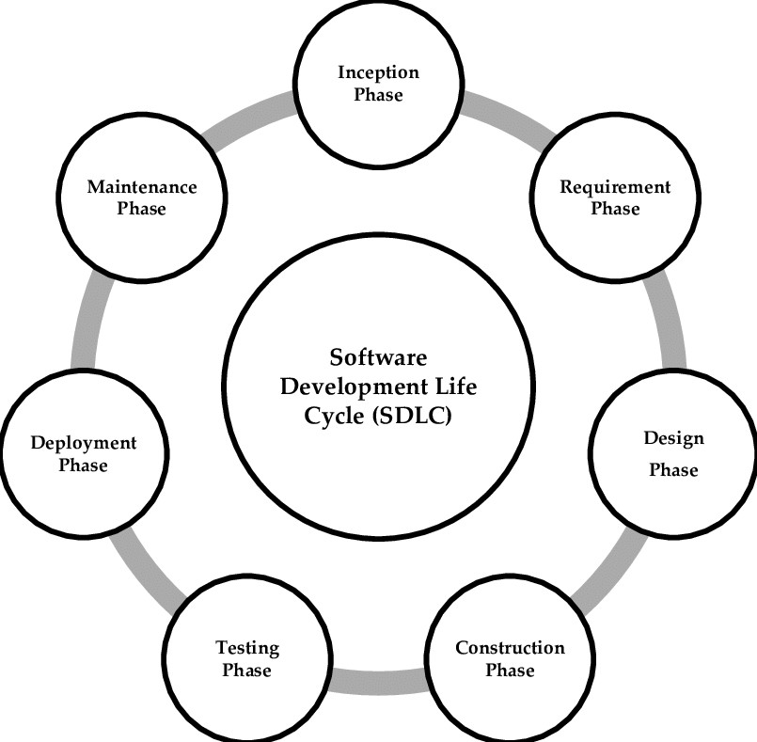

Figure

3.2:

SDLC

Model

### 3.5 System Implementation Plan

|  |  |  |
| --- | --- | --- |
| **Sr.** |  |  |
| **No.** | **System Completion Steps** | **Status** |
| 1 | Requirement | Completed |
| 2 | Analysis | Completed |
| 3 | System Design | Completed |
| 4 | Implementation | Completed |
| 5 | System Testing | Completed |
| 6 | System Deployment | Completed |
| 7 | System Maintenance | Completed |

Table 3.1: System Implementation Plan

### 3.6 Assumptions and Dependencies

#### 3.6.1 Assumptions

* A large dataset of EEG and their corresponding detection is available.
* The images in the dataset are high quality and relevant to the project’s goals.
* The model will use a deep learning model such as a convolutional neural network (CNN) with an attention mechanism to generate captions.
* The model will be trained using a GPU to accelerate the training process.

#### 3.6.2 Dependencies

* Python programming language - as the project will require coding and building the model using Python libraries.
* Deep learning libraries such as Tensorflow, PyTorch, and Keras - to build and train the image captioning model.
* NumPy and Pandas - to manipulate and analyze the data for the project.
* GPU - to accelerate deep learning training.
* Flask - are a built-in web server and debugger, unit testing support.

## 4 SYSTEM DESIGN

### 4.1 System Architecture

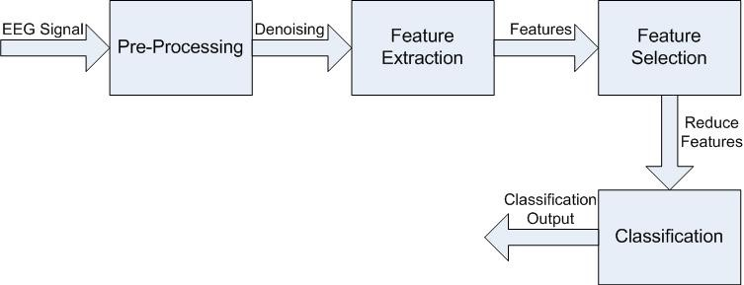

Figure

4.1:

System

Architecture

Epileptic Seizure Detection using CNN

### 4.2 Data Flow Diagrams / UML Diagrams

#### 4.2.1 Data Flow Diagram

Data Flow Diagram is referred to as DFD. DFD is a representation of how data flows through a system or process. Additionally, it sheds light on the inputs and outputs of every entity as well as the process itself. No loops or decision rules exist in DFD, and there is no control flow. A flowchart can be used to explain specific operations based on the type of data. A data flow diagram can be portrayed in a variety of ways. The DFD is one of the modelling techniques used in structured analysis. Due to their ability to help us see the key phases and data involved in software-system processes, data flow diagrams are particularly well-liked.

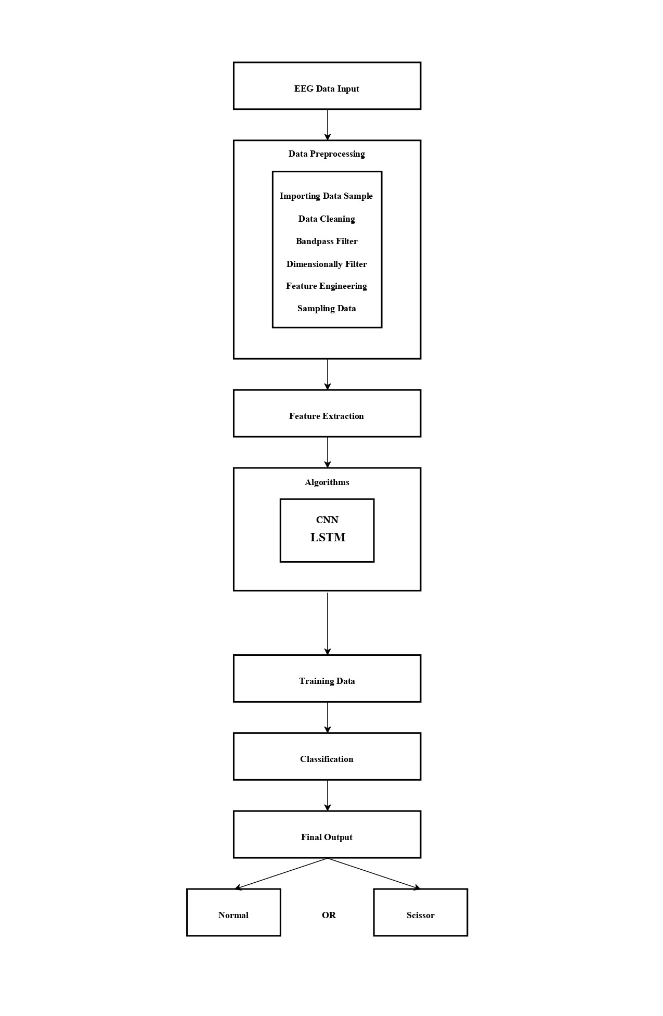

Figure 4.2: Data flow diagram

#### 4.2.2 Use case diagram

The dynamic behaviour of a system is described using a use case diagram. It contains use cases, actors, and their relationships, which embodies the functionality of the system. It simulates the duties, advantages, and features needed by a system or application subsystem. It explains how a system works at a high level and also explains how a user interacts with the system. Use case diagrams have a purpose.

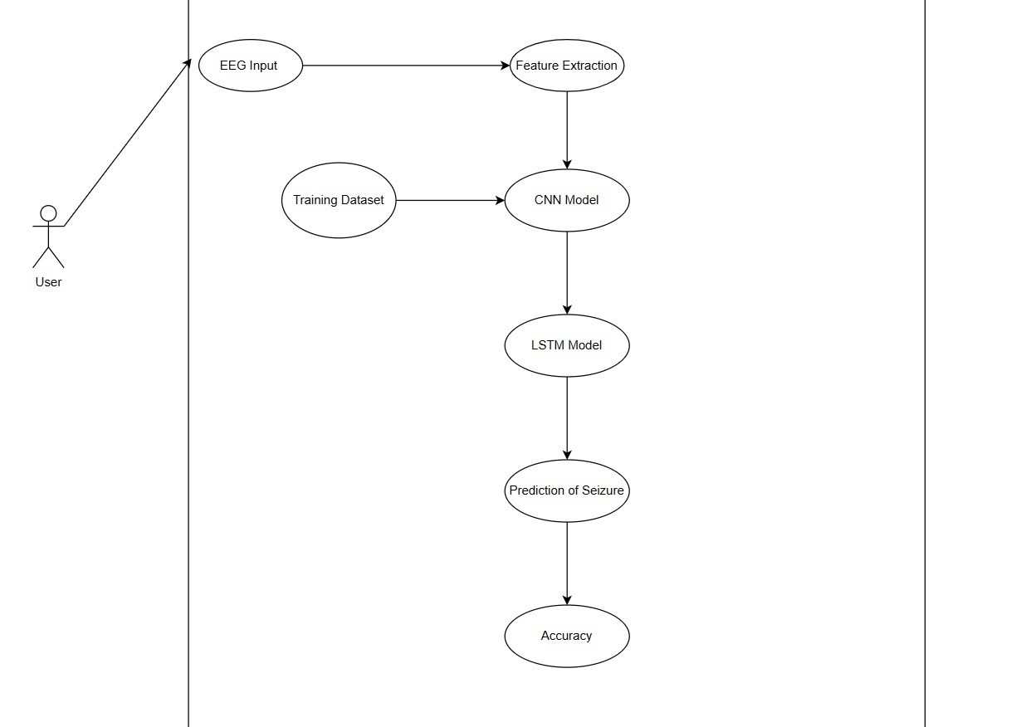

Figure 4.3: Use case diagram

## 5 PROJECT PLAN

### 5.1 Project Estimate

The time and effort required to develop an elpilepsy detection can vary depending on the complexity of the project and the specific requirements. However, a rough estimate for developing an epilepsy seizure detection would be around 2 to 4 weeks for a skilled developer or a small team. This estimate includes tasks such as data collection and preprocessing, model training and optimization, and implementing the caption generation algorithm. Keep in mind that this estimate is a general guideline and the actual time required may vary based on the specific details and challenges of your project.

#### 5.1.1 Reconciled Estimates

**Time Estimate :**

* **Project Planning and Research:** 1 week

Define project scope and objectives Research existing image captioning models and techniques Determine required resources and data sources

* **Data Collection and Preprocessing:** 1-2 weeks

Identify and gather a suitable image dataset Collect corresponding captions for the images Preprocess the images and captions for model training

* **Model Selection and Architecture Design:** 1 week

Choose an appropriate deep learning model architecture (e.g., CNN + RNN) Design the overall structure of the image caption generator model Determine hyperparameters such as learning rate, batch size, etc.

* **Model Training:** 1-4 weeks

Set up the training environment (GPU, libraries, etc.) Split the dataset into training and validation sets Train the model using the training data and optimize the parameters Monitor the model’s performance on the validation set and fine-tune as needed

* **Evaluation and Testing:** 1 week

Evaluate the trained model using appropriate metrics (e.g., BLEU score) Fine-tune and adjust the model based on evaluation results Test the model with unseen images and assess the quality of generated captions

* **Deployment and Integration:** 1 week

Prepare the model for deployment (serialization, optimization, etc.) Integrate the model into an application or system Perform necessary testing and debugging to ensure smooth integration

* **Documentation and Wrap-up:** 1-2 weeks

Document the project details, including the model architecture and training process Create user guides or documentation for using the image caption generator Finalize any remaining tasks, address any outstanding issues, and conclude the project

### 5.2 Risk Management

1. **Inappropriate dataset -** To overcome this risk we are trying to use well organized and complete dataset.

#### 5.2.1 Risk Identification

When developing an image caption generator, it’s important to identify potential risks and challenges that may impact the project’s success. Here are some common risk factors to consider:

* **Insufficient or Low-Quality Data:**

Difficulty in finding a suitable dataset with EEG and accurate detection.

* **Model Complexity and Performance:**

Complex models may require significant computational resources and time for training and inference. Overfitting, where the model performs well on training data but fails to generalize to new EEG data image.

* **Limited Domain or Coverage:**

The trained model may perform well for a specific dataset or domain but struggle with different types of data.

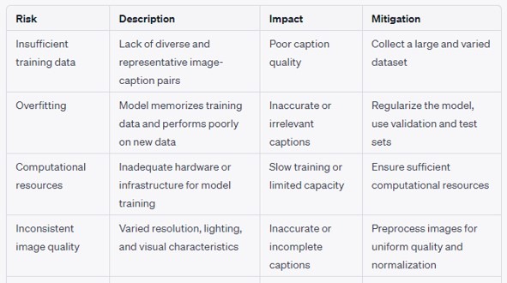

Figure 5.1: Risk Identification

#### 5.2.2 Risk Analysis

Risk analysis and contingency planning assumes that mitigation efforts have failed and that the risk has become a reality. Continuing the example, the project is well under way and a number of people announce that they will be leaving. If the mitigation strategy has been followed, backup is available, information is documented, and knowledge has been dispersed across the team.

### 5.3 Project Schedule

In this chapter we are going to have an overview about how much time does it took to complete each task like- Preliminray Survey Introduction and Problem Statement, Literature Survey, Project Statement, Software Requirement and Specification, System Design, Partial Report Submission, Architecture Design, Implementation, Deployment, Testing, Paper Publish, Report Submission.

#### 5.3.1 Project Task Set

In project management, a task is a work item or activity with a specific purpose related to the larger goal. It’s a necessary step on the road towards project completion. When it comes to setting deadlines, take an “underpromise and overdeliver” approach

#### 5.3.2 Task Network

A task network is a set of tasks and constraints among them. Such a network can be used as the precondition for another compound or goal task to be feasible.Task network is a graphic representation of the task flow for a project.

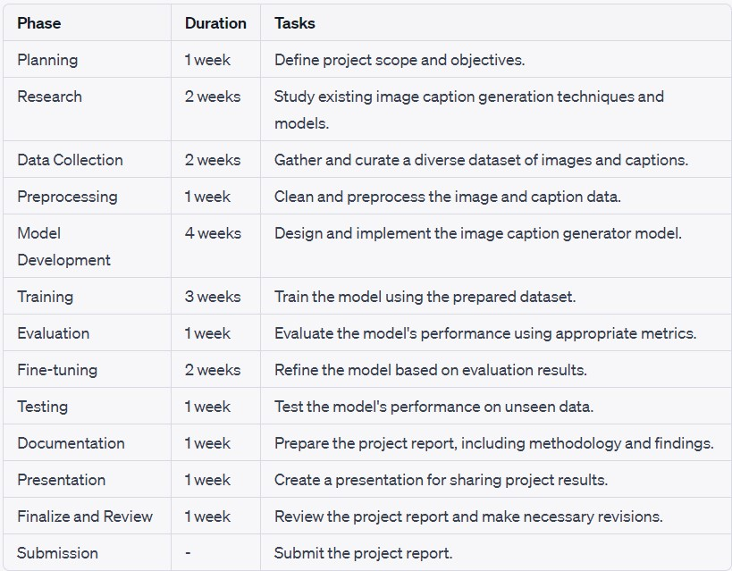

Figure 5.2: Timeline chart

### 5.4 Team Organization

The manner in which a team is organized and the mechanisms for reporting are noted.Updates regarding the improvement of the project are given to the guide. Also once or twice a month,a meet is held with the project guide regarding updates.

#### 5.4.1 Team Structure :

The team structure for the project is identified. Roles are defined.

1. Yash Tajanpure
2. Tanmay Bhankhele
3. Tanishq Chhabda
4. Pratik Khandke

#### 5.4.2 Management reporting and communication

To have understanding of the problem statement.

To know what are the hardware and software requirements of proposed system.

To have understanding of proposed system

## 6 PROJECT IMPLEMENTATION

### 6.1 Overview of Project Modules

1. **Data Collection:** This module involves gathering a large dataset of images and their corresponding captions. The dataset should be diverse and representative of the target domain.
2. **Data Preprocessing:** In this module, the collected data is preprocessed to ensure it is in a suitable format for training the caption generator model. This may involve resizing images, tokenizing captions, handling special characters, and creating training-validation-test splits.
3. **Model Architecture:** This module focuses on designing the architecture of the image caption generator model. It typically involves combining convolutional neural networks (CNNs) for image feature extraction and recurrent neural networks (RNNs) or transformer models for generating captions.
4. **Training:** The training module involves training the image caption generator model using the preprocessed dataset. This step includes feeding images into the CNN to extract features and using those features as input to the RNN or transformer model for caption generation.
5. **Evaluation and Fine-tuning:** Once the initial model is trained, it needs to be evaluated using appropriate metrics such as BLEU (Bilingual Evaluation Understudy) and CIDEr (Consensus-based Image Description Evaluation). Based on the evaluation results, fine-tuning techniques like reinforcement learning or attention mechanisms can be applied to improve the model’s performance.
6. **Epilepsy Detection:** This module focuses on using the trained model to detects Epilepsy . It involves feeding an image into the model, extracting image features, and Detecting.
7. **Post-processing and Evaluation:** The generated captions may undergo post-processing steps such as removing special characters, capitalizing letters, or applying language corrections. The generated captions should be evaluated for quality, coherence, and relevance to ensure they meet the desired standards.
8. **User Interface (UI):** Optionally, a UI module can be included to provide a user-friendly interface for users to upload images and receive generated captions. The UI module may involve integrating the image caption generator model into a web or mobile application.

Epileptic Seizure Detection using CNN

1. **Documentation and Reporting:** This module focuses on documenting the entire project, including the methodology, implementation details, challenges faced, and results obtained. A comprehensive project report is prepared, highlighting the achievements, limitations, and potential areas for future improvement.
2. **Deployment:** If desired, the image caption generator can be deployed to a production environment, making it accessible to end-users. This module involves setting up the necessary infrastructure and ensuring the system’s scalability, reliability, and performance.

### 6.2 Tools and Technologies Used

1. **Programming Languages:**

**Python:** Python is widely used in the field of machine learning and deep learning due to its rich ecosystem of libraries and frameworks. Deep Learning Frameworks:

1. **TensorFlow :** TensorFlow is an open-source deep learning framework developed by Google. It provides a comprehensive set of tools and APIs for building and training neural networks. PyTorch: PyTorch is another popular deep learning framework known for its dynamic computation graph and ease of use. It offers flexible building blocks for designing and training neural networks. Image Processing Libraries:
2. **Miniconda :** Miniconda is a light version of the Anaconda Python distribution that includes only the necessary packages and libraries for scientific computing and data analysis. It allows users to create and manage virtual environments, install packages and dependencies, and run Python scripts and ap- plications.
3. **Google Colaboratory :** Google Colab is a cloud-based service that allows users to run Jupyter note- books on Google’s high-performance virtual machines. It provides free access to GPUs and TPUs, making it ideal for machine learning and deep learning tasks. Users can upload and share notebooks, run code collaboratively, and save results to Google Drive.
4. **Flask :** Flask is a micro web framework written in Python. It is classified as a microframework because it does not require particular tools or libraries. It has no database abstraction layer, form validation, or any other components where pre-existing third-party libraries provide common functions. However, PESMCOE, Department of Computer Engineering 2022-23 26

Flask supports extensions that can add application features as if they were implemented in Flask itself. Extensions exist for object-relational mappers, form validation, upload handling, various open authentication technologies and several common framework related tools.

### 6.3 Algorithm Details

#### 6.3.1 Algorithm 1

**Convolutional Neural Networks(CNNs) :** CNNs are primarily used for image feature extraction in the image caption generator. The CNN architecture, typically pretrained on large-scale image classification tasks (e.g., ImageNet), learns to extract high-level visual features from input images. The CNN takes an image as input and passes it through a series of convolutional layers, pooling layers, and activation functions. These layers help capture local visual patterns and hierarchically learn more abstract representations. The output of the CNN is a fixed-length feature vector that encodes the important visual characteristics of the image.

The extracted image features from the CNN are then passed on to the next module, which is typically an RNN or a transformer model for caption generation.

**7** **RESULTS**

### 7.1 Screenshots/Results :

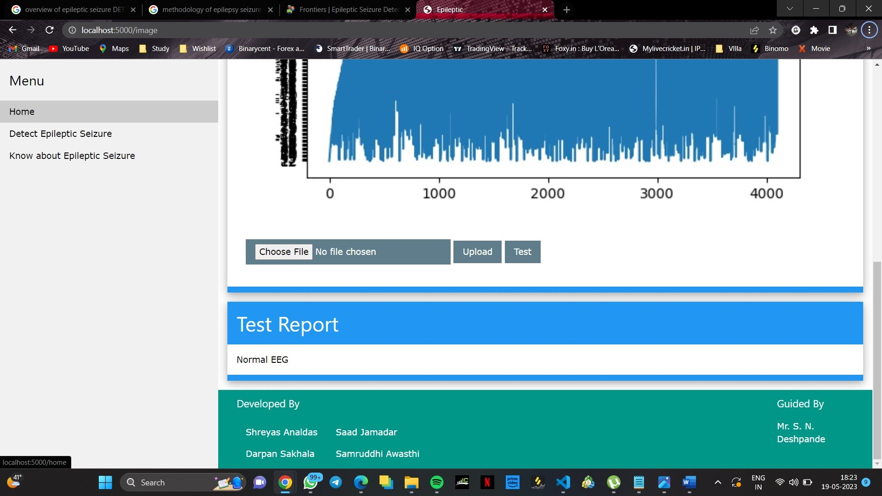

Figure

7.1:

Result

1

Figure 7.2: Result 2

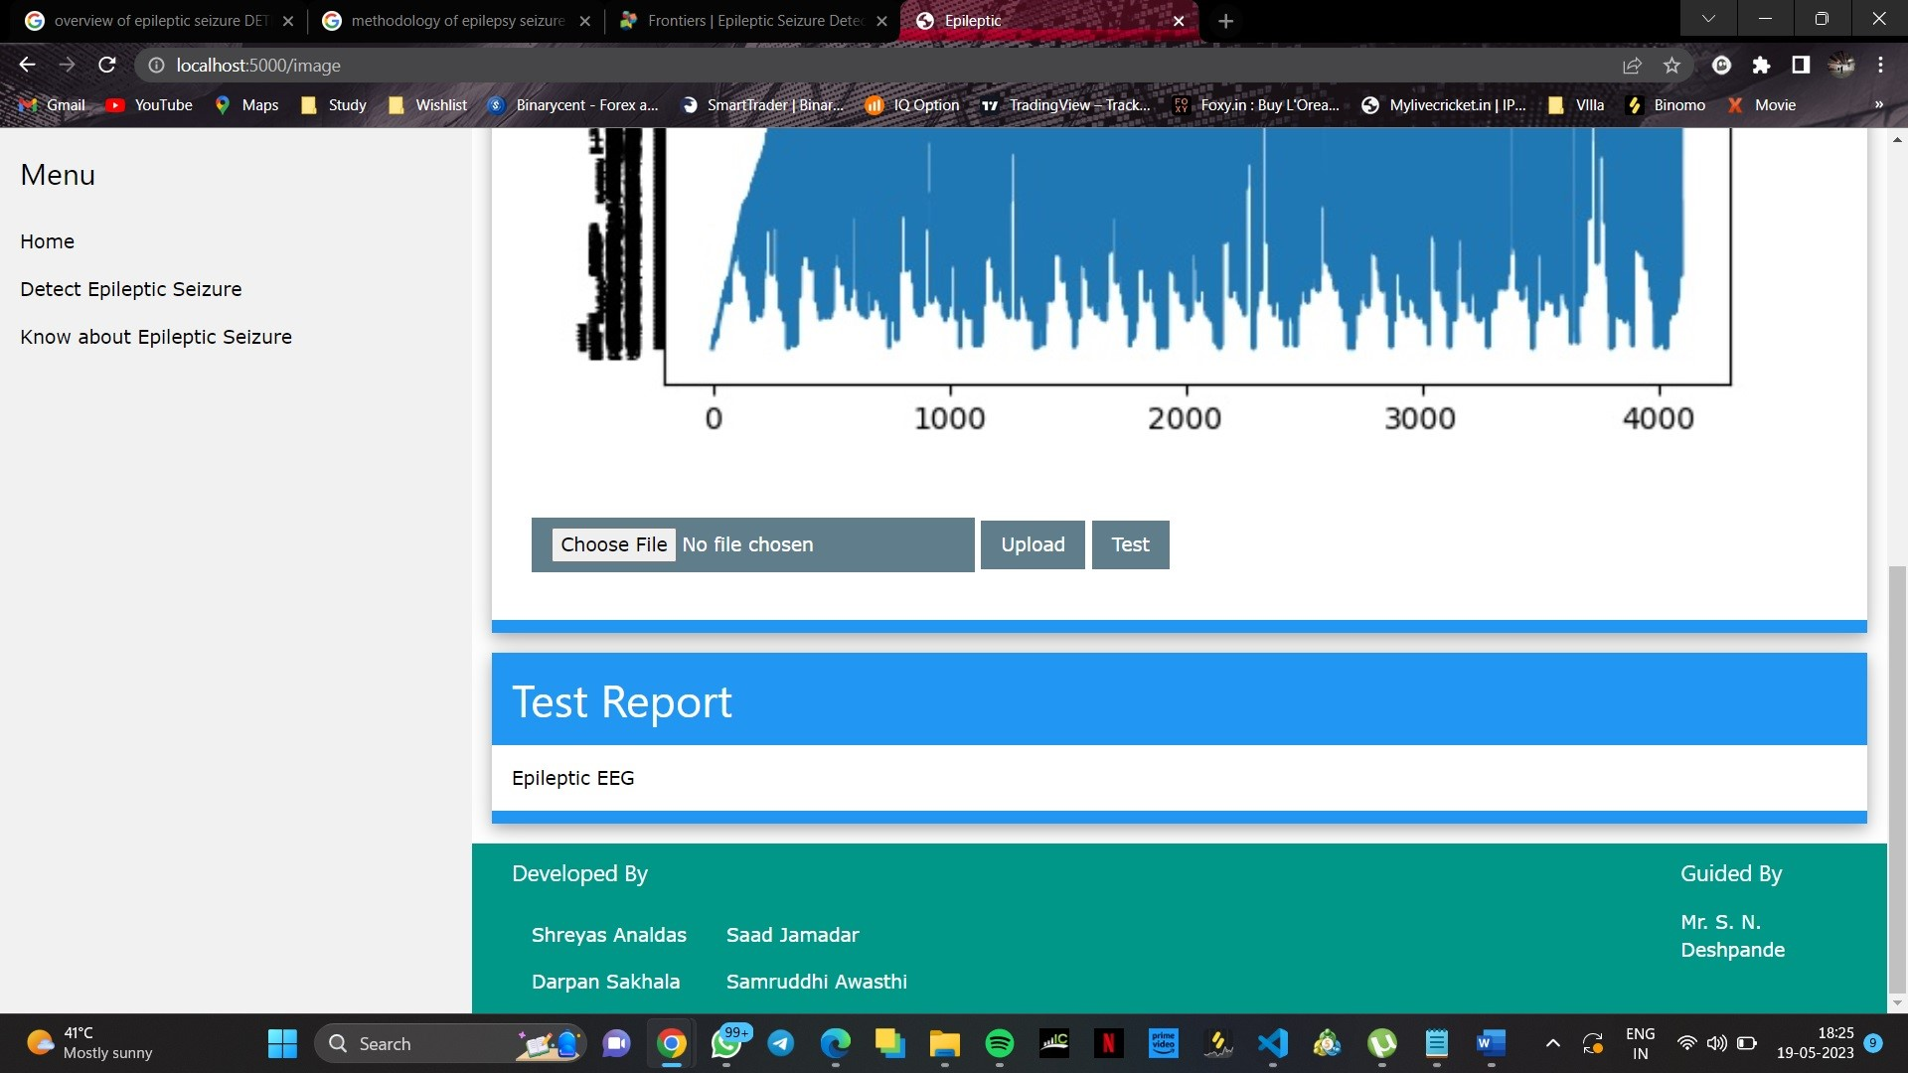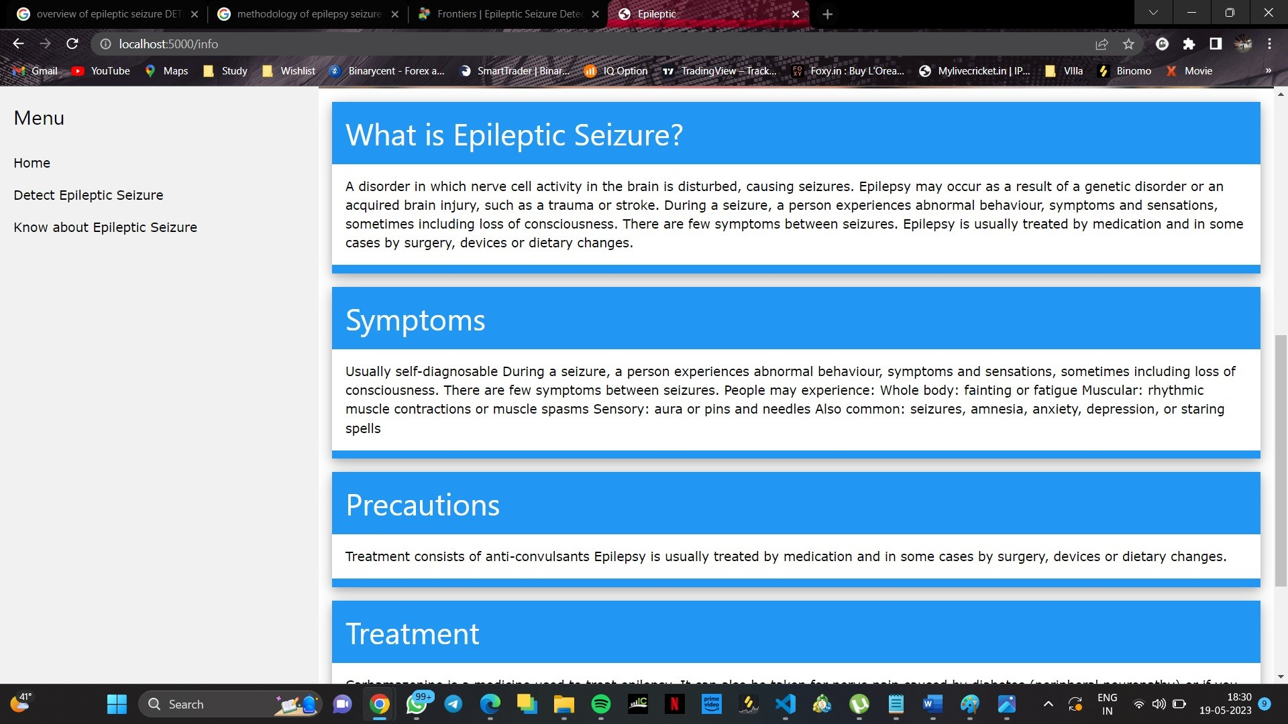

Figure 7.3: Result 2

### 8 Future Work

There are several areas of future work that can be explored for improving image caption generator systems. Here are a few examples:

* **Multimodal approaches:** While most current image captioning systems rely primarily on visual features extracted from the image, there is potential to incorporate other modalities such as audio and text to generate more accurate and diverse captions.
* **Adapting to different domains:** Image caption generators are often trained on generic image datasets, but there is potential to adapt these models to specific domains, such as medical imaging or satellite imagery.
* **Interpretable models:** There is a growing need for models that can generate captions in a way that is interpretable and explainable to humans. This can involve developing models that generate captions in natural language, or incorporating attention mechanisms that highlight the most relevant parts of the image.
* **Improved evaluation metrics:** Current evaluation metrics for image caption generators are often limited and do not fully capture the nuances of language and meaning. Developing better evaluation metrics can help to improve the quality of generated captions and provide more meaningful feedback for model development.
* **Continual learning:** Image caption generator models can be improved by continually learning from new data and feedback. Developing models that can adapt and improve over time can help to keep up with changes in image and language data.

### 8.1 Applications

1. Epilepsy detection systems can be used to monitor patients with epilepsy and detect seizures. This can help patients get timely medical care and improve their quality of life.
2. Epilepsy detection systems can also be used in clinical research to study the effectiveness of treatments and therapies for epilepsy. They can also be used in sports medicine to monitor athletes for head injuries and concussions that may lead to epilepsy.

35

## .

## 9 CONCLUSIONS

### 9.1 Conclusions

We have tested our proposed model on the dataset, and it has been shown in results that our model performs better in terms of both sensitivity and average detection time as compared to other models for detection of epileptic seizures.

The detection of Epilepsy is still undergoing research and no such system has been built yet that is 100 percent reliable to be used by experts in the medical field. Besides, these systems require some sort of technical expertise as well as medical expertise which may or may not be always present. The usage of EEG signals is preferred over ECG signals but these require a better form of pre-processing. The raw data form needs better handling. Epilepsy cases are more prevalent in countries that don’t have a great economic setup, as such, the need is to deploy such systems in these countries where Epilepsy is growing every year and medical treatment is almost negligible. This Project proposes models to better detect Epilepsy in patients. As more cases are emerging every year, this project aims to help researchers better choose a model that can help patients who are prone to become Epileptic so as to provide better treatment and health facilities. The patient’s EEG signals would help the system to predict if they have Epilepsy or not. The model is expected to train using the data set of various epileptic and non-epileptic patients so as to help detect consecutive seizures in epilepsy. The goal of this work is to help patients with the disorder as they usually become prone to various physical injuries like accidents or falls. Since the social stigma around such patients who suffer severe episodes of seizure is high, the self confidence of such patients seems to be lacking and becoming the cause of other problems like depression and anxiety. We aim to help detect the neurological disorder in susceptible patients so that the right course of treatment is given at the right time so that it helps to reduce or maybe, even prevent the disorder.

Epileptic Seizure Detection using CNN

**ANNEXURE A**

### A.1 Problem statement

- To improve the timeliness of the seizure detection and reduce the burden of clinicians, we need a machine that accurately detects the seizure signal in realtime to help physicians diagnose and prescribe. .

### A.2 Feasibility Study

1. **Technical Feasibility:** The project will be implemented using python as a programming language. The entire system will be built using Python and various deep learning libraries.
2. **Schedule Feasibility:** The project will consist mainly of three modules: Data preprocessing, Feature extraction, object detection and vectorization.
3. **Economic Feasibility :** The project is cost-effective as it is a softwarebased application. Efficient design of the proposed system will observe optimal usage of processor capacity and memory.
4. **Ethical Feasibility :** The algorithms used in this project are fully ethical and standardized. The project is free of copyright violations as well.

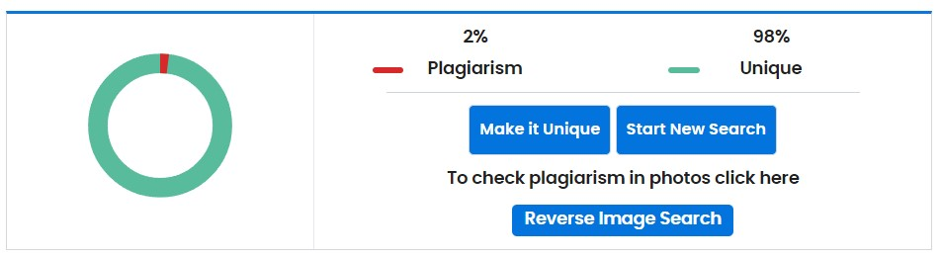

## 10 REFERENCES

1. R. S. Fisher, W. Van Emde Boas, W. Blume et al., “Epileptic seizures and epilepsy: definitions proposed by the International League Against Epilepsy (ILAE) and the International Bureau for Epilepsy (IBE),” Epilepsia, vol. 46 , no. 4, pp. 470–472.
2. U. R. Acharya, S. V. Sree, G. Swapna, R. J. Martis, and J. S. Suri, “Automated EEG analysis of epilepsy: a review,” Knowledge Based Systems, vol. 45, pp. 147–165.
3. L. E. Hebert, P. A. Scherr, J. L. Bienias, D. A. Bennett, and D. A. Evans,“Alzheimer disease in the US population: prevalence estimates using the 2000 census,” JAMA Neurology, vol. 60, no.8, pp. 1119–1122