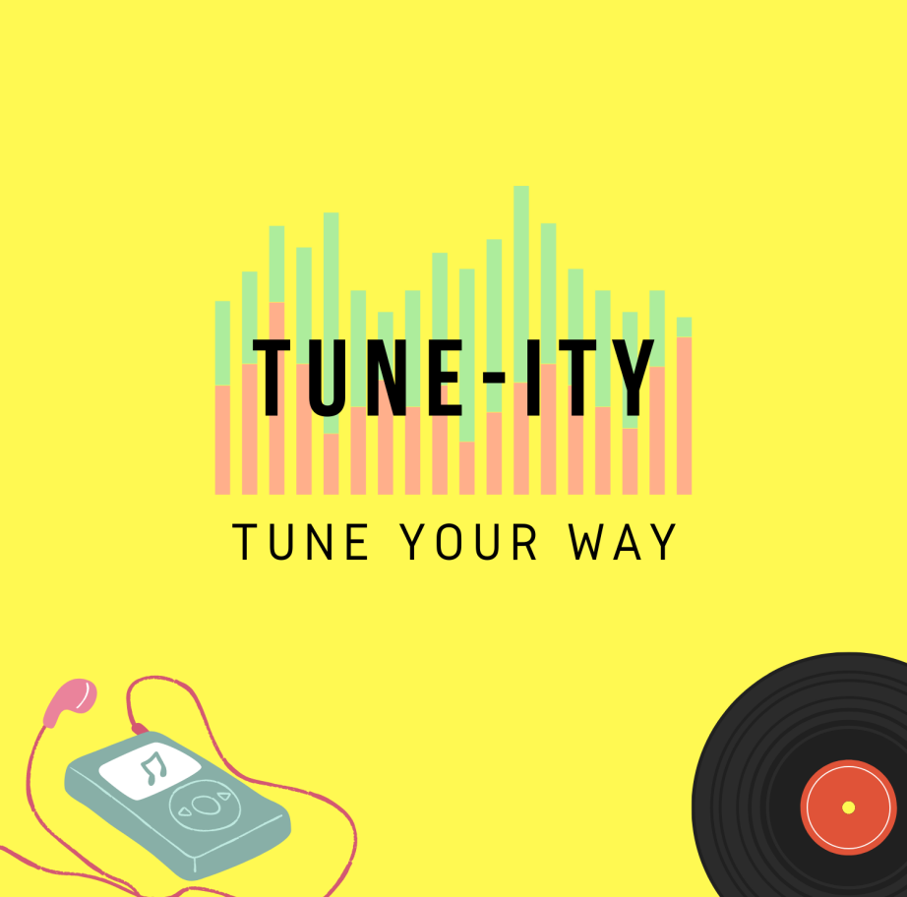

2ndPROJECT

*TUNE-ITY*

(A Music Portal)

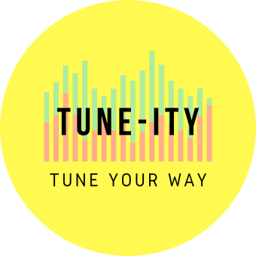

**LOGO**

**COVER IMAGE**

**NAME** : Darpan Deb

Edureka Full Stack Web Development Course (Batch -23)

Overview :

**TUNE-ITY** is a free online music portal with ad free environment to deliver user with great music experience. Although it has a small database of songs, but with the intention of delivering ad free experience to the user , the project is designed accordingly.

Technology Used :

Front- End :

HTML

CSS

BOOTSTRAP

REACT

Dynamic :

Javascript

Ci/cd with AWS

Login and Logout (oauth and jwt)

Database :

MongoDB

Json Data

Code Compiler :

Visual Studio Code

Git Bash (windows) / Terminal (linux/ mac )

Git hub

Node js

Goals :

1. Home page
2. Login Page
3. Music search/ playlist Page
4. Music Stream page
5. Favorites/recently played page
6. Profile page
7. Logout page