USAGE:

Welcome to the usage guide for the MSc Workflow and Documentation System. This section will help you navigate the essential steps to interact with the system effectively.

**1. Login to the Admin Dashboard:** To access the admin dashboard, follow these steps:

* **Create Superuser:** Open your terminal and navigate to the project directory. Run the following command to create a superuser:

python manage.py createsuperuser

* **Login as Superuser:** Launch the development server using **python manage.py runserver**, and then open your web browser and go to **http://127.0.0.1:8000/admin/**. Log in using the following credentials:
  + Username: admin
  + Password: pulchowk

**2. Configure Your Account:** After logging in as the superuser, you can configure your own user account as a coordinator:

* Go to the "Users" section in the admin dashboard.
* Locate and edit your user account.
* Assign the "Coordinator" role to your account.

By making your user account a coordinator, you'll be able to access and utilize the various features and functionalities available in the MSc Workflow and Documentation System.

3. Use:

a. Home Interface:

It contains the links for database control and thesis documents generation. Also, the database can also be controlled through this interface.

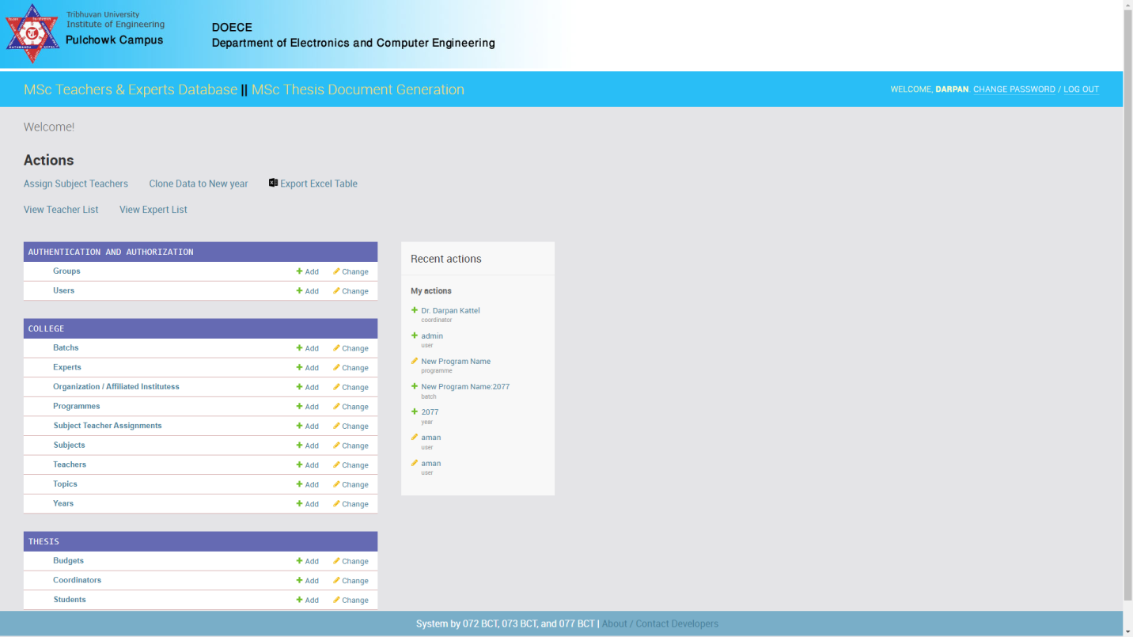

b. Thesis Document Generation Interface:

It contains three link with one add student button; proposal, mid term and final.

