Payloads
The following payload options are available on board the Aerial Vehicle. Payloads is used in various configurations as per user’s preference.
- Luneburg Lens
- Smoke Flare
- Infra-Red Flares
- Radar Altimeter
- Acoustic Miss Distance Indicator (AMDI)

Luneburg Lens
The Luneburg Lens is a passive radar augmentation device used to increase the radar reflectivity of the Aerial Vehicle without the use of additional energy. The Luneburg lens consists of concentric shells of polystyrene with varying reflective indices (dielectric constants) from 1 to 2, the highest refractive index being the innermost shell. A ray passing through the various concentric shell will bend towards the normal and then focus at a point. If a metal reflector is placed around the focal point, the ray gets reflected and retraces the same path. Refer Figure 2-6.
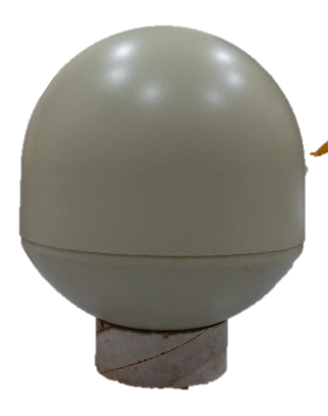
Figure 2-6: Luneburg Lens
ICN-AVS-A-041055-1-1671Y-00154-A-001-04

Refer Table 2-3 for specifications of Luneburg Lens.
Table 2-3: Specifications of Luneburg Lens
Sl. No. | Attribute | Value
 | Diameter | 7 inches
 | RADAR Cross Section (RCS) | > 5.5 m2 at 10 GHz
 | Frequency | 8 GHz to 10 GHz
 | View Angle | 100 degrees
 | Polarization | Rectilinear
 | Weight | 1.5 kg
 | Type | Monostatic

Smoke Flares
Smoke flares are used for visual augmentation to ensure realistic and cost effective acquisition.
Refer Table 2-4 for specifications of Smoke Flares.
Table 2-4: Specifications of Smoke Flares
Sl. No. | Attribute | Value
 | Burn time | > 50 s
 | Colour | Orange
 | Dimensions (L x D) | 120 mm x 60 mm
 | Weight | < 250 grams
 | Operational Temperature range | 5 ℃ to 40 ℃
 | Storage Temperature range | 0 ℃ to 55 ℃
 | UN Class | 432
 | Hazard Class | 1.4 S

IR Flares
The Infra-Red (IR) flare is used for IR augmentation for tracking the Aerial Vehicle. It is mounted on the wingtips. Each wing tip carries up to two IR flares. The trigger provision is provided through the on-board avionics.
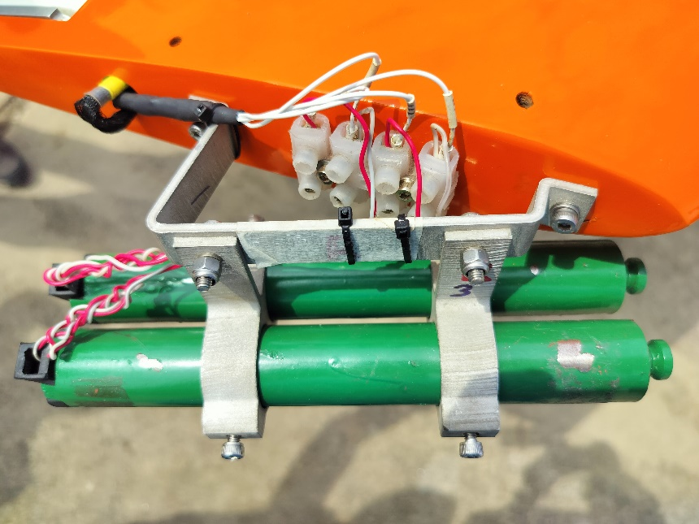
Figure 2-7: IR Flares
ICN-AVS-A-041056-1-1671Y-00154-A-001-04

Refer Table 2-5 for specifications of IR Flares.
Table 2-5: Specifications of IR Flares
Sl. No. | Attribute | Value
 | Output radiant intensity: | >700 W/Sr Over 2.9-5 micron band
 | Burn Time | > 55 seconds per unit
 | Dimensions (L x D) | 200 mm x 25.5 mm
 | Weight | 230 grams
 | Operational Temperature range | 5 ℃ to 45 ℃
 | Storage Temperature range | 0 ℃ to 55 ℃
 | UN Class | 0.0093
 | Hazard Class | 1.3 G

Acoustic Miss Distance Indicator (AMDI)
The Acoustic Miss Distance Indicator (AMDI) detects acoustically the shock wave generated by the passing supersonic projectile. The miss distance of target is determined by the amplitude of the shock wave while the angular position is determined from the hit order between different pressure sensors in the AMDI microphones. Raw data is sent directly to the Scoring Station where all the calculations are made. Scoring Station is located inside the Ground Control Station (GCS) trailer. Refer Figure 2-8 for Acoustic Miss Distance Indicator (AMDI).
Figure 2-8: Acoustic Miss Distance Indicator (AMDI)
ICN-AVS-A-041057-1-1671Y-00154-A-001-04

Refer Table 2-6 for specifications of IR Flares.
Table 2-6: Specifications of Acoustic Miss Distance Indicator (AMDI)
Sl. No. | Attribute | Value
 | General
 | Power supply | Rechargeable NiMH battery
 | Battery operation time | Min. 6 h at +25°C
 | Supply voltage | +12 VDC
 | Operation temperature | -30 °C to +55 °C
 | Storage temperature | -40 °C to +70 °C
 | Total weight | Approx. 1.85 kg
 | Data
 | Scoring capacity | 6000 rounds per minute
 | Scoring caliber | 5.56 mm to 5"+ and missiles
 | Angular accuracy | 15 deg
 | Sensitivity | 6 selectable ranges
 | Transmitter
 | Carrier frequency | 400-470 MHz
 | Channel separation | 50 kHz
 | Radiated power | Min 0.8 W

RADAR Altimeter
RADAR Altimeter measures altitude above the terrain beneath the aircraft. It calculates the time taken by beam to travel to ground, reflect and return to source.
Refer Figure 2-9 for detailed view of RADAR Altimeter.
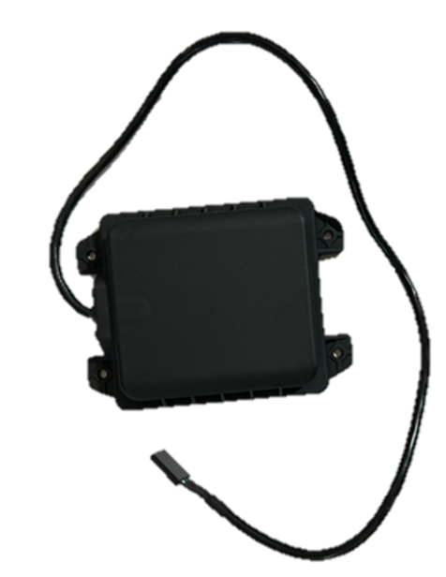
Figure 2-9: RADAR Altimeter
ICN-AVS-A-041058-1-1671Y-00154-A-001-04

Refer Table 2-7 for specifications of RADAR Altimeter.
Table 2-7: Specifications of RADAR Altimeter
Sl. No. | Attribute | Value
 | Frequency | 2.4 GHz
 | Radiation lobe | ±90⁰ (roll) ±90⁰ (pitch)
 | Minimum measurable distance | 0 ft
 | Maximum measurable distance | 500 ft
 | Bandwidth | 83.5 MHz
 | Measurement update | 112 Hz
 | Environmental conditions | -20 ℃ to +65 ℃
 | Dimensions (L x W x H) | 130 mm x 72 mm x 42 mm
 | Weight | 400 g

