GCS Software
The MEAT is intended to simulate an aerial target to be used for firing exercises. It is controlled and monitored using GCS Software.
The GCS software has screens available which are explained in succeeding sections.

Mission View
Refer Figure 2-31 for default screen. The main screen consists of following sections.
- Title Bar
- UAV Mission Area
- UAV Information Display and Control Area (2)
- Alert Messages & Logs
- System Control
- Tabs Bar
- Mode control drawer

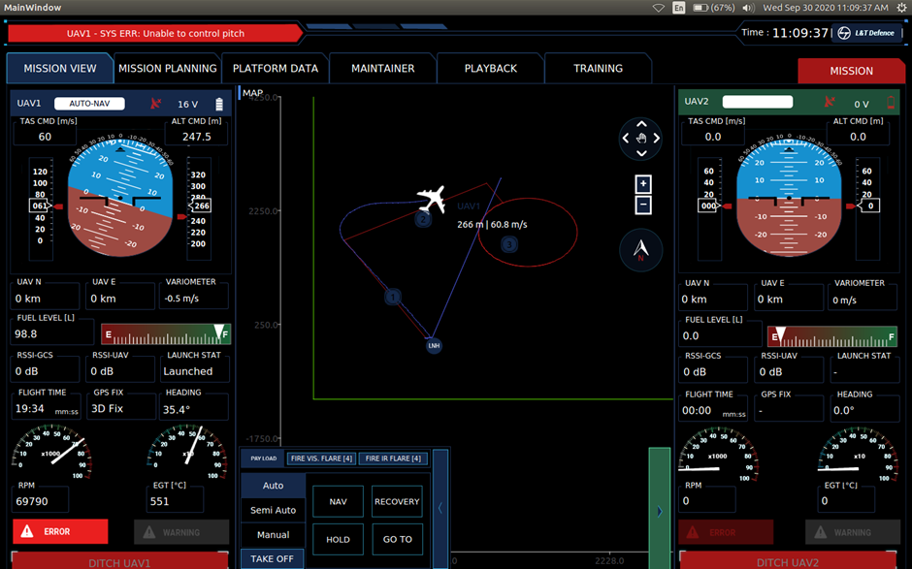
Figure 2-31: Mission View
ICN-AVS-A-041016-1-1671Y-00154-A-001-04

Title Bar
Refer Figure 2-32 for detailed view of title bar.
Figure 2-32: Title Bar
ICN-AVS-A-041017-1-1671Y-00154-A-001-04

The title bar is common across all screens. It shows the latest warning / errors in red on the left, the current time in HH: MM:SS, the L&T Defence logo and below the logo the version number of GCS and FCC.

UAV Mission Area
Refer Figure 2-33 detailed view of UAV Mission Area.
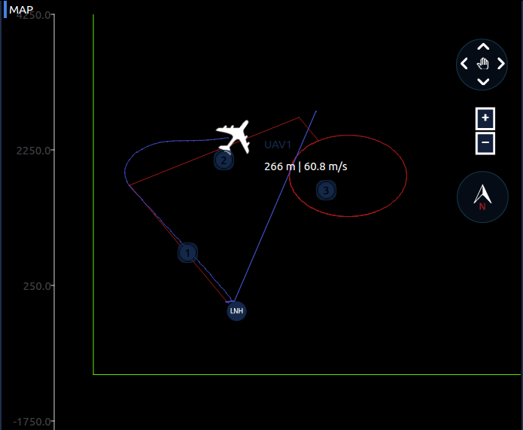
Figure 2-33: UAV Mission Area
ICN-AVS-A-041018-1-1671Y-00154-A-001-04

The UAV Mission area shows the movement of two (02) UAVs, their waypoints, flight plans and projected paths. The UAVs also have moving text associated with them, which displays UAV ID, altitude and airspeed of the UAV. Controls to pan and zoom are available on right. A scale for distance is visible in the bottom right. A compass is visible in bottom right third to represent true north. All the waypoints are colour-coded according to the respective UAV.

UAV Information Display and Control Area
Refer Figure 2-34 for detailed view of UAV information Display and Control Area.

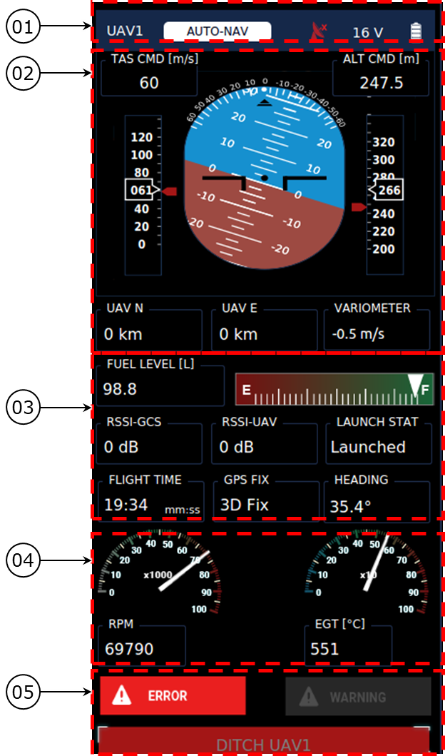
Figure 2-34: UAV Information Display and Control Area
ICN-AVS-A-041019-1-1671Y-00154-A-001-04

Refer Table 2-9 for detailed description of UAV information Display and Control Area.
Table 2-9: Description of UAV Information Display and Control Area
Ref. No. | Description
01 | This section displays UAV ID, System Mode and Sub-Mode of UAV, Datalink Status.
02 | This section displays Northing and Easting of UAV.
03 | This section displays Artificial Horizon to indicate roll, pitch, heading Sidebars to indicate commanded and actual airspeed and altitude.
04 | This section indicates fuel level in litres and its graphical representation, datalink signal strength, launch status, flight time, GPS fix status and heading.
05 | This section displays Engine Parameters – Engine Temperature, RPM.
The UAV Information Display and Control Area has two copies, one on the right and the other on the left; each corresponds to one of the two UAVs. All the information on respective UAV’s display area is colour-coded. Both these areas remain common across all screens. Buttons in this area become disabled during Playback of recorded data.

System Control
Refer Figure 2-35 for detailed view of System Control area. The system control area is available on main screen and during simulation.
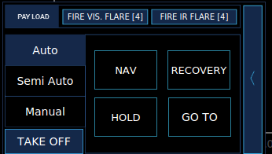
Figure 2-35: System Controls
ICN-AVS-A-041020-1-1671Y-00154-A-001-04

The system control area is available in main screen and during simulation. The left tabs allow user to select between system modes. The buttons to enter the sub modes available in Auto mode are shown on the left. More detailed menus are available as user selects each mode of operation. IR and visual flares can also be fired by pressing the respective buttons available on the top area.

Tab Bars
Refer Figure 2-36 for tab bar.
Figure 2-36: Tab Bar
ICN-AVS-A-041021-1-1671Y-00154-A-001-04

The tabs bar is common across all screens. It allows the user to switch between the other screens. Platform Data Screen shows all the platform data for the UAVs at a glance. Mission Planning Screen is used for flight plan creation and editing. Maintainer Screen is used for editing gains of the control system. Playback Screen is used to replay logged data. Training Screen is used to run simulations with the UAVs.

Mission Planning
Refer Figure 2-37 for mission planning screen. The screen is accessed by selecting mission planning from Tabs Bar. The mission planning screen consists of below mentioned sections.
- Title Bar
- UAV Mission Area
- Mission Planning
- UAV Information Display and Control Area (2)
- Tabs Bar
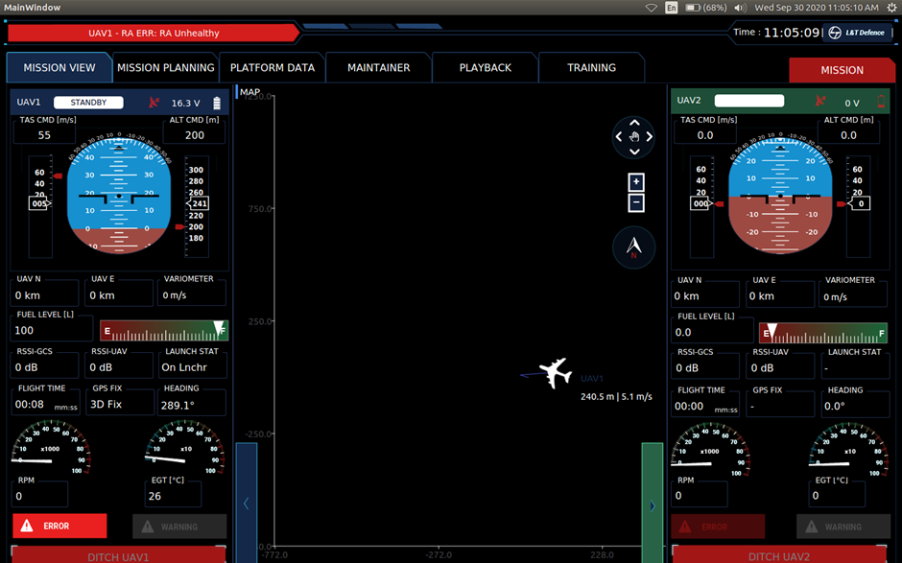
Figure 2-37: Mission Planning
ICN-AVS-A-041022-1-1671Y-00154-A-001-04

The UAV Mission area shows only expected flight paths and trajectories. The list on the left of the Navigation Setup area allows selection and editing of individual waypoints. The text fields on the right of the Mission Planning area can be used to create new waypoints. The buttons are used to save the flight plan thus created, and to transmit the same to the UAVs.

Platform Data Screen
Refer Figure 2-38 for platform data screen. It is accessed by selecting Platform Data from the Tabs Bar. The platform data screen consists of the following sections.
- Title Bar
- Platform Data Area
- Tabs Bar
The platform data shows all relevant data from all the sub-systems of the UAV. It also allows diagnostics and pre-flight checks to be performed.

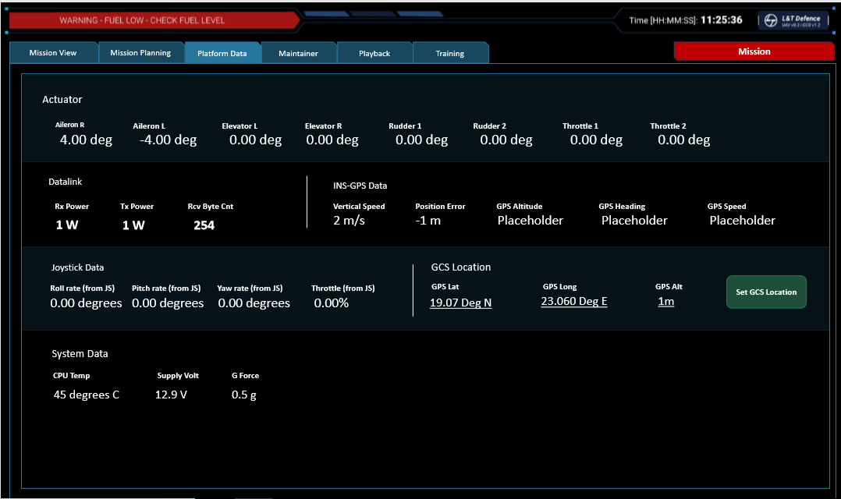
Figure 2-38: Platform Data Screen
ICN-AVS-A-041023-1-1671Y-00154-A-001-04

Control
Refer Figure 2-39 for detailed view of Control Data Screen.
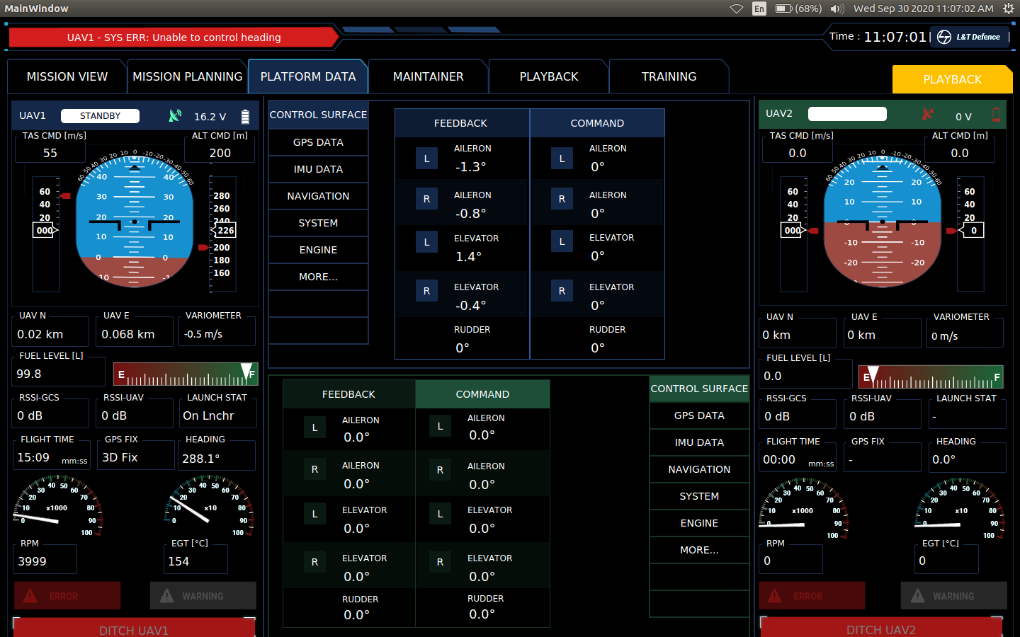
Figure 2-39: Control Data Screen
ICN-AVS-A-041024-1-1671Y-00154-A-001-04

Engine
Refer Figure 2-40 for detailed view of Engine Data Screen.
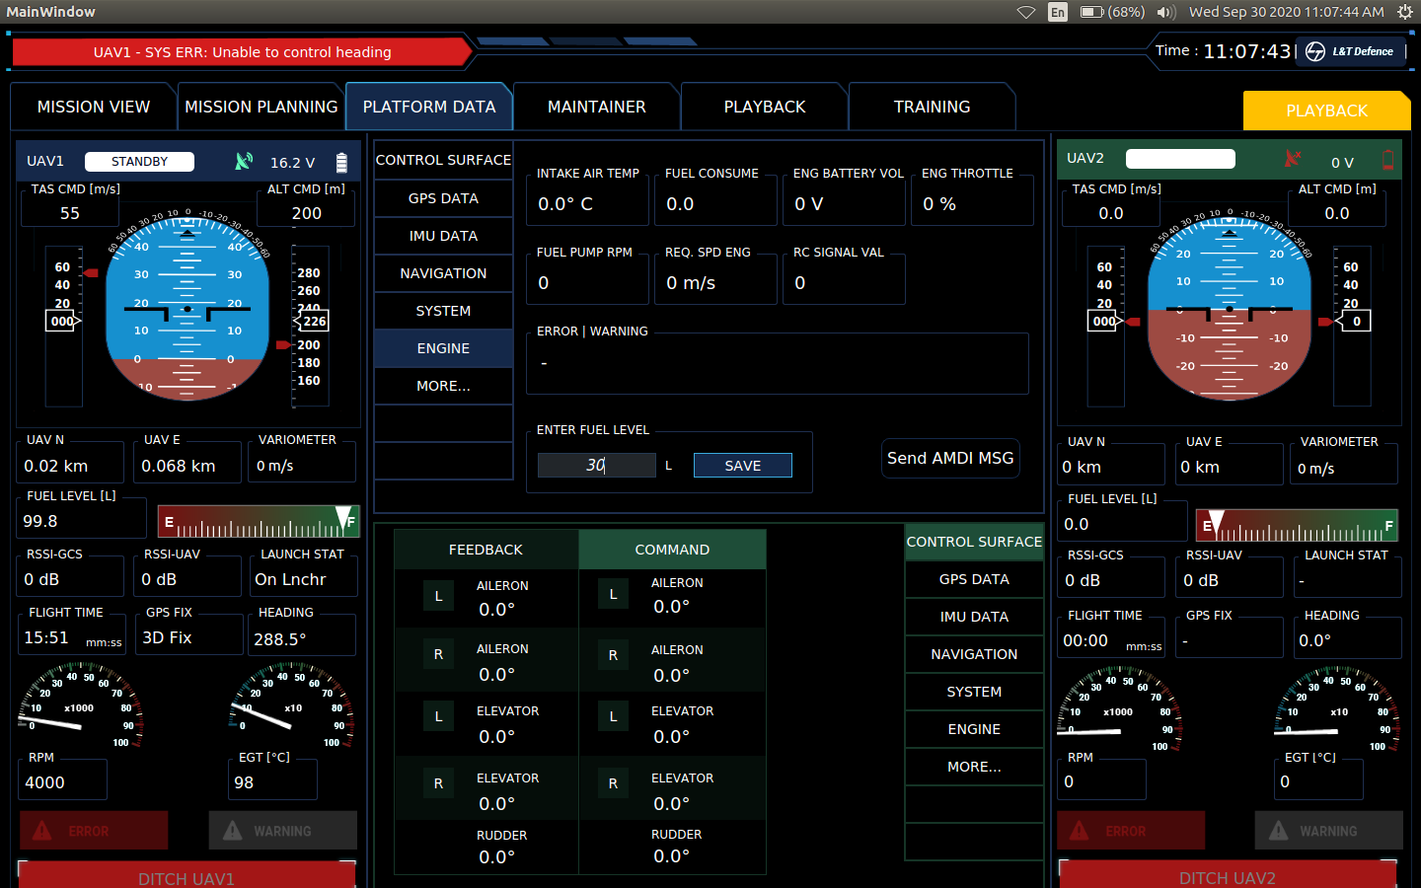
Figure 2-40: Engine Data Screen
ICN-AVS-A-041026-1-1671Y-00154-A-001-04

GPS Data Screen
Refer Figure 2-41for detailed view of GPS Data Screen.
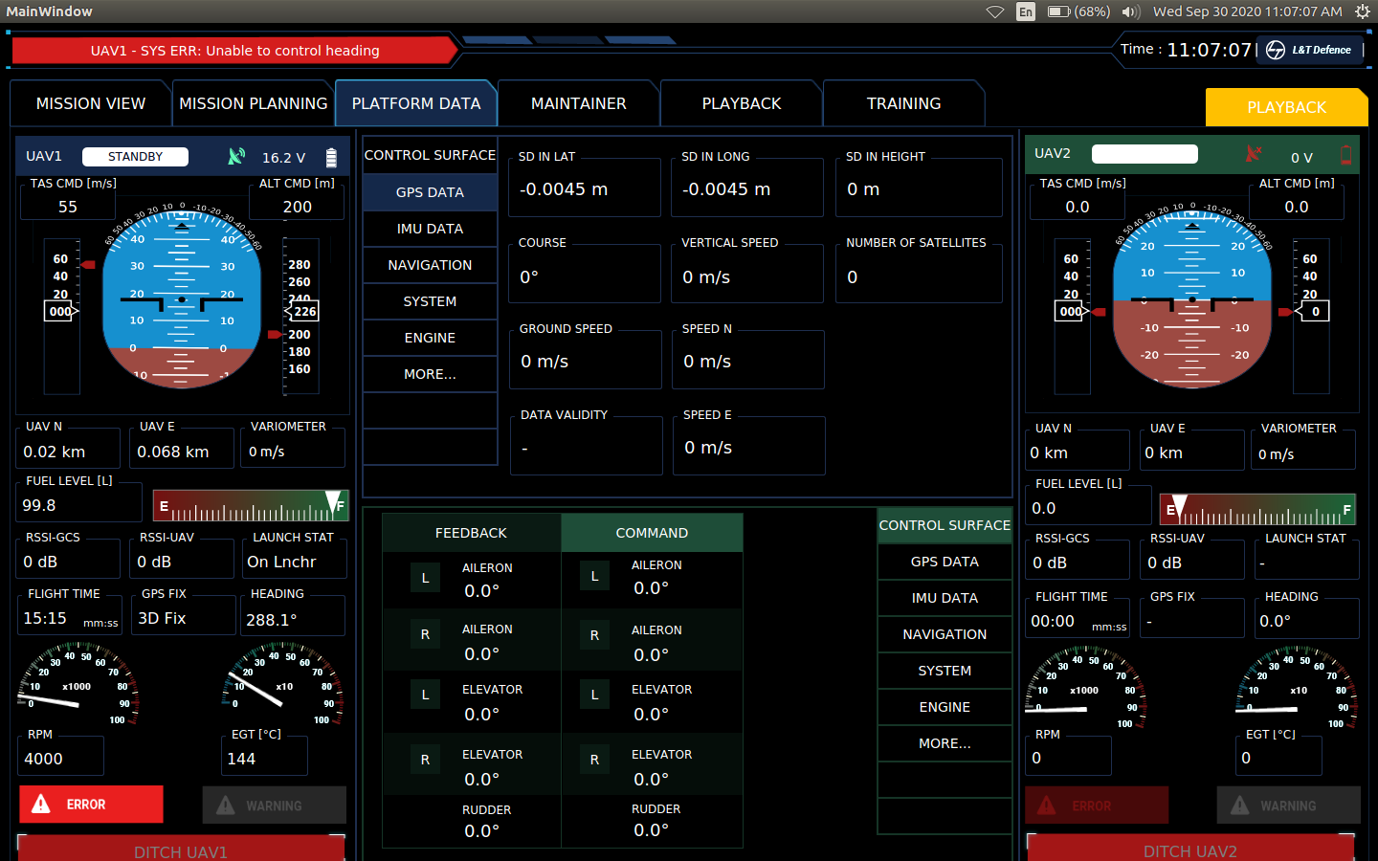
Figure 2-41: GPS Data Screen
ICN-AVS-A-041027-1-1671Y-00154-A-001-04

IMU
Refer Figure 2-42 for detailed view of IMU Data Screen.
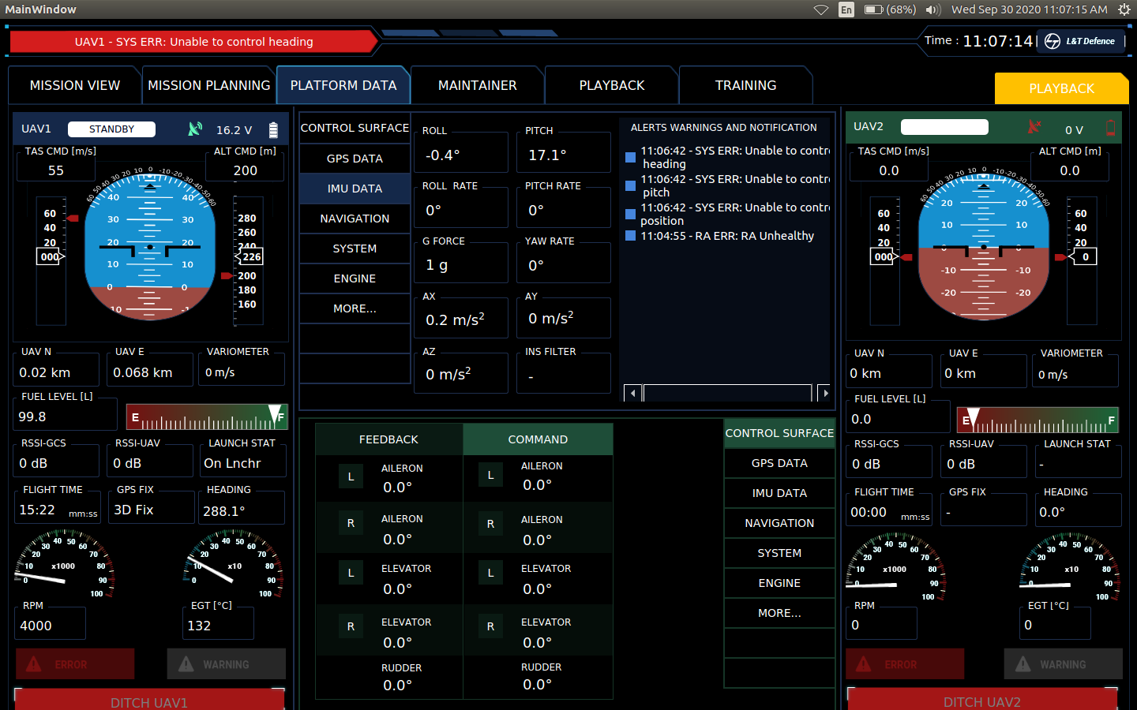
Figure 2-42: IMU Data Screen
ICN-AVS-A-041028-1-1671Y-00154-A-001-04

Navigation
Refer Figure 2-43 for detailed view of Navigation Data Screen.
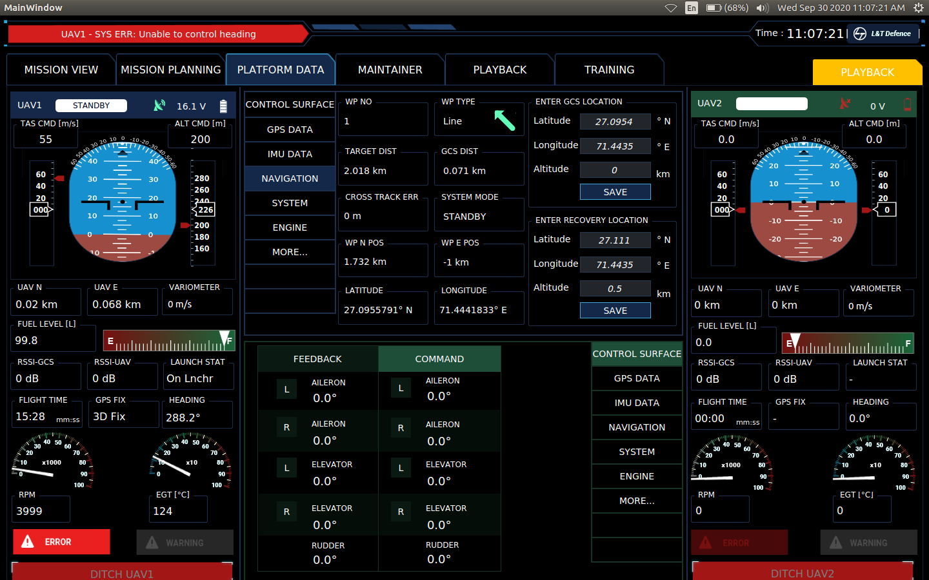
Figure 2-43: Navigation Data Screen
ICN-AVS-A-041029-1-1671Y-00154-A-001-04

System
Refer Figure 2-44 for detailed view of System Data Screen.
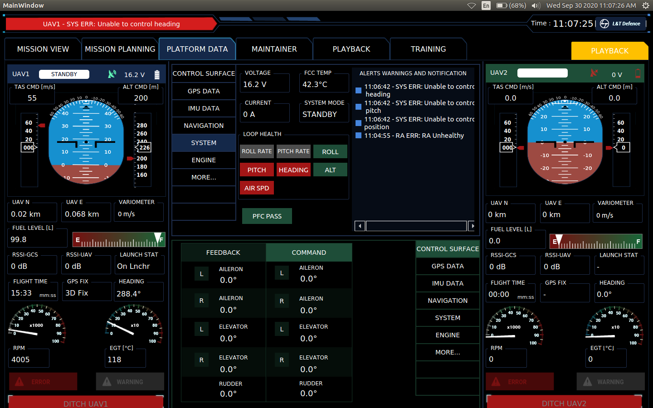
Figure 2-44: System Data Screen
ICN-AVS-A-041030-1-1671Y-00154-A-001-04

More
Refer Figure 2-45 for detailed view of More Data Screen.
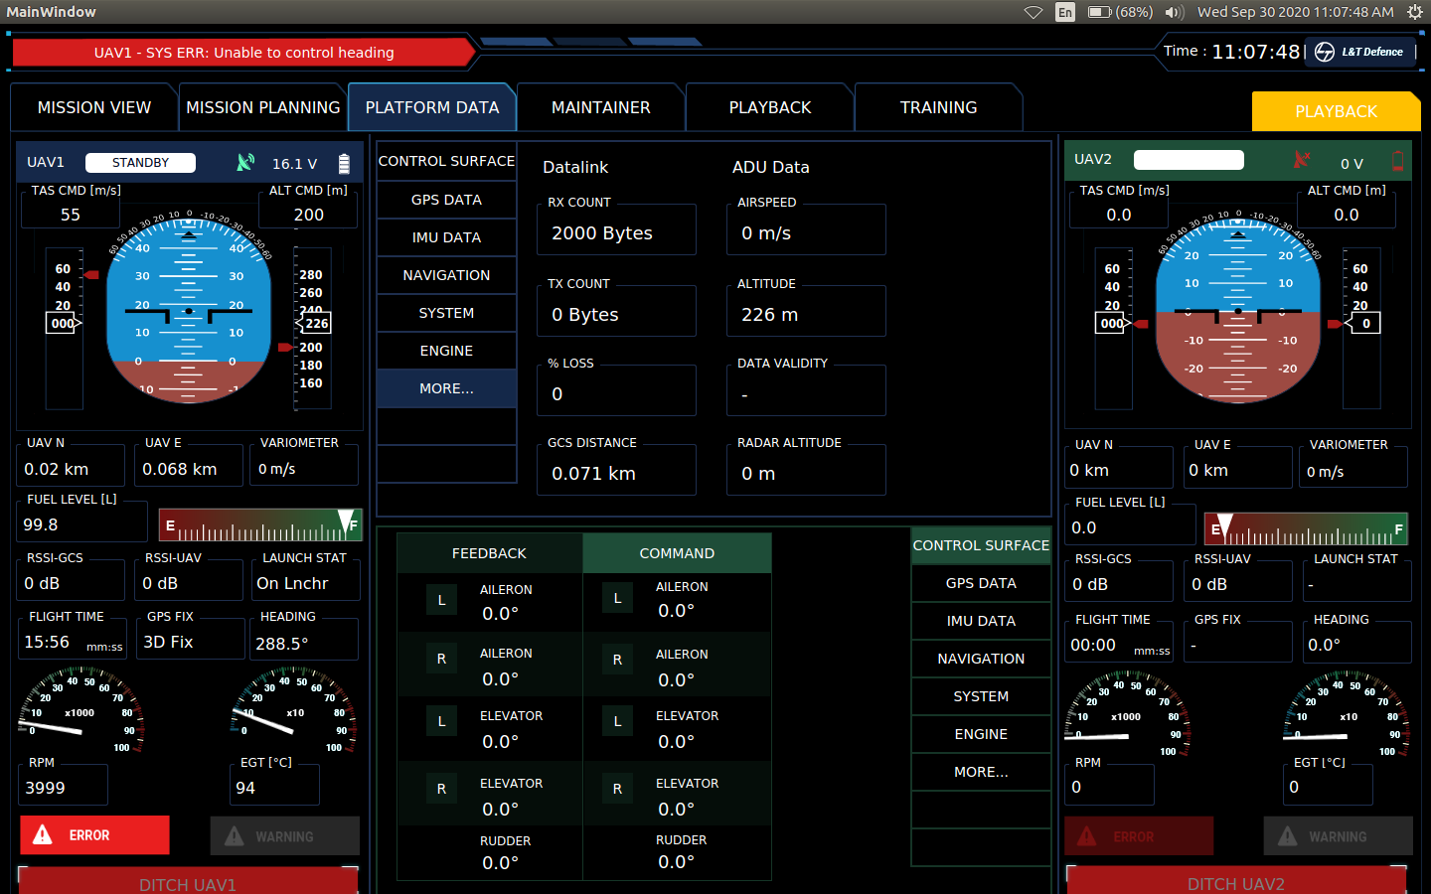
Figure 2-45: More Data Screen
ICN-AVS-A-041031-1-1671Y-00154-A-001-04

Playback Screen
Refer Figure 2-46 for playback screen. It is accessed by selecting Playback from the Tabs Bar. The playback screen consists of the following sections:
- Title Bar
- UAV Mission Area
- Playback Options Area
- UAV Information Display and Control Area (2)
- Tabs Bar
The list on the left of the Playback Options area allows selection of individual log files. The buttons on the right of the Playback Options area are used to play, pause, speed up or slow down the playback and a slider to skip to the required location in the playback file. When a playback is in progress, the bar on the top right, shows GCS mode to be in Playback in yellow.
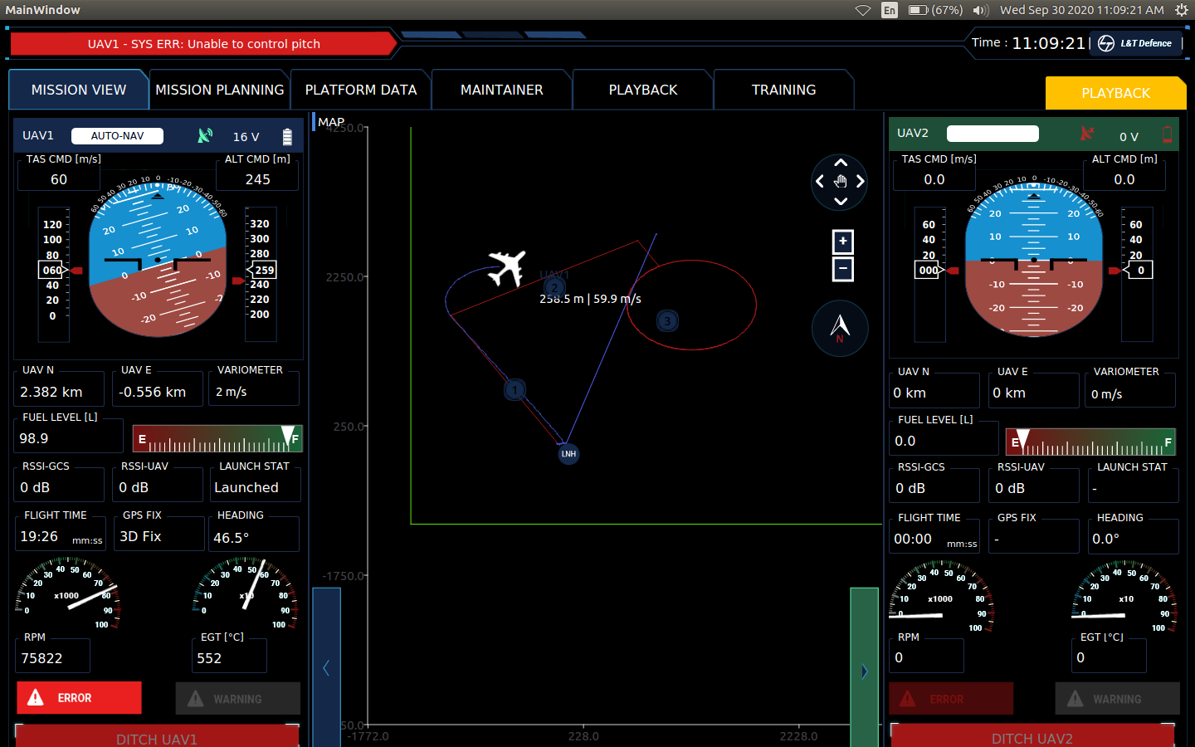
Figure 2-46: Playback Screen
ICN-AVS-A-041032-1-1671Y-00154-A-001-04

Training Screen
Refer Figure 2-47 for detailed view of training screen.
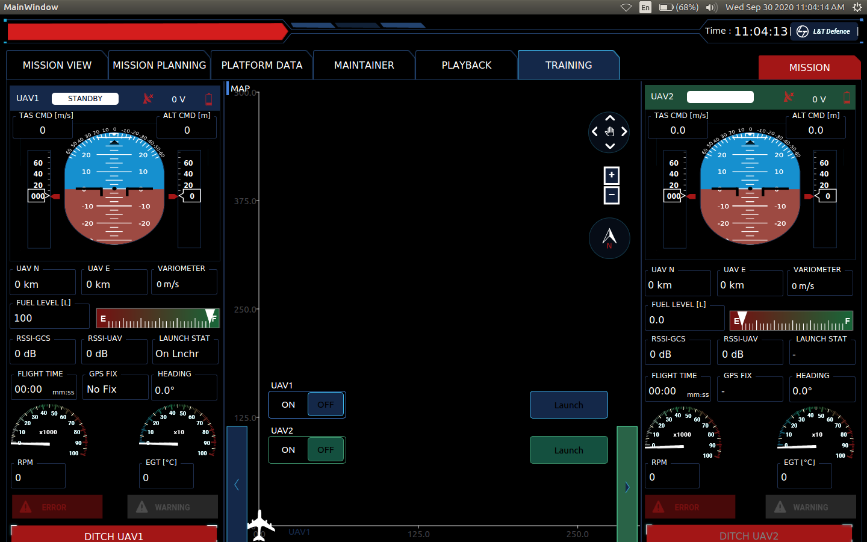
Figure 2-47: Training Screen
ICN-AVS-A-041033-1-1671Y-00154-A-001-04

The training screen consists of the following sections:
- Title Bar
- UAV Mission Area
- UAV Information Display and Control Area (2)
- Alert Messages and Logs
- System Control
- Tabs Bar
In this screen, the two UAVs are simulated internal to the GCS. A checkbox at the bottom left of the UAV Mission area selects whether to activate Training Mode. If it is checked, then the GCS enters into Training Mode. A green text “TRAINING” flashing on the top right indicates that Training Mode is active. All the other functionality remains same as in Mission View screen.

