Punctual Sarkar

Introduction:

According to a survey, 75% of general public believe that the government employees fail to report on time. There is a dire need to keep a check on government employees in this developing age.

Problem statement:

Records of daily visits

Avoiding proxies & faking presence

Absence leading to disorder & numerous health issues

Incentives for disciplined employees

Notice to all in real-time

Procedures:

An administrator would be the invigilator who would monitor the day-to-day activities of the employees including their location along with time stamp. An employee and a host would be the active members of the proposed project. Both of which would be provided an account which they would use to mark their presence at the required location and time. This would be successfully functioned with the help of QR code system which would be integrated and provide a secure base for the information.

Results:

If implemented the following would be the results:

- A database of everyday whereabouts

-Elimination of late attendees

-A real-time updates of employees whereabouts

-No case of proxies

Conclusion:

Herewith we have successfully made a web app that can be used in mobiles too, so that it can be implemented over a mass of population without any case of negligence of duties.

Snapshot:

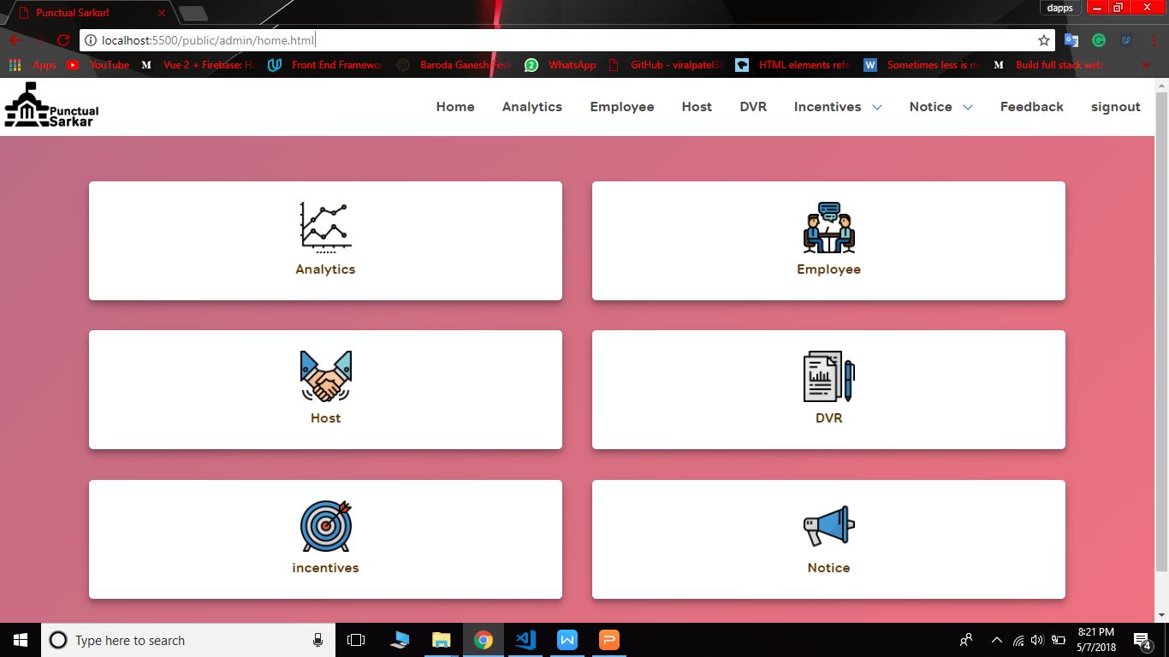

Admin Panel

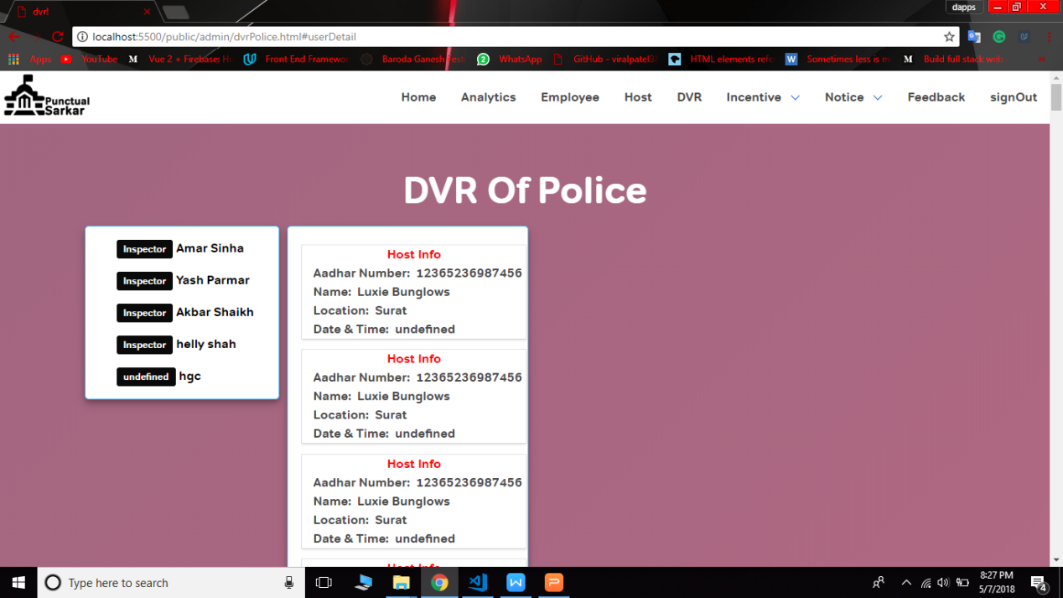

Daily Visit Report

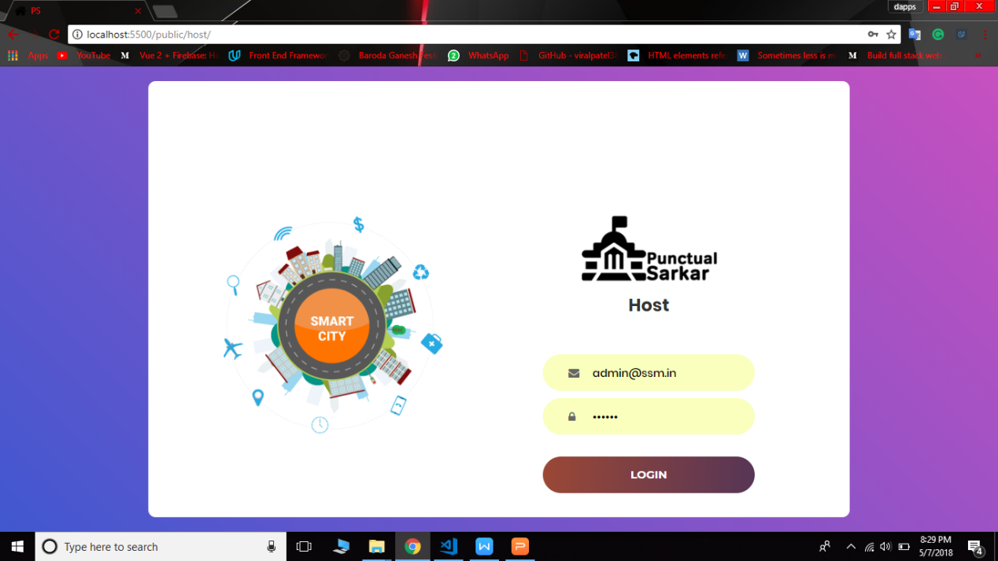

Host Login Page

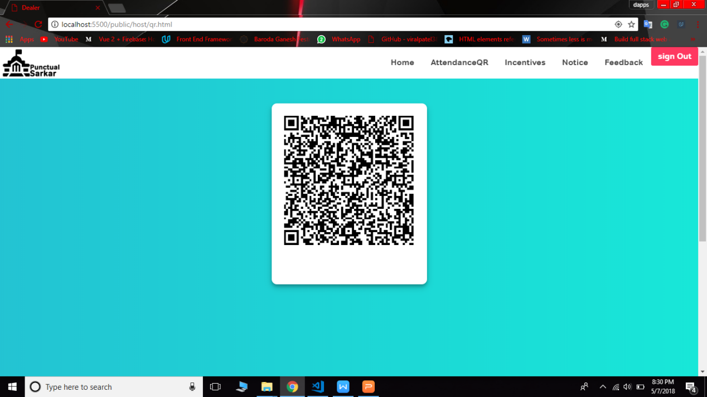

Dynamic QR Generator