Week 3: Levy process models for financial returns
A conceptual guide: the Laplace, Variance-Gamma (VG) and Normal Inverse Gaussian (NIG)
1. Where Week 2 left off
Week 2 fitted the Gaussian distribution and the Student-t distribution to 6,287 daily log-returns on the S&P 500 (Standard and Poor's 500 Index, a market-capitalisation-weighted index of the 500 largest publicly traded companies in the United States) from January 2000 to December 2024. The Student-t gave nu-hat (the fitted degrees-of-freedom parameter, which controls how heavy the tails of the distribution are; smaller values mean fatter tails and a higher probability of extreme returns) = 2.648. The 99% Expected Shortfall (ES, the average loss on the worst 1% of days, the risk metric mandated by the Basel Committee on Banking Supervision under the Fundamental Review of the Trading Book, BCBS 2013, commonly abbreviated FRTB) was -5.81% under the Student-t against -3.24% under the Gaussian. A bank using the Gaussian to set capital under FRTB rules would hold 44% too little.
But the Student-t has a hard constraint it cannot get around: it is symmetric. Both tails must always be equal. Daily equity returns are not symmetric. Large losses happen more often than large gains of the same size. This is called negative skewness, the tendency for a distribution to have a longer or heavier left tail than right tail. The Student-t forces the tails to mirror each other regardless of the data. The two models introduced this week, the Variance-Gamma (VG) and the Normal Inverse Gaussian (NIG), remove that constraint. Each has a dedicated asymmetry parameter that lets the left tail be heavier than the right independently of how heavy the tails are overall.
There is a second issue with the Student-t. It ties all tail behaviour to a single parameter nu (degrees of freedom), which simultaneously controls how heavy the tails are and, because of the symmetry constraint, forces the same heaviness on both sides. VG and NIG separate these. Each has distinct parameters for scale (how spread out the distribution is), tail heaviness (how much probability sits in the extreme tails), and asymmetry (which tail is heavier). That separation makes their estimates economically interpretable in a way a single nu is not.
2. What a Levy process is
A Levy process is a continuous-time stochastic process, meaning a mathematical object that describes how something evolves randomly over time, with two defining properties. First, its increments are stationary: the distribution of changes over any interval of length t is the same regardless of when that interval starts. Second, its increments are independent: what happened in the past has no bearing on what happens next. Brownian motion, the continuous random process underlying the Gaussian model, is the simplest Levy process. VG and NIG are also Levy processes, but they allow for infinitely many small jumps per unit time, which is what produces heavier tails than Brownian motion alone.
Both VG and NIG belong to the class of Normal Variance-Mean Mixtures. The idea is that returns are still conditionally Gaussian (that is, if you knew the variance in advance, they would be normally distributed), but the variance and mean of that conditional Gaussian are themselves random variables drawn from a mixing distribution. Integrating out the mixing variable produces a heavy-tailed, potentially asymmetric marginal distribution. VG uses a Gamma distribution as its mixing distribution. NIG uses an Inverse Gaussian distribution. The Gamma distribution is a two-parameter family of continuous distributions on the positive real line, commonly used to model waiting times. The Inverse Gaussian distribution is the distribution of the first time a Brownian motion with drift reaches a fixed positive level; it also lives on the positive real line and has heavier tails than the Gamma. That extra tail weight in the mixing distribution is why NIG fits the S&P 500 returns better than VG. The mathematics works out to a closed-form probability density function (PDF), meaning an explicit formula that can be written down and evaluated numerically, making Maximum Likelihood Estimation (MLE), which is the process of finding the parameter values that make the observed data most probable, directly feasible.
3. The Laplace distribution: the simplest heavy-tailed step
Before the two Levy models, it is worth fitting the simplest distribution that improves on the Gaussian: the Laplace, also called the double-exponential. This was suggested by Neil, and it turns out to be one of the most informative single steps in the whole comparison. The Laplace density is f(x) = exp(-|x - mu| / b) / (2b), where mu is a location parameter and b is a scale parameter (both with the same roles as in the Gaussian). The defining feature is the absolute value |x - mu| in the exponent, in place of the Gaussian's squared term (x - mu)^2. That single change is what creates heavy tails: the Gaussian density dies off like exp(-x^2), extremely fast, whereas the Laplace dies off like exp(-|x|), much more slowly. The Laplace is literally two exponential distributions placed back to back, one decaying to the right of mu and one to the left.
The Laplace has exactly two parameters, the same count as the Gaussian, but its excess kurtosis (a measure of tail-heaviness; zero for the Gaussian) is exactly 3, meaning genuinely fatter tails. It is a fair like-for-like test of one idea in isolation: keep the model as simple as the Gaussian, change only the tail decay from quadratic to linear, and see how much of the gap to the data that closes. The answer (Section 7) is: most of it.
Why it belongs with the Levy models
The Laplace is not just a convenient benchmark; it is a special case of the Variance-Gamma distribution introduced in the next section. The VG is built by running a Brownian motion on a random Gamma clock with variance rate nu and drift theta. When that clock has unit shape (which corresponds to nu = 1) the Gamma distribution becomes an Exponential distribution, and when the drift theta = 0 the construction is symmetric. Under those two restrictions, VG(mu, sigma, theta = 0, nu = 1) is exactly a Laplace distribution. So the Laplace is the symmetric, single-parameter-clock corner of the VG family. Fitting it first means that when the full VG is fitted afterwards, the extra log-likelihood it earns can be read directly as the value of freeing those two restrictions (asymmetry through theta, and a more variable clock through nu).
Fitting it
The Laplace is the one model here with a fully closed-form MLE (Maximum Likelihood Estimate), needing no numerical optimiser at all. The likelihood is maximised by setting mu to the sample median (not the mean) and b to the mean absolute deviation of the returns about that median. The median appears because minimising a sum of absolute deviations, which is what the |x - mu| term in the log-likelihood demands, is solved by the median, just as minimising squared deviations in the Gaussian case is solved by the mean. The fitted values on the full sample are mu = +0.000602 and b = 0.008078, with standard errors of 0.000102 on each (for the Laplace both standard errors equal b / sqrt(n)).
4. The Variance-Gamma distribution
The random-time intuition
The cleanest way to understand VG is through the random-time construction from Madan, Carr and Chang (1998). Start with an ordinary Brownian motion with drift theta (the asymmetry parameter, which controls how much the process trends up or down between time-change events; negative theta produces left skew, meaning losses are more likely than gains of the same size) and volatility sigma (the scale parameter, which controls the width of the distribution contributed by the Brownian component alone). Now replace calendar time t with a random Gamma clock G(t).
Instead of time passing at a steady rate, it passes faster on some days and slower on others. Think of it as market activity being uneven: on a quiet day, very little information arrives and prices barely move; on a busy day, news floods in and prices shift sharply. The Gamma clock G(t) captures this by having mean t, so on average the clock runs at the right speed, and variance nu times t, where nu is the variance rate of the Gamma time-change (the parameter that controls how much the clock fluctuates around its mean). Large nu means the clock is highly erratic, which produces heavy tails in the resulting return distribution because occasionally the clock runs very fast and prices make large moves. When nu = 0, the clock is deterministic and VG collapses to the Gaussian. The return over one period is X = theta times G plus sigma times W(G), where W is standard Brownian motion.
The four parameters
mu is the location parameter. It shifts the whole distribution left or right without changing any other property. The full-sample MLE estimate is mu = +0.000907. This is the average daily log-return after the asymmetry and other parameters have been accounted for.
sigma is the scale parameter, the volatility of the underlying Brownian motion. The full-sample MLE estimate is sigma = 0.011627. This is smaller than the raw standard deviation of returns (0.012234) because sigma only captures the Brownian diffusion component; the random Gamma time-change adds additional spread on top.
theta is the asymmetry parameter, the drift of the underlying Brownian motion between events in the Gamma clock. Negative theta means the process trends slightly downward between clock ticks, producing a left-skewed return distribution. The full-sample MLE estimate theta = -0.000684 is negative and statistically significant, confirming that left skew is present in S&P 500 daily returns.
nu is the variance rate of the Gamma time-change. It controls tail heaviness by determining how erratic the clock is. Larger nu means the clock fluctuates more, which produces heavier tails. The full-sample MLE estimate nu = 1.173 means the Gamma clock has variance roughly equal to its mean, which is substantial clock randomness. In the Global Financial Crisis (GFC, the period from approximately October 2007 to March 2009 when the collapse of mortgage-backed securities triggered a near-failure of the global banking system) sub-period, nu = 1.248; in COVID-19 (the market shock of February to June 2020 caused by the global pandemic), nu = 1.439. Both are noticeably higher than in the dot-com crash (nu = 0.397) or the Federal Reserve rate-hike cycle (nu = 0.493), confirming that GFC and COVID produced fundamentally heavier-tailed return distributions.
The mathematics
The VG PDF, derived by integrating out the Gamma mixing variable, is (Madan, Carr, Chang 1998, equation 2):
f(x; mu, sigma, theta, nu) = 2 * exp(theta*(x-mu)/sigma^2) / [sigma*sqrt(2*pi) * nu^(1/nu) * Gamma(1/nu)] * (|x-mu| / omega)^(1/nu - 1/2) * K_{1/nu - 1/2}(omega*|x-mu|/sigma^2)
where omega = sqrt(2*sigma^2/nu + theta^2), Gamma(.) is the gamma function (a generalisation of the factorial to non-integer arguments), and K_v is the modified Bessel function of the second kind of order v. The Bessel function K_v is a standard mathematical function that appears naturally when solving certain differential equations; here it arises because the Gamma-Normal integral produces it analytically. For large |x-mu|, K_v(z) decays as sqrt(pi/(2z))*exp(-z), so the tails die exponentially but more slowly than the Gaussian's exp(-x^2) decay. This slower decay is what produces the heavier tails. Numerically, K_v(z) can underflow to floating-point zero for large z; the implementation uses the exponentially scaled version kve(v,z) = K_v(z)*exp(z) to prevent this.
The VG mean is mu + theta. The variance is sigma^2 + theta^2 * nu. The second term, theta^2 * nu, shows how the random time-change adds variance on top of the Brownian diffusion. Both terms contribute to the total spread; only the time-change term produces the heavy tails.
5. The Normal Inverse Gaussian distribution
The mixing idea
NIG replaces the Gamma mixing distribution of VG with an Inverse Gaussian (IG) distribution. The IG distribution is the distribution of the first time a Brownian motion with drift reaches a fixed positive boundary. It lives on the positive real line, like the Gamma, but has heavier tails. Because the mixing distribution is heavier, the resulting return distribution is also heavier, which is why NIG fits the S&P 500 data better than VG.
The construction is: the return X given V follows a Normal distribution with mean mu + beta*V and variance V, where V is the random variance drawn from the IG mixing distribution. V has mean delta/gamma and variance delta/gamma^3. Here gamma = sqrt(alpha^2 - beta^2) is a derived quantity computed from the other parameters, not itself a free parameter. The mean of the conditional distribution is mu + beta*V. When beta is negative, large values of V push the mean downward and simultaneously widen the distribution, amplifying the left tail. This joint effect on mean and variance is what produces the asymmetry.
The four parameters
mu is the location parameter. It shifts the distribution left or right. The full-sample MLE estimate mu = +0.001111 captures the average daily log-return after the asymmetry and tail parameters have been accounted for.
alpha is the tail-heaviness parameter. Larger alpha means lighter tails; as alpha approaches infinity the NIG distribution approaches the Gaussian. Smaller alpha means heavier tails. Values in the range 20 to 60 indicate genuinely heavy-tailed behaviour that is materially different from the Gaussian. The full-sample MLE estimate alpha = 52.3 sits in that range. During the GFC (alpha = 25.9) and COVID-19 (alpha = 17.8), alpha falls sharply, showing the distribution shifting deep into heavy-tail territory. During the dot-com crash (alpha = 98.6) and the Fed rate-hike cycle (alpha = 111.9), alpha is near the Gaussian regime.
beta is the asymmetry parameter. It must satisfy the constraint alpha > |beta|, meaning the absolute value of beta must be smaller than alpha, to ensure the distribution is mathematically proper. Negative beta produces a left-skewed distribution, consistent with equity returns. The full-sample MLE estimate beta = -6.095 is negative and statistically significant. During the dot-com crash, beta = +10.04, an unusual positive value discussed in Section 9.
delta is the scale parameter, analogous to sigma in the Gaussian. It controls the overall spread of the distribution. The full-sample MLE estimate delta = 0.007574 is close to the Student-t scale estimate of 0.007077 from Week 2, which makes sense: both are scale parameters in heavy-tailed distributions fitted to the same data.
The mathematics
The NIG PDF is:
f(x; mu, alpha, beta, delta) = (alpha*delta / pi) * exp(delta*gamma + beta*(x-mu)) * K_1(alpha * sqrt(delta^2 + (x-mu)^2)) / sqrt(delta^2 + (x-mu)^2)
where gamma = sqrt(alpha^2 - beta^2) and K_1 is the modified Bessel function of the second kind of order 1. The Bessel argument is alpha*sqrt(delta^2 + (x-mu)^2), which grows linearly in |x-mu| for large departures from the centre. This gives the same exponential tail decay as VG but with different curvature near the peak.
The NIG mean is mu + delta*beta/gamma. The variance is delta*alpha^2/gamma^3. The skewness (a measure of asymmetry; negative values indicate a longer left tail) is 3*beta / (alpha*sqrt(delta*gamma)), confirming that negative beta produces negative skewness.
6. Fitting by Maximum Likelihood Estimation (MLE)
What MLE does
Maximum Likelihood Estimation (MLE) finds the parameter values that make the observed data as probable as possible under the assumed distribution. Formally, for n observed returns r_1, ..., r_n, the MLE solves: maximise the log-likelihood L(theta) = sum of log f(r_i; theta) over all i, where f is the PDF of the distribution and theta is the vector of parameters. The log-likelihood is used instead of the raw likelihood because sums are easier to work with numerically than products of very small numbers.
Why numerical optimisation is needed
For the Gaussian, MLE has closed-form solutions, meaning exact algebraic formulas: mu-hat (the MLE estimate of mu, the location parameter) equals the sample mean and sigma-hat (the MLE estimate of sigma, the scale parameter) equals the standard deviation of the data. The Laplace is also closed form, but with the median in place of the mean: mu-hat is the sample median and b-hat is the mean absolute deviation about it. VG and NIG have no such shortcuts. All four parameters must be optimised simultaneously over a four-dimensional parameter space. The implementation uses L-BFGS-B (Limited-memory Broyden-Fletcher-Goldfarb-Shanno with Bounds), a quasi-Newton numerical optimisation algorithm that approximates the curvature of the objective function from past gradient evaluations and supports box constraints, meaning upper and lower bounds on each parameter individually.
For VG, the constraints are sigma (scale) > 0 and nu (variance rate) > 0, both box constraints that L-BFGS-B handles directly. For NIG, the constraint alpha (tail-heaviness) > |beta| (absolute value of the asymmetry parameter) is a nonlinear constraint, meaning it cannot be expressed as a simple upper or lower bound on a single parameter. The solution is to reparametrise by defining xi = beta/alpha (the ratio of the asymmetry parameter to the tail-heaviness parameter). Whenever alpha > |beta|, xi lies in (-1, 1), so constraining xi to (-1, 1) is equivalent to enforcing the original constraint and is a box constraint that L-BFGS-B handles natively. The output converts xi back to beta using beta = xi * alpha.
Three starting points are tried for each model and the best result is kept. This guards against local optima, which are parameter values where the log-likelihood is higher than any nearby point but lower than the true global maximum. Standard errors are recovered from the observed Fisher Information matrix, which is the matrix of second derivatives of the negative log-likelihood at the MLE estimates. The Fisher Information matrix measures how sharply curved the likelihood surface is: a sharper peak means the parameters are more precisely identified and gives smaller standard errors. The Hessian (the matrix of second partial derivatives of the objective function with respect to the parameters) is approximated numerically using a four-point central-difference formula, and its inverse gives the asymptotic covariance matrix of the parameter estimates. The square roots of the diagonal entries of this matrix are the standard errors.
Risk measures by Monte Carlo simulation
Value at Risk (VaR) is the loss threshold exceeded on the worst alpha% of days. At the 99% confidence level, VaR is the loss exceeded on only 1% of days. Expected Shortfall (ES) is the average loss on those worst days. ES is the more informative capital metric because it describes the inside of the tail, not just its edge. VaR and ES have no closed-form expressions under VG or NIG since neither distribution has a closed-form cumulative distribution function (the function giving the probability that a return falls below a given value). They are therefore computed by Monte Carlo simulation: draw a large sample from the fitted distribution and take empirical quantiles.
Monte Carlo simulation is a technique for approximating quantities that cannot be computed analytically by generating a large number of random draws from the relevant distribution and averaging or taking percentiles over those draws. With 500,000 draws per model the Monte Carlo error on VaR and ES is well below one basis point (one hundredth of one percent). For VG, sampling uses the Gamma-Normal mixture directly: draw G from a Gamma distribution with shape parameter 1/nu and scale parameter nu (where nu is the variance rate of the time-change), then draw the return X from a Normal distribution with mean mu + theta*G and variance sigma^2*G. For NIG, draw V from an Inverse Gaussian distribution with mean delta/gamma and scale delta^2, then draw X from Normal(mu + beta*V, V).
7. What the data says
Model ranking
NIG is the best-fitting model. Its log-likelihood, the sum of log-PDF values evaluated at the fitted parameters over all 6,287 observations, is 19,691.7. The Student-t scores 19,666.7, VG scores 19,665.5, and the two-parameter Laplace scores 19,649.9. The Akaike Information Criterion (AIC = 2k minus 2 times the log-likelihood, where k is the number of free parameters) penalises model complexity to prevent simply rewarding the model with the most parameters. AIC is lower for better models. The AIC improvement of NIG over the Gaussian is 1,851 units. The Bayesian Information Criterion (BIC = k times log(n) minus 2 times the log-likelihood, where n is the number of observations) imposes a heavier penalty for extra parameters than AIC; NIG also leads on BIC.
The Laplace result is the one to dwell on. With only two parameters, the same count as the Gaussian, it improves AIC by 1,771 units, which is 96% of the 1,851-unit improvement that the four-parameter NIG achieves. On a per-parameter basis it is the most efficient model in the comparison. The lesson is that the single most important defect of the Gaussian is not its symmetry or its precise tail shape, but simply that its tails are far too thin. Replacing the quadratic exponent with a linear one, at no extra parameter cost, recovers almost all of the available gain. The richer models then refine what is left: the full VG adds 15.6 log-likelihood units over the Laplace by freeing theta and nu, and NIG adds more again through its heavier mixing distribution.
The Kolmogorov-Smirnov (KS) goodness-of-fit test provides a formal statistical test of whether the fitted distribution matches the data. The KS statistic D measures the maximum absolute difference between the empirical cumulative distribution function of the data and the fitted model's cumulative distribution function. Smaller D means better fit. NIG gives D = 0.0113 with p-value 0.40, meaning there is a 40% probability of observing a D this large by chance if NIG is the true model. NIG cannot be rejected at any standard significance level. VG also passes (p = 0.25). The Student-t (p = 0.030) and the Laplace (D = 0.0180, p = 0.034) are both borderline, and they tie almost exactly on the KS statistic, so a two-parameter symmetric model matches the three-parameter Student-t on this measure. The Gaussian fails badly (D = 0.094, p < 0.001).
VG with four parameters is slightly worse than the Student-t with three by AIC. This is a genuinely interesting result. The Gamma mixing distribution of VG captures a similar signal to the Student-t's nu (degrees-of-freedom) parameter but does not improve on it. NIG's Inverse Gaussian mixing distribution adds something extra because the IG is right-skewed; its variance V occasionally takes very large values, which simultaneously widens the conditional distribution and shifts its mean in the direction of beta. This joint effect amplifies the left tail of returns in a way the symmetric Gamma-based VG cannot replicate.
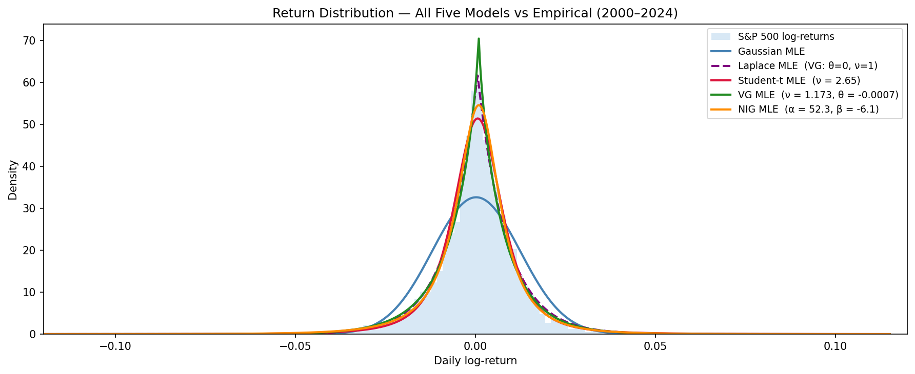
Figure 1. Histogram of S&P 500 daily log-returns (January 2000 to December 2024) with all five fitted PDFs overlaid. Gaussian (blue), Laplace (purple, dashed), Student-t (red), VG (green), NIG (orange). The four non-Gaussian models are visually close to each other and all substantially better than the Gaussian at the centre and in the tails; the Laplace and Student-t are nearly coincident.
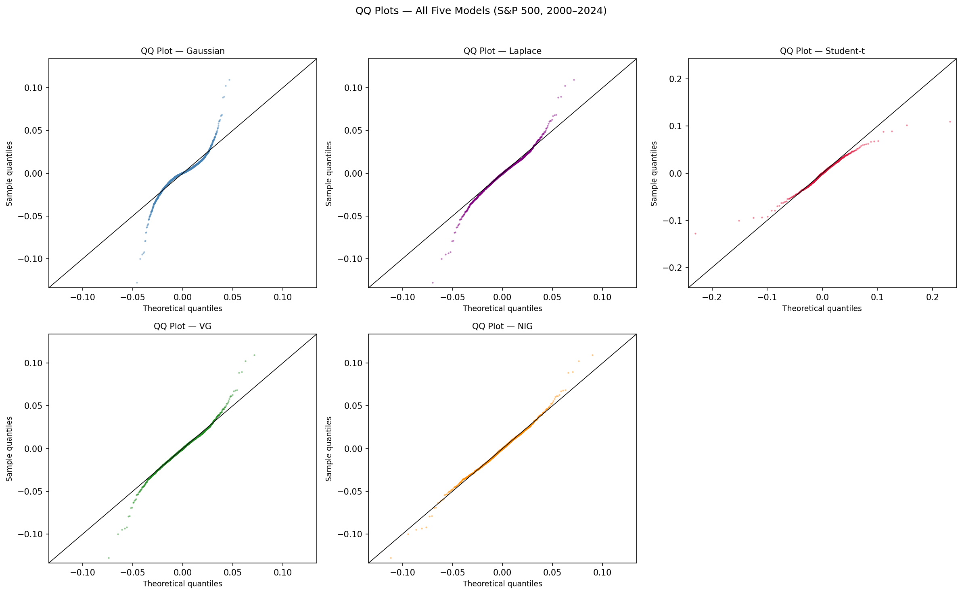
Figure 2. Quantile-Quantile (QQ) plots for all five models. A QQ plot sorts the observed returns and plots each against the value the fitted distribution predicts at that rank. Points on the diagonal line indicate perfect fit. The Gaussian (top left) shows a severe S-shape, confirming fat tails. NIG (bottom row) sits closest to the diagonal, especially in the left tail where capital losses occur; the Laplace tracks the body well but its tails are slightly too light at the extremes.
What the parameters mean economically
The full-sample VG estimate of theta (the asymmetry parameter, the drift of the underlying Brownian motion) = -0.000684 confirms negative skewness in daily returns. The fitted nu (the variance rate of the Gamma time-change, controlling tail heaviness) = 1.173 means the random clock has variance roughly equal to its mean. For NIG, alpha (the tail-heaviness parameter; smaller means heavier tails) = 52.3 and beta (the asymmetry parameter; negative means left-skewed) = -6.095. Both are consistent with the stylised facts of equity returns documented in Cont (2001): negative skewness, excess kurtosis (fatter tails than a Gaussian), and tail decay that is slower than Gaussian but faster than a power law.
8. Risk measures
At 99% ES (the average loss on the worst 1% of days), the five models span a wide range. The Gaussian gives -3.24%, which is the most optimistic. The Laplace gives -3.91%, already 21% more conservative than the Gaussian from its exponential tails alone. VG gives -4.27%, NIG gives -5.19%, and the Student-t gives -5.81%. The Student-t's outlier reading is not because it is the best model; it is because at nu (degrees of freedom) = 2.648, very close to the boundary nu = 2 below which the variance becomes infinite, the Student-t forces extremely heavy symmetric tails. It overstates the right tail to match the left, and the resulting ES is inflated. VG and NIG, with their separate asymmetry parameters theta (VG) and beta (NIG), fit the two tails independently and produce more moderate ES values.
Using the Gaussian ES of -3.24% to set regulatory capital under FRTB (Fundamental Review of the Trading Book), the Basel Committee on Banking Supervision framework that replaced Value at Risk with Expected Shortfall as the primary capital metric, leaves a 24% shortfall relative to VG (-4.27%) and a 37% shortfall relative to NIG (-5.19%). This is the practical consequence of distributional misspecification.
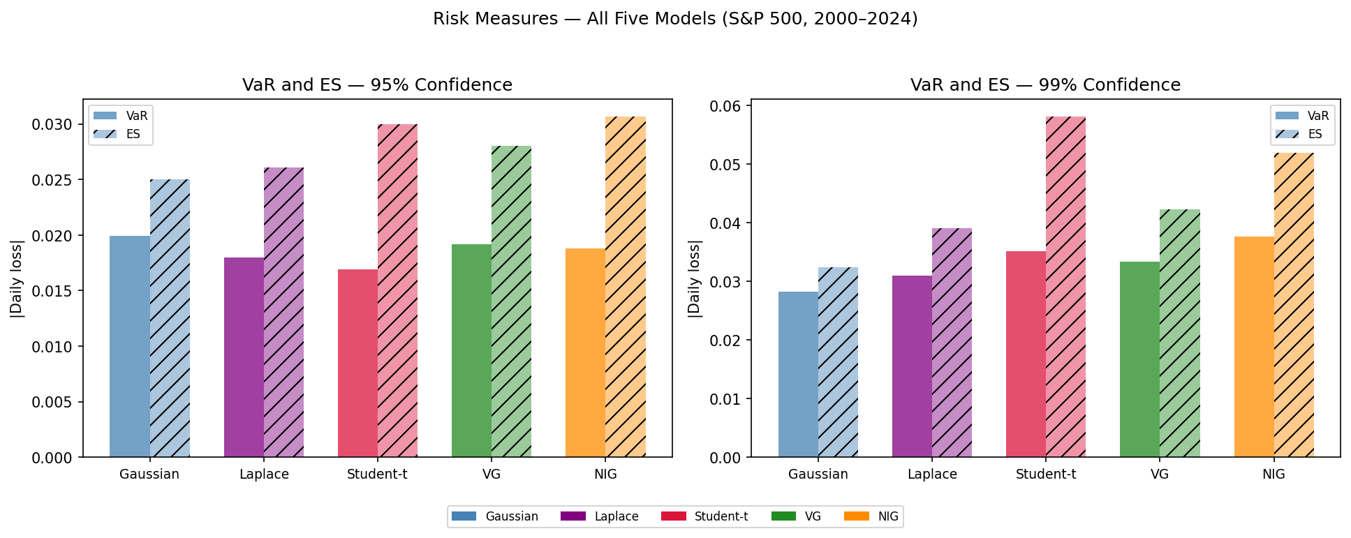
Figure 3. VaR (Value at Risk, the loss threshold exceeded on the worst alpha% of days) and ES (Expected Shortfall, the average loss on those days) at 95% confidence (left panel) and 99% confidence (right panel) for all five models. Solid bars are VaR; hatched bars are ES. The ES bars grow faster than VaR as confidence rises because ES depends on the full shape of the tail, not just its edge.
Table 1. Daily Expected Shortfall (ES) for all five models. ES is the average loss on days that exceed the VaR threshold. Gaussian, Laplace and Student-t computed analytically; VG and NIG computed by Monte Carlo simulation using 500,000 draws from the fitted distribution.
Confidence | ES (Gaussian) | ES (Laplace) | ES (Student-t) | ES (VG) | ES (NIG)
95% | -2.501% | -2.608% | -3.000% | -2.818% | -3.075%
99% | -3.238% | -3.908% | -5.813% | -4.269% | -5.187%

9. The distributional fingerprint of each crisis
Fitting all four models independently to each of the four market shock windows gives a distributional fingerprint of each period. A distributional fingerprint is simply the set of fitted parameter values for a given time window; comparing fingerprints across windows shows how the statistical character of returns changed from one crisis to another.
The GFC (Global Financial Crisis, approximately October 2007 to March 2009) and COVID-19 windows return Student-t nu (degrees of freedom; values closer to 2 indicate fatter tails approaching infinite variance) of 2.607 and 2.285. VG nu (variance rate of the Gamma time-change, controlling tail heaviness; larger values mean heavier tails) rises to 1.248 and 1.439. NIG alpha (tail-heaviness parameter; smaller values mean heavier tails) falls to 25.9 and 17.8. These are extreme readings across all three models simultaneously.
The dot-com crash (approximately March 2000 to October 2002, when the collapse of overvalued technology stocks led to a prolonged equity bear market) and the Federal Reserve rate-hike cycle (2022 to 2023, when rapid interest rate increases caused a broad repricing of growth assets) look completely different. Student-t nu = 6.526 and 6.525. NIG alpha = 98.6 and 111.9. Both periods are near the Gaussian regime in their tail structure. Gaussian annualised sigma (the standard deviation of daily log-returns scaled by the square root of 252 trading days per year, giving an annualised volatility figure) in the dot-com period is 23.5%, visibly elevated. But the tail parameters reveal that the elevation is in scale, not in tail shape. The GFC and COVID produced clustered extreme single-day moves. The dot-com crash was a gradual grinding decline. That difference is invisible in volatility but shows up immediately in nu, alpha, and beta.
One unusual result: VG theta (asymmetry parameter) = +0.00190 and NIG beta (asymmetry parameter) = +10.04 during the dot-com crash, both positive. Every other period shows negative asymmetry. The dot-com crash had more prolonged losses interspersed with volatile rallies, which a slightly right-skewed daily distribution can capture. The GFC and COVID had asymmetric, crash-dominated days where losses dramatically outnumbered gains of the same size.
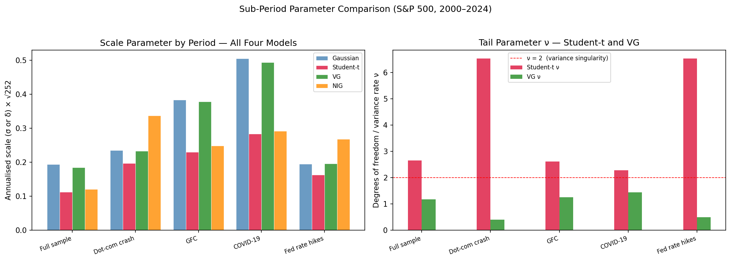
Figure 4. Left: annualised scale parameter across all five periods for all four models. Right: tail parameter nu (degrees of freedom for Student-t; variance rate for VG) across the same periods. The dashed line at nu = 2 marks the variance singularity below which the Student-t variance becomes infinite. GFC and COVID approach it; all other periods stay well above.
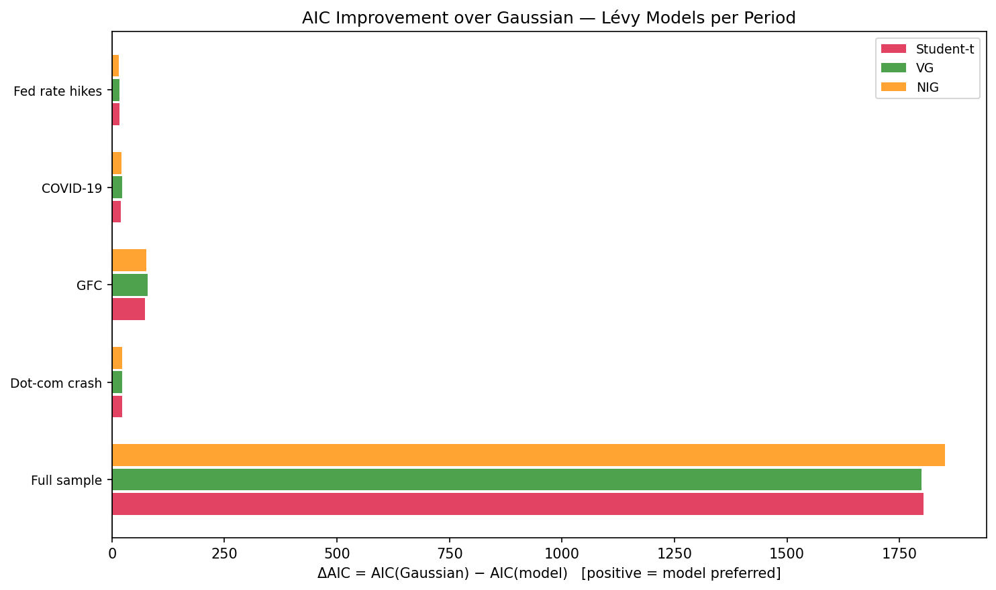
Figure 5. AIC (Akaike Information Criterion) improvement of each Levy model over the Gaussian benchmark by sub-period. Positive values mean the Levy model is preferred. The GFC improvement of 72 to 79 units dwarfs the calmer periods (15 to 23 units), confirming that fat-tail models add the most value when markets are most severely dislocated.
10. What comes next
The MLE (Maximum Likelihood Estimation) results reported throughout this document are point estimates: a single parameter vector that maximises the log-likelihood. Standard errors give an approximate measure of uncertainty based on the curvature of the likelihood surface, but they rely on asymptotic theory, meaning they become accurate as the number of observations n grows toward infinity. With n = 104 observations in the COVID-19 sub-period window, and with nu (variance rate, controlling tail heaviness) near the edge of the identifiable region where the likelihood surface becomes flat, the asymptotic approximation is not reliable for those sub-period estimates.
Weeks 4 and 5 address this using Bayesian estimation via NUTS (No-U-Turn Sampler, an efficient Markov Chain Monte Carlo algorithm that automatically tunes its step sizes and avoids the inefficiency of random walks by using gradient information to explore the parameter space) implemented in PyMC (a Python library for probabilistic programming that builds and samples from Bayesian models). Markov Chain Monte Carlo (MCMC) is a class of algorithms that generates a sequence of parameter values whose distribution converges to the posterior distribution, meaning the probability distribution over parameter values given the observed data. Instead of a single point estimate like nu = 1.173, NUTS produces thousands of samples from the full posterior distribution over nu, which can be used to compute probabilities like: what is the probability that nu exceeds 1.5 given this data? That is the question a risk manager actually needs answered when trying to judge whether a tail regime shift has occurred, and it cannot be answered with a point estimate alone.

