Week 3: Lead-up regression on forward risk
What observable factors accompanied the build-up of tail risk before historical market shocks?
1. Scope: this is risk attribution, not market prediction
This regression does not attempt to predict the direction or level of stock returns. Forecasting whether the market will go up or down is outside the scope of this project and is not reliably possible: daily equity returns are very close to unforecastable. The dependent variable here is never a return sign or level. It is always a risk quantity, specifically forward realised volatility, which is the dispersion of returns over the coming month, not their direction.
Modelling the dispersion of returns is legitimate, and it is the foundation the Basel VaR and Expected Shortfall apparatus rests on, because volatility clusters. Large moves are followed by large moves and calm is followed by calm. This is one of the stylised facts of asset returns documented in Cont (2001), and it is why a static Gaussian risk number, which assumes constant volatility, fails. Using volatility clustering to describe how the risk environment evolves is a risk-measurement exercise, not a market-timing one.
The framing throughout is retrospective and in-sample. The question is: which observable, daily factors were systematically elevated in the run-up to historical episodes of extreme returns, and do tail-shape factors carry information about future risk beyond what plain volatility already tells us? No out-of-sample forecasting skill is claimed, no trading strategy or profit-and-loss is computed, and no held-out test is presented as a forecasting scorecard. The factor trajectories shown against the four shock windows are a descriptive diagnostic of the historical record, not an early-warning system.
There is a hard reason this restraint is not optional. The 25-year sample contains only four crisis episodes. Anything framed as predicting the crash would have effectively four positive events to learn from, which guarantees overfitting and supports no honest claim of forecasting power. A continuous risk target avoids this entirely: forward realised volatility is defined on roughly 6,200 daily observations, so the relationships estimated are statistically meaningful in a way a four-event crash model never could be.
2. How this differs from the earlier parameter-on-VIX regression
An earlier exploratory regression in this project regressed the fitted annual Levy parameters on each year's average VIX. That earlier exercise is cross-sectional and contemporaneous: the unit of observation is a calendar year (n = 25), and the VIX and the parameters are measured over the same window, so it can only say whether two quantities move together. It carries no notion of before versus after and therefore cannot speak to lead-up dynamics. It is reported separately and is not part of this write-up.
The regression here is a time-series predictive regression in the econometric sense of that term: the unit of observation is a single trading day (n = 6,207), and every predictor is measured strictly at time t while the outcome is measured over the subsequent window t+1 to t+h. That deliberate temporal gap between predictors and outcome is the defining feature, and it is what makes the analysis a lead-up analysis rather than a contemporaneous description.
3. The model
The outcome: forward realised volatility
The dependent variable is forward realised volatility over the next h = 21 trading days (approximately one calendar month). For each day t it is computed as the square root of the sum of squared daily log-returns over days t+1 to t+h, scaled by 252/h and then square-rooted, giving an annualised volatility figure. Squared returns are used as the building block because they measure the magnitude of moves regardless of sign, which is exactly the dispersion content we want and which strips out any directional (return-prediction) information by construction.
The predictors: all knowable at time t
Every predictor is built only from information available up to and including day t. The set is small and economically motivated. Two of the predictors, the rolling skewness and rolling excess kurtosis of recent returns, are short-window empirical analogues of the Variance-Gamma and NIG asymmetry and tail-heaviness parameters estimated elsewhere in Week 3. Including them lets the model speak the project's own vocabulary: it asks whether the tail shape of recent returns, not just their volatility, carries information about the risk to come.
Table 1. The seven lead-up predictors. All are trailing quantities, so none uses information from after day t.
Predictor | Definition (all measured at day t)
Trailing 21d vol | Annualised standard deviation of returns over the last 21 days
VIX level | CBOE Volatility Index level (options-implied 30-day vol)
Delta VIX (5d) | 5-day change in the VIX (momentum of implied volatility)
|return| (1d) | Absolute value of the most recent daily return
Rolling skew (21d) | Sample skewness of returns over the last 21 days
Rolling kurtosis (21d) | Excess kurtosis of returns over the last 21 days (tail proxy)
Drawdown (252d) | Current price relative to its trailing 252-day peak (<= 0)

Estimation and standard errors
The model is a single Ordinary Least Squares (OLS) regression fitted on the full daily sample. Because the forward windows of consecutive days overlap (the outcome for day t and day t+1 share 20 of their 21 days), the regression residuals are strongly autocorrelated, and ordinary OLS standard errors would be badly understated, so coefficients would look more significant than they are. To correct for this, all standard errors are Newey-West HAC (heteroskedasticity and autocorrelation consistent) standard errors, computed with a Bartlett kernel and a bandwidth set equal to the forecast horizon of 21 days, which is the mechanical overlap length. Every t-statistic and p-value reported below uses these robust standard errors.
Coefficients are reported in standardised (z-score) form, meaning each predictor and the outcome are rescaled to have mean zero and standard deviation one before fitting. A standardised coefficient of 0.40 then reads as: a one-standard-deviation increase in that factor is associated with a 0.40-standard-deviation increase in forward volatility, holding the other factors fixed. Standardisation makes the factor loadings directly comparable to one another despite their different natural units.
4. Results
Tail factors add information beyond volatility alone
The main result is an incremental one. A baseline regression that uses only trailing 21-day volatility to explain forward volatility achieves an R-squared of 0.441: as expected from volatility clustering, recent volatility alone explains a large share of future volatility. Adding the other six factors raises the R-squared to 0.553. The additional 0.112, roughly eleven percentage points of explained variation, is contributed by the implied-volatility, shock, tail and drawdown factors over and above plain volatility persistence. The risk environment is better described by tail-aware factors than by volatility on its own. This is the same message the Levy models give for the static distribution, now in a dynamic form.
Table 2. Variance in forward 21-day realised volatility explained by the baseline and full models. n = 6,207 daily observations.
Model | Predictors | R-squared | Adjusted R-squared
Baseline | Trailing 21d vol only | 0.441 | 0.441
Full | All seven lead-up factors | 0.553 | 0.552
Increment | Tail / VIX / drawdown factors | +0.112 | --

Which factors carry the signal
Table 3 reports the standardised coefficients of the full model with Newey-West HAC standard errors. The VIX level is the single strongest factor (standardised coefficient +0.40, t = 4.2), which is expected: options-implied volatility is the market's own forward-looking estimate of dispersion, so it should and does carry the most information about future realised volatility. The five-day change in the VIX is also significant and positive (+0.12, t = 2.4): a rising VIX, and not only its level, precedes higher realised risk. The most recent absolute return carries a small but significant positive loading (+0.05, t = 2.2): a large move today tends to be followed by more turbulence over the next few weeks.
The two coefficients that warrant comment are the drawdown and the rolling kurtosis. Drawdown carries a negative loading (-0.11, t = -1.8, marginally significant): the closer the market is sitting to its trailing peak, the higher the volatility that tends to follow. Put differently, calm conditions near a record high are not reassuring on this measure. Rolling excess kurtosis also loads negatively and significantly (-0.04, t = -2.1). The negative sign should be read carefully and not over-interpreted: once recent volatility and the VIX are already in the model, a spike in trailing kurtosis tends to mark an isolated jump that has already happened rather than a build-up of risk still to come, so the residual association with future volatility is mildly negative. Rolling skewness is not statistically distinguishable from zero (t = -1.0).
Table 3. Standardised coefficients of the full model with Newey-West HAC standard errors (bandwidth 21). The intercept is zero by construction under standardisation and is omitted.
Factor | Std. coefficient | HAC SE | t-stat | p-value
VIX level | +0.399 | 0.094 | +4.23 | <0.001
Trailing 21d vol | +0.203 | 0.105 | +1.94 | 0.053
Delta VIX (5d) | +0.122 | 0.050 | +2.44 | 0.015
|return| (1d) | +0.052 | 0.023 | +2.24 | 0.025
Rolling skew (21d) | -0.025 | 0.026 | -0.97 | 0.333
Rolling kurtosis (21d) | -0.040 | 0.019 | -2.09 | 0.037
Drawdown (252d) | -0.115 | 0.063 | -1.82 | 0.069

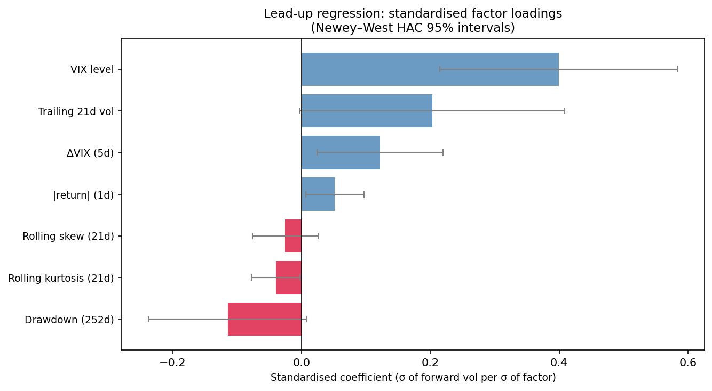
Figure 1. Standardised factor loadings with Newey-West HAC 95% intervals. Bars whose interval does not cross zero are statistically significant. The VIX level dominates; drawdown and rolling kurtosis carry negative loadings.
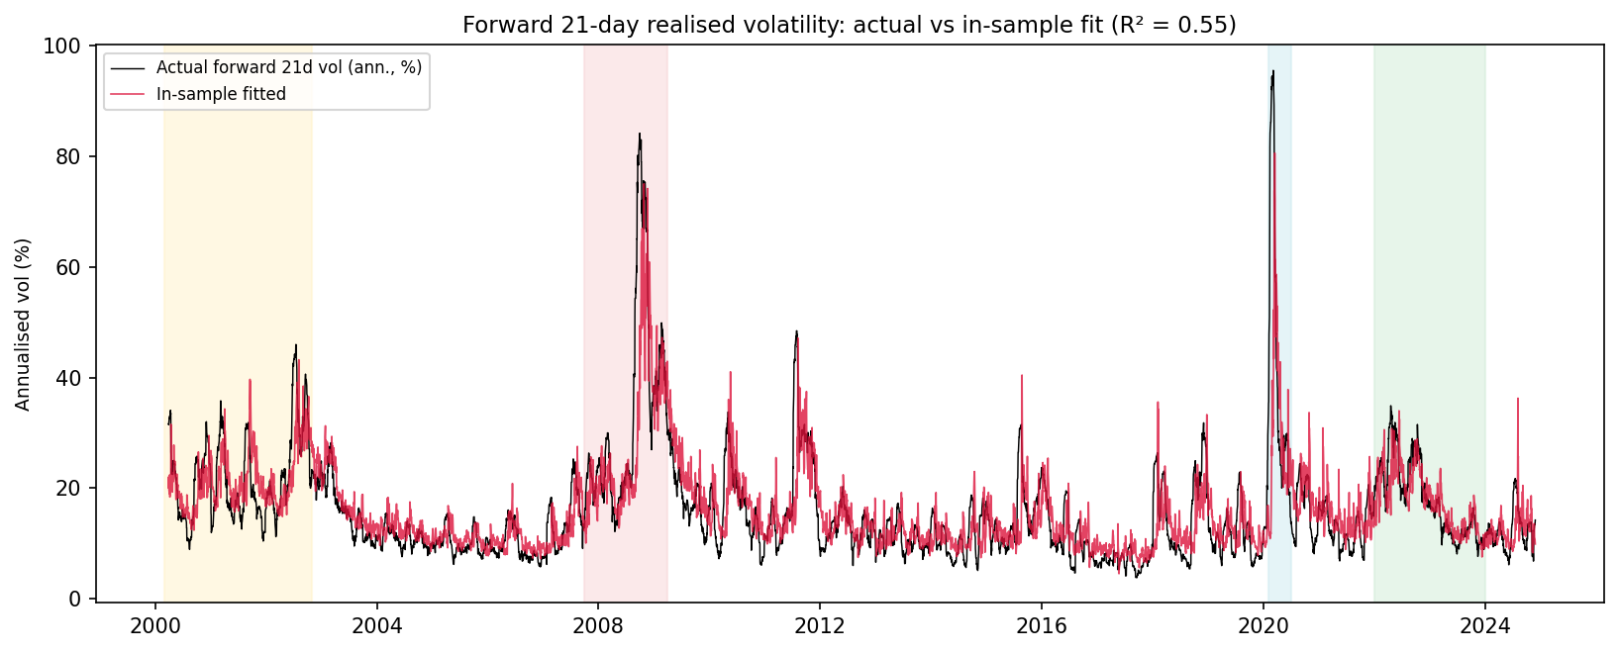
Figure 2. Actual forward 21-day realised volatility (black) against the in-sample fitted values from the full model (red), with the four shock windows shaded. The model tracks the broad evolution of risk, including the 2008 and 2020 spikes, with an in-sample R-squared of 0.55. This is an in-sample fit shown for diagnostic purposes; it is not an out-of-sample forecast.
5. What was elevated before each shock
Table 4 is the retrospective attribution exhibit. For each shock window it reports the average standardised level of each factor over the 21 trading days immediately before the window began. Because the factors are z-scored over the full sample, a value of +0.7 means that factor stood 0.7 sample standard deviations above its typical level going into the episode, and a negative value means it was below its typical level. This describes the conditions that preceded each episode in the historical record. It is explicitly not a forecast.
The clearest pattern is the drawdown factor, which was positive before all three episodes (+0.34, +0.68, +0.64). Each of these shocks began from a market sitting near its trailing peak rather than from an already depressed level. Beyond that the picture is mixed, which is the result worth stating plainly. The Global Financial Crisis was preceded by mildly elevated volatility and VIX (+0.39 and +0.30), consistent with a slow build-up. COVID-19 was the opposite: volatility, the VIX and skewness were all well below average in the weeks before the crash (-0.80, -0.70, -0.57), because that shock erupted out of an unusually calm market with almost no warning in these factors. This contrast is exactly why a forecasting claim would be indefensible, and why the analysis is framed as attribution rather than prediction.
Table 4. Mean standardised factor level in the 21 trading days before each shock window (z-scores; descriptive only). The dot-com crash is omitted because its start date (March 2000) falls inside the 252-day warm-up required by the drawdown factor, so a clean 21-day pre-window is not available in the sample.
Shock window | Trail vol | VIX | dVIX | |ret| | Skew | Kurt | Drawdn
GFC | +0.39 | +0.30 | -0.36 | -0.09 | +0.04 | -0.25 | +0.34
COVID-19 | -0.80 | -0.70 | +0.25 | -0.26 | -0.57 | -0.47 | +0.68
Fed rate hikes | +0.14 | +0.12 | -0.59 | +0.13 | -0.14 | -0.64 | +0.64

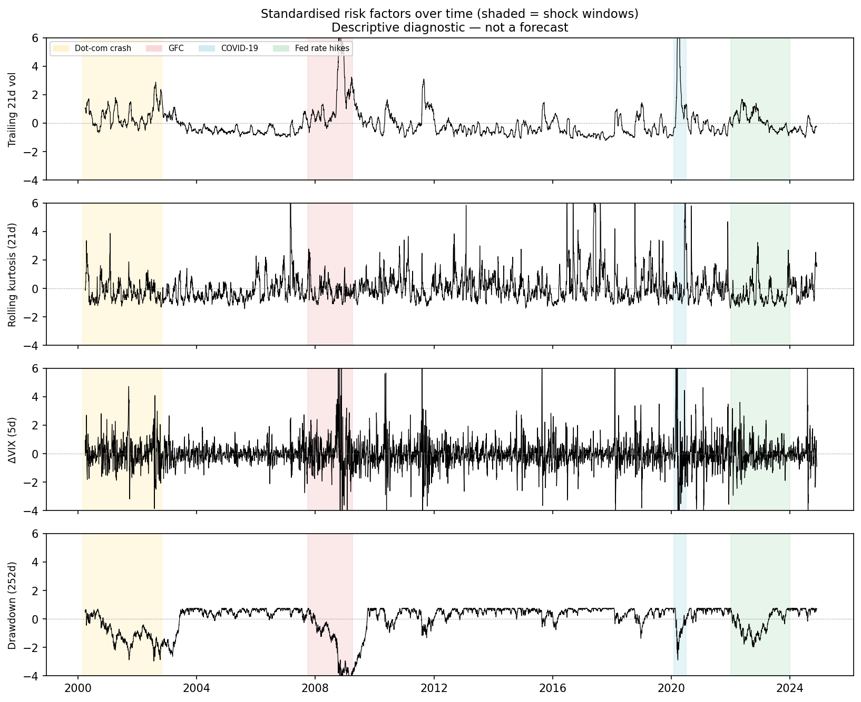
Figure 3. Standardised trajectories of four representative factors (trailing volatility, rolling kurtosis, the 5-day VIX change, and drawdown) across the full sample, with the four shock windows shaded. The figure is a descriptive diagnostic of how the risk environment evolved, not a forecast.
6. Limitations and honest caveats
First, every R-squared and coefficient reported here is in-sample. The model has not been validated out of sample, and no claim of out-of-sample predictive skill is made; doing so responsibly would require a far larger set of crisis episodes than the historical record provides. Second, the predictors are correlated with one another, most obviously trailing volatility and the VIX level, so individual coefficients should be read as partial associations rather than independent causal effects, and the split of credit between collinear factors is not sharp. Third, the forward windows overlap, which is the reason Newey-West standard errors are used throughout; even so, effective sample information is smaller than the nominal 6,207 observations suggest. Fourth, the choice of a 21-day horizon is a modelling decision; shorter or longer horizons would shift the relative weight of the fast factors (the VIX change, the latest absolute return) against the slow ones (drawdown).
Read with these caveats, the regression supports one conclusion, and it stays within the project's risk-measurement scope: the dispersion of future returns is partially describable from present, observable conditions, and tail-shape information adds materially to that description beyond volatility alone. It reinforces, in a dynamic form, what the Levy models show for the static distribution: the risk that matters lives in the tails, and it depends on the prevailing market state.

