Week 3 results: Variance-Gamma and NIG MLE
1. Overview
This week I fitted two Levy process models to the same 6,287 daily log-returns used in Week 2: the Variance-Gamma (VG) and the Normal Inverse Gaussian (NIG). Both have four parameters and allow asymmetric tails, which the Student-t cannot. On Neil's suggestion I also fitted the Laplace (double-exponential) distribution as a simple two-parameter benchmark. The Laplace is the symmetric special case of the VG (theta = 0, nu = 1), so it sits between the Gaussian and the heavier Levy models. With only two parameters, the same count as the Gaussian, it captures 1,771 of the 1,851 AIC units the four-parameter NIG gains over the Gaussian. Most of the improvement over the Gaussian therefore comes from allowing exponential rather than thin tails, before any extra parameters are added. NIG remains the best-fitting model. Its 99% Expected Shortfall of -5.19% sits between the Gaussian (-3.24%) and the Student-t (-5.81%), and it is the only model that passes a formal goodness-of-fit test. The sub-period analysis shows that the GFC and COVID were structurally different crises from the dot-com crash and the rate-hike cycle, and that the difference is clear in the Levy parameters.
2. Parameter estimates
Tables 1 and 3 carry the Week 2 Gaussian and Student-t results forward. Tables 2, 4 and 5 (Laplace, VG, NIG) are new.
Table 1. Gaussian MLE (Week 2).
Parameter | Estimate | Standard Error | t-statistic
mu (daily drift) | +0.000223 | 0.000154 | 1.45
sigma (scale) | 0.012234 | 0.000109 | --
Log-likelihood | 18,764.3 | -- | --
AIC | -37,524.5 | -- | --
BIC | -37,511.0 | -- | --

Table 2. Laplace MLE (symmetric VG special case: theta = 0, nu = 1).
Parameter | Estimate | Standard Error
mu (location) | +0.000602 | 0.000102
b (scale) | 0.008078 | 0.000102
Log-likelihood | 19,649.9 | --
AIC | -39,295.7 | --
BIC | -39,282.2 | --

The Laplace closed-form MLE sets mu to the sample median and b to the mean absolute deviation about it. Its log-likelihood of 19,649.9 beats the Gaussian by 885.6 and falls only 15.6 short of the full VG, which frees the two parameters (theta and nu) that the Laplace holds fixed. A likelihood-ratio test of that restriction gives 31.2 on 2 degrees of freedom (p < 0.001), so the asymmetry and variance-rate freedom are real, but small next to the 885-unit gain the exponential tails alone give.
Table 3. Student-t MLE (Week 2).
Parameter | Estimate | Standard Error | 95% CI
nu (degrees of freedom) | 2.648 | 0.110 | (2.43, 2.87)
mu (location) | +0.000656 | 0.000110 | --
sigma (scale) | 0.007077 | 0.000128 | --
Log-likelihood | 19,666.7 | -- | --
AIC | -39,327.5 | -- | --
BIC | -39,307.2 | -- | --

Table 4. Variance-Gamma MLE.
Parameter | Estimate | Standard Error
sigma (scale) | 0.011627 | 0.000163
theta (asymmetry) | -0.000684 | 0.000149
nu (variance rate) | 1.17306 | 0.043087
mu (location) | +0.000907 | 0.000028
Log-likelihood | 19,665.5 | --
AIC | -39,322.9 | --
BIC | -39,296.0 | --

The VG log-likelihood of 19,665.5 is almost identical to the Student-t's 19,666.7 despite two extra parameters, so its AIC is slightly worse. The negative theta confirms left skew, and the variance rate nu = 1.173 is well above zero, so the Gamma time-change is doing real work rather than collapsing toward the Gaussian limit.
Table 5. Normal Inverse Gaussian MLE.
Parameter | Estimate | Standard Error
alpha (tail-heaviness) | 52.341 | 2.786
beta (asymmetry) | -6.095 | 1.498
delta (scale) | 0.007574 | 0.000217
mu (location) | +0.001111 | 0.000150
Log-likelihood | 19,691.7 | --
AIC | -39,375.3 | --
BIC | -39,348.4 | --

NIG achieves the highest log-likelihood of the five models. Its AIC improvement over the Gaussian is 1,851 units, 48 better than the Student-t. Negative beta confirms left skew, and alpha = 52.3 indicates heavy tails; the values of 17-26 it falls to during the GFC and COVID (Section 5) show how much deeper the tails run in acute crises.
3. Model fit
Figure 1 overlays all five PDFs on the return histogram. The four non-Gaussian models look similar to the eye; the Laplace (dashed) and Student-t are nearly indistinguishable at this scale, and the NIG peak is marginally sharper. The QQ plots in Figure 2 show the difference more precisely. NIG and VG sit closest to the diagonal throughout, with the smallest residuals at the extreme observations; the Laplace tracks the body well but its tails are a touch too light at the most extreme points.
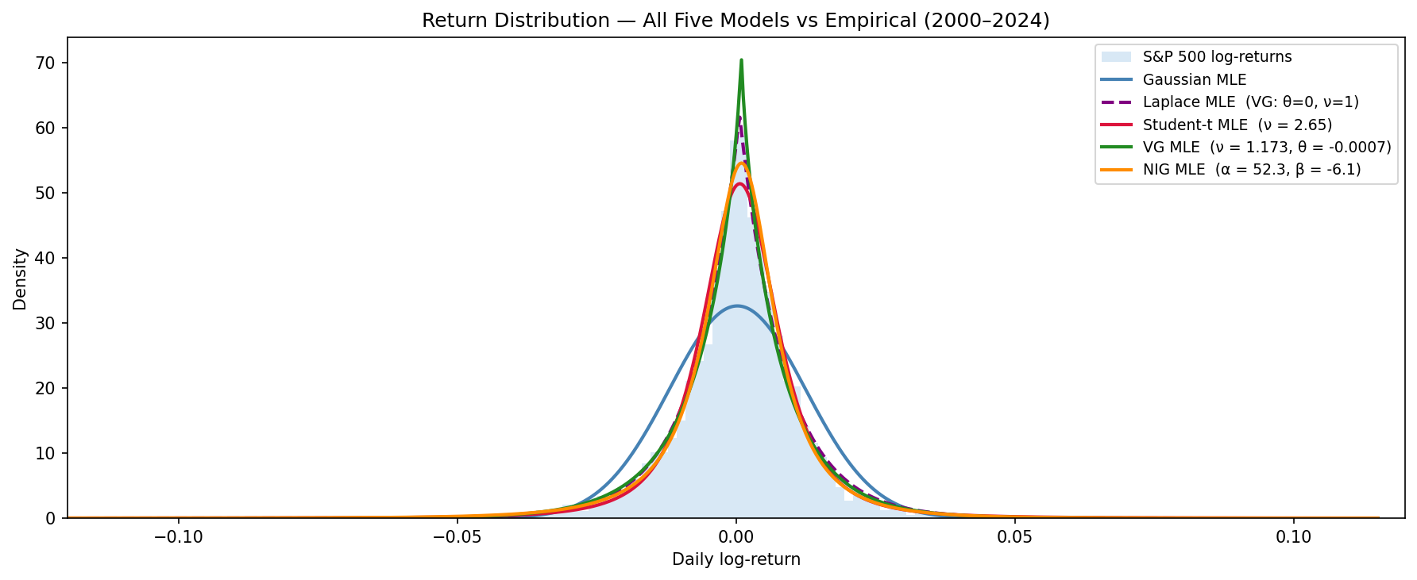
Figure 1. Return histogram with all five fitted PDFs. Gaussian (blue), Laplace (purple, dashed), Student-t (red), VG (green), NIG (orange).
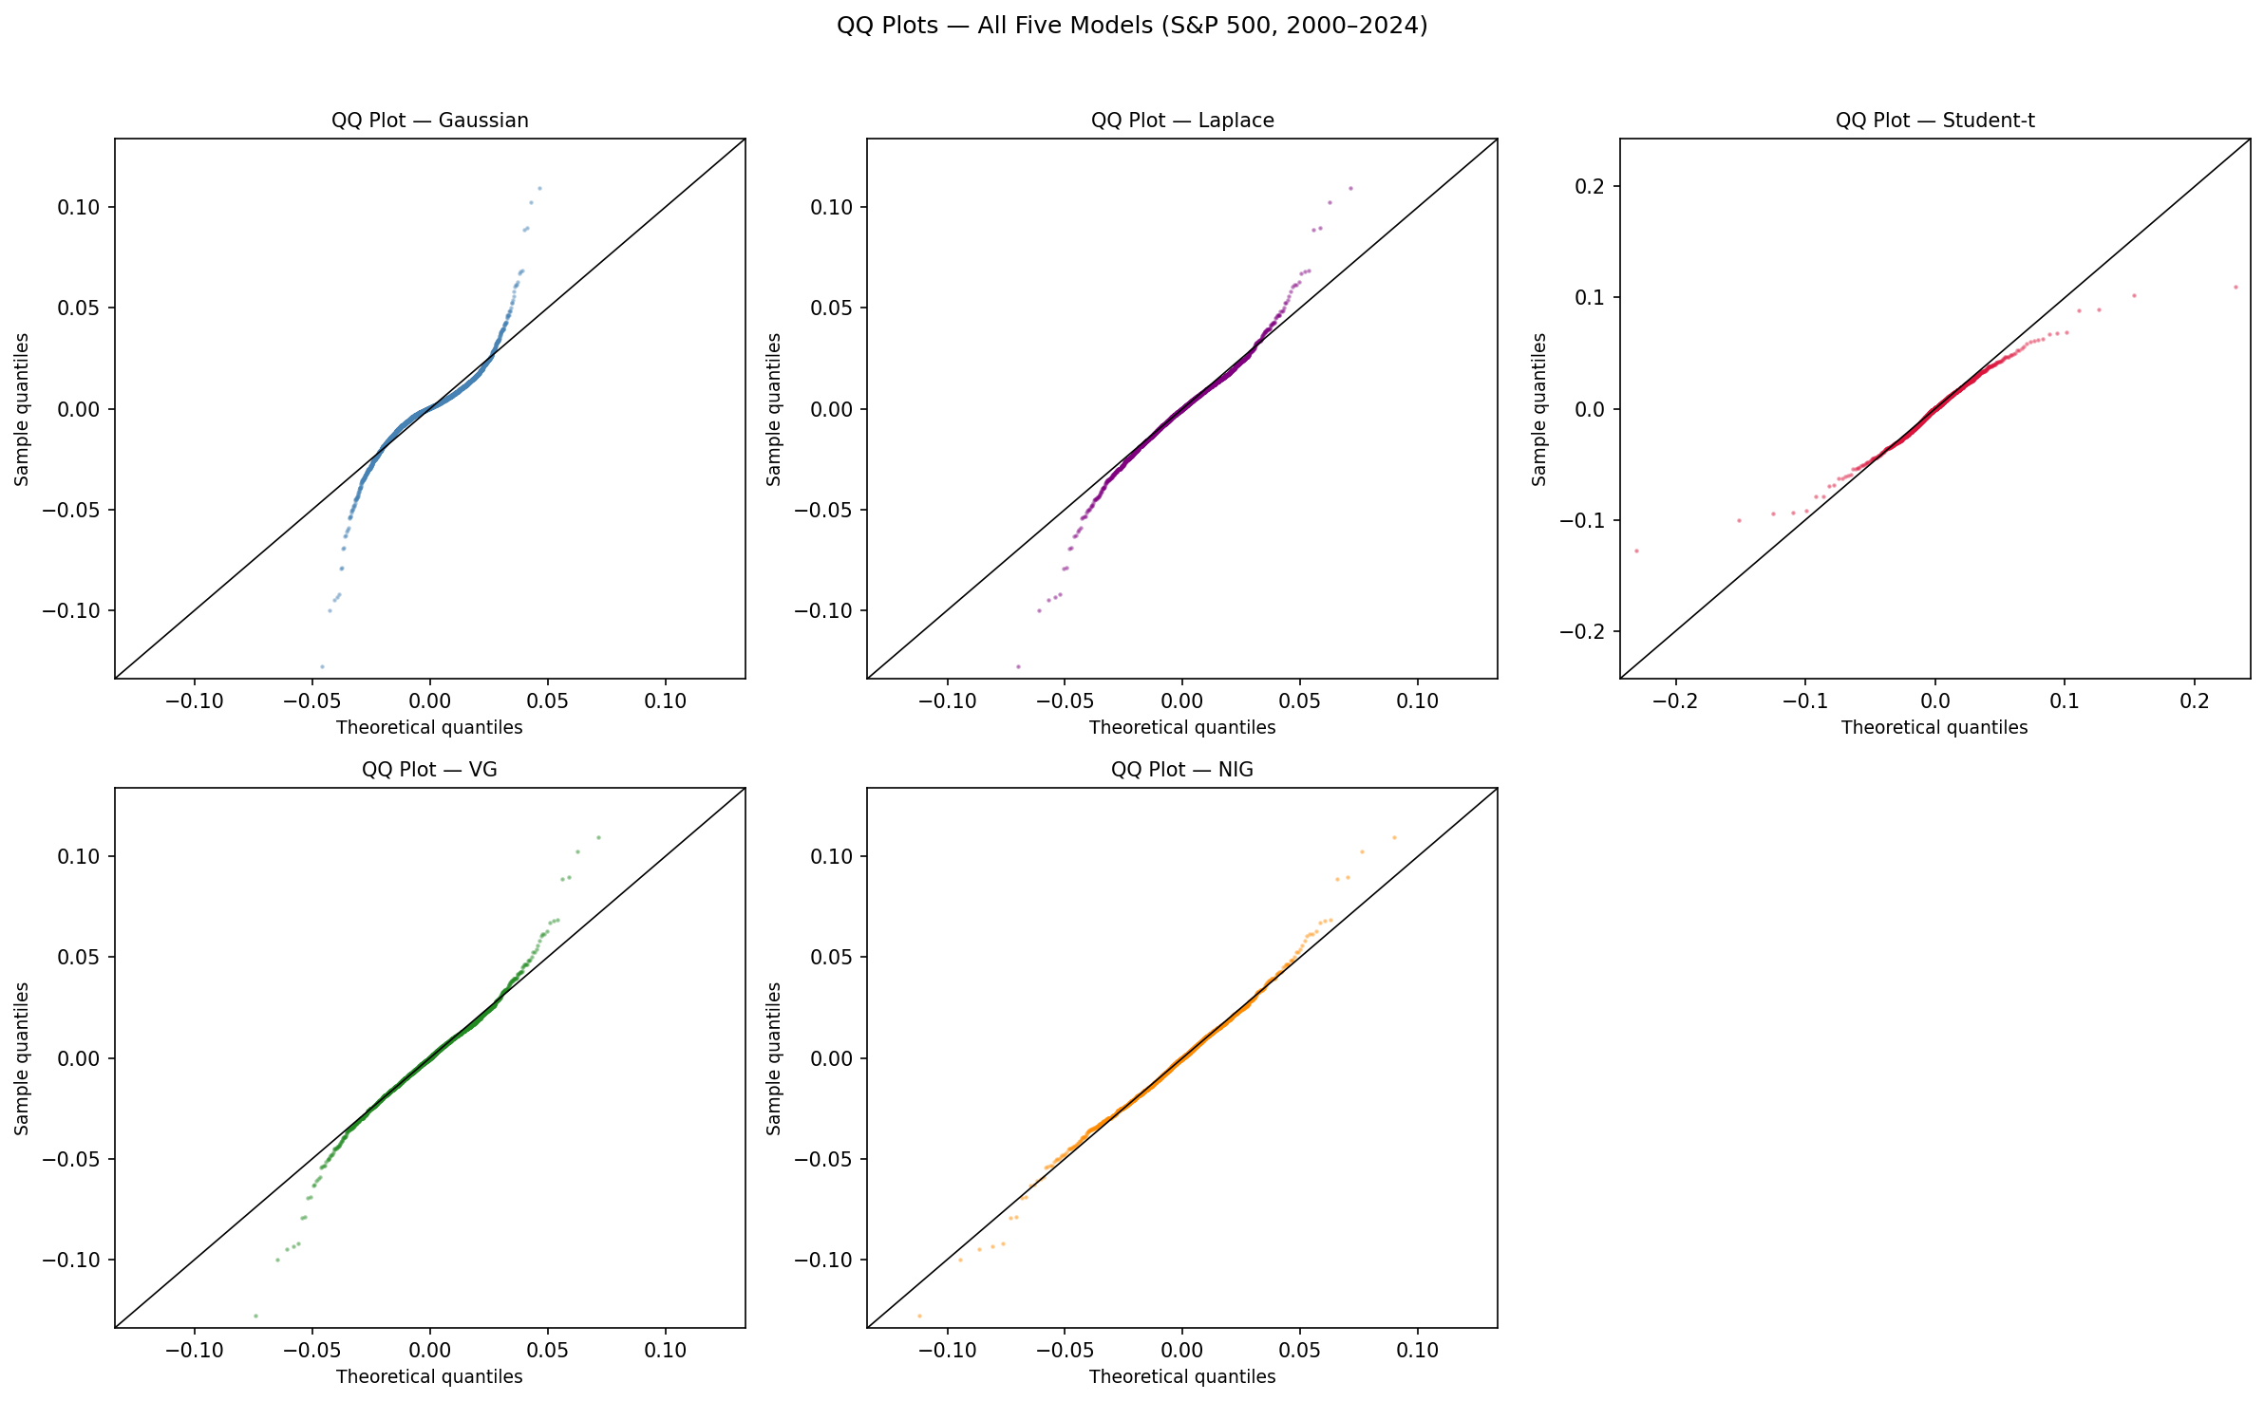
Figure 2. QQ plots for all five models. The Gaussian S-shape (top left) is severe. NIG (bottom row) sits closest to the diagonal.
Table 6. KS goodness-of-fit. Gaussian, Laplace and Student-t: one-sample test (analytical CDF). VG and NIG: two-sample test against 1,000,000 simulated draws. D is the meaningful metric.
Model | KS statistic (D) | p-value | n
Gaussian | 0.0938 | <0.001 | 6,287
Laplace | 0.0180 | 0.034 | 6,287
Student-t | 0.0182 | 0.030 | 6,287
VG | 0.0129 | 0.250 | 6,287
NIG | 0.0113 | 0.399 | 6,287

NIG is the only model that cannot be rejected. VG passes too. The Laplace and Student-t are both borderline, and tie almost exactly on D (0.0180 versus 0.0182): a two-parameter symmetric model matches the three-parameter Student-t on this measure. The Gaussian fails at any threshold.
Table 7. Model comparison. Lower AIC/BIC is better.
Model | Parameters | Log-lik | AIC | BIC | DAIC vs Gaussian
Gaussian | 2 | 18,764.3 | -37,524.5 | -37,511.0 | --
Laplace | 2 | 19,649.9 | -39,295.7 | -39,282.2 | -1,771.2
Student-t | 3 | 19,666.7 | -39,327.5 | -39,307.2 | -1,802.9
VG | 4 | 19,665.5 | -39,322.9 | -39,296.0 | -1,798.4
NIG | 4 | 19,691.7 | -39,375.3 | -39,348.4 | -1,850.8

The Laplace, with two parameters, reaches DAIC -1,771, within 80 units of the four-parameter NIG and the most efficient model per parameter: most of the gain over the Gaussian comes from exponential tails rather than from extra parameters. The VG result cuts the other way. With four parameters it is slightly worse than the three-parameter Student-t on both AIC and BIC, which is not what you would expect if adding parameters always helped. NIG uses the same number of parameters as VG but gains 26 log-likelihood units, so the Inverse Gaussian mixing distribution captures something the Gamma mixing of VG cannot.
4. Risk measures
Table 8. Daily VaR and ES for all five models. Gaussian, Laplace and Student-t use closed-form expressions; VG and NIG use Monte Carlo (500,000 draws).
Confidence | VaR (Gauss.) | ES (Gauss.) | VaR (Lap) | ES (Lap) | VaR (t) | ES (t) | VaR (VG) | ES (VG) | VaR (NIG) | ES (NIG)
95% | -1.990% | -2.501% | -1.800% | -2.608% | -1.694% | -3.000% | -1.915% | -2.818% | -1.880% | -3.075%
99% | -2.824% | -3.238% | -3.100% | -3.908% | -3.515% | -5.813% | -3.360% | -4.269% | -3.769% | -5.187%

At 99% ES the five models span from -3.24% (Gaussian) to -5.81% (Student-t). The Laplace sits at -3.91%, already 21% above the Gaussian from its exponential tails alone, with no asymmetry parameter. The Student-t's outlier reading comes from its symmetric tail assumption at nu = 2.648: forced to treat both tails equally at that extreme a nu, it overstates the right tail to match the left, and the overall ES inflates. VG and NIG, with separate asymmetry parameters, sit at -4.27% and -5.19% respectively. Using the Gaussian ES of -3.24% to set capital leaves a 24% shortfall relative to VG and 37% relative to NIG. Both gaps are large enough to matter under FRTB (BCBS 2013).
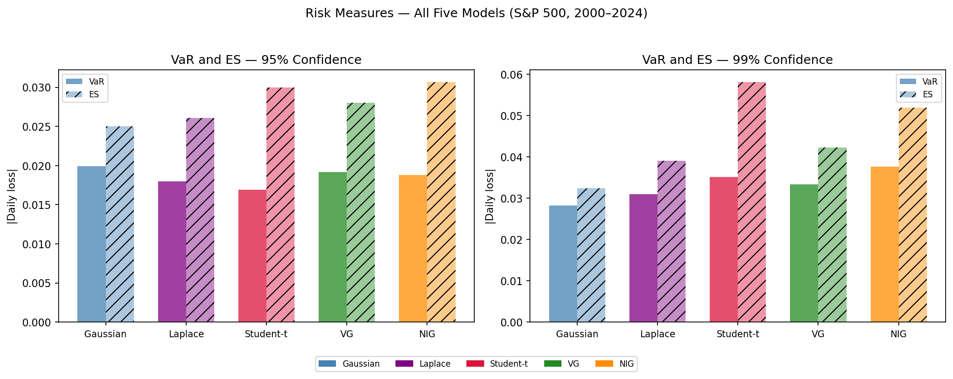
Figure 3. VaR and ES at 95% and 99% for all five models. Hatched bars are ES.
5. How crises change the distribution
Table 9. Sub-period parameter estimates. Each window fitted independently.
Period | n | Gauss. sigma (ann.) | t nu | VG nu | VG theta | NIG alpha | NIG beta
Full sample | 6,287 | 19.4% | 2.648 | 1.173 | -0.00068 | 52.3 | -6.09
Dot-com crash | 671 | 23.5% | 6.526 | 0.397 | +0.00190 | 98.6 | +10.04
GFC | 378 | 38.3% | 2.607 | 1.248 | -0.00296 | 25.9 | -2.74
COVID-19 | 104 | 50.5% | 2.285 | 1.439 | -0.00455 | 17.8 | -4.17
Fed rate hikes | 501 | 19.5% | 6.525 | 0.493 | -0.00002 | 111.9 | -3.85

The GFC and COVID return Student-t nu around 2.3-2.6, very close to the variance singularity at nu = 2. NIG alpha falls to 25.9 and 17.8. The dot-com crash and the rate-hike cycle show nu around 6.5 and NIG alpha around 99-112, near-Gaussian territory. The two types of crisis differ in kind, not merely in magnitude: the dot-com crash was a slow drawdown, while the GFC and COVID were clusters of extreme single-day moves. That difference is invisible in volatility alone but shows up immediately in the tail parameters.
Table 10. AIC improvement over Gaussian by period. Positive = Levy model preferred.
Period | DAIC (Student-t) | DAIC (VG) | DAIC (NIG)
Full sample | 1,802.9 | 1,798.4 | 1,850.8
Dot-com crash | 22.7 | 22.3 | 23.0
GFC | 72.7 | 78.7 | 76.4
COVID-19 | 19.7 | 22.6 | 20.9
Fed rate hikes | 16.0 | 16.2 | 15.1

The GFC improvement is 72-79 units; the calm periods are 15-23. Levy models earn their keep exactly when markets are worst.
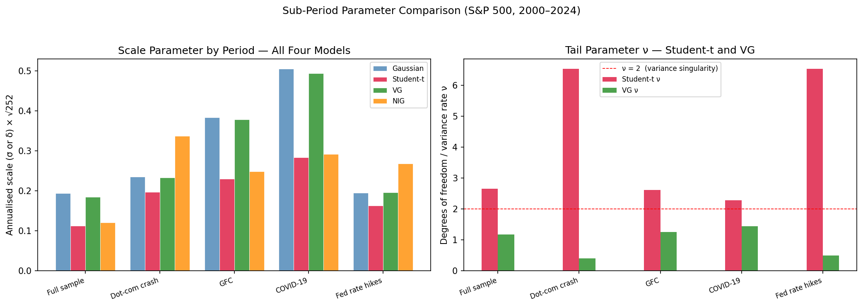
Figure 4. Left: annualised scale by period and model. Right: tail parameter nu for Student-t and VG. The dashed line is the nu = 2 variance singularity.
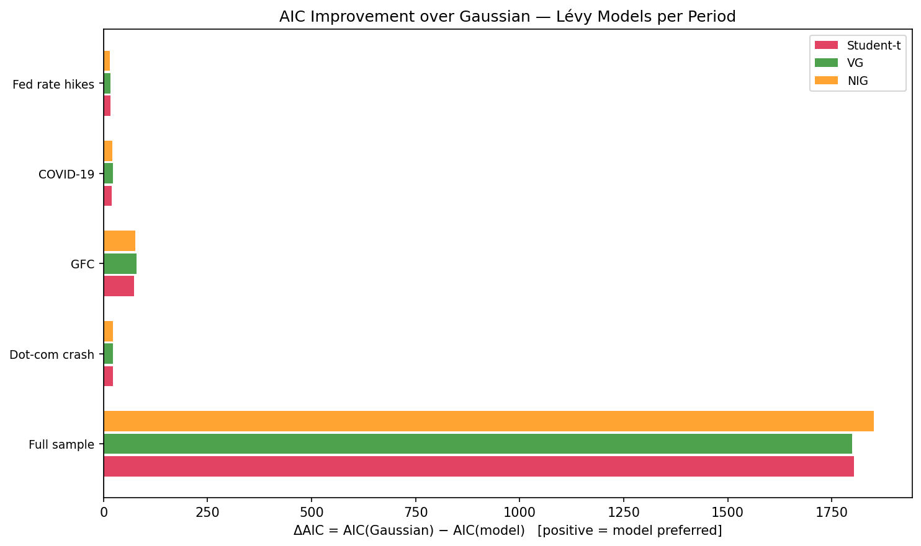
Figure 5. AIC improvement of each Levy model over the Gaussian by period.

