NOTE: Use of internet is permitted **only** to access software website, calculators are permitted and your answers must include worked solutions. If you require extra sheet(s) please write your name and student number at the top of each additional sheet.

<https://logic.ly/>

**Part A**

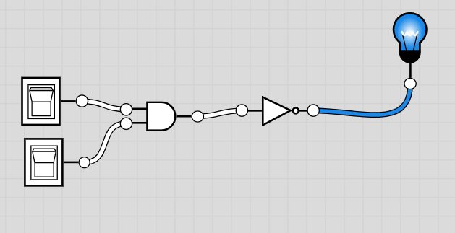**Objective**

Understand various logic gates

|  |
| --- |
| 1. Using Logic.ly create a circuit file and label Gate Symbols, Functional Notation and truth table for the gates listed in the table below: |
| **C:\Users\c00263806\AppData\Local\Microsoft\Windows\INetCache\Content.Word\nand gate.PNG**   |  |  |  |  |  |  |  | | --- | --- | --- | --- | --- | --- | --- | | **Inputs** | | **Output(s) Truth Table** | | | | | | **A** | **B** | **AND** | **OR** | **XOR** | **NAND** | **NOR** | | **0** | **0** | 0 | 0 | 0 | 1 | 1 | | **0** | **1** | 0 | 1 | 1 | 1 | 0 | | **1** | **0** | 0 | 1 | 1 | 1 | 0 | | **1** | **1** | 1 | 1 | 0 | 0 | 0 | | **Gate**  **Symbol** | |  |  |  |  |  | | **Functional**  **Notation** | |  |  |  |  |  | |

|  |  |  |  |  |  |  |  |  |
| --- | --- | --- | --- | --- | --- | --- | --- | --- |
| 1. Construct the logic circuit below using Lab Logic and detail the functional notation and truth table for a two input **AND** gate.  |  |  |  |  | | --- | --- | --- | --- | |  | Switches | AND Gate | LED Output | |  | | | | |
|  |

**Part B**

**Objective**

Understand the construction of Logic Gates from various combinations of logic gates

|  |
| --- |
| 1. Using Lab Software prove that combining and **AND** and a **NOT** constructs a **NAND** Gate    **NOTE:** solution must be demonstrated to Lecturer prior to leaving laboratory |
| |  |  |  |  |  |  | | --- | --- | --- | --- | --- | --- | | Demonstrated to lecturer | |  |  | | --- | --- | | Yes | No | |  |  | | |

|  |  |  |  |  |  |  |  |  |  |  |  |  |  |  |  |  |  |  |  |  |  |  |  |
| --- | --- | --- | --- | --- | --- | --- | --- | --- | --- | --- | --- | --- | --- | --- | --- | --- | --- | --- | --- | --- | --- | --- | --- |
| 1. Prove using Lab Software and a truth table that the circuit below is a XOR Gate. Place an LED on the output of the constructed circuit.   **NOTE:** solution must be demonstrated to Lecturer prior to leaving laboratory   |  |  | | --- | --- | | **Inputs** | | | **A** | **B** | **XOR** | | **0** | **0** | 1 | | **0** | **1** | 0 | | **1** | **0** | 0 | | **1** | **1** | 1 |  |  |  |  |  |  |  | | --- | --- | --- | --- | --- | --- | | Demonstrated to lecturer | |  |  | | --- | --- | | Yes | No | |  |  | | |
| 1. Prove DeMorgan’s Law ¬(A  B) = ¬A  ¬B using Lab Software |
| |  |  |  |  |  |  | | --- | --- | --- | --- | --- | --- | | Demonstrated to lecturer | |  |  | | --- | --- | | Yes | No | |  |  | | |

**Hand up this practical report at the end of session and ensure it has been checked**

|  |  |  |  |
| --- | --- | --- | --- |
| **Student Name** |  | **Student Number** |  |
| **Date** |  | **Checked** |  |
| **Group** | **A / B** |  |  |