Recognising German traffic signs using Neural Networks with Transfer Learning

Darragh Sherwin

*IT Sligo*

Abstract

Recognising traffic signs is very important for autonomous vehicles. Convolutional  Neural Networks (CNN) can classify images; however, they are computationally expensive to train and require vast amounts of data. Transfer learning allows the re-use of an existing knowledge base to classify a new set of images. We will demonstrate how CNNs can be quickly trained with a small dataset to accurately classify traffic signs through transfer learning.

**Keywords:** Convolutional  Neural Network, Transfer Learning

# 1 Introduction

Traffic sign recognition is essential for autonomous vehicles if they are to obey the rules of the road. Traffic signs are simple in their design with simple shapes, colours and symbols to inform all road users of various hazards or changes to road conditions in all weather and lighting both during the day and at night.

Autonomous vehicles use cameras to detect traffic signs. The images taken by these cameras are subject to obstructions, poor lighting, motion blur, and other impediments to clear identify the traffic sign [Arcos-García, Álvarez-García and Soria-Morillo, 2018].

There is a need to classify the traffic sign images correctly under various and numerous conditions. CNNs offer a mechanism to classify images into appropriate classes. However, CNNs require vast quantities of data and computing resources to train [Simonyan & Zisserman, 2014]. Trained CNNs have knowledge about images and their classification. That knowledge gained in the CNN on one set of problems can be used to solve a different but related set of problems. A CNN trained for classifying cars can be used to classify trucks as cars and trucks are related through transfer learning, a process of taking several of the trained layers from existing CNN and putting them into a new model.

It will be demonstrated that applying transfer learning to a pre-existing model can be highly accurate without the significant overhead of training all layers of a new CNN.

# 2 State of the Art

Currently, there are three popular models for transfer learning, they are [Brownlee, 2021]:

* VGG (e.g. VGG16 or VGG19).
* GoogLeNet (e.g. InceptionV3).
* Residual Network (e.g. ResNet50).

The best performing CNN for German road traffic signs was developed by the DeepKnowledge Seville team, who used a CNN with three spatial transformers to achieve an accuracy of 99.71% [GTSRB - German Traffic Sign Recognition Benchmark, 2018].

# 3 Methodology

This project used data pre-processing, model configuration, transfer learning, model training and model verification to obtain satisfactory accuracy levels. These methods are described in the following subsections. A full implementation is available on Github [Sherwin, 2021].

## 3.1 Dataset and data pre-processing

The German Traffic Sign Recognition Benchmark (GTSRB) dataset was used [Stallkamp et al., 2011]. Thisdataset contains 39,209 training images, and 12,630 test images split into 43 classes of road signs. A sample of these images are displayed in Figure 1. The images have various dimensions ranging from 32 x 32 pixels up to 224 x 201 pixels and are not balanced amongst all 43 classes as shown in Figure 2.

For the purposes of training and validation, the training dataset was split into two datasets, a training dataset of 31,368 images and a validation set of 7,841 images. All images were resized to 224x224 pixels using Keras Image Data Generators and for some iterations were encoded using the Keras Preprocessor (preprocess_input) [Michlin, 2019]. A weight was computed for each class of images using the Keras compute_weight function based on the number of images in that class.

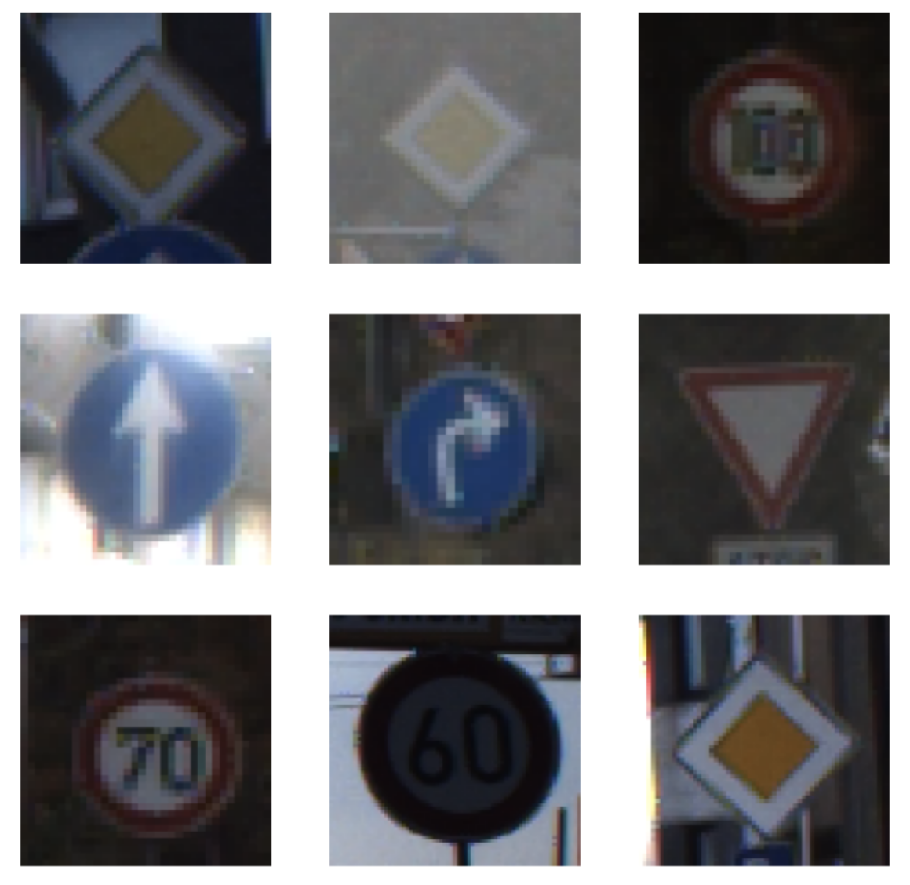

Figure 1: Sample traffic signs from German Traffic Sign Recognition Benchmark dataset.

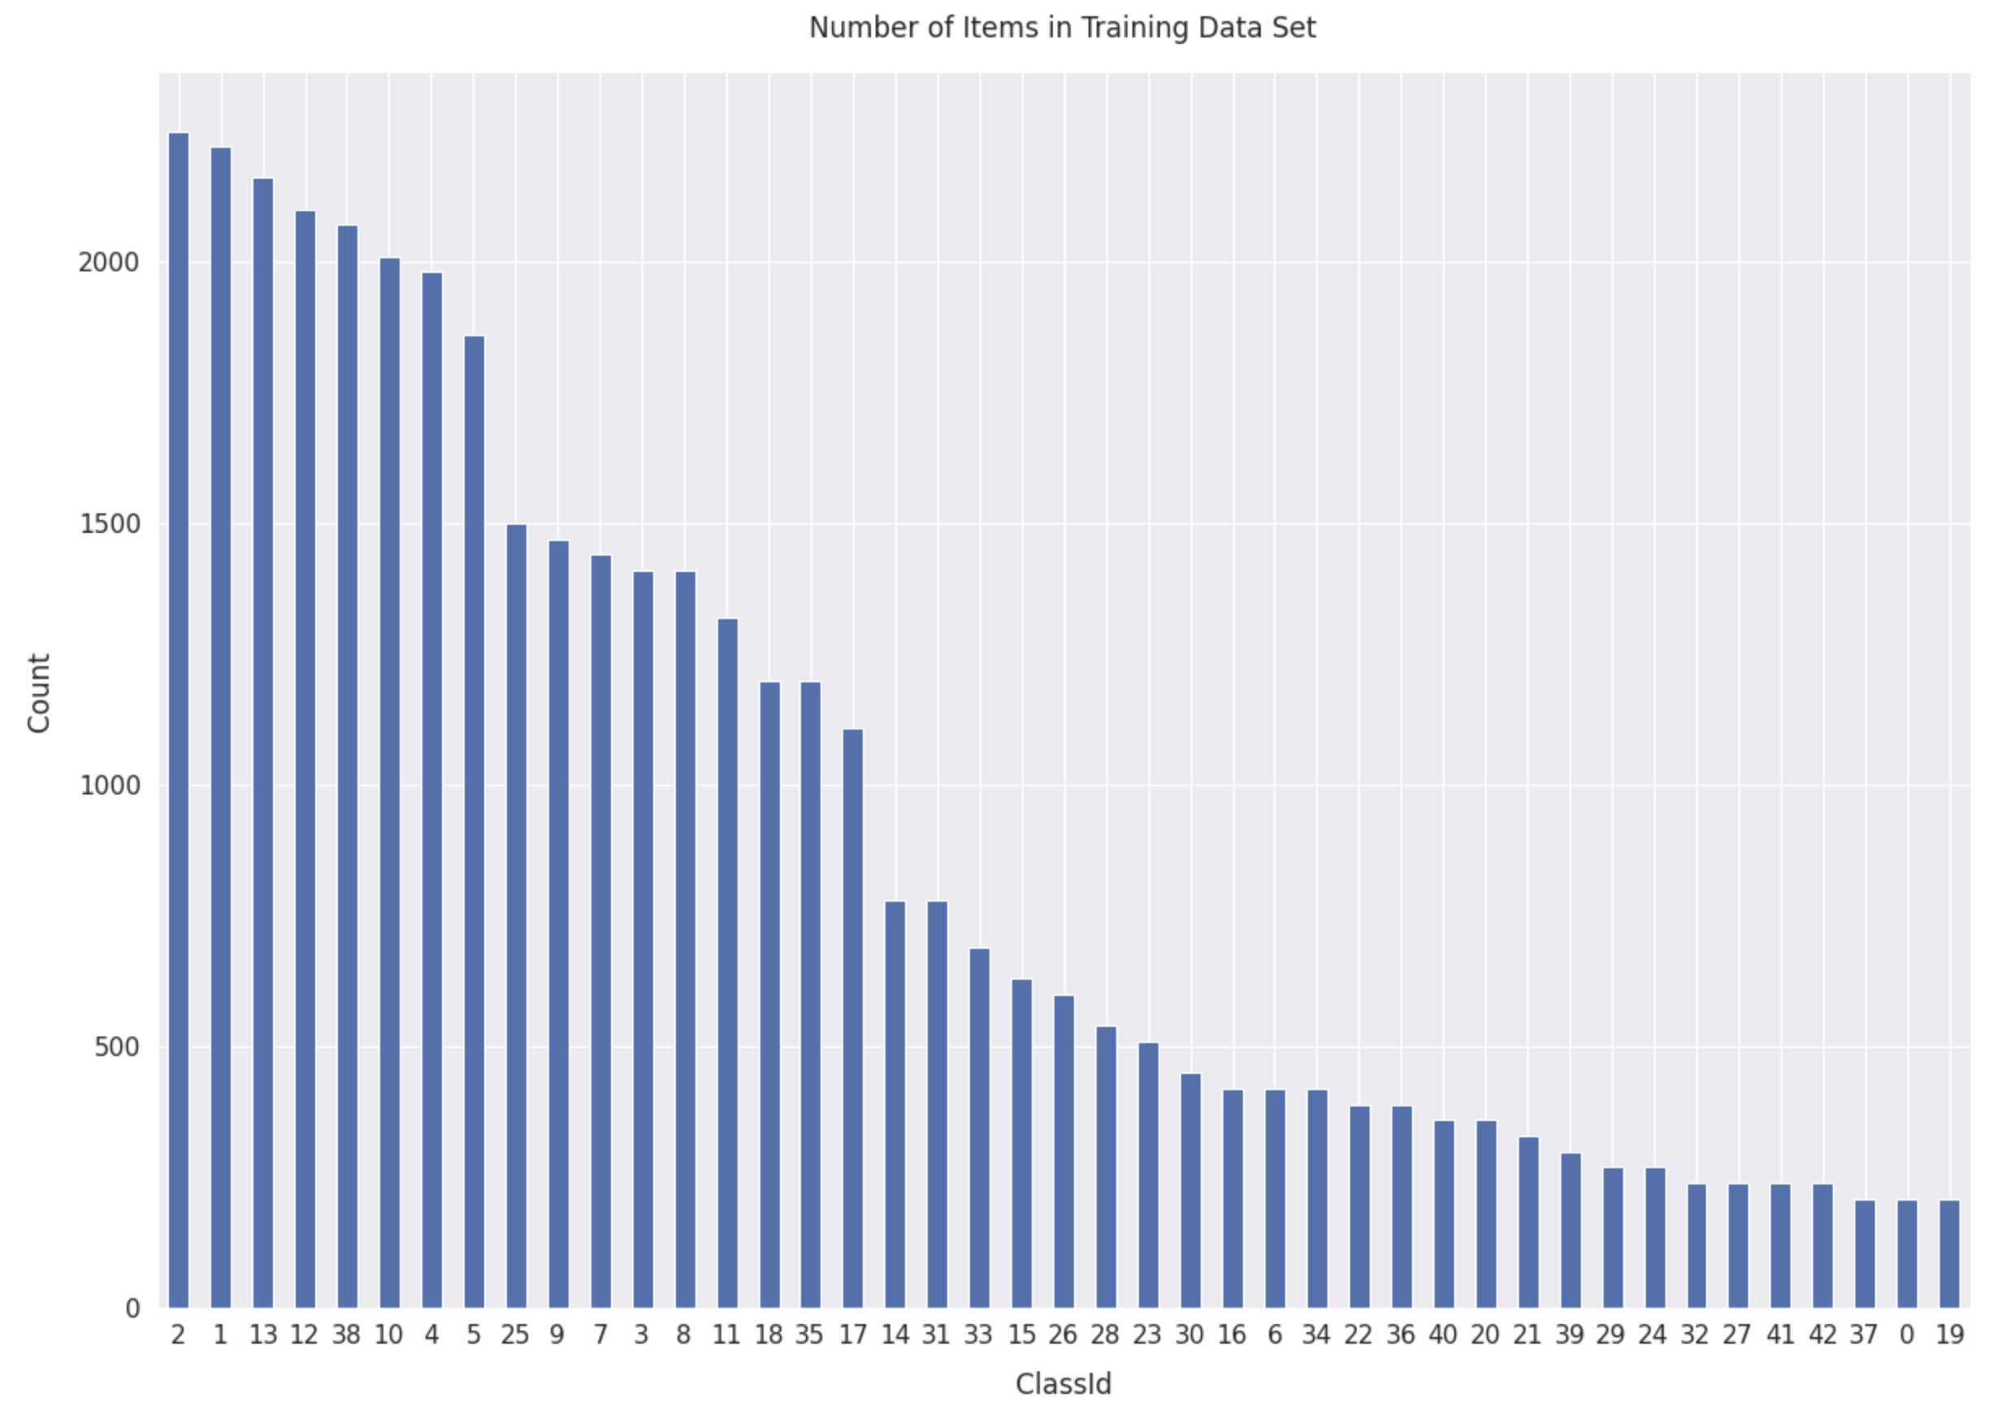

Figure 2: Balance of image classes in GTSRB dataset.

## 3.2 Model configuration

The CNN model VGG16 from the Keras library was used. It has 16 convoluted layers and has been previously trained on 14 million images in 1000 classes. It has an accuracy of 92.7% in the top-5 test accuracy in the ImageNet Large Scale Visual Recognition Challenge (ILSVRC) [Simonyan and Zisserman, 2014].

The Adam optimiser was chosen as the model optimiser as it is computationally efficient [Kingma and Ba 2014]. All models were configured with call backs to stop early based on validation losses to prevent overfitting and save the best model weights at the end of each epoch.

## 3.3 Transfer Learning

The top layers of the VGG16 model were replaced with new dense layers that were trainable to classify the traffic signs. Initially, all convoluted layers were frozen to prevent modifying their previously trained weights. Several layers were allowed to be trainable in subsequent iterations to gain higher accuracy in training and testing.

## 3.3 Model Training

All model iterations were trained with the data as outlined in subsection 2.1. The training and prediction was performed on a Google Cloud virtual machine with four vCPUs, 26GB of Ram and one Nvidia Tesla T4 GPU. A validation dataset was used in the training by the early stopping call-back to ensure there was no overfitting.

## 3.4 Model Verification

Once the model iteration was trained, it was used to generate predictions based on the uncategorised testing dataset. These predictions were used to verify the model for accuracy. Results of each training iteration are shown in Table 1.

|  |  |  |  |  |  |  |  |  |  |
| --- | --- | --- | --- | --- | --- | --- | --- | --- | --- |
| Iteration | Pre-processed Input | Trainable Layers | Epochs | Execution Time  (h:mm:ss) | Training Accuracy | Training Loss | Validation Accuracy | Validation Loss | Testing Accuracy |
| 1 | No | 0 | 14 | 41:55 | 97% | 0.293 | 76.2% | 13.103 | 73.71% |
| 2 | No | 5 | 17 | 57:20 | 100% | 0.001 | 96.5% | 0.583 | 95.86% |
| 3 | Yes | 5 | 21 | 1:11:15 | 99.9% | 0.009 | 95.7% | 0.612 | 96.17% |
| 4 | Yes | 10 | 23 | 1:41:59 | 99.9% | 0.002 | 98.5% | 0.078 | 97.38% |

Table 1: Results of model training iterations.

# 4 Conclusions

Recognition of traffic signs using CNNs with transfer learning shows high accuracy. In training iterations, a CNN with transfer learning was demonstrated to have an accuracy of 97.38% with an uncategorised testing dataset. Others have achieved a 99.71% accuracy with the same dataset [Arcos-García, Álvarez-García and Soria-Morillo, 2018]. There is potential for further exploration of transfer learning on CNNs to improve accuracy.

# References

[Arcos-García, Álvarez-García and Soria-Morillo, 2018] Arcos-García, Á., Álvarez-García, J. and Soria-Morillo, L., 2018. Deep neural network for traffic sign recognition systems: An analysis of spatial transformers and stochastic optimisation methods. *Neural Networks*, 99, pp.158-165.

[Brownlee, 2021] Brownlee, J., 2021. *Transfer Learning in Keras with Computer Vision Models*. [online] Machine Learning Mastery. Available at: <https://machinelearningmastery.com/how-to-use-transfer-learning-when-developing-convolutional-neural-network-models/> [Accessed 30 December 2021].

[GTSRB - German Traffic Sign Recognition Benchmark, 2018] Benchmark.ini.rub.de. 2018. *German Traffic Sign Benchmarks*. [online] Available at: <https://benchmark.ini.rub.de/gtsrb_results.html> [Accessed 1 January 2022].

[Kingma and Ba 2014] Kingma, D.P. and Ba, J., 2014. Adam: A method for stochastic optimisation. *arXiv preprint arXiv:1412.6980*.

[McDermott, 2021] McDermott, J., 2021. *Hands-on Transfer Learning with Keras and the VGG16 Model*. [online] Learndatasci.com. Available at: <https://www.learndatasci.com/tutorials/hands-on-transfer-learning-keras/> [Accessed 30 December 2021].

[Michlin, 2019] Michlin, I., 2019. *Keras data generators and how to use them*. [online] Medium. Available at: <https://towardsdatascience.com/keras-data-generators-and-how-to-use-them-b69129ed779c> [Accessed 22 December 2021].

[Sherwin, 2021] Sherwin, D., 2021. *GitHub - darraghs/SligoIT_ML2021_VGG16: Assignment on transfer learning in neural networks*. [online] GitHub. Available at: <https://github.com/darraghs/SligoIT_ML2021_VGG16> [Accessed 3 January 2022].

[Simonyan and Zisserman, 2014] Simonyan, K. and Zisserman, A., 2014. Very deep convolutional networks for large-scale image recognition. *arXiv preprint arXiv:1409.1556*.

[Stallkamp et al., 2011] Stallkamp, J., Schlipsing, M., Salmen, J., & Igel, C. (2011). The German traffic sign recognition benchmark: A multi-class classification competition. In The 2011 international joint conference on neural networks (pp. 1453–1460).