Implementation of ZipF Matrix Factorization

Darragh Sherwin

*IT Sligo*

Abstract

**Keywords:** Convolutional  Neural Network, Transfer Learning

# 1 Introduction

# 2 State of the Art

# 3 Methodology

## 3.1 Dataset and data pre-processing

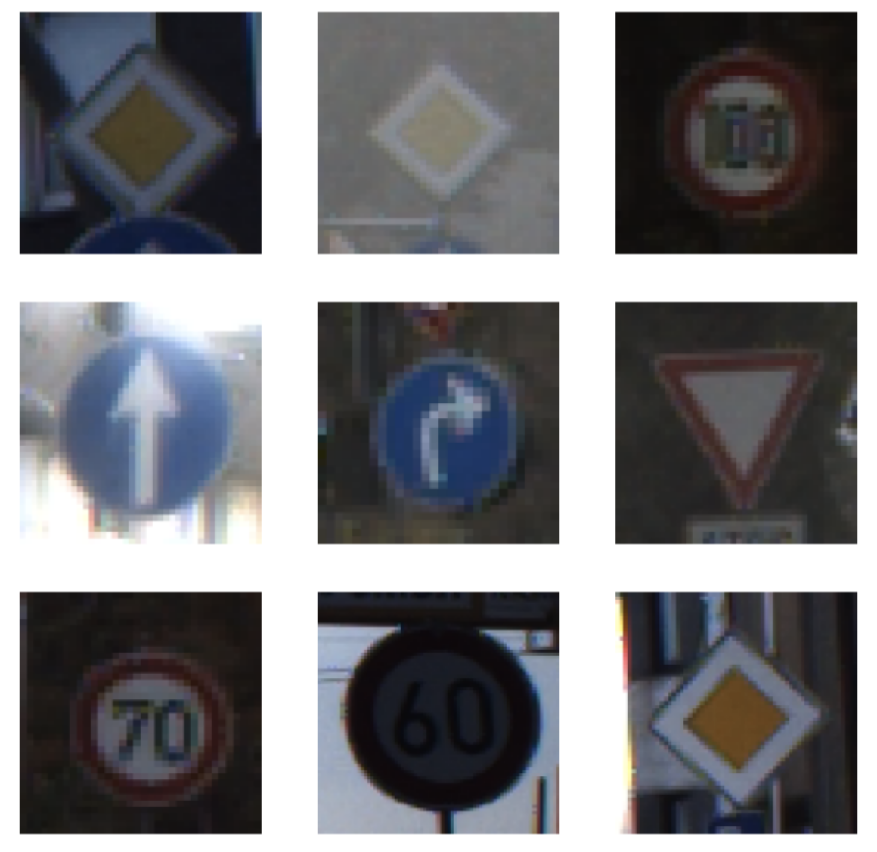

Figure 1: Sample traffic signs from German Traffic Sign Recognition Benchmark dataset.

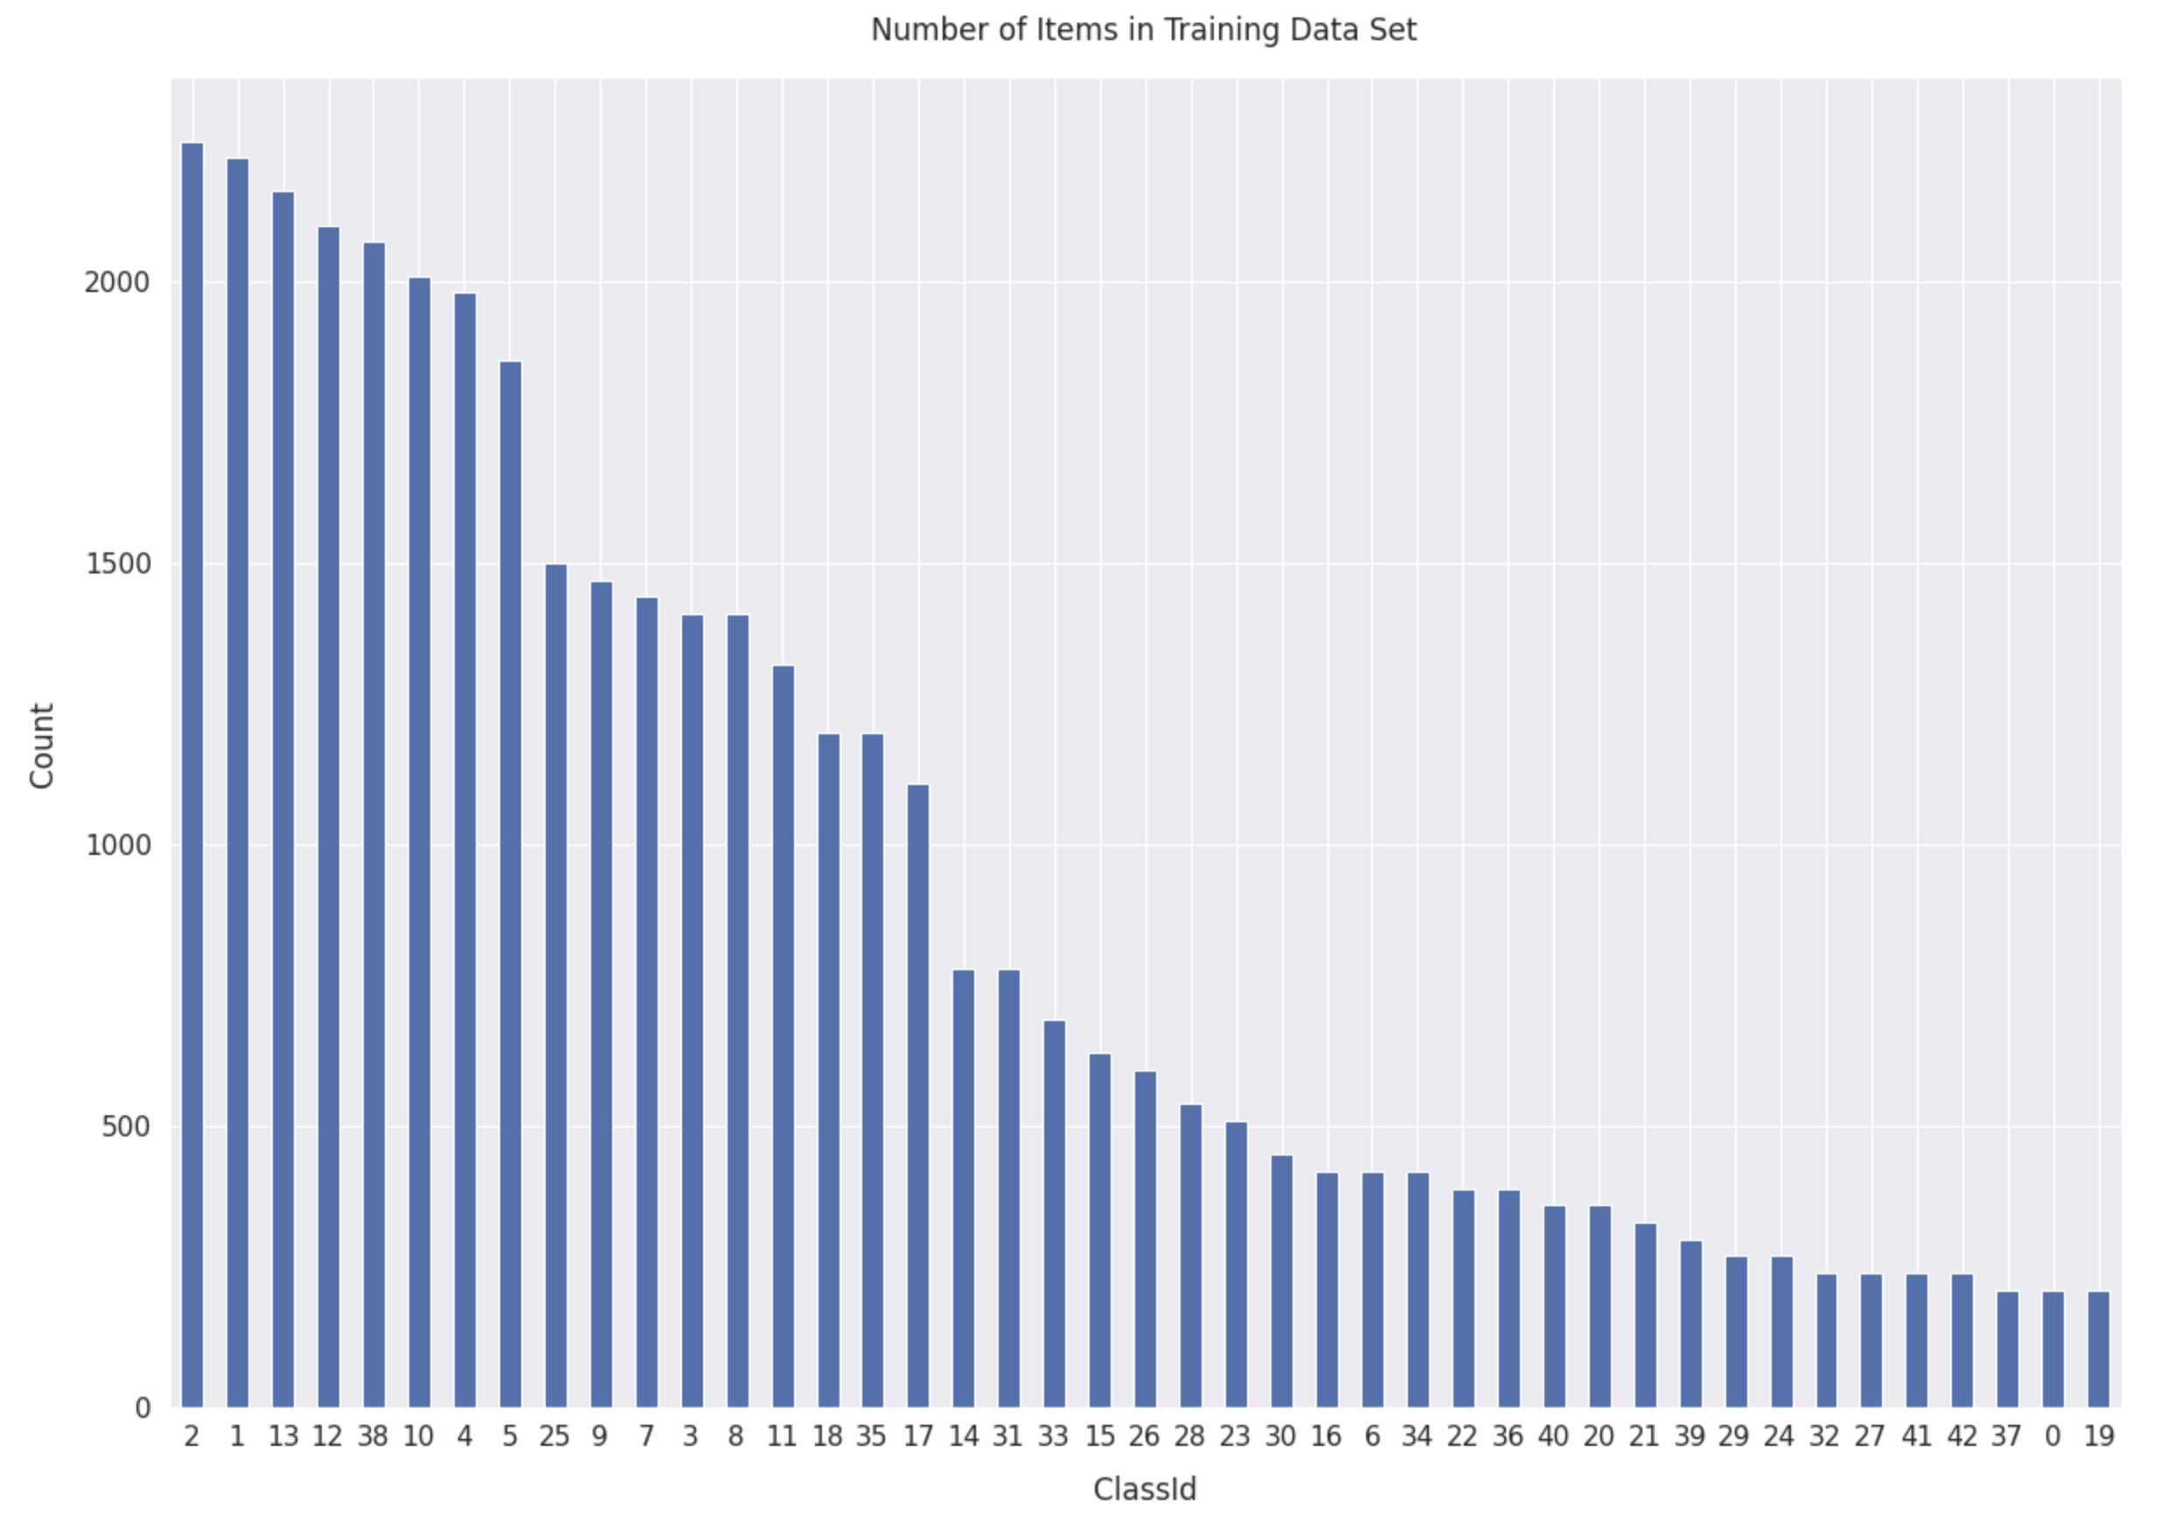

Figure 2: Balance of image classes in GTSRB dataset.

## 3.2 Model configuration

## 3.3 Transfer Learning

## 3.3 Model Training

## 3.4 Model Verification

|  |  |  |  |  |  |  |  |  |  |
| --- | --- | --- | --- | --- | --- | --- | --- | --- | --- |
| Iteration | Pre-processed Input | Trainable Layers | Epochs | Execution Time  (h:mm:ss) | Training Accuracy | Training Loss | Validation Accuracy | Validation Loss | Testing Accuracy |
| 1 | No | 0 | 14 | 41:55 | 97% | 0.293 | 76.2% | 13.103 | 73.71% |
| 2 | No | 5 | 17 | 57:20 | 100% | 0.001 | 96.5% | 0.583 | 95.86% |
| 3 | Yes | 5 | 21 | 1:11:15 | 99.9% | 0.009 | 95.7% | 0.612 | 96.17% |
| 4 | Yes | 10 | 23 | 1:41:59 | 99.9% | 0.002 | 98.5% | 0.078 | 97.38% |

Table 1: Results of model training iterations.

# 4 Conclusions

.

# References

[Arcos-García, Álvarez-García and Soria-Morillo, 2018] Arcos-García, Á., Álvarez-García, J. and Soria-Morillo, L., 2018. Deep neural network for traffic sign recognition systems: An analysis of spatial transformers and stochastic optimisation methods. *Neural Networks*, 99, pp.158-165.