**A GENETIC ALGORITHM TO OPTIMIZE HEURISTIC VARIABLES FOR CONSTRAINT SATISFACTION PROBLEMS**

by

RYAN DARRAS

B.I., University of Colorado, 2016

A thesis submitted to the Graduate Faculty of the

University of Colorado at Colorado Springs

in partial fulfillment of the

requirements for the degree of

Master of Science

Department of Computer Science

2019

© Copyright Ryan Darras 2019

All Rights Reserved

This thesis for the Master of Science degree by

Ryan Darras

has been approved for the

|  |
| --- |
| Date |

Department of Computer Science

by

|  |
| --- |
| Sudhanshu K. Semwal, Chair |

|  |
| --- |
| Albert Chamillard |

|  |
| --- |
| Yanyan Zhuang |

Darras, Ryan (M.S., Computer Science)

A Genetic Algorithm to Optimize Heuristic Variables

for Constraint Satisfaction Problems

Thesis directed by Professor Sudhanshu K. Semwal

Constraint satisfaction problems, even if one doesn’t know it, are problems that we interact with almost every day. Many researchers are studying constraint satisfaction problems and focusing on optimizing them because they are relevant and can directly impact and improve daily situations.

Everybody loves Amazon, the modern age option to shop in the comfort of home and have the items shipped directly to your doorstep. However, many of us might not understand the complexity behind managing such a massive operation. The traveling salesperson problem is a common lesson for in Analysis/NP-Completeness courses, yet dwarfs in comparison to what Amazon and other distributors have to deal with. In the United States alone, Amazon delivers millions of packages per day throughout thousands of cities. Each delivery driver works a scheduled shift anywhere from roughly four to ten hours a day, with many cities managing multiple drivers. Every single route needs to be planned as optimally as it can to have the availability of two-day shipping. The scheduler also needs to consider shipping between warehouses that are on the opposite ends of the country. Without researchers designing effective algorithms to increase the efficiency of this massive problem, we wouldn’t have the luxury of having our online purchases appearing on our doorstep in just a few days of the order. This is simply because of the massive complexity of their problem, which is why research on constraint satisfaction problems, which are NP-hard problems, is so important.

Due to the potential NP-Hardness of many constraint satisfaction problems and their relationships that allow research to share across problems, they have been subject of profound study in both artificial intelligence and operations research. Often times, new NP-Hard problems contain or can be derived from existing NP-Complete and NP-Hard problems to provide a research area for more specified problems that severely impact the real world. A solution to these problems can be found by using branch-and-bound algorithms. Branch and bound algorithms are a very common tool when solving NP-Hard problems due to their nature to become an exhaustive search which will provide every possible answer and look at it before reporting the best answer. However, exhaustive branch and bound algorithms are incredibly inefficient yet they can be heavily optimized by implementing a heuristic which determines if a branch cannot be a potential solution, in which case the branch is pruned. These heuristics are generally obtained by studying the given problem and using insight, logic, and reason to determine the most optimal values and weights.

Due to the possible increase in efficiency, creating a heuristic that accurately measures each branch is an incredibly important part of optimizing these problems. Determining which branch is not worth searching heavily reduces the algorithms runtime. In this research, we propose a genetic algorithm that will determine the optimal heuristic values for any given CSP.

Table of Contents

CHAPTER 1 1

INTRODUCTION 1

Purpose of this Research 1

The Focus Problems 2

0-1 Knapsack Problem 3

Traveling Salesman Problem 4

Job Shop Scheduling Problem 6

N-Queens Problem 7

Graph Coloring Problem 9

EVALUATION METRICS 10

Time 10

Space 10

Accuracy 11

CHAPTER 2 11

REVIEW OF THE LITERATURE 11

Heuristics 11

Genetic Algorithms 12

General Constraint Satisfaction Problems 12

0-1 Knapsack Problem 12

Traveling Salesman Problem 12

Job Shop Scheduling Problem 13

N-Queens Problem 13

Graph Coloring Problem 13

SIGNIFICANCE OF THIS RESEARCH 13

CHAPTER 3 (TODO: Finish all problems) 13

PROJECT IMPLEMENTATION 13

Framework 13

Genetic Algorithm 14

Chromosome 16

Population 16

Focus Problems 17

0-1 Knapsack Problem 17

Traveling Salesman Problem 19

Job Shop Scheduling Problem 19

N-Queens Problem 19

Graph Coloring Problem 19

CHAPTER 4 19

SYSTEM OVERVIEW 20

DATA & RESULTS 20

0-1 Knapsack Problem 20

Traveling Salesman Problem 26

Job Shop Scheduling Problem 26

N-Queens Problem 27

Graph Coloring Problem 27

CONCLUSION 27

BIBLIOGRAPHY/REFERENCES (TODO) 27

# CHAPTER 1

## INTRODUCTION

Constraint satisfaction problems consist of a set of objects V, each with their own variables, and a set of constraints E on the variables of the objects. To solve a constraint satisfaction problem a state V must be found that satisfies every e ε E. Constraint satisfaction problems often require a combination of heuristics and search algorithms to solve due to their exponential complexity of NP-Completeness[1]. Branch-and-bound algorithms are commonly used for solving NP-Complete problems due to its nature of searching a state space. A branch-and-bound algorithm uses heuristics to optimize the upper and lower bounds, reducing the total amount of space searched to optimize efficiency. However, heuristic variables are a challenge due to the complexity of the problems which prevents us from being able to easily determine the optimal values. Hence, in our work, we will be implementing a genetic algorithm that will search for optimal heuristic values to speed up our branch-and-bound algorithms.

### Purpose of this Research

Constraint satisfaction problems (CSPs) are hurdles for many projects and goals that countless people run into on a day-to-day basis. This research will look at a different way to solve these problems by simply optimizing the way we attempt their solution.

In the past, software engineers and software developers relied on Moore’s Law to increase the range of possibilities for modern computers. However, Moore’s Law is coming to an end[2], and computers may not see the same level of speedup as we have the past half-century. Due to this, the responsibility of writing fast and effective algorithms falls directly on the software engineers and software developers themselves.

By providing the research that demonstrates the values and benefits of having a genetic algorithm find the optimal method to solve constraint satisfaction problems, we open a pathway for many other NP-Hard[3] problems to be studied to provide more optimal solutions.

### The Focus Problems

There are an insurmountable amount of constraint satisfaction problems and even more sub-problems that have derived from them. Due to this, it is impossible to apply this research to every single constraint satisfaction problem so we have pulled a subset of five problems that can be used as an entry point, and give us a good breadth of data that should be representative of constraint satisfaction problems as a whole.

#### 0-1 Knapsack Problem

The 0-1 knapsack problem is defined by having a knapsack with a given weight limit W. Given a collection of items N each with a value v and weight w, the goal of this problem is to select items to put in the knapsack that results in the highest possible total value. While the 0-1 knapsack problem is the most common, there are many derivations of the knapsack problem such as the unbounded knapsack problem, multi-objective knapsack problem, multi-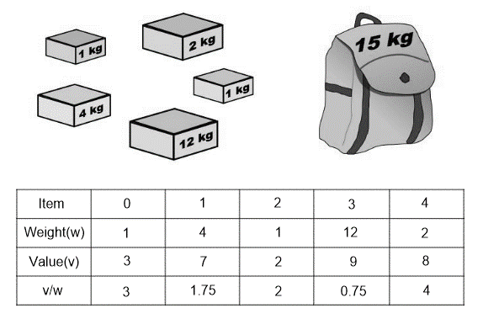dimensional knapsack problem, and the multiple knapsack problem.

Figure . Shows an example of a 0-1 knapsack problem, including v/w which is used in the approximation algorithm called the greedy knapsack algorithm.

#### Traveling Salesman Problem

The traveling salesman problem has long been studied as an intro to algorithms and big-O notation. It is a problem that many people, even those not studying computer science, may have heard about. This problem involves a traveling salesperson that needs to visit n cities to sell their merchandise. In order to optimize his time, and therefore his profits, he needs to plan out the route that is the shortest possible route between the cities. Traditional forms of the problems limit the salesperson to a single visit to each city, whereas other forms allow the salesperson to pass through a city multiple times if it yields a faster route.

This is a very rigorously studied problem as it fully demonstrates the property of NP-complete because all possible combination of routes must be looked at. Not only that, but this problem affects billions of people every single day. Without optimal path planning, Amazon’s costs could go up, which in turn causes their merchandise to increase in price which affects all of their users.

A brute force search for the optimal route would result in an algorithm that has a running time of O(n!) where n is the number of cities that need to be visited. This makes a brute force algorithm non-feasible even when the number of cities is only 15. Linear programming techniques work well for up to 200 cities, but the current method for solving large instances is an approach using a derivative of a branch-and-bound algorithm called a branch-and-cut algorithm. This solution holds the current record, solving an instance with 85,900 unique 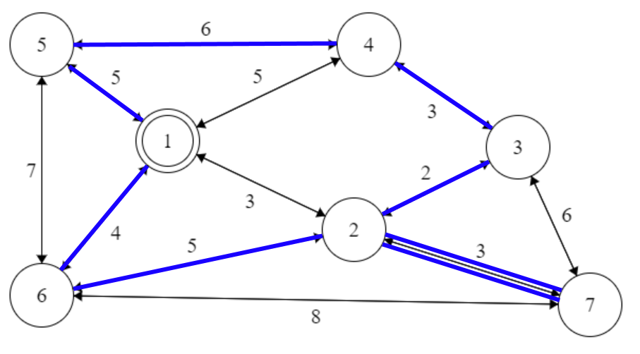cities[4]­.

Figure . An example of a solved traveling salesman problem starting at city 1, and ending back at city 1. This example demonstrations the version of the problem where the salesman can backtrack if doing so would result in a more optimal path.

#### Job Shop Scheduling Problem

The job shop scheduling problem is another very popular problem that is shared with students during their architecture and operating systems classes because it is an impressive optimization problem that severely impacts computers today.

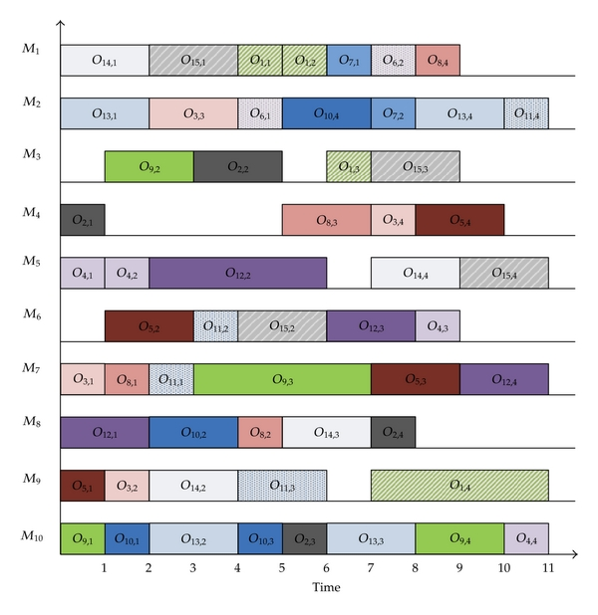The problem focuses on scheduling computer tasks (jobs) in such a way that optimizes performance. What makes the job shop scheduling problem so tricky is that the method of optimizing performance is different for many different systems based on the objective of that machine. For example, if we have a uniprocessor system we need to determine if multiprogramming is important to us, or if we want to frontload all processing power to singular tasks.

Figure . This is an example of a job shop scheduling problem with each job is a specific color and each objective for each job must be completed in order (denoted by Oj,n where j is the job and n is the order at which it must complete. This example uses 10 machines to optimize the schedule.

The job shop scheduling problem encapsulates the traveling salesman problem. The traveling salesman problem is a special case of a job shop scheduling problem where the salesman is a machine, and the cities are the jobs. Knowing that the traveling salesman problem is NP-Hard, we can infer that the job shop scheduling problem is also NP-Hard.

The problem consists of n jobs J­1, J2, … , Jn each with a set of operations O1, O2, … , On that need to be processed in a specific order. Throughout the variations of this problem the many constraints include, but are not limited to: each operation having a specific machine that it needs to be processed on, is multiprocessing available, focus on minimizing the average response time, job dependencies, deterministic or probabilistic processing times, and minimizing the total length of the schedule.

#### N-Queens Problem

The n-queens problem is described as placing n queens on an nxn chessboard, where no queen can attack another queen. More specifically, no two queens share the same row, column, or diagonal. This problem was first established in 1848 by Max Bezzel who rigorously studied the strategies of chess[5].

What makes the n-queens problem interesting is that while researchers are interested in finding a solution, they are also interested in finding the number of possible solutions for any value of n. Similar to the traveling salesman problem, any value of n is relatively simple to solve up until n=15 where you run into the same situation due to the n-queens problem for solving the number of possible solutions being O(n!).

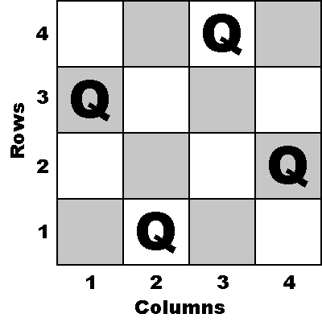

Figure . Example of an n=4 n-queens problem. Note that no queen shares a row, column, or diagonal with any other queen.

The n-queens problem has many related problems that make research towards it more valuable. These related problems include higher dimensions, n-knights/bishops/kings/rooks, a mix of different chess pieces, and completing a partial n-queens solution.

#### Graph Coloring Problem

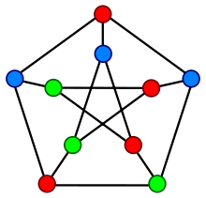 The simplest form of the graph coloring problem focuses on coloring vertices of a graph in such a way that no two adjacent vertices share the same color. However, the graph coloring problem is one of the most dynamic constraint satisfaction problems due to the additional constraints that can be added into the problem.

Figure . A solution for vertex coloring of the Petersen graph.

The graph coloring problem can be separated into three different problems: vertex coloring where no two adjacent vertices share a color, edge coloring where no two adjacent edges share a color, and face coloring where no face on a planar graph shares a boundary with another face of the same color. Not only that, but the problem can be altered to consider alternative constraints such as: blue cannot be adjacent to green, or red must only be adjacent to purple or yellow. We can apply the graph coloring technique to an uncolored map to determine the smallest number of colors we need, as well as to solve a configuration of colors to color the map. Another use of the graph coloring problem, for example, would be to match *n* number of candidates with *n* number of jobs where each candidate has the appropriate qualifications for the job they are assigned.

## EVALUATION METRICS

Due to the nature of these problems, it is important to evaluate multiple dimensions of complexity to fully understand the implications of these problems in large scale. Therefore, we have recorded and studied the three dimensions of time, space, and accuracy. By considering multiple dimensions, we can discover relationships and correlations that will further our research.

### Time

Time is a tricky evaluation metric due to factors such as computer specifications, project implementation, and outside interference. Therefore, we are logging both real-time as well as any data pertaining to the algorithm. Specifically: array accesses, array copies, swaps, failed branches, etc. By recording this additional information, an understanding can be made of the relationships between different heuristics for each problem.

### Space

Easier than time, space can be calculated by determining the total memory usage used to calculate the problem. However, evaluating space needs to consider maximum space required during the algorithm and average space required during the algorithm in order to more fully encompass the problem solution. To do this, data structure sizes and count of data structures in use will be calculated to provide a reasonable space evaluation.

### Accuracy

These problems indeed have optimal solutions, but to find the perfect answer is exponentially more complex and time consuming than using heuristics for educated estimates. Therefore, our heuristics might not be 100% correct 100% of the time. For many of these problems, estimates are more than enough to claim that the problem is satisfied, but at which point is an estimate not good enough? Specifically, at what point of accuracy is that estimate not valid? To record and evaluate accuracy, we will simply be comparing to the theoretical optimal solution for each problem. Therefore, Accuracy = Our Solution / Theoretical Optimal Solution.

# CHAPTER 2

## REVIEW OF THE LITERATURE

The following sections are simple surveys of the topics studied in this thesis. These surveys will consider the most state-of-the-art to ensure our work is based on the top of the line research.

### Heuristics

The power of a heuristic does not come from the solution, but rather the method of obtaining the solution. Constraint Satisfaction Problems are faced with the problem of not being able to find the most optimal solution in polynomial time, but by using a heuristic you can approximate the solution in polynomial time. Taking a step further, Burke et al. have surveyed the topic of Hyper-Heuristics, “heuristics to choose heuristics” or “a search method or learning mechanism for selecting or generating heuristics to solve computational search problems”[6] .

Selecting heuristics is a difficult problem. The scientific communities understanding regarding why certain heuristics work well, or do not work well, does not create a simple solution when selecting heuristics. Because of this, there is a lack of guidance as to how to select the heuristics to use for any given problem. Hyper-heuristics attempt to determine the most effective heuristic to use, which results in a more efficient solution to the problem.

These hyper-heuristics can be broken down in to the two main categories of: heuristic selection and heuristic generation. We will be applying the heuristic generation category to each of our focus problems in hopes that we may determine effective heuristics for solving these problems.

### Genetic Algorithms

### General Constraint Satisfaction Problems

### 0-1 Knapsack Problem

### Traveling Salesman Problem

### Job Shop Scheduling Problem

### N-Queens Problem

### Graph Coloring Problem

## SIGNIFICANCE OF THIS RESEARCH

The results of this research may be taken and used to accelerate algorithm development when using heuristics. It will help show relationships and correlations between heuristics and evaluation metrics that should help researches narrow down to more effective, accurate results.

# CHAPTER 3

## PROJECT IMPLEMENTATION

The objective is to make the project as generic and adaptable as possible, meaning implementing new constraint satisfaction problems and solving for their heuristic variables should be as easy as possible. A generic solution would allow this framework to be implemented in the form of a NuGet package which would make this project easy to use for other researchers.

### Framework

This project is written in C# and uses tools and features from Visual Studio. We provide an interface that allows for running the program on our focus problems so we can easily test our outputs vs our inputs.

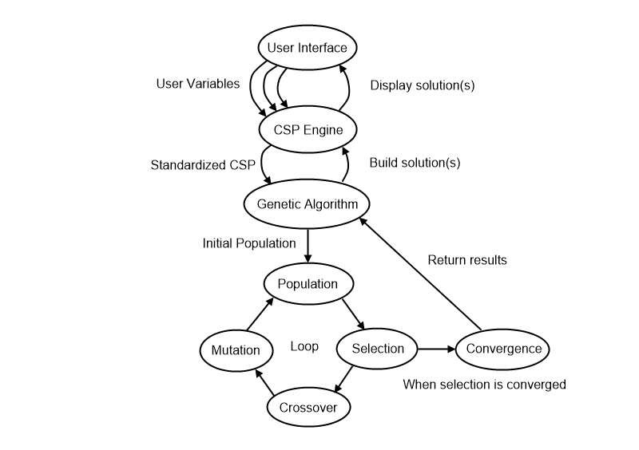

Figure . Demonstration of framework architecture used to test our thesis.

### Genetic Algorithm

The simplest form of a genetic algorithm creates a population of chromosomes where the chromosomes is an array of bits. These bits are toggled on or off throughout the genetic algorithms runtime in hopes to converge on an optimal solution. While this was a potential option, we chose to go with a different route. An alternate form of a genetic algorithm creates a population of chromosomes where the chromosomes are any type of mutable value. By organizing our chromosomes into an array of mutable values we can develop our algorithm to where it modifies weights that are used to calculate fitness.

The algorithm takes the following approach to converge on a result:

1. Generate initial population with a set of default chromosomes and said chromosomes mutated the initial amount.
2. Calculate the fitness of each chromosome in the population by passing the fitness delegate for the specific constraint satisfaction problem we are considering.
3. Determine if the population has converged to similar fitness values. If so, return the result.
4. Selection: Keep the chromosomes with the highest fitness, and dispose of the remaining chromosomes.
5. Crossover: Randomly selects a crossover point valued between 1 and n - 1 where n is the number of genes in a chromosome. Then take two chromosomes and split them at that point to form a new child chromosome. These new children combined with the parents from the previous generation form the new generation.
6. Mutation: At this point we have a new, complete generation and we randomly select a set of chromosomes to mutate. For each of those chromosomes, we randomly select the set of individual genes to mutate, and then mutate them. The chromosome selection chance, gene selection chance, and mutation amount are all values between 0 and 1 that can be adjusted. 0 means 0% chance for selection, or a maximum mutation amount of 0%. 1 means 100% chance for selection, or a maximum mutation amount of 100%. A maximum mutation amount of 100% means that the value in our gene can at maximum double, and at a minimum mutate to 0, or anywhere in between.
7. Go to step 2 and repeat.

After convergence, we return all unique solutions to the problem that were in the convergence threshold. With these solutions, we can either select the best one, or view all solutions as a set to extrapolate data.

#### Chromosome

In some genetic algorithms, a chromosome is an array of bits that are toggled on or off based on the state of the genetic algorithm. In our algorithm, chromosomes are arrays of mutable values, namely integers and floating point values. Each individual value is called a gene, and it is used within the fitness algorithm to determine which chromosomes yield the most accurate results.

#### Population

The population is the collection of chromosomes used when percolating the genetic algorithm. What makes our implementation of the genetic algorithm relatively unique is that our population size must be of a certain format:

size = x + y, where x = y(y-1)/2

This formula forces the size of our population into a form where x is the number of children chromosomes generated each generation and y is the number of parent chromosomes that were the y fittest chromosomes of the previous generation. This formula allows us to have every single parent breed with every other parent, giving us strong coverage for each new generation.

for (int i = 0; i < Chromosomes.Count - 1; i++)

{

for (int j = i + 1; j < Chromosomes.Count; j++)

{

object[] newGenes = new object[GeneCount];

for (int x = 0; x < crossoverPoint; x++)

newGenes[x] = Chromosomes[i].Genes[x];

for (int y = crossoverPoint; y < GeneCount; y++)

newGenes[y] = Chromosomes[j].Genes[y];

chromosomesToAdd.Add(new Chromosome(newGenes));

}

}

### Focus Problems

The following sections will explain, in detail, specific information about how each problem was implemented. They will include information about the heuristic variables used in the chromosomes of the genetic algorithm, as well as details about the fitness algorithm used to determine which chromosomes are superior. How the genetic algorithm is applied so that the solution instances are being created to test if they satisfy the solution or not will also be defined, which includes termination criteria such as a maximum number of loops or iterations.

#### Knapsack Problem

When solving the 0-1 knapsack problem, the variables we need to consider include weight and value. The objective is to obtain the highest available value within the capacity constraints of the knapsack. Traditional techniques for estimating the solution to this problem include finding the ratio R between weight W and value V; specifically, R = V / W.

The greedy algorithm takes the largest R values until the maximum capacity will be overwhelmed to approximate the optimal solution. We will be following this approach, but will instead be using a heuristic to determine the value of R. Our heuristic will be the combination of priority of high/low weight and value. We assume that our genetic algorithm will push our heuristic to prioritize low weight, and high value more than high weight and low value.

We formatted the chromosomes in the following form:

* [0] = priority of low weight (float)
* [1] = priority of high weight (float)
* [2] = priority of low value (float)
* [3] = priority of high value (float)

Our fitness algorithm is as follows:

Items = Items.OrderByDescending(item =>

(MaximumWeight - item.Weight) * Convert.ToSingle(genes[0]) +

item.Weight * Convert.ToSingle(genes[1]) +

(MaximumValue - item.Value) * Convert.ToSingle(genes[2]) +

item.Value * Convert.ToSingle(genes[3])

).ToArray();

List<KnapsackItem> inBag = new List<KnapsackItem>();

foreach (KnapsackItem item in Items)

if (inBag.Sum(t => t.Weight) + item.Weight < Capacity)

inBag.Add(item);

return inBag.Sum(t => t.Value);

Our fitness algorithm first orders the available items to add to the knapsack in descending order based on the chromosome’s values. The sorting algorithm is broken into 4 parts:

1. “MaximumWeight - item.Weight * [0]” allows the first gene to directly influence positively when the items weight is low.
2. “item.Weight * [1]” allows for the second gene to directly influence positively when the items weight is high.
3. “MaximumValue - item.Value * [2]” allows for the third gene to directly influence positively when the items value is low.
4. “item.Value * [3]” allows for the fourth gene to directly influence positively when the items value is high.

When summed, these four values can be used to sort the available items in such a way that when following the greedy algorithm for the 0-1 knapsack problem all we have to do is take from the items list if we have the available space. Once we have fit all that we can into the knapsack, we simply return the total value of all the items in the knapsack as the overall fitness score.

#### Traveling Salesman Problem

#### Job Shop Scheduling Problem

#### N-Queens Problem

#### Graph Coloring Problem

# CHAPTER 4

## SYSTEM OVERVIEW

## DATA & RESULTS

### Knapsack Problem

As expected, the heuristics to solve 0-1 Knapsack Problem were very simple, and the results were similar to what we expected; being that value is attractive, where weight is not. All our tests placed a low priority on large weight and small value, and a high priority on small weight and large value.

We created a knapsack with 300 capacity and randomly generated 300 objects with weights and value between 10-20. Our max R value was 1.889 with a value of 19.318 and a weight of 10.229. Our min R value was .528 with a value of 10.042 and a weight of 19.025.

|  |  |
| --- | --- |
| % Chromosomes Mutated | 50% |
| % Genes Mutated | 50% |
| Maximum % Mutation Deviation | 25% |

All tests used a population size of 528 and a convergence requirement of within 5% fitness, but the genetic algorithm variables used to select which chromosomes and genes were passed on or mutated were modified to discover how these elements effect the results.

We started with the above variables as we felt it was a reasonable starting point with no clear outliers that would heavily affect the data. Essentially, all genes were obtained from the previous generation and 25% of them were mutated by up to 25% of their current value. This put us in a position where we were keeping the good genes but testing the waters with up to a 25% mutation to see if we found an improvement. Below is the top five heuristic values generated by the genetic algorithm and the total value that was obtained from the knapsack.

|  |  |  |  |  |
| --- | --- | --- | --- | --- |
| Min Weight | Max Weight | Min Value | Max Value | Total Value |
| 0.937 | 0.334 | 0.394 | 1 | 490.279 |
| 1 | 0.17 | 0.267 | 0.972 | 488.994 |
| 1 | 0.294 | 0.284 | 0.878 | 488.303 |
| 1 | 0.153 | 0.267 | 0.92 | 485.735 |
| 1 | 0.361 | 0.248 | 0.629 | 484.262 |

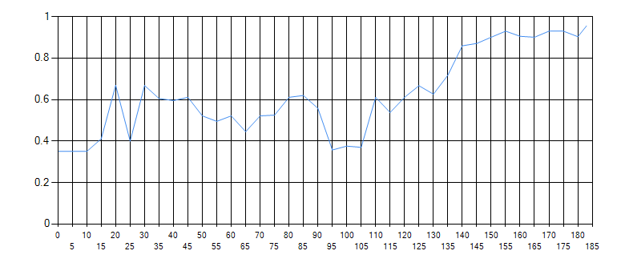

Figure shows the convergence over 185 generations until the convergence threshold of being within 5% was reached.

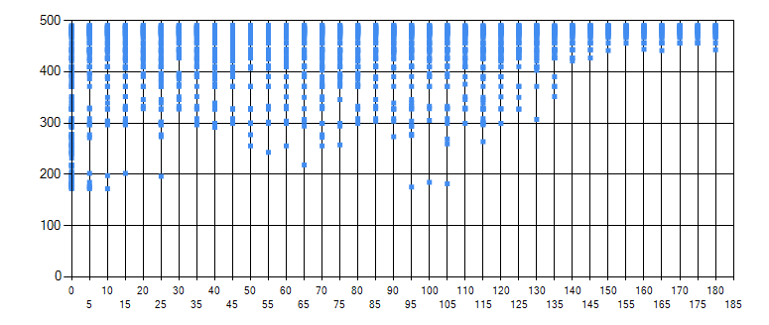

Figure shows the fitness of each parent chromosome selected in each generation.

|  |  |
| --- | --- |
| % Chromosomes Mutated | 100% |
| % Genes Mutated | 100% |
| Maximum % Mutation Deviation | 25% |

Next, we ran the same simulation with the same knapsack and knapsack objects but we wanted to test a very liberal approach, but we quickly noticed that when being too liberal (100% on everything) we ran into an issue where the mutations got out of hand to the point where passing genes hardly mattered because they were immediately mutated. So we tried the following:

These results blew us away! By offering every single gene the ability to mutated every generation, you open doors that would otherwise be shut by forcing 50% of the chromosomes to exist as-is, as a direct descendant of two chromosomes from the previous generation and only actually mutating 50% of the genes of the chromosomes that were selected to mutate. Below are the results, which are surprisingly similar when it comes to the actual goal of the algorithm, but what we find most interesting is the heuristic values.

|  |  |  |  |  |
| --- | --- | --- | --- | --- |
| Min Weight | Max Weight | Min Value | Max Value | Total Value |
| 1 | 0.015 | 0.039 | 0.976 | 490.279 |
| 1 | 0.006 | 0.04 | 0.89 | 488.994 |
| 1 | 0.006 | 0.032 | 0.854 | 488.303 |
| 1 | 0.007 | 0.043 | 0.837 | 485.735 |
| 1 | 0.007 | 0.021 | 0.35 | 485.472 |

Judging by the common theme of the minimum weight being the most heavily prioritized heuristic variable here we theorized that it was due to our 300 randomly generated knapsack objects were generally more heavy than the middle of the allowed generation weight range, while it was likely that the values were generally lower than the middle of the allowed generation value range. So, we calculated the average weight and value of our 300 objects and discovered that our average weight was 15.06 and our average value was 14.79, thus, our theory that our randomly generated objects were on the more heavy side, and lower value side was correct.

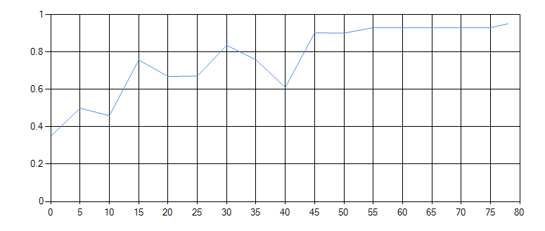

Figure shows that the liberal approach to genetic mutation converged in only 80 generations.

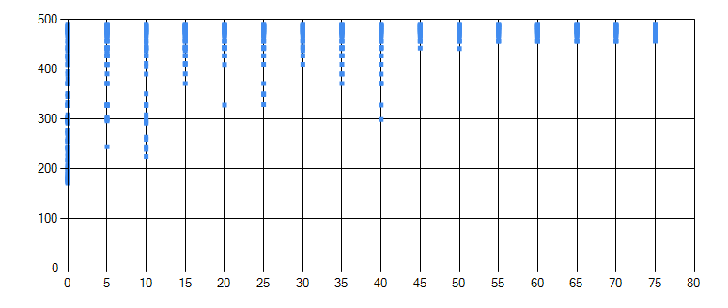

Figure shows the fitness of each parent chromosome selected in each generation.

Finally, after trying the liberal strategy we wanted to try a more conservative approach to mutating the genes. We were surprised that it converged with similar results even faster than the liberal approach!

|  |  |
| --- | --- |
| % Chromosomes Mutated | 25% |
| % Genes Mutated | 25% |
| Maximum % Mutation Deviation | 25% |

By only selecting 25% of the population to mutate, and only selecting 25% of each chromosome’s genes, we only ended up mutating 6.25% of the total gene pool. However, the algorithm still converged quickly because it was given the ability to test the new generations mutations directly against the previous generations genes whereas the liberal approach was more so just trying new things as much as it could.

|  |  |  |  |  |
| --- | --- | --- | --- | --- |
| Min Weight | Max Weight | Min Value | Max Value | Total Value |
| 0.956 | 0.624 | 0.672 | 1 | 490.279 |
| 0.956 | 0.618 | 0.714 | 1 | 488.994 |
| 1 | 0.618 | 0.62 | 0.936 | 488.303 |
| 1 | 0.771 | 0.643 | 0.811 | 485.735 |
| 1 | 0.711 | 0.703 | 0.787 | 485.472 |

The conservative approach generated the exact same solutions but had wildly different heuristic variables to do so.

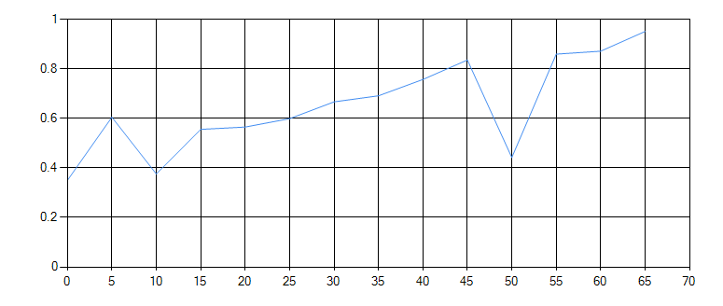

Figure shows a convergence in 65 generations using the conservative approach.

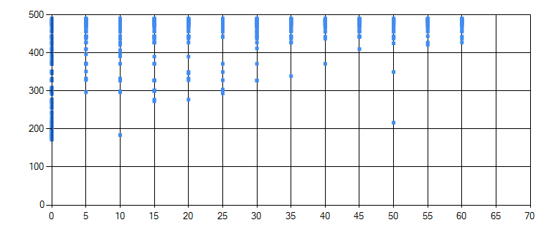

Figure shows the fitness of each parent chromosome in each generation.

The results generated from the conservative approach has a very aggressive dip in convergence at generation 50. We theorize this is due to the conservative approach being more selective in what it mutates. If it mutates something in a very negative way, it will eventually use the chromosomes it did not mutate to overwrite the problem.

To compare our results, we used the standard 0-1 Knapsack approximation algorithm, the greedy algorithm. This traditional algorithm finds the ratio R between weight W and value V, specifically R = V / W, and takes the largest R values until the maximum capacity will be overwhelmed. The greedy algorithm calculated a maximum total value of 485.737. All three genetic algorithm heuristic values produced a higher total value than the traditional greedy algorithm! All three genetic algorithm heuristic values also found a few possible heuristic settings to get a better result than the greedy algorithm. Thus, proving our generated heuristics can be used to generate an equally efficient algorithm that can generates more accurate results.

To test our claim, we generated new random sets of knapsack objects and applied the best heuristic variables generated by the three genetic heuristics as well as the greedy algorithm to see how it worked. These are the results:

|  |  |  |  |  |  |
| --- | --- | --- | --- | --- | --- |
| Seed | Balanced | Liberal | Conservative | Greedy | Best(Lib) |
| 1 | 469.269 | 469.269 | 469.269 | 478.673 | 482.398 |
| 2 | 487.921 | 487.921 | 487.921 | 494.275 | 497.26 |
| 3 | 475.156 | 475.156 | 475.156 | 471.45 | 478.833 |
| 4 | 479.334 | 479.334 | 479.334 | 475.94 | 491.844 |
| 5 | 493.8 | 492.868 | 493.8 | 491.2 | 502.341 |
| 6 | 481.49 | 480.289 | 481.49 | 474.299 | 486.407 |
| 7 | 480.984 | 480.779 | 480.984 | 480.779 | 480.984 |

From these tests we can see that our heuristic is generated for a specific knapsack instance, and we only generated the best result in one of our seven tests. We also noticed that it is entirely possible for our heuristic to generate an algorithm that works less effective than the greedy algorithm.

### Traveling Salesman Problem

### Job Shop Scheduling Problem

### N-Queens Problem

### Graph Coloring Problem

## CONCLUSION

# BIBLIOGRAPHY/REFERENCES (TODO)

<https://www.researchgate.net/publication/220059985_David_L_Applegate_Robert_E_Bixby_Vasek_Chvatal_William_J_Cook_The_Traveling_Salesman_Problem_A_Computational_Study_Princeton_University_Press_Princeton_2007_ISBN-13_978-0-691-12993-8_606_pp>

1. An answer to NP-Complete problems can be verified in polynomial time (quickly) but an optimized answer can only be solved/provided in exponential time (very slowly). Because of this, NP-Complete problems are often solved using approximation algorithms.
2. Gordon Moore
3. The set of NP-Hard problems has solutions that can be used to derive the solutions to problems in NP in polynomial time.
4. Applegate et al. (2006)
5. W.W. Rouse Ball
6. Burke et al.