# Setup develop environment

* Install Python (>3.68)
* Create virtual environment

On console prompt, type “python -m venv virtual_env_name”

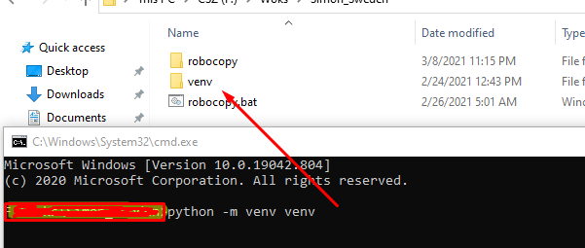

* Activate the virtual env



* Install dependency packages

Dependency packages are listed in .\requirements.txt

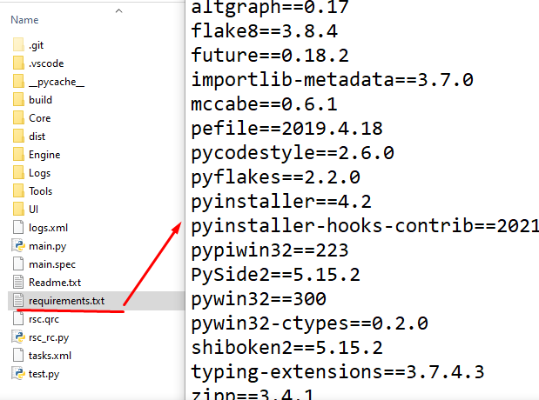

On console prompt, type following



* Run the main script



# How to debug?

I recommend you use Visual Studio Code for development

* Run the Visual Studio Code, and open the workspace directory.
* Set the virtual environment

Select the main.py and click here.

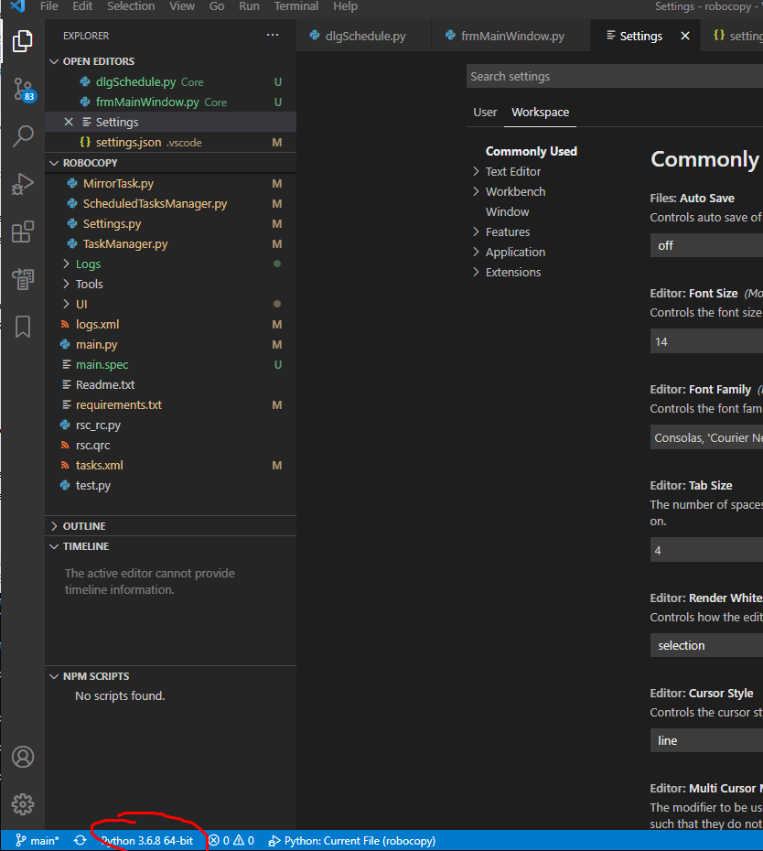

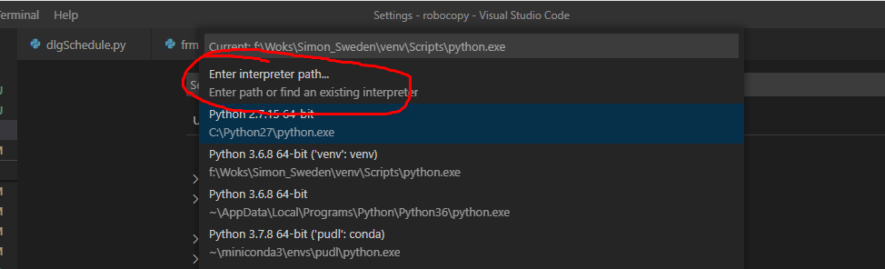

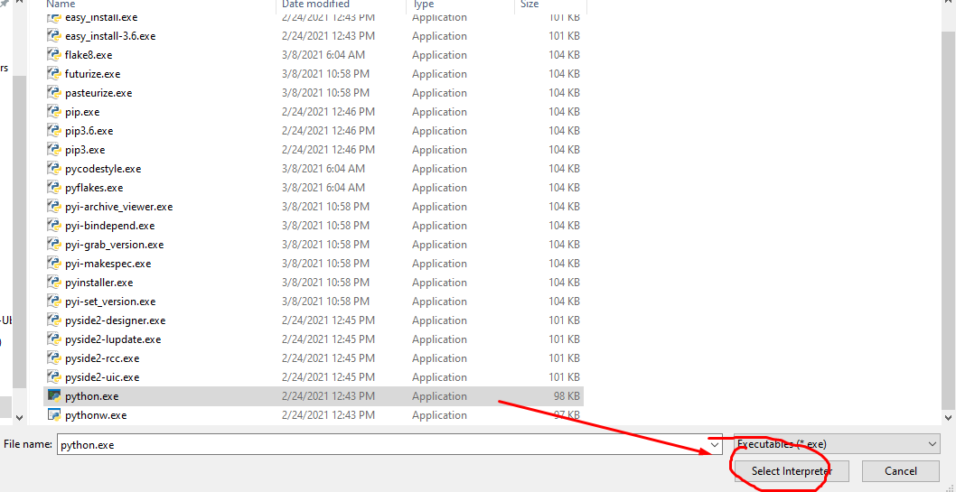

Now you are in virtual environment.

* Set the run configuration

Click [Run]/[Add configuration], and edit as following.

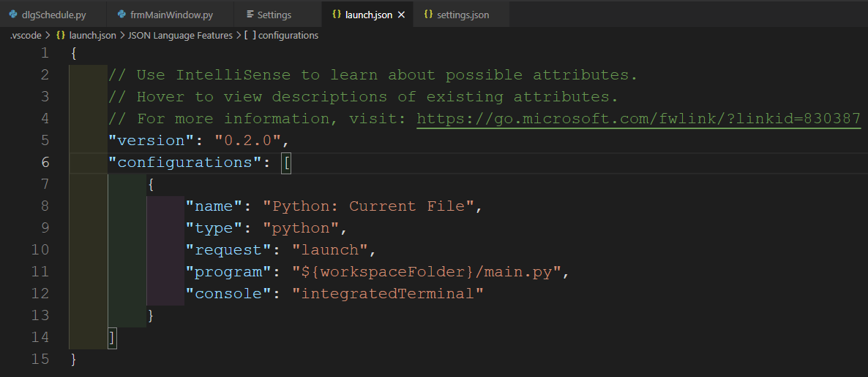

So, when you press ‘F5’, you can run the scrip in debug mode.

# How to edit UI files?

* Edit PySide2 configuration.

On [File/Preference/Settings], click this icon.

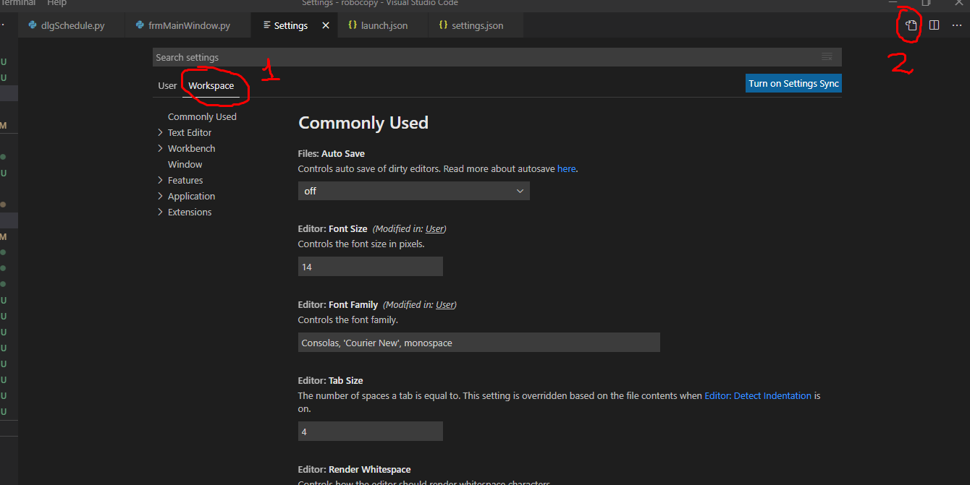

That will generate .\vscode\settings.json.

Add following flags.

{

    "python.pythonPath": "f:\\Works\\venv\\Scripts\\python.exe",

    "pyside2-vsc.designer-creator.path": "f:\\Works\\venv\\Lib\\site-packages\\PySide2\\designer.exe",

    "pyside2-vsc.uic.cmd":"f:\\Works\\venv\\Scripts\\pyside2-uic.exe",

    "pyside2-vsc.rcc.cmd":"f:\\Works \\venv\\Scripts\\pyside2-rcc.exe"

}

* Edit the UI files

When you right-click ui files on .\UI directory, you can see additional menu items.

Click ‘Edit Form in Designer/Creator’ item to open QDesigner.

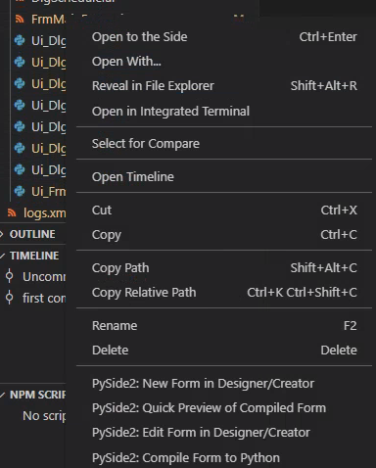

* Compile the UI file to py

On right-click menu, click ‘Compile Form to Python’. That will generate Ui_**.py automatically.

# Building windows executable

Run the ‘build.bat’

That will create ‘build’ and ‘dist’ folders.

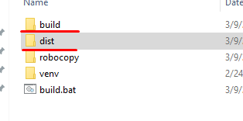

You can distribute ‘dist\rocketcopy’ folder

Compiling ui files are on ‘build.bat’. I will compile and wraps into exe file.