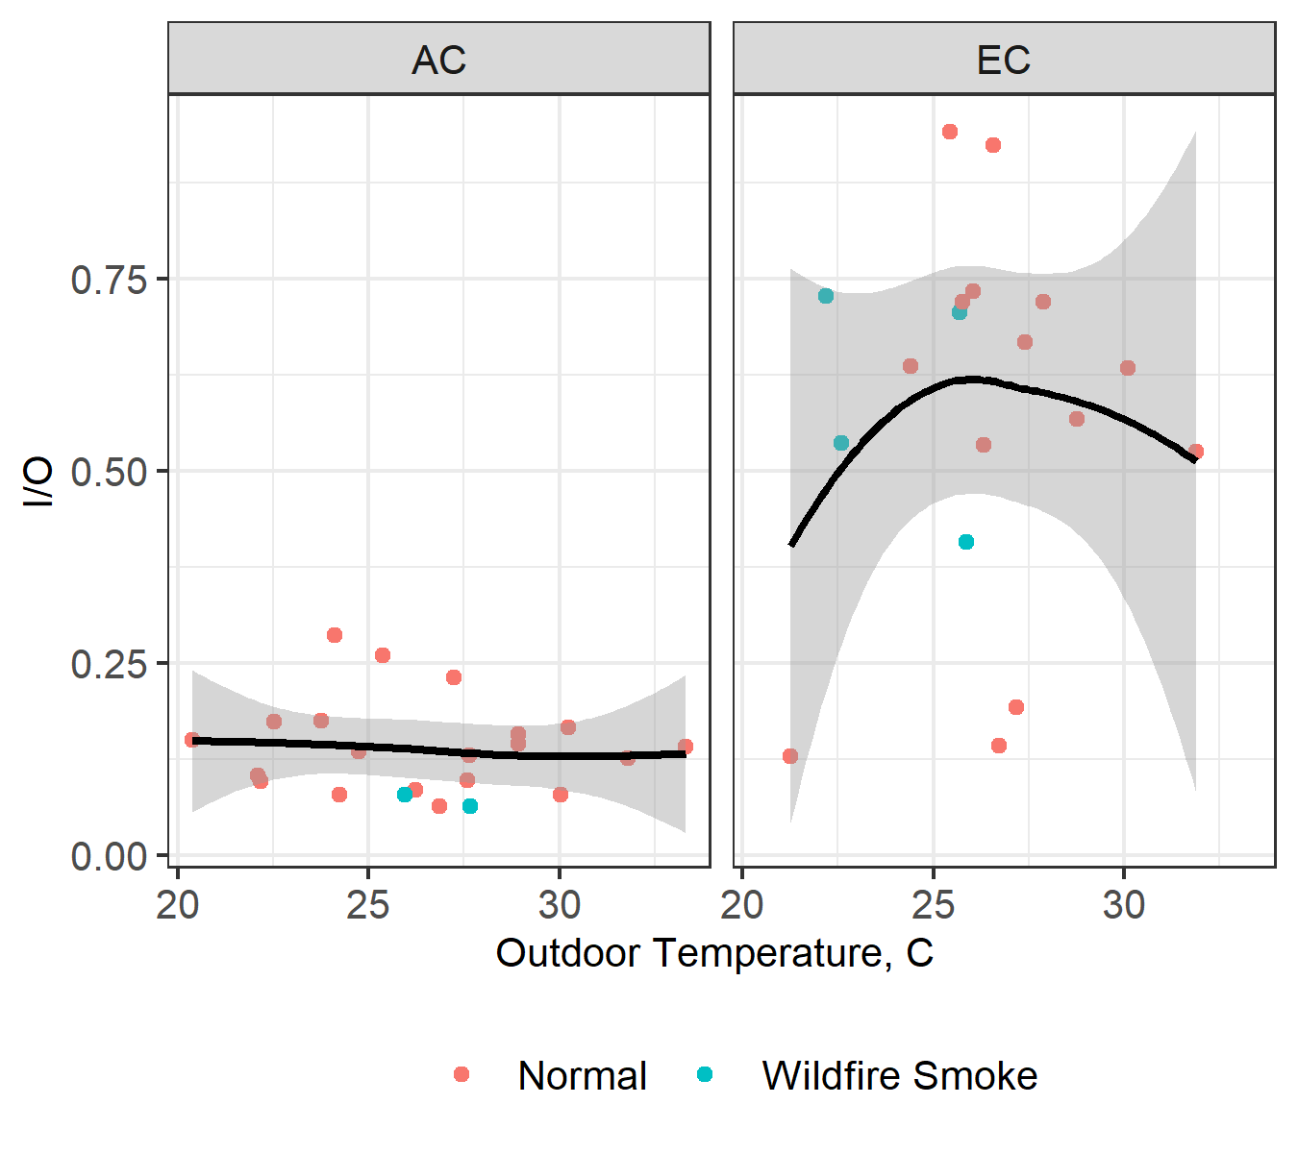

Figure S- 1. Correlation of I/O ratio with Outdoor Temperature

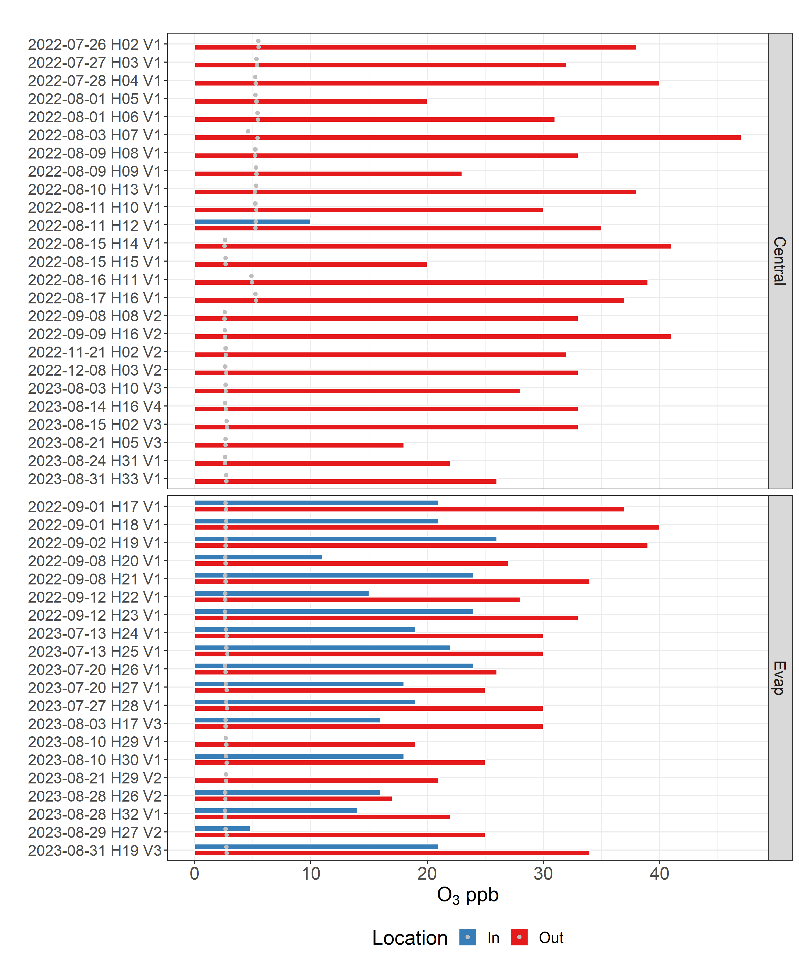

Figure S- 2. Average Ozone concentrations for each date

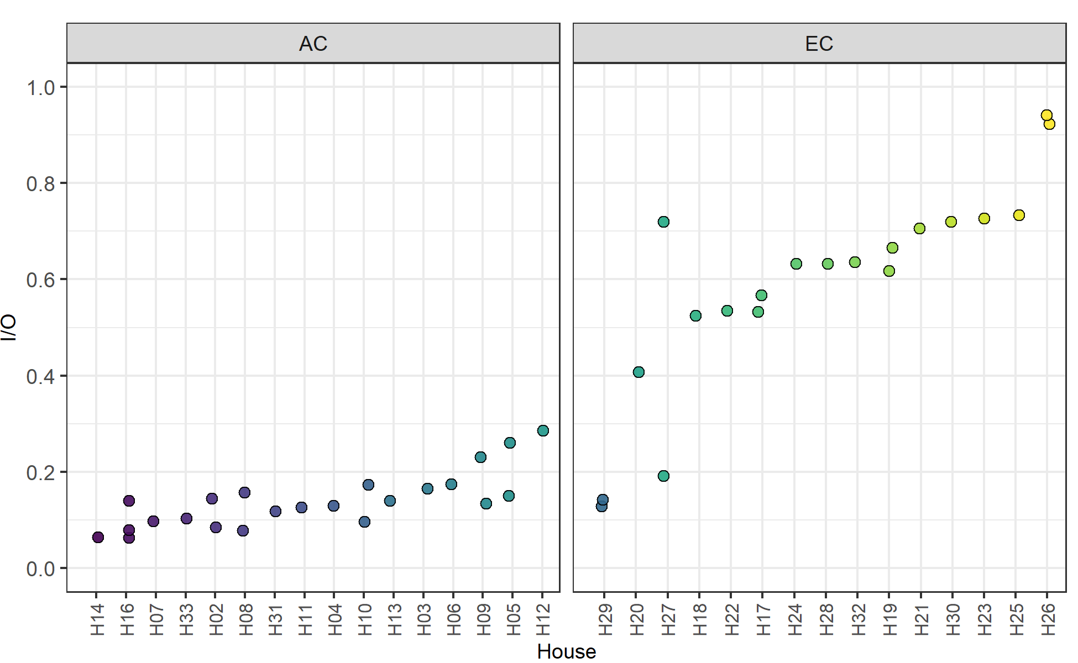

Figure S- 3

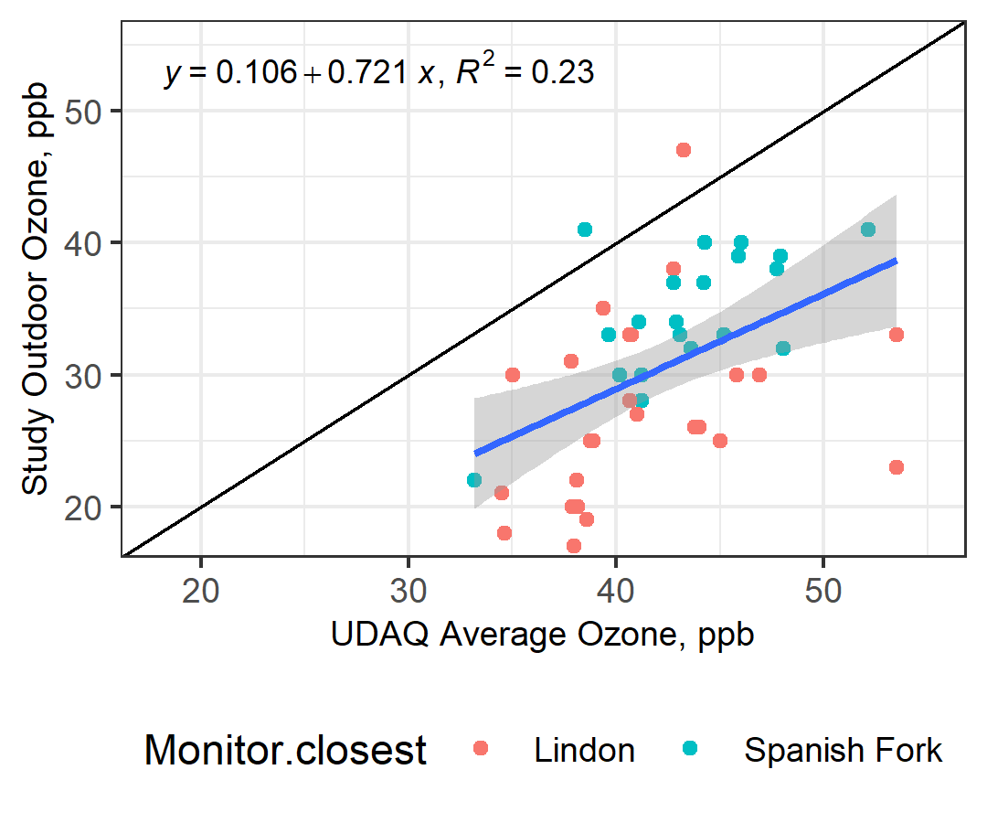

Figure S- 4

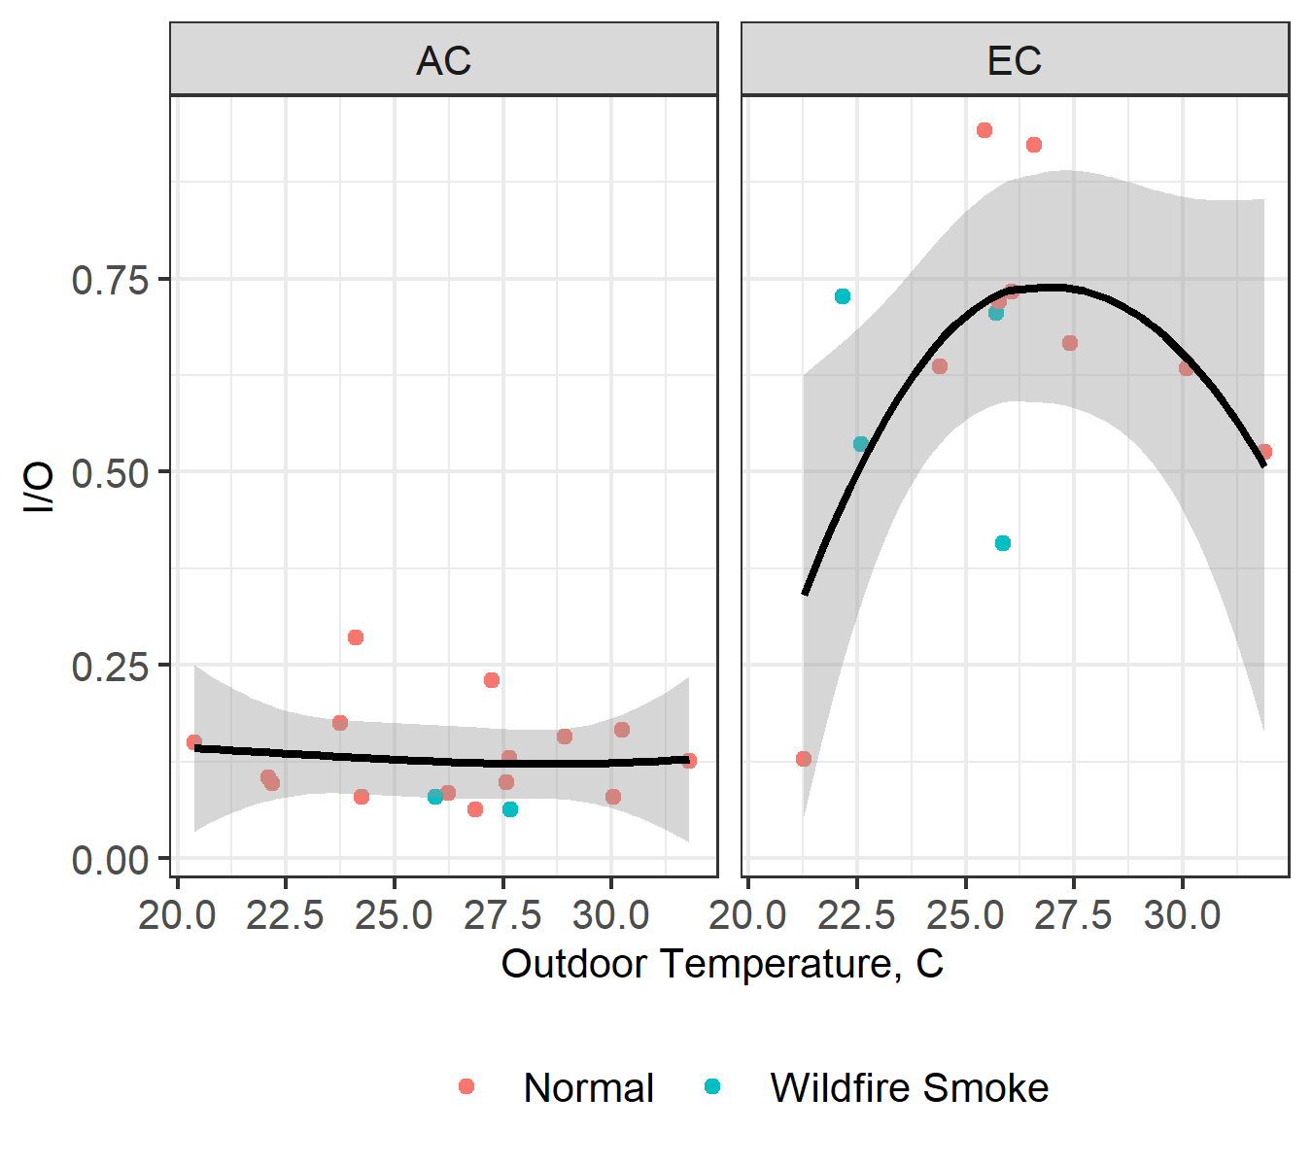

Figure S- 5 Correlation of I/O ratio with Outdoor Temperature(summer)

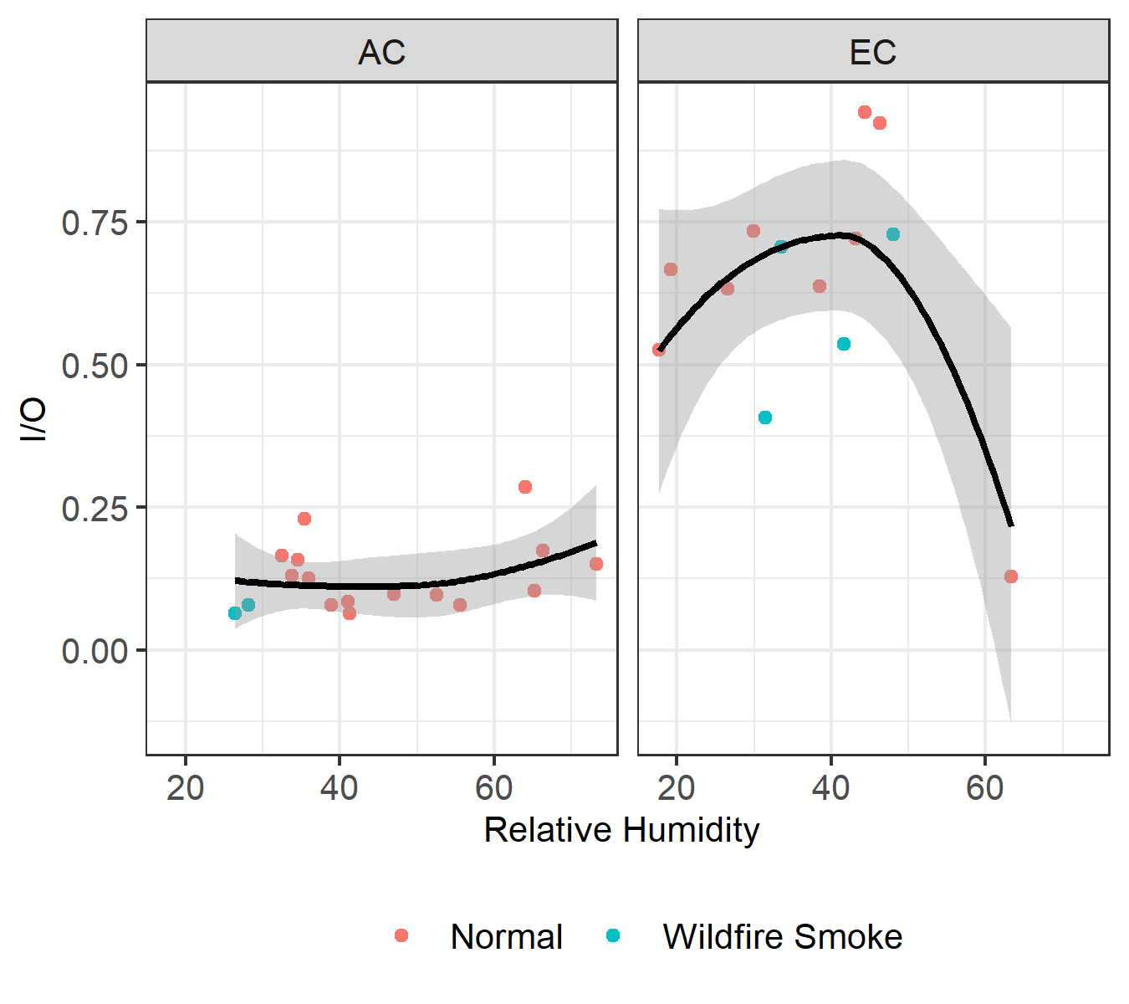

Figure S- 6 Correlation of I/O ratio with Relative Humidity

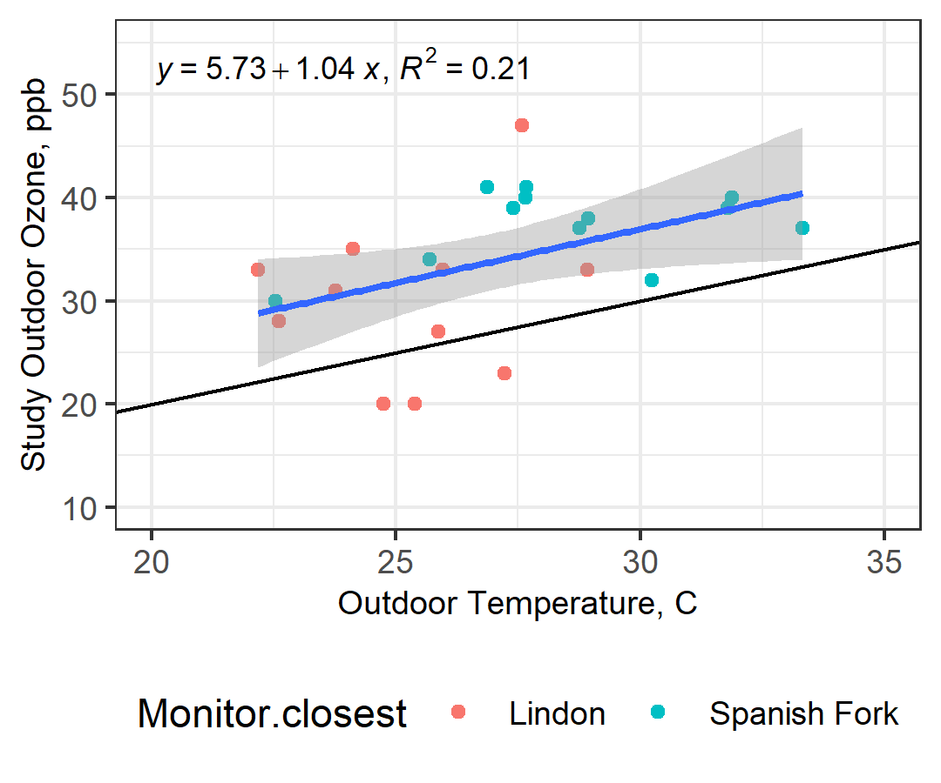

Figure S- 7 Correlation of Outdoor Ozone with Outdoor Temperature

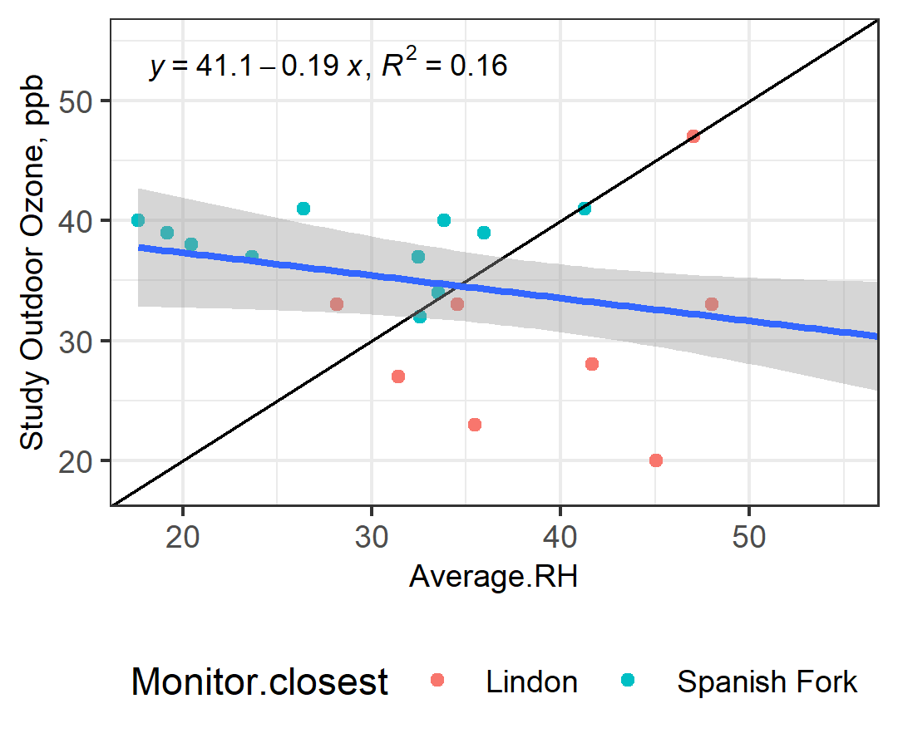

Figure S- 8 Correlation of Outdoor Ozone with Outdoor Relative Humidity