ON-THE-JOB TRAINING
at
Teratomo Corporation

In Partial Fulfillment of
the Requirements for
Bachelor of Science in Information Technology

Submitted by:
Darrell B. Cheng

Submitted to:
Mary Rose Columbres

March 14, 2018

Table of Contents

 |  | Page
I. Brief History/Background of the Company/Company Profile |  | 1
II. Summary of the OJT Experience |  | 4
III. Assessments of the OJT/Practicum Program |  | 7
 | - New knowledge, attitudes, and skills acquired | 7
 | - Theories actually seen in practice | 7
 | - Feedback that can be given to the company or institution | 8
 | - Benefits gained  - Problems encountered | 8  9
IV. Appendices |  | 10
 | - Company brochure and/or pamphlet
 | - Copy of the Endorsement Letter
 | - Copy of the Training Plan
- Copy of the signed Waiver Form
- Daily Time Record
- Quarterly Performance Appraisal Forms
 | - Certificate of Completion

I. Brief History/Background of the Company/Company Profile
ABOUT TERATOMO

- Teratomo is a software development company that provides solutions for business process automation. Teratomo is also a system integrator and value-added reseller of next-generation technologies. Teratomo was established in 2015. It is a very young company but its founders have years of experience, working with upper management, developing and marketing software solutions, and driving revenues of well-known firms abroad. Teratomo has a core team that understands the technology needs of a business and design a solution that will have a positive return on investment.
- Teratomo imagines and builds custom-made software and delivers outcomes that make businesses work better. Teratomo brings together the physical and digital worlds in ways that help people do more things in less time.

VALUES
• Customer Focus. Offering the best to our clients.
• Integrity. Making fact-based statements and actions.
• Diligence and Teamwork. Unrelenting and coordinated hard work.
• Excellence. Producing high-quality work on time.
• Kaizen. Improving self and work continuously.

PARTNERS
• SAS, USA. Big data analytics.
• Nutanix, USA. Data center hyperconverged solutions.
• Garapon TV, Japan. Cloud Digital TV Recorder.
• myCall, Japan. Customer Flow Management Systems.
• Transactor, New Zealand. Loyalty, gift cards, and payment solutions.
• PCPOS, Japan. POS terminals and ordering systems.
• NCore, Malaysia. Internet and mobile banking.
• Computrade, Philippines. Security, big data hardware, and IT infrastructure solutions.
• ADFIAP, Philippines. Development banking.

EXPERTISE
• Customized software development.
• Big data and visual analytics.
• Smartphone application development.
• Game development for cloud and smartphone.
• Loyalty system, gift card program, stored-value payment, and targeted marketing.
• Android mobile POS system.
• Asset maintenance and operations system.
• ERP for construction companies.
• CRM and billing system.
• System integration.

CUSTOMER INDUSTRIES
• Manufacturing
• Retail
• Telecommunications
• Banking
• Construction

Industrial Data Exchange Automation
• IDEA is a remote data capture, collaboration, and reporting platform that gathers business data from field or mobile web-enabled devices and electronic sensors.
• IDEA processes and generates real-time business intelligence and analytics.
• IDEA is designed for manufacturing companies.
Automated Maintenance and Operations System
• AMOS is a cloud-based fleet management platform similar to IDEA.

OBJECTIVES & PHILOSOPHY
- To enable clients to become high-performance organizations by providing responsive and relevant software solutions.
- To simplify business processes and make it more efficient. Our project management philosophy is to provide clients with the “I-am-in-good-hands” experience when we are chosen to execute their projects. Our emphasis on clear communication and follow-through procedures ensures that clients’ objectives are given top priority in planning and execution.

MISSION

- To enable clients to succeed by providing world-class software solutions.

VISION

- To be a trusted and respected software consulting firm in the Asia-Pacific region by the year 2020.

II. Summary of the OJT Experience
On the first day of my OJT in Teratomo, I assigned as a quality assurance (QA) to test the quality of the Automated Maintenance and Operations System (AMOS) website, I need to test the maintenance, transaction, reports, website settings, access rights and the security of the website.

I need to test all the modules of AMOS to familiarize the process and how it actually works, I have a lot of modules reported to the programmers of Teratomo from the features, bugs, and vulnerability of the website. Some of the modules need to fix are features and bugs, most of the features are need to add validation and on the bugs are sometimes it displays a syntax error and not working modules.

Then on the security of the website, since I have a knowledge in penetration testing I tried to test the vulnerability of the website using Cross Site Scripting (XSS), I tried all modules to test if it is vulnerable in Cross Site Scripting but it is not working. Then I try to use SQL injection to check the vulnerability of website if it is hackable, then some of the modules are vulnerable in SQL injection, I tried to list the database, tables, and columns of the website and it working so that I report it on the CEO that the website is vulnerable in SQL Injection.

I give a reminder that the security of the website is important because if it is vulnerable in SQL Injection or in penetration testing, some hacker can hack and change all the data on the database they can update, insert and delete data and hacker can also drop tables and database of the website. Because of the security problem they assigned me to the security testing.

After testing and familiarizing of the website, I assigned as a programmer of Tera Human Resources Information System (HRIS) website, we used laravel and vuejs in developing the website, since I don’t have a knowledge and experience in developing using laravel and vuejs I need to learn it and familiarize the process of implementing a vuejs to laravel.

The first task assigned to me is the maintenance of company profile and branch profile in this task I can apply what I learn from the tutorial. Then after I finished the module of company profile, I have another task which is the homebase of the company and branches, homebase means a location per branches it has a marker that indicates every branch and you can search branch using an address of the branch and branch name.

After I finished the assigned module, I have another task which is to create the maintenance of department, position, SSS, Pagibig, Tax, Employee maintenance, and the backup and restore modules.

Then after I finished the assigned module, I assigned for a new project which is a captive portal. A captive portal is a Web page that the user of a public-access network is obliged to view and interact with before access is granted. Captive portals are typically used by business centers, airports, hotel lobbies, coffee shops, and other venues that offer free Wi-Fi hotspots for Internet users.

In this project I need to install all the tools needed for the captive portal, my first module need to finish is making router as an access point, since its more on networking I don’t know how I can make a router as an access point so I need some research to make it. It is difficult to make the router as an access point since there is two router and I need to disable the DHCP before the router works properly.

My next task is installing and configuring the coovachilli. It is a big challenge for me because I don’t have a knowledge in creating a captive portal and it is more on networking, when I’m configuring the coovachilli I encountered so many errors, I need some research to fix the installation, when installing is finished I need to configure it an connect it on the access point router. I need to assign IP on the router so that every user connect on the router redirect on the captive portal splash page or login page, after I finished it I need to change the login page, because the login page is from the coovachilli default login so I need to make the coovachilli redirect to CBTL login it is an online website.

Then when I finished configuring and installing coovachilli, my next task is installing and configuring freeradius and connecting the freeradius to coovachilli. Freeradius is the most popular and the most widely deployed RADIUS server in the world. It serves as the basis for multiple commercial offerings, and it supplies the authentication, authorization, and accounting (AAA) needs of many Fortune 500 companies and Tier 1 ISPs. It is also widely used by the academic community.
Freeradius was started in August 1999 by Alan Dekok and Miquel van Smoorenburg. Miquel had previously written the Cistron RADIUS server software, which had been widely adopted when the Livingston server was no longer in service. Freeradius was developed using a modular design, to encourage more active community involvement.

When I starting installing and configuring freeradius it also has an error but I fix it easily, then after I install the freeradius I need to connect it on coovachilli so that freeradius act as an authentication and data management, then after I finished connecting and configuring, my next task is the authentication of the user so I need to create login page so that user can login and register, then after the login I need to configure freeradius to add use time per session and per day. Then my next task is bandwidth per user I need to configure again the freeradius to create a bandwidth per user.

My last task is making coovachilli redirect on HTTPS website so that when I access the https://facebook.com it redirect on the login page of the captive portal and I need to make a documentation of installing coovachilli, freeradius and making router as an access point. Then I need also to make the documentation about configuring coovachilli, freeradius and connecting coovachilli to freeradius and the time and bandwidth per user.

III. Assessment of the OJT/Practicum Program
- New knowledge, attitudes, and skills acquired
1. The new knowledge I acquired on my OJT is creating a captive portal and framework like laravel and vuejs and how industries work as a team, integrating a google map API on the website, new tools in developing a website and integrating API on a website.
2. The new attitudes I acquired on my OJT are time management, and how to cooperate with each other, how we can handle problem and bugs in our program and the culture and attitude of the Japanese sometimes we used the language of Japanese for greetings.
3. The new skills I acquired are creating a captive portal because it is not my specialty and it is more on networking, and how to properly used the framework like laravel and vuejs and how to used and create API to integrate on the system, another skill are creating tools that can help in developing.
- Theories actually seen in practice
I’ve seen many theories while I’m in the Teratomo. First I saw and used the algorithms of automated tools that can help programmer or developer to easily check the validation of fields on the website, the algorithm helps me for creating an automated security checker for a website. Second is creating an encrypted password and decrypt it using their own algorithm. The third is the theory of organizing of data on the database they make a way to organize the data that can be easy to process the multiple amounts of data from the database.

- Feedback that can be given to the company or institution
My feedback on Teratomo is thank you for accepting me as an intern in your company and for improving my skills from basic knowledge to professional and for teaching us to have a self-confidence. I learned through experience how to interact and communicate with people. They help us to develop and improve my coding skills and also my networking skills. The employees are nice and friendly. The CEO and Vise President of Teratomo were very approachable and kind. Overall I enjoyed my internship in the Teratomo. The company taught me a lot.

- Benefits gained
1. The first benefit is how we can come up on the better idea, during our OJT the CEO of the company held a meeting for the gathering of information and idea, we as interns we need to cooperate and give an idea on how we can create a bitter payroll application that has unique features. The CEO of the company collect all the ideas and discuss it. On this strategy, we can learn and analyze if the ideas help us to create a better payroll application.
2. The second benefit is tools, Teratomo teach as about the tools used in the industry, using this tool we can easily create a better application, and make our assigned task easily.
3. The third benefit is attitude, Teratomo make as a professional person they teach us how we can face on the client perfectly without shy, how we can easily deliver our ideas in front of the other employees.
4. The fourth benefit is skills, Teratomo improves our skills in programming, networking and in analytical skill. They also teach us the correct database normalization.

- Problems encountered
1. I encounter a problem on integrating google map on the project, since I’m a beginner in implementing a google map API, I encountered a lot of problems because I need to search the location of the branches of the company using the address provided by the branch.
2. The second problem is understanding the assigned module because we have a different idea about the problem and we did not come up with the best idea, misunderstanding of the topic and pushing their own idea.
3..The third problem I encountered is creating a captive portal using freeradius and coovachilli, since I’m not familiar on what the captive portal work and how it can be setup, and what is the correct network diagram to make a router as a access point, and when I’m installing the captive portal I encountered a lot of error and bug fixing, I have a lot of time and searching on the internet before I can solve the problem and install the captive portal correctly.

IV. Appendices
- Company brochure and/or pamphlet
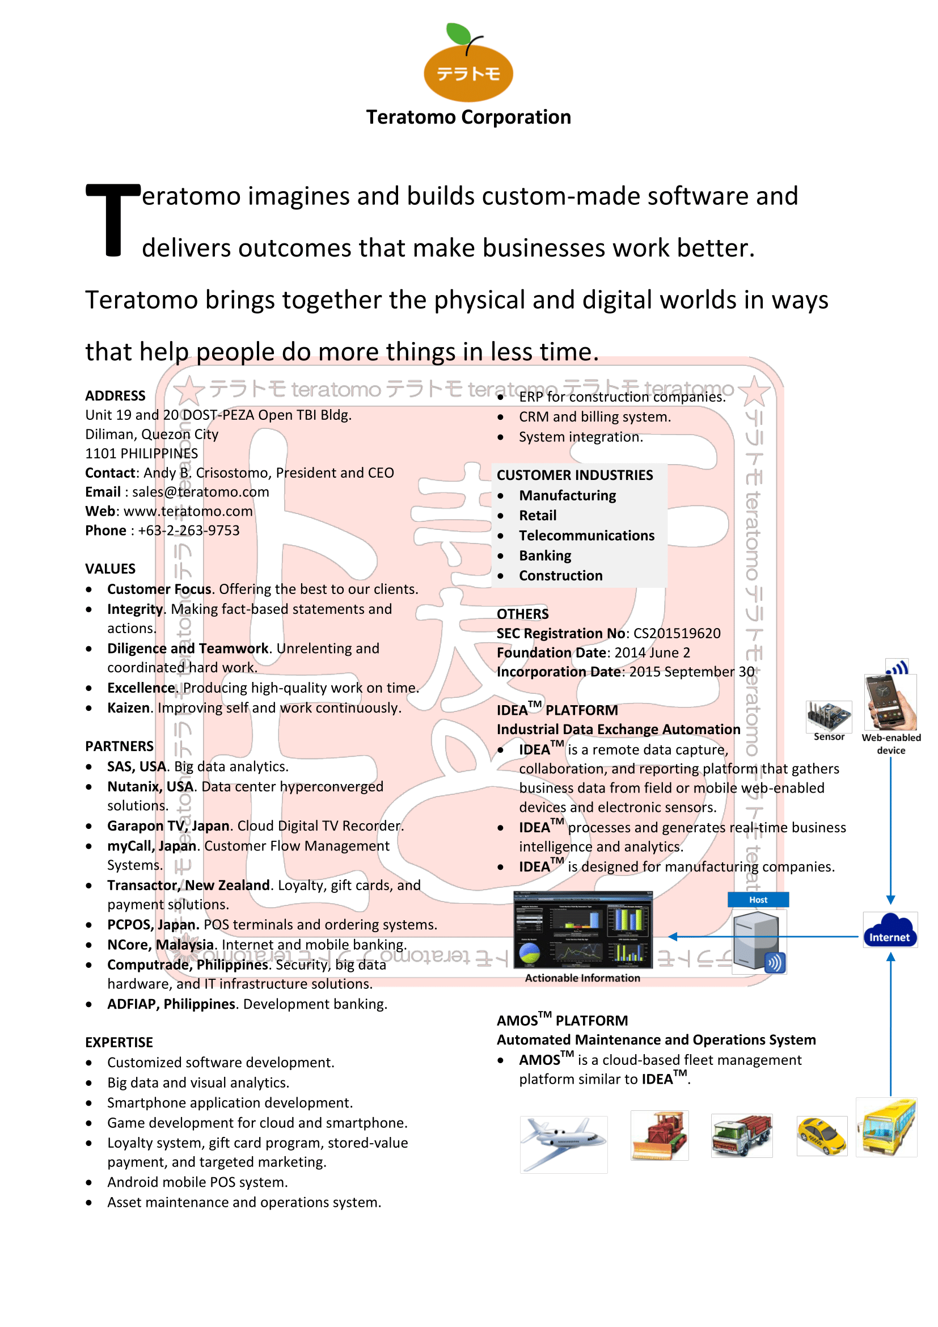
- Copy of the Endorsement Letter

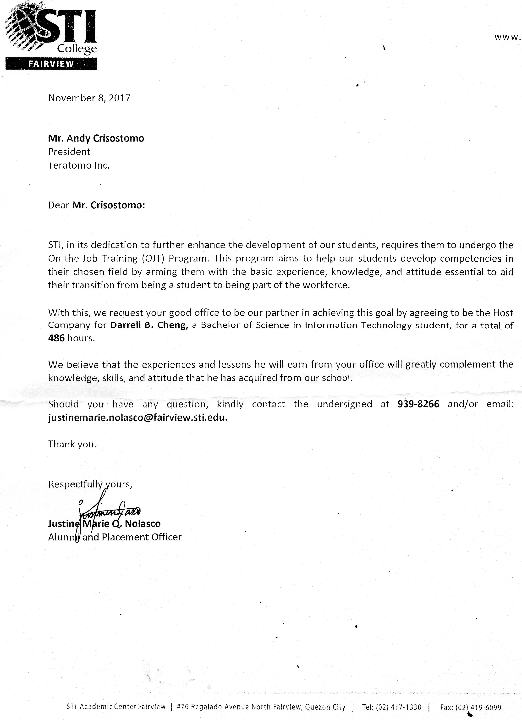

- Copy of the Training Plan

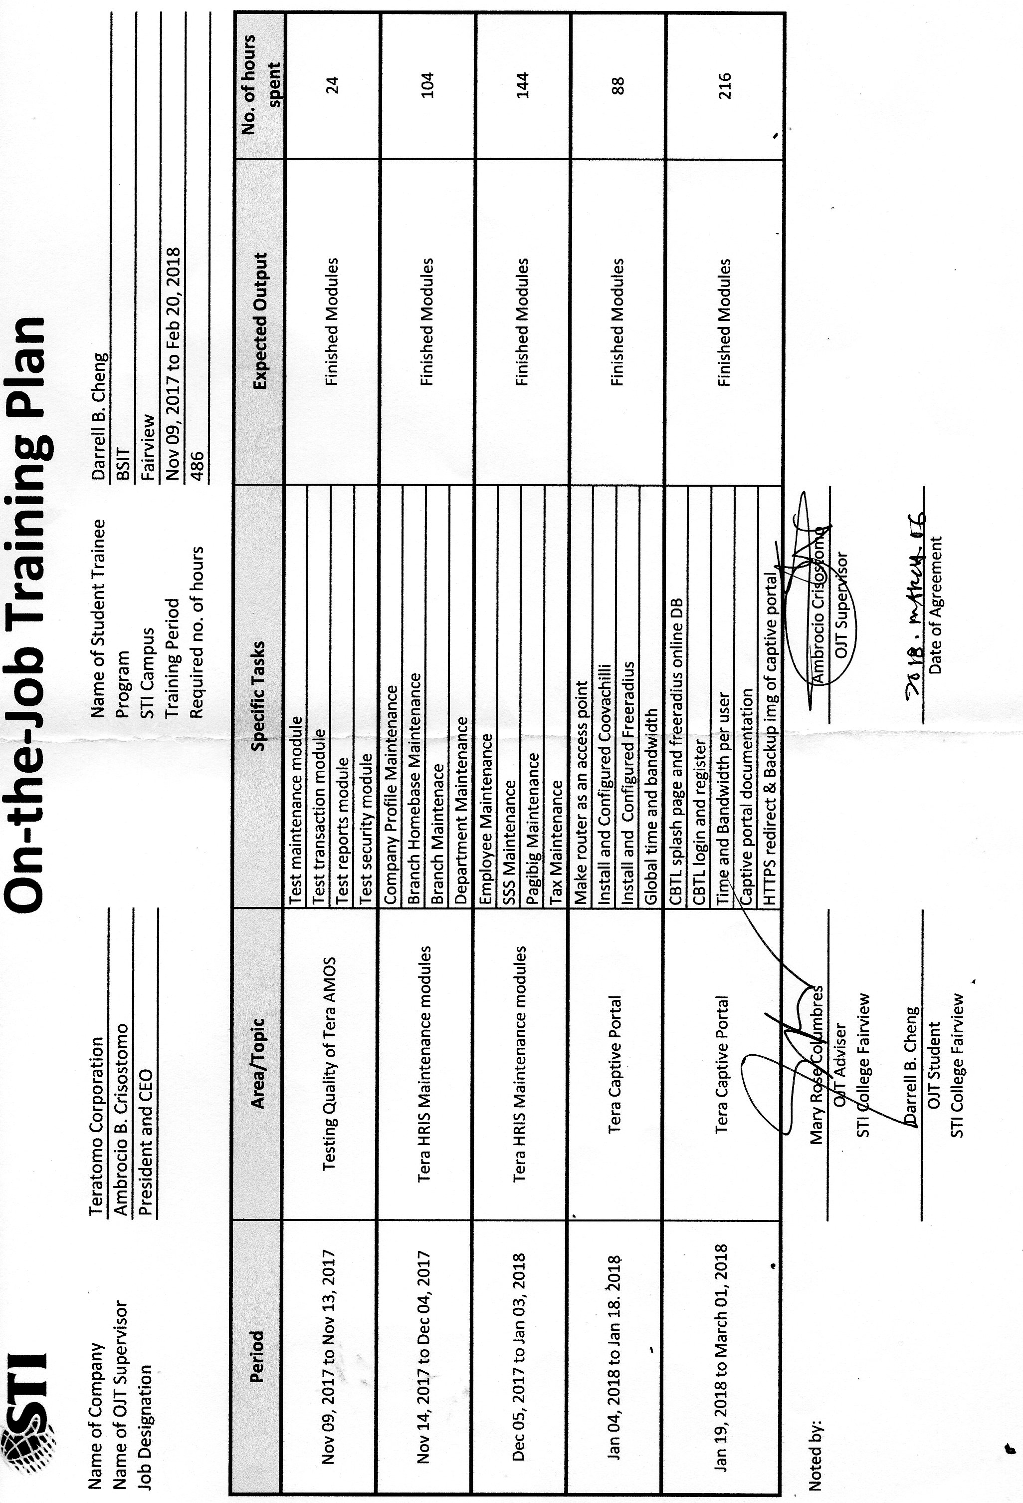
- Copy of the signed Waiver Form

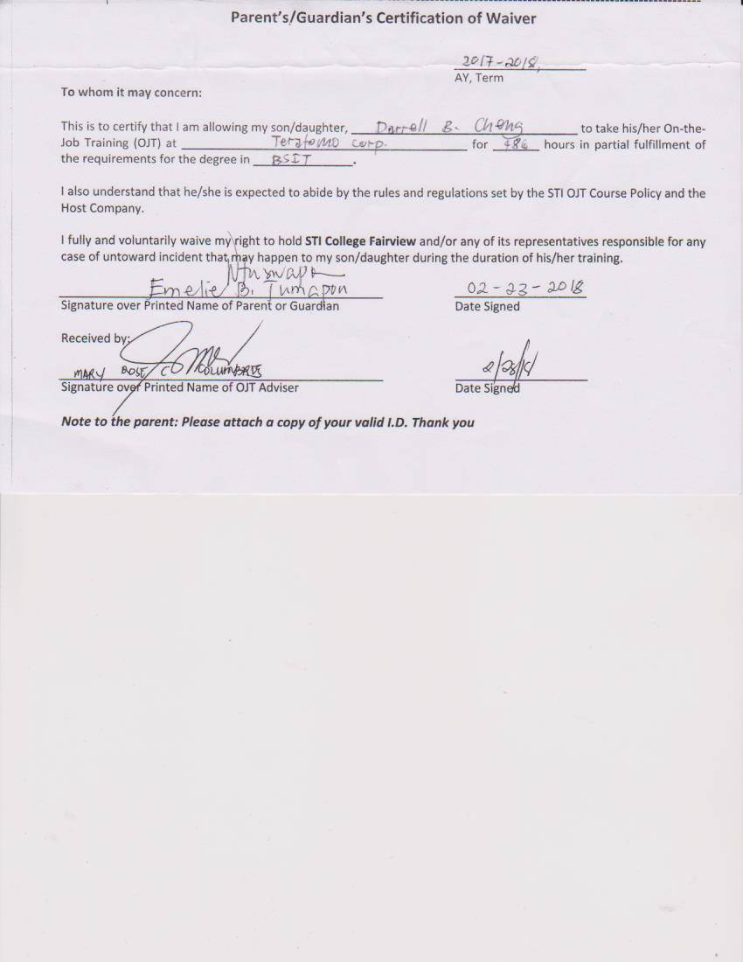
- Daily Time Record

- Quarterly Performance Appraisal Forms

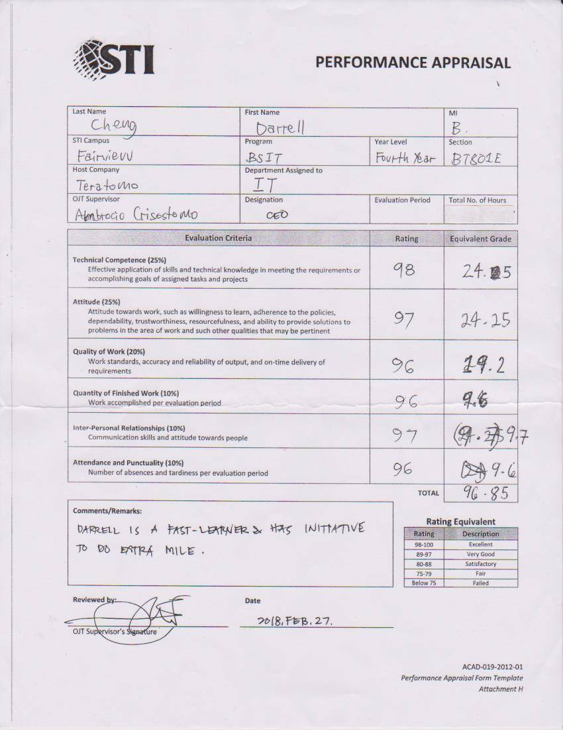
- Certificate of Completion



