Darrell Martin

Data Model Concept – Checkers

CS4330

**User Interface:**

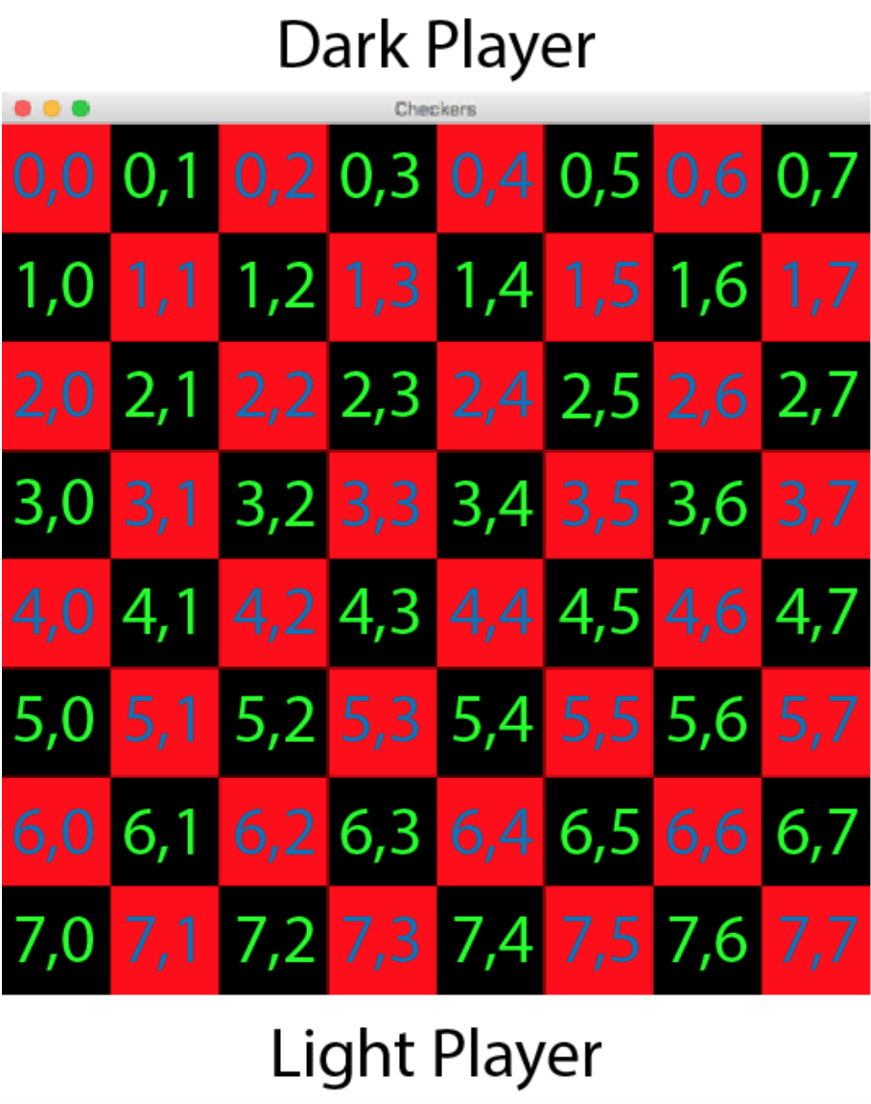

* The user interface will be an 8x8 checkerboard with the cells being represented by x and y indices

**Objects:**

* Checkerboard
  + Variables
    - Int numRows
    - Int numCols
    - double boardWidth
    - double boardHeight
  + Methods
    - Build()
    - updateBoard()
    - findMoves()
    - setActive()
    - saveBoard()
* CheckerPiece
  + Variables
    - Int xIndex
    - Int yIndex
    - Boolean selected
    - Boolean king
    - Boolean visible
    - Color color
  + Methods
    - findMoves()
    - deletePiece()
    - movePIece()
* Player
  + Variables
    - String username
    - Color color
    - Boolean nextTurn
  + Methods
    - setUsername(String username)
    - setColor()
* BoardCell
  + Variables
    - Color color
    - Int xIndex
    - Int yIndex
    - CheckerPiece checkerPiece
  + Methods

**Checkerboard Description:**

* This will be a Checkerboard game made of objects using Java. The checkerboard will be made up of a grid that contains ArrayList BoardCell objects that represent the spaces on the board. There will also be a CheckerPiece object that represents the Player’s pieces. The game will abide by the official rules of Checkers.