HW2: Hands-On Assignment : Setting up a Linux System on Windows

Part 1: Configure the Host OS with a Microsoft Loopback Adapter

- First, we need to create a Microsoft Loopback Adapter so that we can connect the host OS and the VMs.
- To create an adapter, go to device manager. (Run>devmgmt.msc)

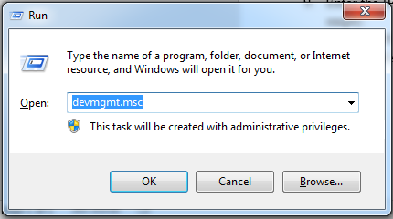

- Click on Network Adapters and then click on Actions on the top and then select Add legacy hardware.

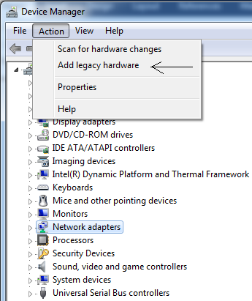

- A window will pop up. Click next and then select Install a Hardware Manually.
- Another window will pop up and then scroll down and select Network Adapters.
- Then select Microsoft in Manufacturer and then select Microsoft Loopback Adapter (For Windows 10: Microsoft KM-TEST Loopback Adapter) in the Model and then click next and Finish. (Add Screenshot)

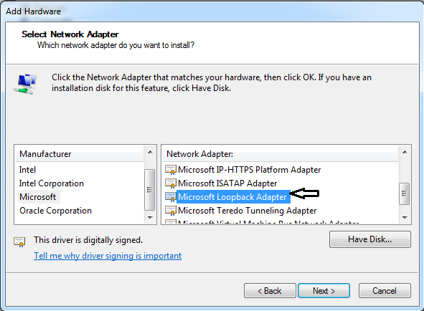

- Go to Network and Sharing Centre in Control Panel. (Run>ncpa.cpl)

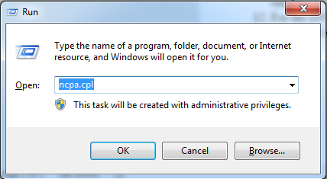

- You should see a new MS Loopback Network Adapter which we just created. (Add Screenshot)

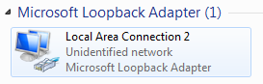
- Now look for the other Host Network Adapter which has the Internet Connectivity. If you are using Wi-Fi connection then it would be as below. (Add Screenshot)

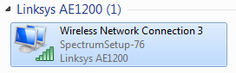
- Right click on Host Network Adapter and click on Properties.
Click on Sharing, Check the option “Allow other network users to connect through this computer’s Internet connection” and select the Loopback Network Adapter which we created earlier. Also, check on “Allow other network users to control or disable the shared Internet connection” option and click OK.
Note: This process is to allow Internet Connectivity through Loopback Network Adapter.
(Add Screenshot)

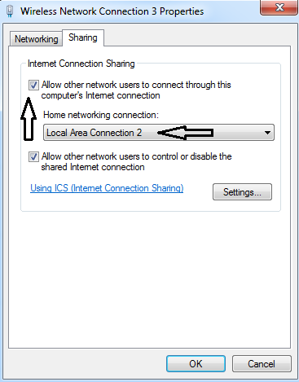

- Then select the Microsoft Loopback Adapter and open its properties and select Internet Protocol Version 4 (TCP/IPv4).
- Go to properties, remove all the default IP configurations and use the following IP address.
- Enter the IP address as 10.10.10.1 and Subnet mask as 255.255.255.0. You can keep default gateway as empty.
- For the DNS server select Use the following the DNS server address option and keep the Preferred DNS server and Alternate DNS Server address blank. When done click OK. (Add Screenshot)

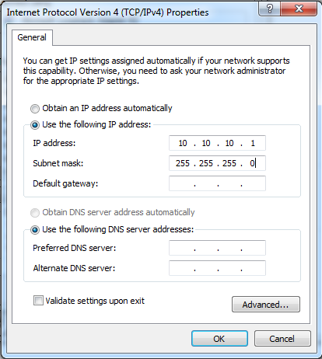

- Open Command Prompt, run “ipconfig” command. Your Loopback Adapter details should look similar to as below. (Add Screenshot).

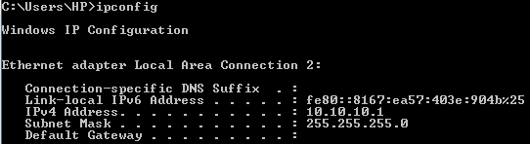

Part 2: Install Oracle Virtual Box version 6.1 and download CentOS ISO on the Host OS.

- Download and Install VirtualBox for your respective Windows or Mac OS machine. (Add Screenshot)
https://www.virtualbox.org/wiki/Downloads
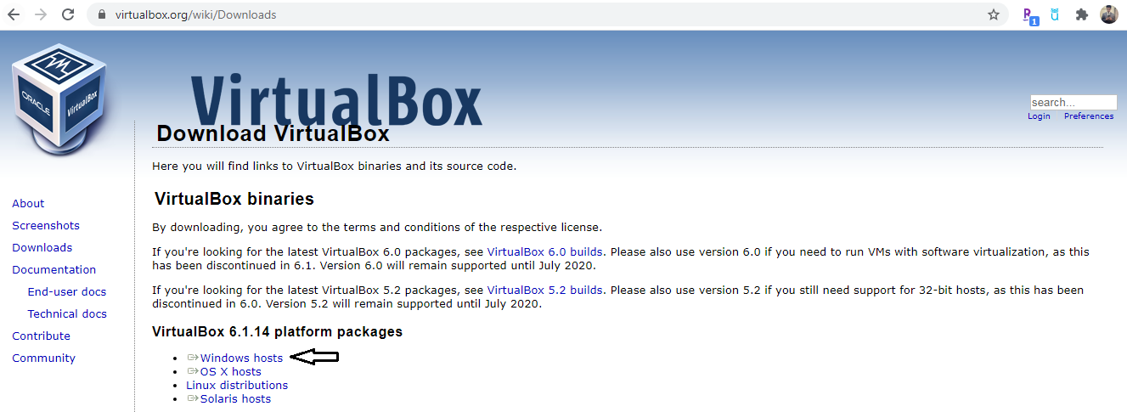

- Download the latest CentOS minimal version iso. (Add Screenshot)
https://www.centos.org/download/
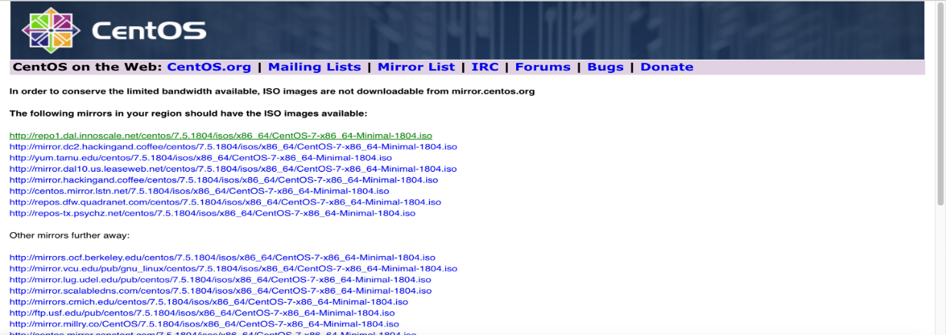

Part 3: Deploy CentOS 7 Virtual Machine on the Oracle VirtualBox.

Following are the steps for creating a virtual machine:

Open Oracle VirtualBox.

Click on New => Type in Name as “Centos-FirstName_LastName”.
Select the appropriate Machine Folder to store the VM Disk files.
Select Type as Linux and Version as Red Hat(64-bit)

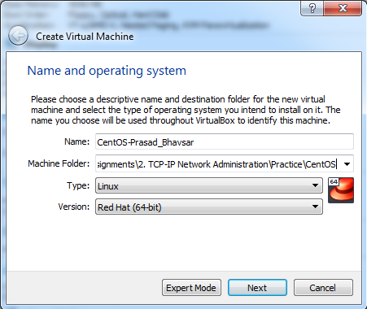

Change the Memory Size to 4096MB.

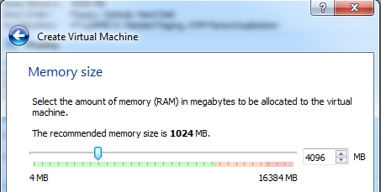
Select Create a new virtual hard disk now and click on Create.

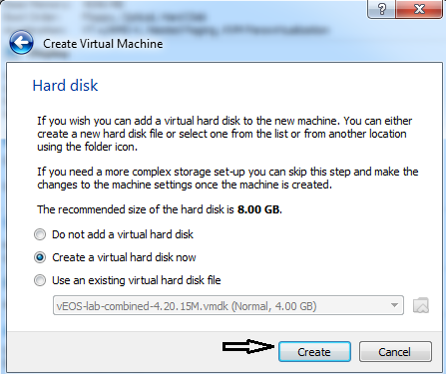
Select VHD on the next option.
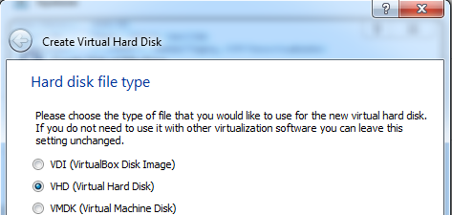
Select Dynamically allocated hard disk (Thin Provisioned).
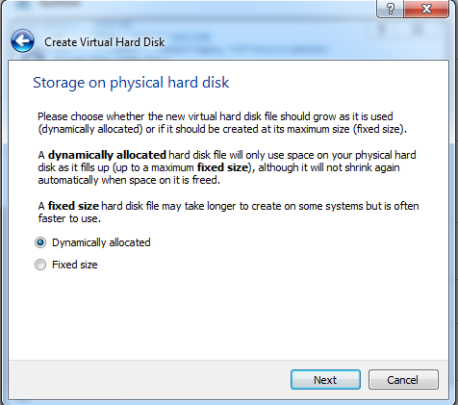
Make the file size to 30 GB and click on Create.
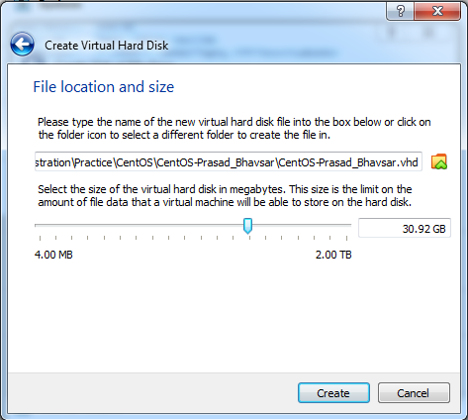
Your CentOS Virtual Machine is almost Ready! (Attach Screenshot)
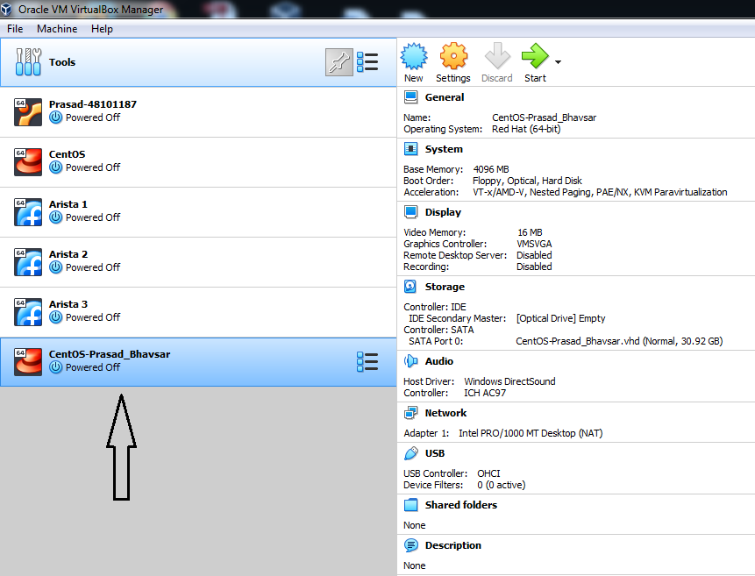

Before powering ON the VM, select the VM and click on Settings which is at the left top and go Network Section and Select Attached to: Bridge Adapter and Name: Microsoft Loopback Adapter (Which we created in Step 1). This way we are bridging the VM Network with the Host Network. (Attach Screenshot)
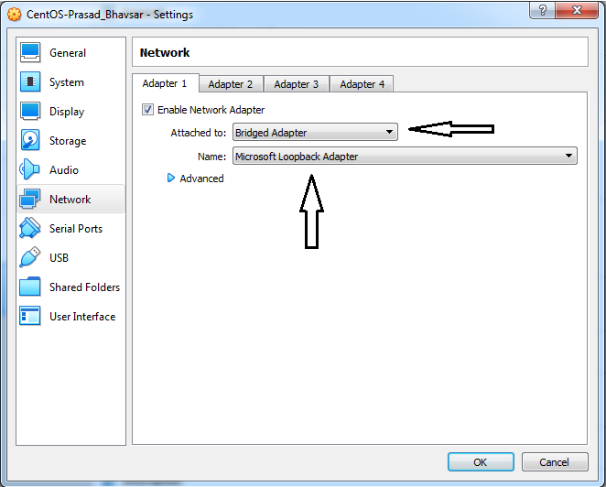
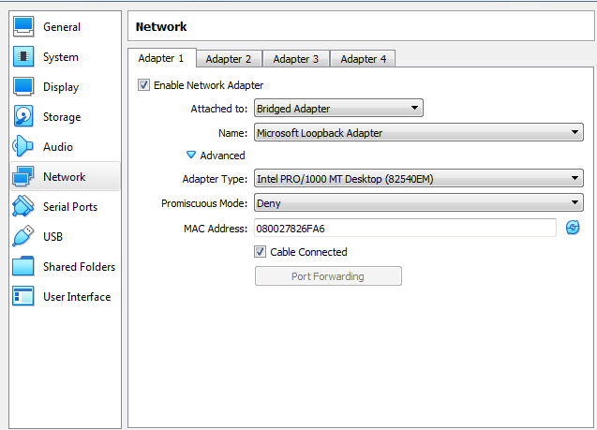

Once that is done, go to storage section and select Controller: IDE > Empty and click on the rightmost disk option and browse the ISO file that you downloaded earlier here. (Attach Screenshot)
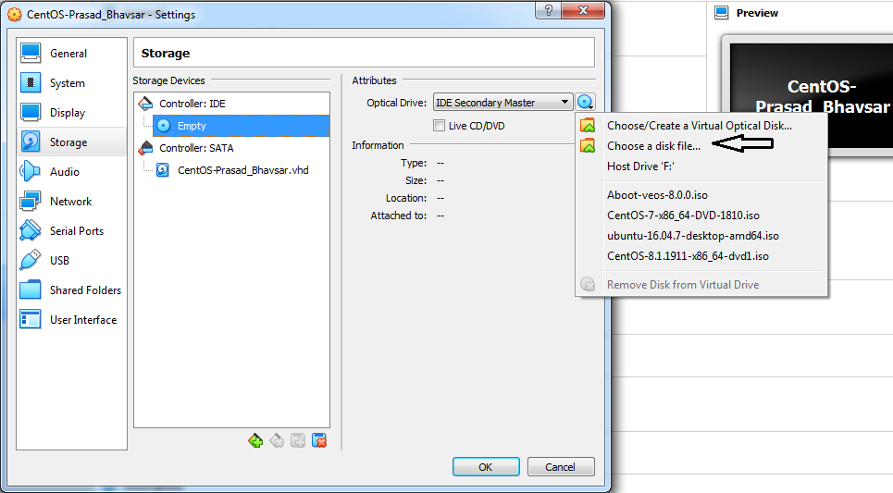
Click Okay and click on System and select Pointing Device as USB Tablet.
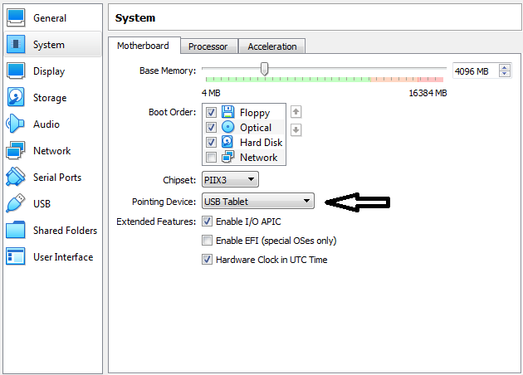
Click on Ok and start the VM.

In-case if you get the below option while VM startup, select the CentOS ISO Image.
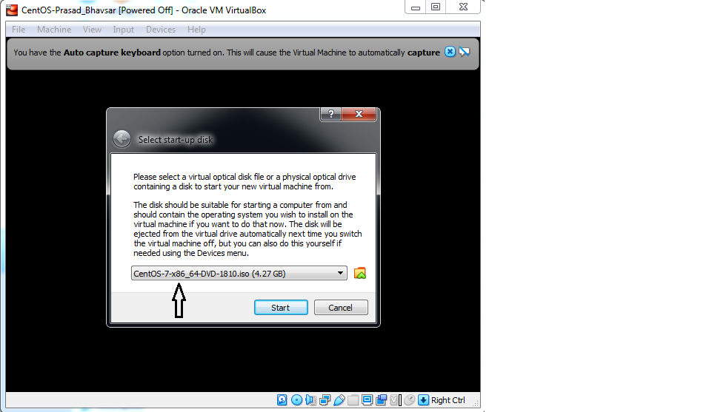
Select “Install CentOS 7”.
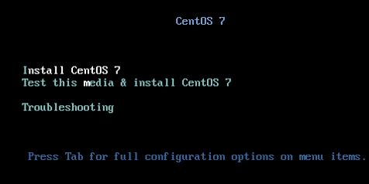
Select Language as English.
Click on Installation Destination and then click on Done.
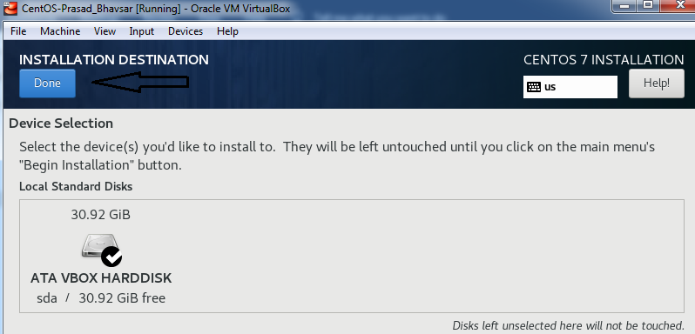

Then, click on Network & Host Name option, and enable the Ethernet connection option. Specify the Hostname as centos-FirstnameLastname. Once enabled as shown below, click on Done
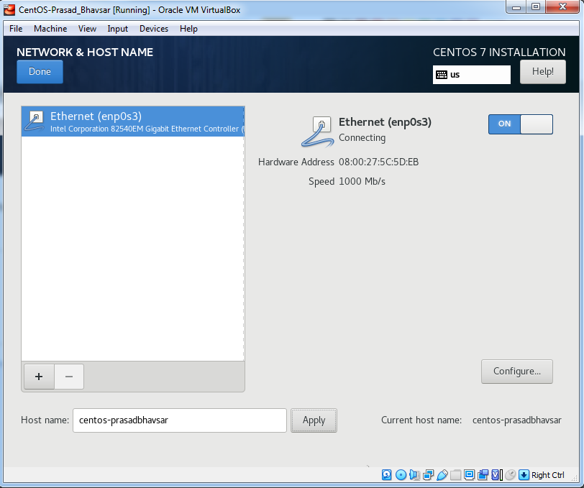

Note: Even if your VM Network gets disconnected at this stage, it won’t be a problem.
Click on Begin Installation.
Now, we will configure the root and user password.
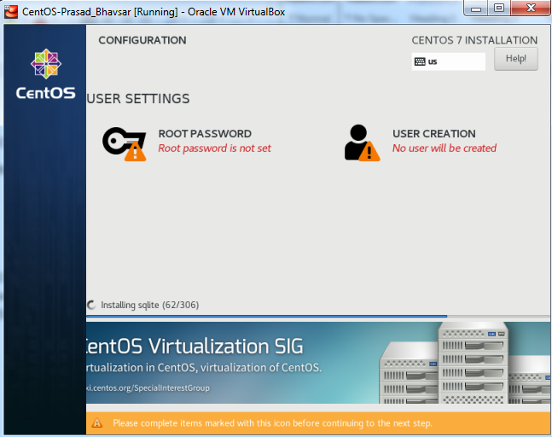

Click on Root Password and set the Root Password as “redhat”. Once done, press DONE tab twice.
Click on User Creation option first. Type in “FirstnameLastname”. Check both the checkboxes. Set Password as “redhat”. Click on Done. (press DONE tab twice.)
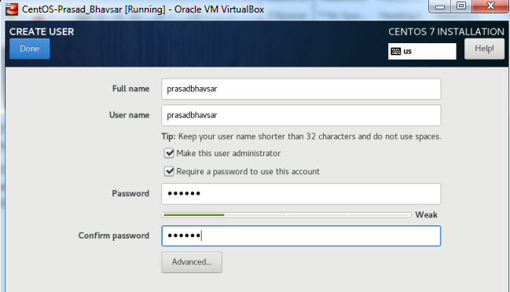
It will take some time for the VM to setup. Reboot it when prompted.
After reboot, Login into the system with your credentials (FirstnameLastname).
(Attach Screenshot)

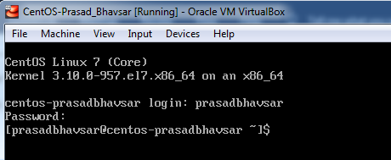

Part 4: Configure CentOS 7 Virtual Machine.

Type in the command “ip a” to get the VM Network Adapter details. Note down the MAC Address for future use. MAC Address: 08:00:27:5c:5d:eb (Yours will be different!) (Attach Screenshot)
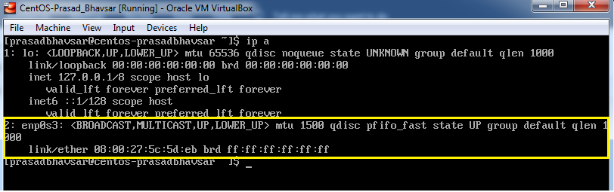
Let’s now set the permanent static IP Address on the VM.
Run the below command and locate the VM Network Adapter configuration file. (Attach Screenshot)
Command: cd /etc/sysconfig/network-scripts
Filename: ifcfg-enp0s3
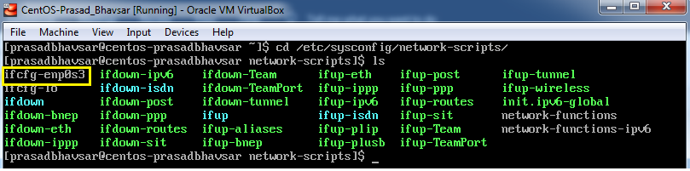
Run the below command to delete this configuration file. (Attach Screenshot)
Command: sudo rm -f ifcfg-enp0s3
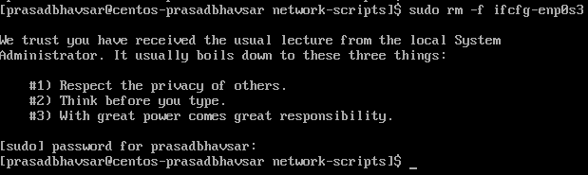
Run the below command to create a new Network configurations file of the same name. (Attach Screenshot)
Command: sudo vi ifcfg-enp0s3
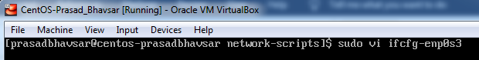
Add the below fields in the new configuration file. (Attach Screenshot)
Make sure to provide “HWADDR” as the MAC Address which you noted down earlier.
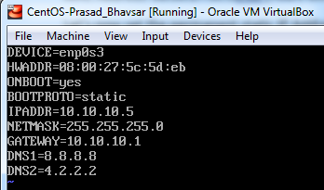
Save the new configuration file. (wq!)
Run the below command to restart the Network Manager service. (Attach Screenshot)
Command: sudo systemctl restart NetworkManager
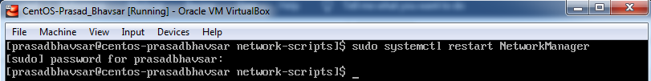
Run the below commands to enable/disable the VM Network Card. (Attach Screenshot)
Command: sudo ifdown enp0s3
Command: sudo ifup enp0s3
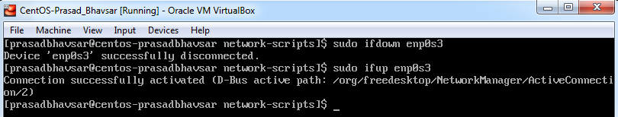
Run the below command to check whether the IP has been assigned to the system or now? (Attach Screenshot)
Command: ip a
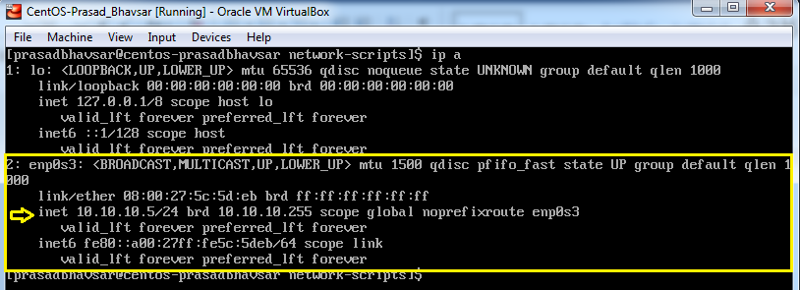
Run the below command to verify the DNS entries have been updated in the System. (Attach Screenshot)
Command: sudo cat /etc/resolv.conf
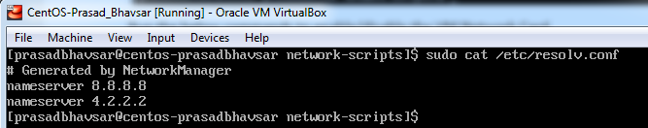
Run the below command to check the Internet Connectivity on the CentOS System. (Attach Screenshot)
Command: ping google.com
Command: ping 8.8.8.8
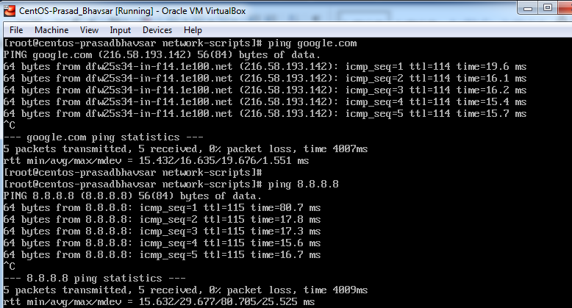
Also ping the Host System from the CentOS VM.
Command: ping 10.10.10.1
Come to your Host Machine (Windows) and open the Command Prompt.
Run the below command to check the connectivity with the CentOS VM. (Attach Screenshot)
Command: ping 10.10.10.5 (You should get ICMP replies back.)
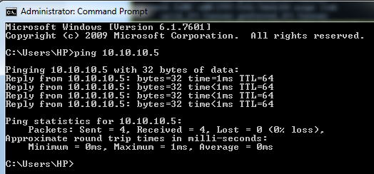

In-case if you didn’t get response in any of the ping command, make sure to disable the Host Machine Firewall.
Go to Run>firewall.cpl.
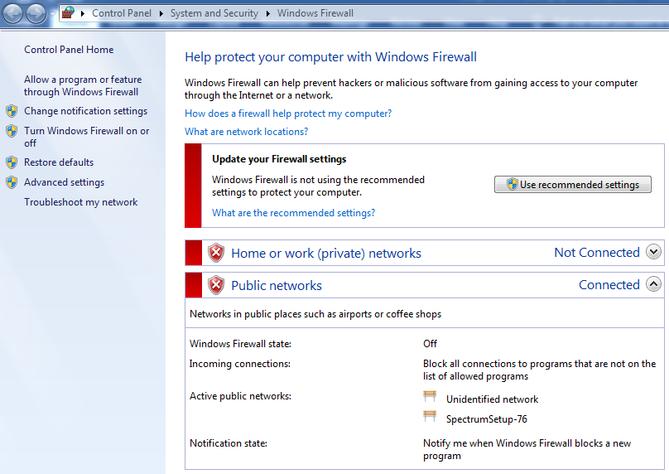

NOTE :- Make sure to disable and enable Microsoft loopback adapter, every time you shut down your device (laptop) and bring the VM back up again after turning the device on again. Failing in doing so will result in intermittent ping issue once the device(laptop) has been shut down.

Step 5: Boot CentOS 7 in GUI Mode (Desktop Environment)
Come back to the CentOS terminal on VirtualBox.
To update the packages in the system, run the below command.
Command: sudo yum update -y
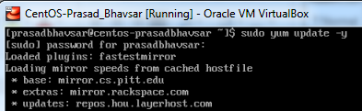
Let’s install GNOME Desktop with the following command. (Attach Screenshot)
Command: sudo yum groups install "GNOME Desktop"
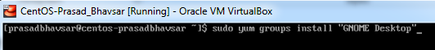
It will take a few minutes to install the packages needed for GNOME.
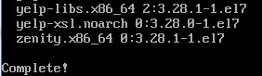
Once it’s completed, run “startx” command.
Command: startx
You’ll observe that the CentOS7 system is now available in GUI mode.
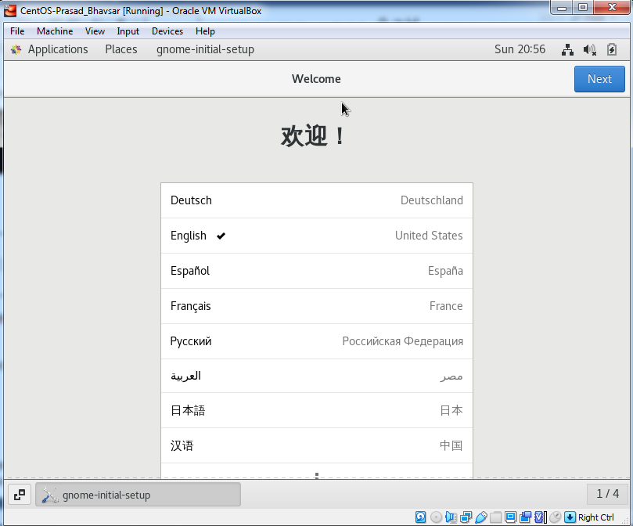
You need to go through accepting a license, configuring language, keyboard type, etc. and finally you will have the CentOS GUI ready. (Attach Screenshot)
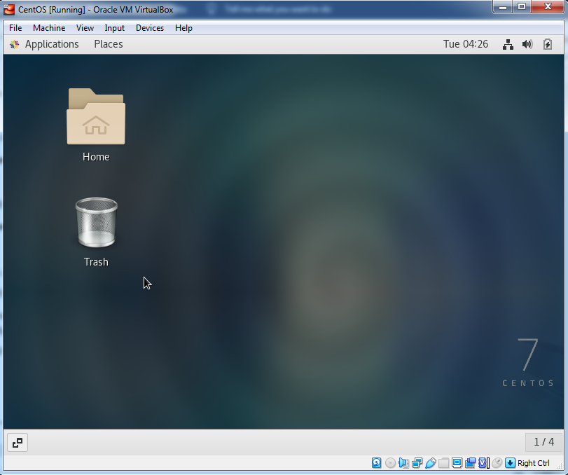
Open terminal within the VirtualBox and run the below commands to set GUI mode permanently.
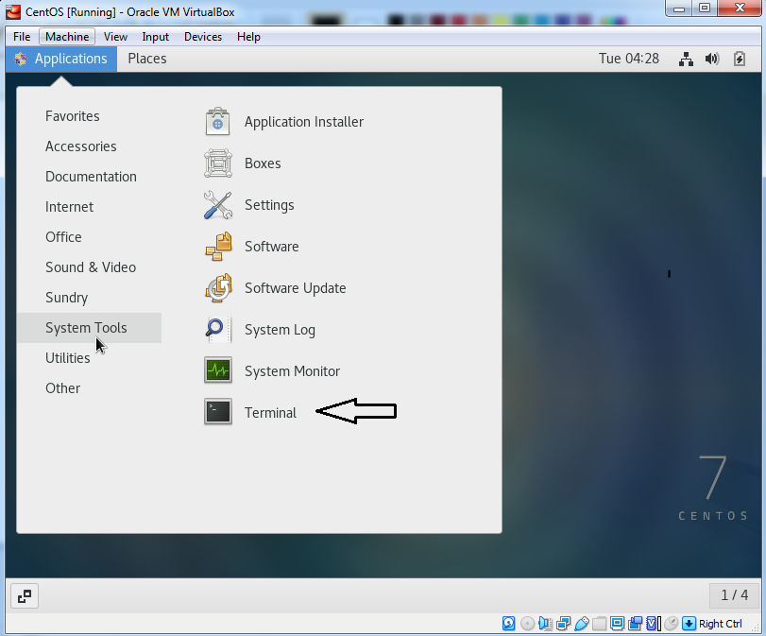

Command: sudo systemctl set-default graphical.target (Attach Screenshot)
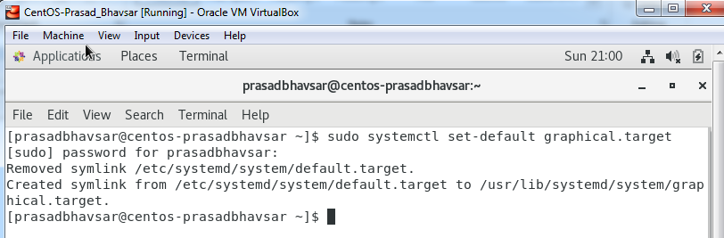
Reboot the CentOS System using below command.
Command: reboot
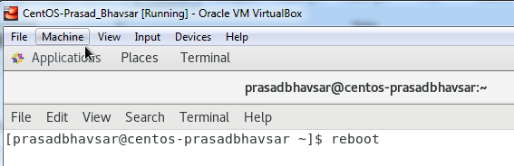
You’ll now boot up in GUI mode permanently.

Login into the CentOS system with your credentials. (Attach Screenshot)
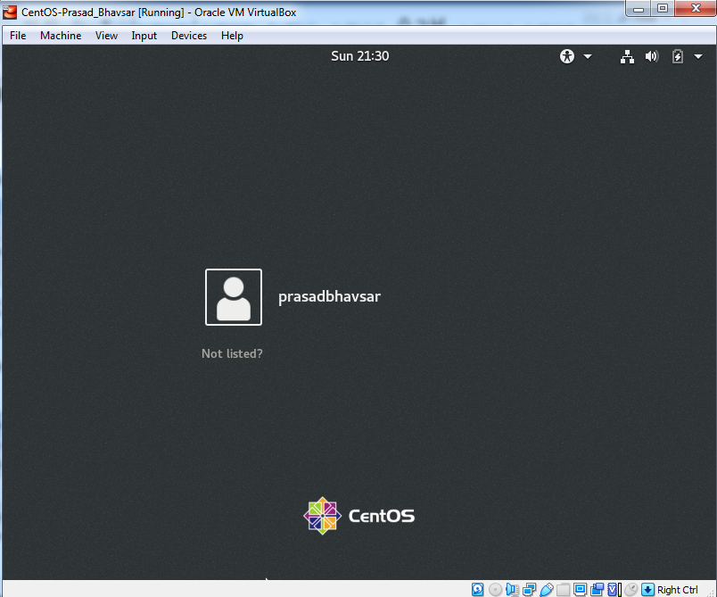
Open the web-browser (Mozilla) and check the Internet Connectivity. (Attach Screenshot)
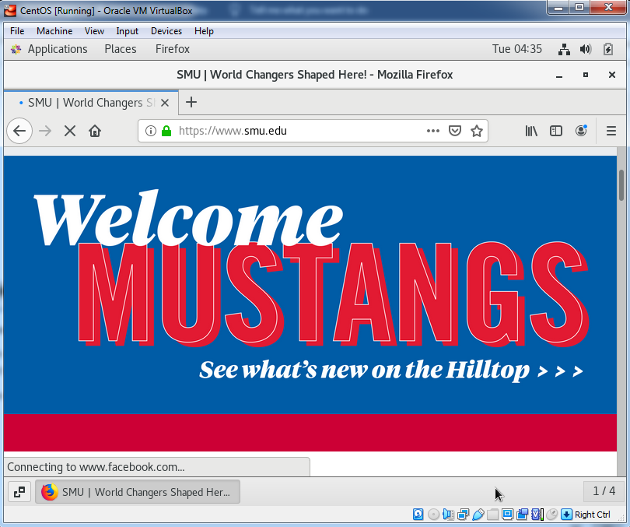
Open the terminal again and run the below commands to install vim and emac2 software in the CentOS system.
Command: sudo yum install vim -y (Attach Screenshot)
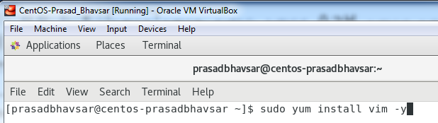
Command: sudo yum install emacs -y (Attach Screenshot)
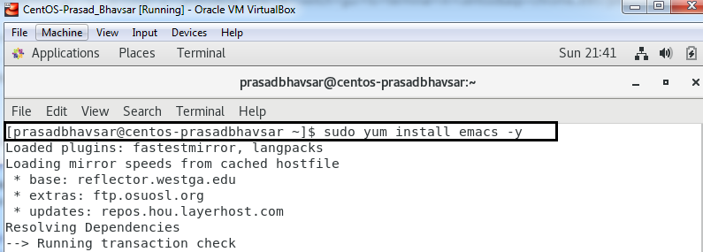

----- END OF LAB -----

