EETS 7302 Homework 3:

Part 1: PuTTY Installation.

In the previous Lab, we configured the CentOS Virtual Machine to boot up in the GUI Mode. You can log in into the System locally and open the Command Line Terminal inside it to execute the commands.

What if your System is at remote location and you want to access it from your Laptop?

In Windows Operating System, if we want access any remote Windows Servers or Computers, we can make use of Remote Desktop Connection (RDP) software from our Laptop.

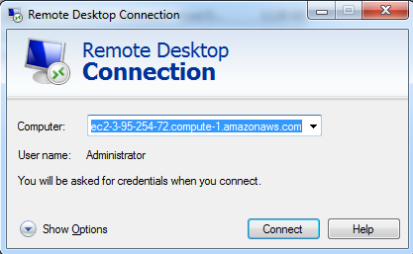

Is there any Tool or Software available to access Linux Systems remotely?

Yes, there are plenty of ways to access the remote Linux Systems. The most popular one is “PuTTY”. Through this tool you can access all the Linux based Systems including Linux Servers, Network Devices, VMware ESXi etc.
You can choose various connection types in PuTTY to have a secured connection with the remote systems.

Let’s download the PuTTY in our system now and access the Virtual Machine which we launched in VirtualBox.

Download and Install Putty on your local device:
https://www.chiark.greenend.org.uk/~sgtatham/putty/latest.html
Open Putty and put IP address of the CentOS VM in Hostname and select SSH for the connection type. Refer below image. (Attach Screenshot)
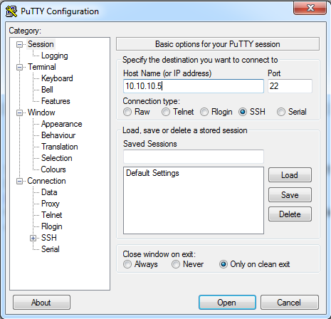
Select Yes when you receive the prompt and you are logged into the device.
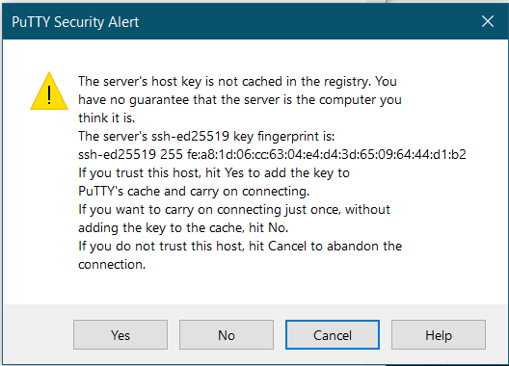
In-case if the PuTTY doesn’t work, make sure to check SSH Service is running in the CentOS VM.
Command: sudo systemctl status sshd
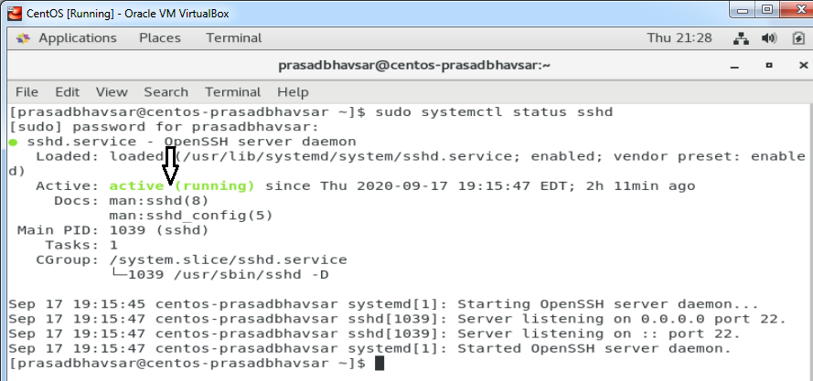
In-case if the SSH Services is not running in the system then execute the below command to start it.
Command: sudo systemctl start sshd
Login with your Username on the system (Do not login with ROOT).
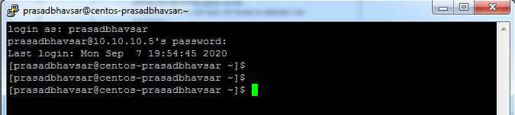
You’ve now successfully logged in into your CentOS VM using PuTTY (SSH).
(Attach Screenshot)

To update the packages in the system, run the below command.
Command: sudo yum update -y
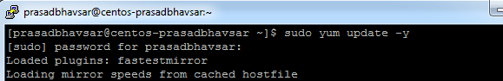

Part 2: Python Installation
To Install VIM editor, run the below command.
To Install python3 on the CentOS VM, run the below command.
Command: sudo yum install python3 -y
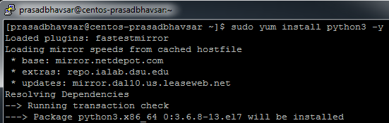
Verify the Python3 Installation.
Command: python3
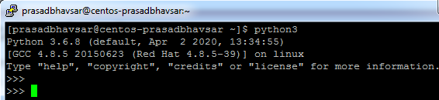
Run the simple Code. (Attach Screenshot)
Code: print(“Hello FistnameLastname”)
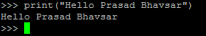

Part 3: Installing Python on your computer.
- Go to https://www.python.org/ and download the 3.7.X Python version.
- Once the package is downloaded, install it with the “Add to the path” option checked and then click install.
- You can open Python interpreter in command prompt in Windows.
- Open command prompt and just type python.
- You will enter the python shell.
OR
- You can use Python IDLE too, just search IDLE version 3.7.4 and Install it on your computer.

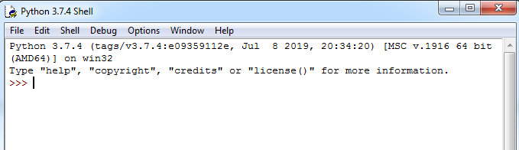

Part 4: Practice

- Try text editor options you like and make a decision which text editor you plan to use moving forward in your Linux environment. Report your decision and insert a screen shot of your text editing environment.
- Create a sample text with your text editor and try at least 5 regular expression with $grep command and include screen shots of the results.
e.g. $ grep “expression” file_name
- Use crontab –e to schedule the job to record the date at every minute in a file in your home directory. After 10 minutes of running , include a screen shot of the file.
4) Practice various performance tools (iostat, vmstat, etc.) on your Linux system and include only 2 screen shots of your choosing from these tools.

-----end of assignment-----

