Homework 4: Linux Networking and Domain Name System (DNS)
Part 1: Linux Networking
Connect to your CentOS Virtual Machine using PuTTY.
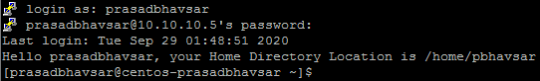
If you recollect, in the Homework 3, we assigned the permanent IP Address to the CentOS Virtual Machine by removing and re-adding the network configuration file (ifcfg-enp0s3) of the VM Network Adapter (enp0s3).
Navigate to the Systems Configuration directory and locate your Network Configuration file. (Attach Screenshot)
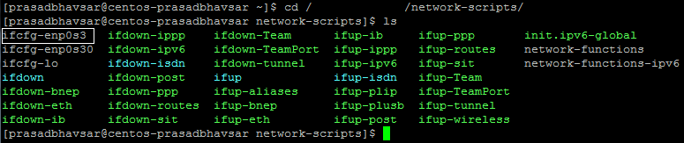
Open the Network Configuration file of the Network Adapter “enp0s3” using your favorite editor and make a note of IP Address, Gateway, DNS etc. (Attach Screenshot)
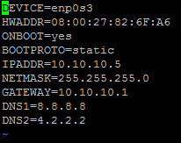
To get the Information about the Network Manager Service in CentOS VM, run the below command.
(Attach Screenshot)
Command: systemctl status NetworkManager
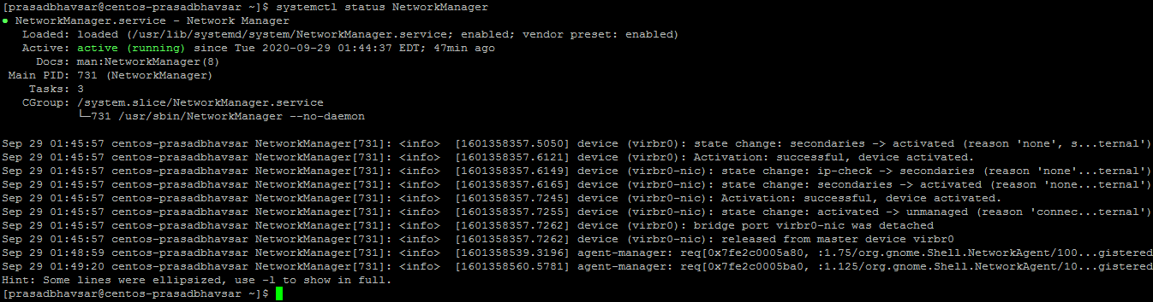
Now let’s concentrate more on the Network Interface Card (enp0s3).
To view the detailed information about the Network Interface Card “enp0s3”, run the following command.
Command: sudo ethtool enp0s3
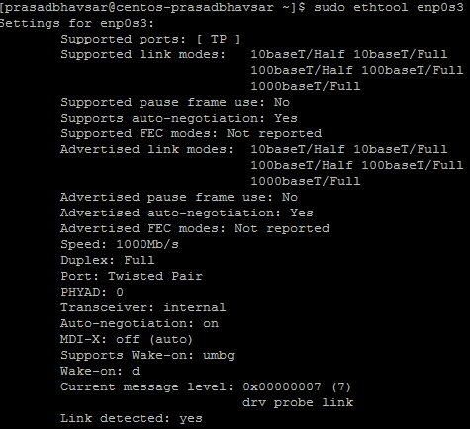
If you recollect, we issued “ifup enp0s3” command to bring back up the Network Interface Card “enp03”
Verify whether the Network Adapter “enp0s3” is up or down? (Attach Screenshot)
Command: sudo ethtool enp0s3 | grep -I ‘Link det’
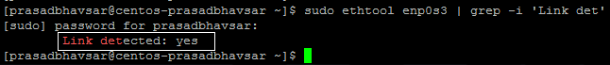
You can also view it through the following command.
OR Command: cat /sys/class/net/enp0s3/operstate

To get the firmware information of the Network Adapter “enp0s3”, run the below command.
Command: sudo ethtool -i enp0s3
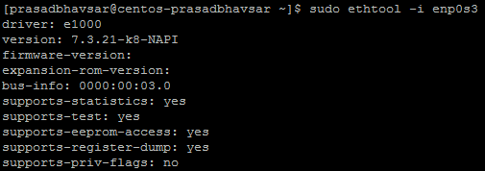
To list the information about all the Network Interface Cards attached to your CentOS Virtual Machine, run the below command. (Attach Screenshot)
Command: ifconfig
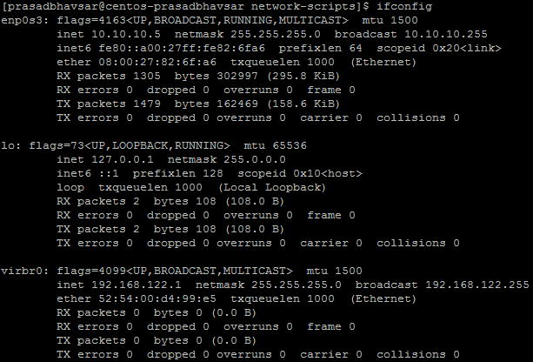
To view the information about a specific Network Interface Card (Eg. enp0s3), run the below command.
(Attach Screenshot)
Command: ifconfig enp0s3
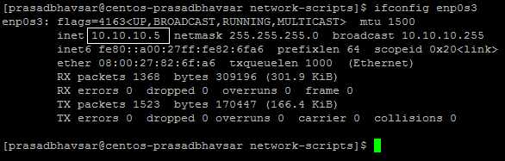
We’ve verified that the Virtual Machine’s Network Adapter has got the correct IP Address which we assigned earlier.
To verify the default gateway, run the below command. (Attach Screenshot)
Command: ip route show
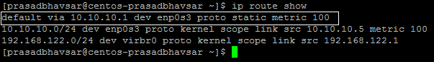
OR Command: route -n
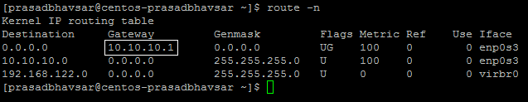
OR Command: netstat -rn
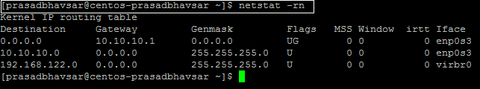
Destination (0.0.0.0) means any unknown network traffic would get routed to the Gateway (10.10.10.1) which is the Microsoft Loopback Adapter in our case and then to the Internet.
To verify the DNS configured on the CentOS VM, run the following command. (Attach Screenshot)
Command: cat /etc/resolv.conf
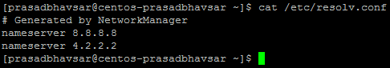
To verify the Internet Connectivity of our CentOS Virtual Machine, run the below command.
Command: ping smu.edu
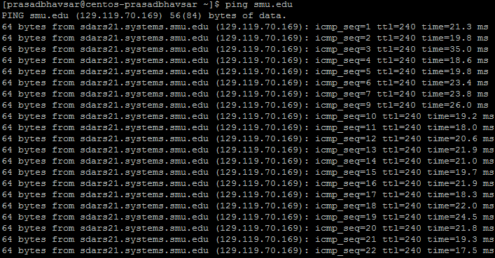
In Linux Systems, if you issue ping command, it keeps on going unless you manually stop it.
To get a specific count of ping responses, we add count flag (-c) in the command. (Attach Screenshot.)
Command: ping smu.edu -c 4
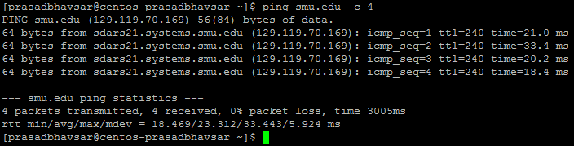
You can add wait condition by running the following command. (Wherein 10=10Seconds)
Command: ping smu.edu -i 10
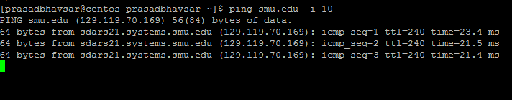
Let’s verify the traceroute package is installed on your CentOS VM or not. (Attach Screenshot)
Command: yum list traceroute
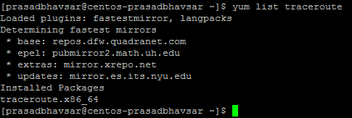
If it is not installed, run the below command to install it.
Command: sudo yum install traceroute -y
To view the flow of the packets or numbers of hops between your CentOS VM and the SMU.EDU webserver, run the below command. (Attach Screenshot)
Command: traceroute smu.edu
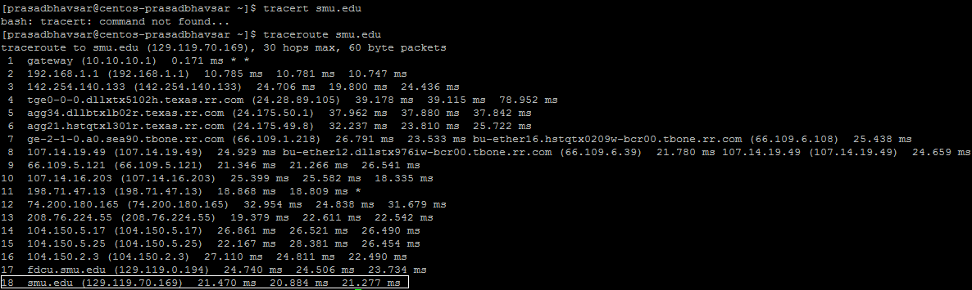
If you notice, packet first routed to our Loopback Adapter (10.10.10.1), then to the Home Router (192.168.1.1) and then to the couple of hops (Managed by ISP) and finally reaches SMU Web Server (129.119.70.169).
Copy the Public IP of SMU Web Server and Paste it in your browser, it should open the webpage. (Attach Screenshot)
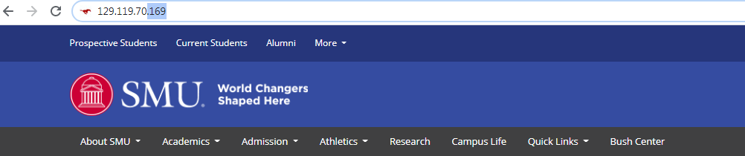
To list the Listening and Non-Listening Ports/Sockets on the CentOS VM, run the below command. (Attach Screenshot)
Command: netstat -a
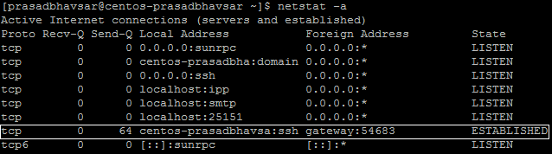
Since we’ve taken PuTTY SSH connection on our windows systems, we can see that the connection has been established with the Windows System’s port “54683”.
Come to windows System, and run the below command in Command Prompt. (Attach Screenshot)
Command: netstat 54683
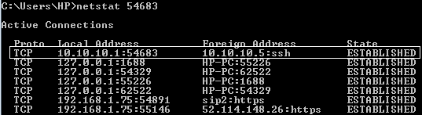
We’ve successfully verified the SSH connection with the CentOS Virtual Machine.

NMAP:
Run the below command to download “NMAP” package.
Command: sudo yum install nmap -y
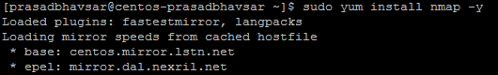
To get the scan report of the SMU.EDU web server, run the below command. Use SMU.EDU-Public IP Address. (Attach Screenshot).
Command: nmap 129.119.70.169
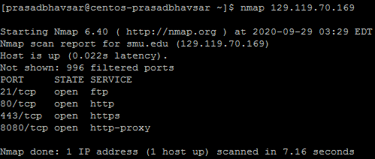
You can see the Host is Up and Services, Ports Informations.
TCPDUMP:
Run the below command to install TCPDUMP.
Command: sudo yum install tcpdump
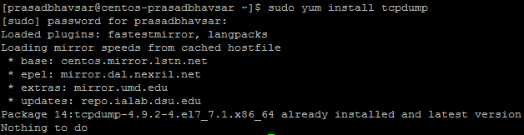
Capture packets on the Network Adapter “enp0s3” using TCPDUMP. (Attach Screenshot)
Command: sudo tcpdump -c 5 -i enp0s3
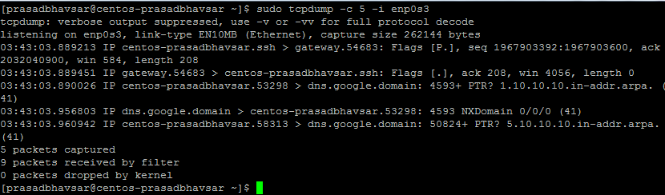
Capture ARP packets on the Network Adapter “enp0s3” using TCPDUMP. (Attach Screenshot)
Command: sudo tcpdump -c 5 -i enp0s3 arp
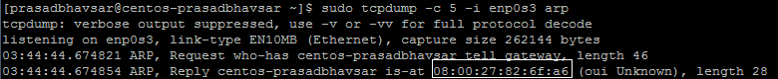
There would be one broadcast request as highlighted, lets verify the MAC Address of the Network Adapter “enp0s3”. (Attach Screenshot)
Command: ip a
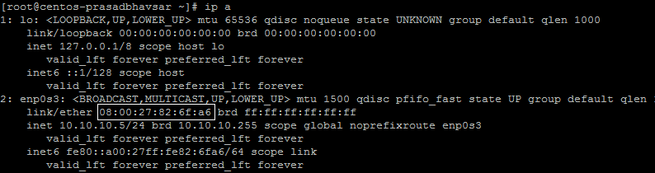
We’ve successfully verified ARP Request and Reply packets.
Part 2: Domain Name System (DNS).
To retrieve IP when the Domain Name is given. (Attach Screenshot)
Command: nslookup smu.edu
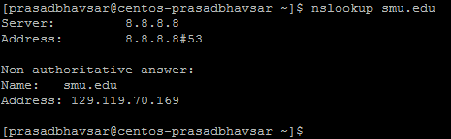
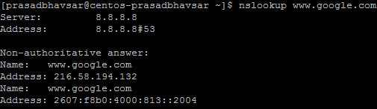
To retrieve Domain Name when the IP Address is given. (Attach Screenshot)
Command: nslookup 129.119.70.169
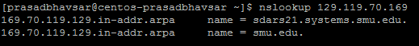

To request various DNS records (Eg. MX, SOA, NS), run the below command. (Attach Screenshot)
Command: nslookup -query=mx smu.edu
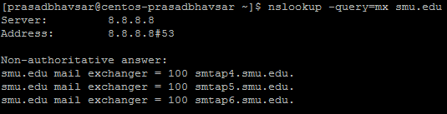
Command: nslookup -query=soa smu.edu
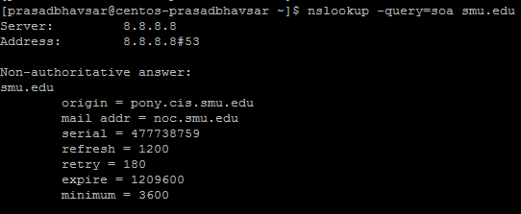
Command: nslookup -query=ns smu.edu
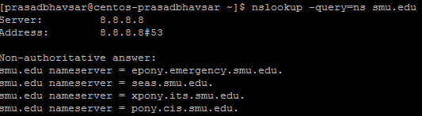

You can request all the DNS records by running the following command. (Attach Screenshot)
Command: nslookup -query=any smu.edu
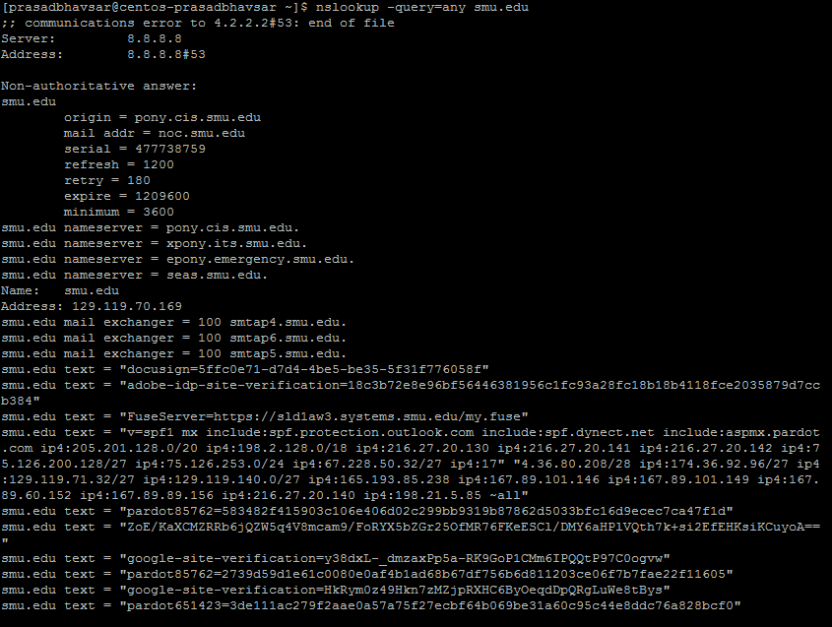
Domain Information Groper (DIG):
Install DIG using the following command.
Command: sudo yum install bind-utils -y
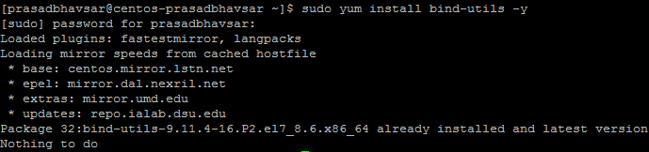

Query a domain by issuing following command. (Attach Screenshot)
Command: dig smu.edu
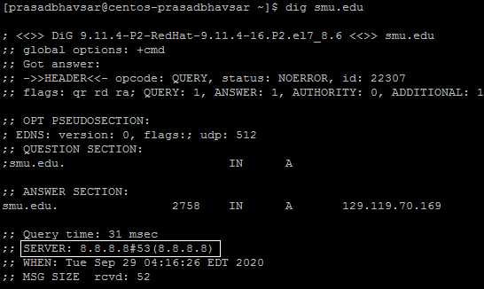
If you notice, it is utilizing the DNS Server which we specified in the Network Configuration file (ifcfg-enp0s3).
Try querying the Domain with the Secondary DNS. (Attach Screenshot)
Command: dig @4.2.2.2 smu.edu
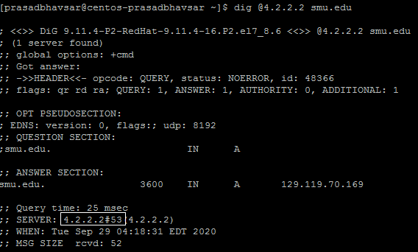

Question: By issuing the above command, why the other record types (AAAA, NS, SOA, MX) are not displayed?
Let’s search for the specific record types. (Attach Screenshot)
Command: dig smu.edu CNAME
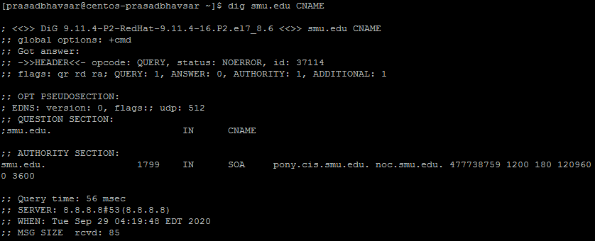
Command: dig smu.edu CNAME
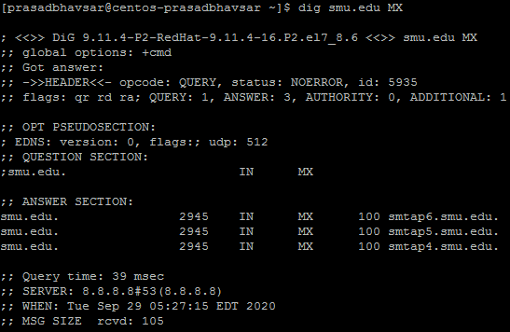
Perform DNS Lookup with the following command. (Attach Screenshot)
Command: dig smu.edu +short
Perform reverse DNS Lookup with the following command. (Attach Screenshot)
Command: dig -x 129.119.70.169 +short
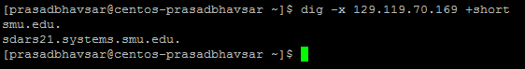

You can do multiple DNS Lookups by storing information of various Domains in a file. (Attach Screenshot)
Command: cat > SMU_ID.txt (Add your favorite Domains)
Command: dig -f query.txt +short
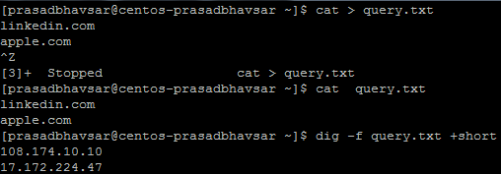
To perform trace for the DNS Lookup path, run the below command. (Attach Screenshot)
Command: dig smu.edu +trace
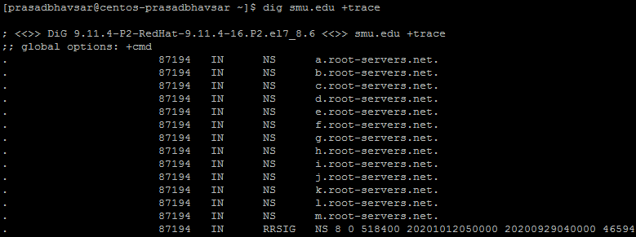
HOST FUNCTION:
This method is similar to Domain Information Groper (DIG).
Perform DNS Lookup with the following command. (Attach Screenshot)
Command: host smu.edu
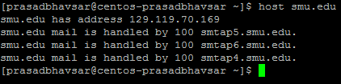
Perform reverse DNS Lookup with the following command. (Attach Screenshot)
Command: host -i smu.edu
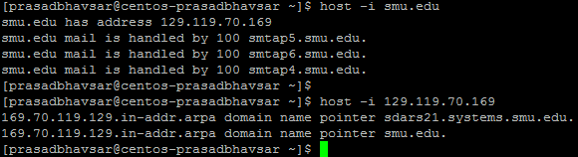
Run the below command to query the Record Types. (Attach Screenshot)
Command: host -t A smu.edu (Query Record Types mentioned in the Screenshot).
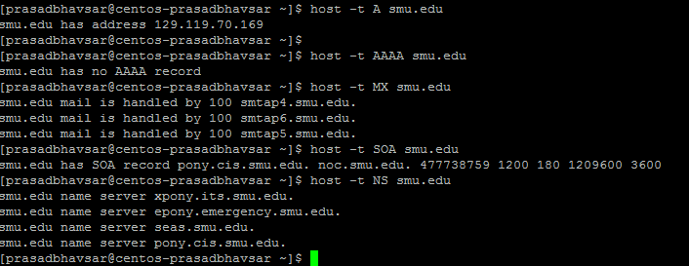

Practice:
- Change the Secondary DNS Server as 8.8.4.4 in your CentOS Virtual Machine and confirm this change with a command. (Attach Screenshot)
- Try querying any Domain with the new Secondary DNS. (Hint: DIG) (Attach Screenshot)
- Get the DNS records (MX, SOA, NS) of the domain harvard.edu.
- Get the traceroute result for linkedin.com. (Attach Screenshot)
Optional Practice Questions:
- Install PingPlotter software on your windows system and get the traceroute result of your favorite domain.
- Get the DNS Server IP of your ISP from your host OS. (Hint: Windows System if your host OS is Wndows)

-----END -----

