EETS 7302 HOMEWORK 5: BASH SCRIPTING
Q.1 Write a shell script using your favorite editor. The script should display Username, UID, User’s Home Directory, Host Name and Terminal Type. Include Comments in the script for explanation. An example output of the script may look like as below. Attach Screenshot of your Script and its Output in your submission.
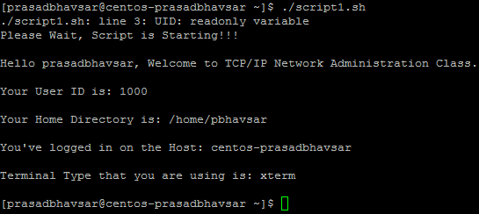
Q.2 Write a shell script using your favorite editor. The script should ping a given number of IP addresses one at a time starting from a given IP address. If the IP cannot be pinged, the script indicated no connection. If it can ping then script runs 5 more pings and reports the min, average and max delay and also reports domain name for the IP. Include Comments in the script for explanation. An example output of the script may look like as below. Attach Screenshot of your Script and its Output in your submission.
