# Gas Prices in USA, historical analysis

This report is intended to review gas prices in the USA historically for comparison against various claims.

One such claim is that the sitting US President has a direct affect on gas prices.

## Data from the EIA - US Energy Information Administration

This dataframe set GasPrices_eia_prices_1970_2022 comes from the EIA website as a downloadable CSV.

The [EIA](https://www.eia.gov/TOOLS/FAQS/faq.php?id=26&t=10) provides an FAQ for using the data, which includes instructions to download the [CSV](https://www.eia.gov/state/seds/seds-data-complete.php?sid=US#CompleteDataFile) and for a reference [Excel](https://www.eia.gov/totalenergy/data/monthly/index.php#appendices) document that helps with conversion.

“To obtain the historical prices from the SEDS data, use the CSV file for All States—Prices. In the file, the code for gasoline prices for the transportation sector, in $/MMBtu, is: State Abbreviation (in column A) and MGACD (in column B). For example, the code for Alaska is AK—MGACD. Those prices, in $/MMBtu, can be converted to approximate dollars per gallon using the heat contents in Table A3 Petroleum consumption and fuel ethanol. There are 42 U.S. gallons in a barrel.”

The CSV is downloaded from > Section: Prices and expenditures > Subsection: All price and expenditure estimates > SubSubsection: Prices > 1970-2022 > XLSX CSV ZIP

The following shows the barrel prices falling sharply well before 2016’s national election, and remaining relatively stable until after the pandemic crashes of 2020.

import pandas as pd  
import matplotlib.pyplot as plt  
  
# Path to the CSV file  
file_path = 'C:/Users/dwolfe/Documents/Demo_Skills_SampleCode/Projects/National_Market_Markers/_dataframes/GasPrices_eia_prices_1970_2022.csv'  
  
# Read the CSV file  
df = pd.read_csv(file_path)  
  
# Filter rows where 'MSN' column contains 'MGACD'  
filtered_df = df[df['MSN'].str.contains('MGACD', case=False, na=False)]  
  
# Calculate the average for each year for the filtered data  
average_prices = filtered_df.iloc[:, 3:].mean() # Assumes year data starts at the 4th column  
  
# Create a line plot  
plt.figure(figsize=(10, 5)) # Set the figure size  
plt.plot(average_prices.index, average_prices.values, marker='o') # Plot the average prices  
plt.title('Average Gas Prices Over Years for MGACD') # Add a title  
plt.xlabel('Year') # Add x-axis label  
plt.ylabel('Average Price') # Add y-axis label  
plt.grid(True) # Add a grid  
plt.xticks(rotation=45) # Rotate x-axis labels for better readability  
plt.tight_layout() # Adjust layout to make room for the rotated x-axis labels  
plt.show() # Display the plot

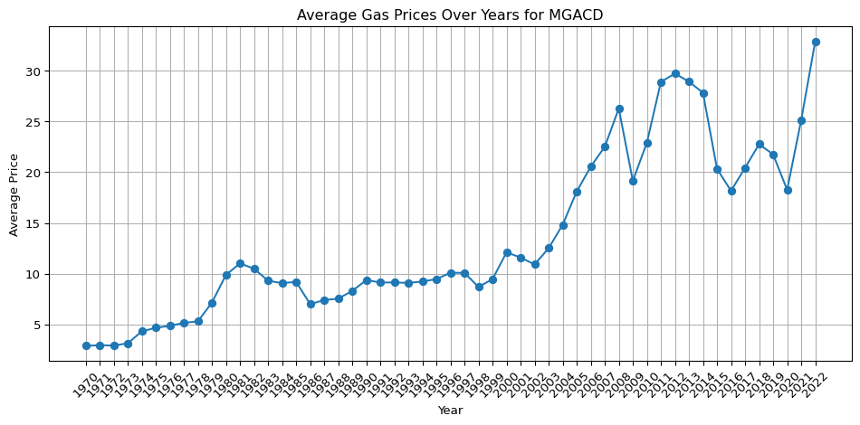

## Data from Our World in Data

Our World in Data provides an international dataset to review.

This dataframe set GasePrices_OWD_crude-oil-prices.csv comes from the Our World in Data website as a downloadable CSV.

“Data Page: Oil price - Crude prices since 1861”, part of the following publication: Hannah Ritchie, Pablo Rosado and Max Roser (2023) - “Energy”. Data adapted from Energy Institute. Retrieved from https://ourworldindata.org/grapher/crude-oil-prices [online resource]

These international crude oil prices show the same trends, clearly indicating that the US President is unrelated to gas prices.

import pandas as pd  
import matplotlib.pyplot as plt  
  
# Path to the CSV file  
file_path = 'C:/Users/dwolfe/Documents/Demo_Skills_SampleCode/Projects/National_Market_Markers/_dataframes/GasPrices_owd_intl_1861_2023.csv'  
  
# Read the CSV file  
df = pd.read_csv(file_path)  
  
# Display the first few rows to verify the data  
print(df.head())  
  
# Filter data for years 1970 to 2023  
filtered_df = df[(df['Year'] >= 1970) & (df['Year'] <= 2023)]  
  
# Plotting the filtered data  
plt.figure(figsize=(12, 6)) # Set figure size  
plt.plot(filtered_df['Year'], filtered_df['Oil price - Crude prices since 1861 (current US$)'], marker='o', linestyle='-')  
plt.title('International Crude Oil Prices from 1970 to 2023')  
plt.xlabel('Year')  
plt.ylabel('Oil Price (current US$)')  
plt.grid(True)  
plt.xticks(rotation=45) # Rotate x-axis labels for better readability  
plt.tight_layout() # Adjust layout  
plt.show() # Display the plot

Entity Code Year Oil price - Crude prices since 1861 (current US$)  
0 World OWID_WRL 1861 3.082002  
1 World OWID_WRL 1862 6.604290  
2 World OWID_WRL 1863 19.812870  
3 World OWID_WRL 1864 50.695790  
4 World OWID_WRL 1865 41.449783

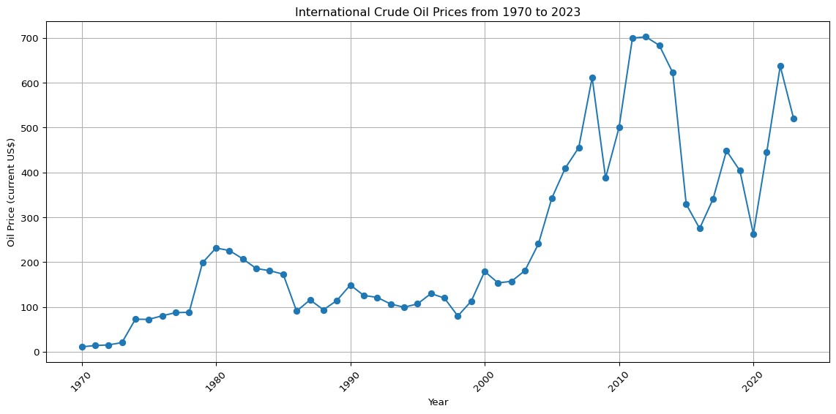

## Placeholder TBC…

Text