# 變更貨物狀態 QR-Code

建立訂單

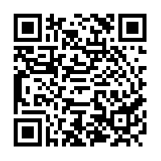

<http://api.happyfarm.darren-cv.site/setLogisticsStatus/300>

已到物流中心

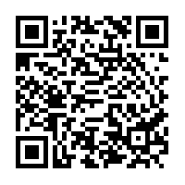

<http://api.happyfarm.darren-cv.site/setLogisticsStatus/3024>

買家已取貨

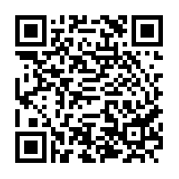

<http://api.happyfarm.darren-cv.site/setLogisticsStatus/3022>