**Report**

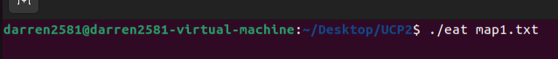



The user must type this input to open a txt file with the map layout to run the program.

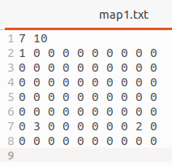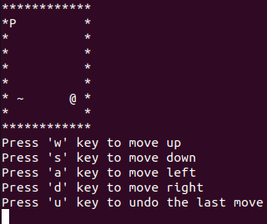

This is the map layout for map1.txt and is shown on the program.

(‘1’ indicates the Player, ‘2’ indicates the Food, ‘3’ indicates the snake.)

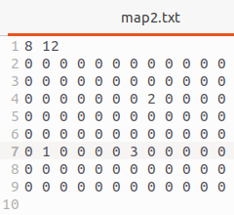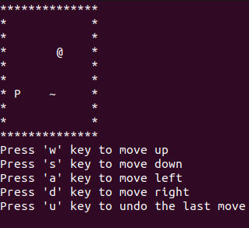

This is the map layout for map2.txt and is shown on the program.

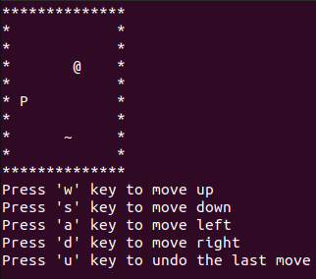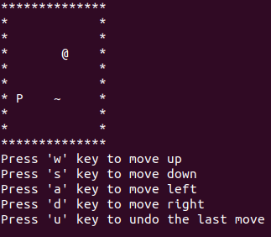  
From map2.txt when the user presses the ‘w’ key the player moves up one step as usual. The movement of the player can be undone by pressing the 'u’ once and the ‘P’ will move back one step to the previous position.

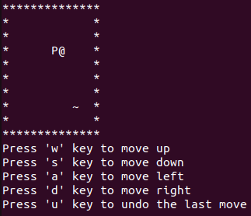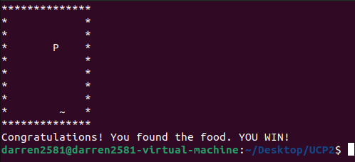

When the player moves to the next position to eat the Food. The program will tell the user that they Won the game.

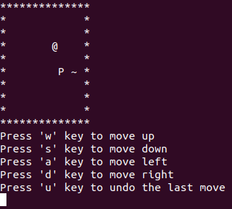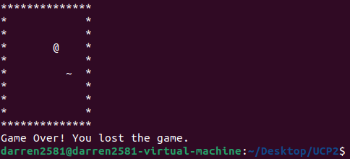

When the player moves to the next position near the snake. The snake will eat the player and tell the player that they have lost.

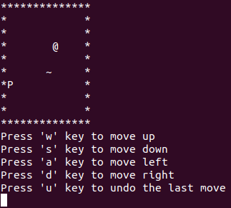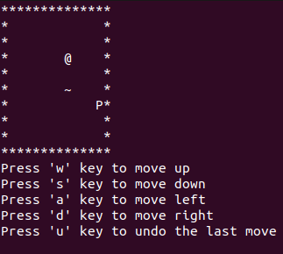

When the user presses ‘a’ at the left border to move the player. The player position will be updated to the border on the right side. This shows that the player will be warped horizontally around the border.

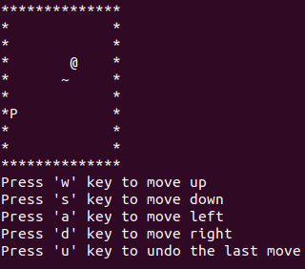

When the user presses ‘d’ at the right border to move the player. The player position will be updated to the border on the left side. This shows that the player will be warped horizontally around the border.

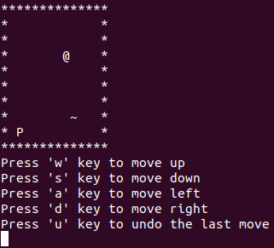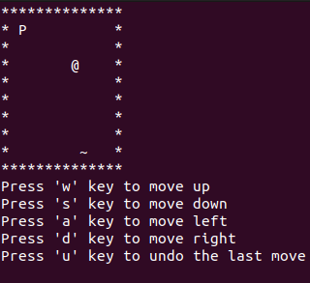

When the user presses ‘s’ at the bottom border to move the player. The player position will be updated to the border at the top. This shows that the player will be warped vertically around the border.

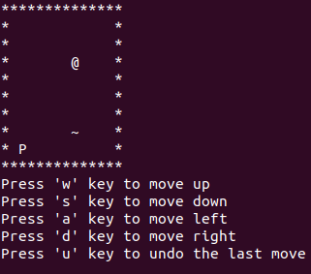

When the user presses ‘top’ at the bottom border to move the player. The player position will be updated to the border at the top. This shows that the player will be warped vertically around the border.