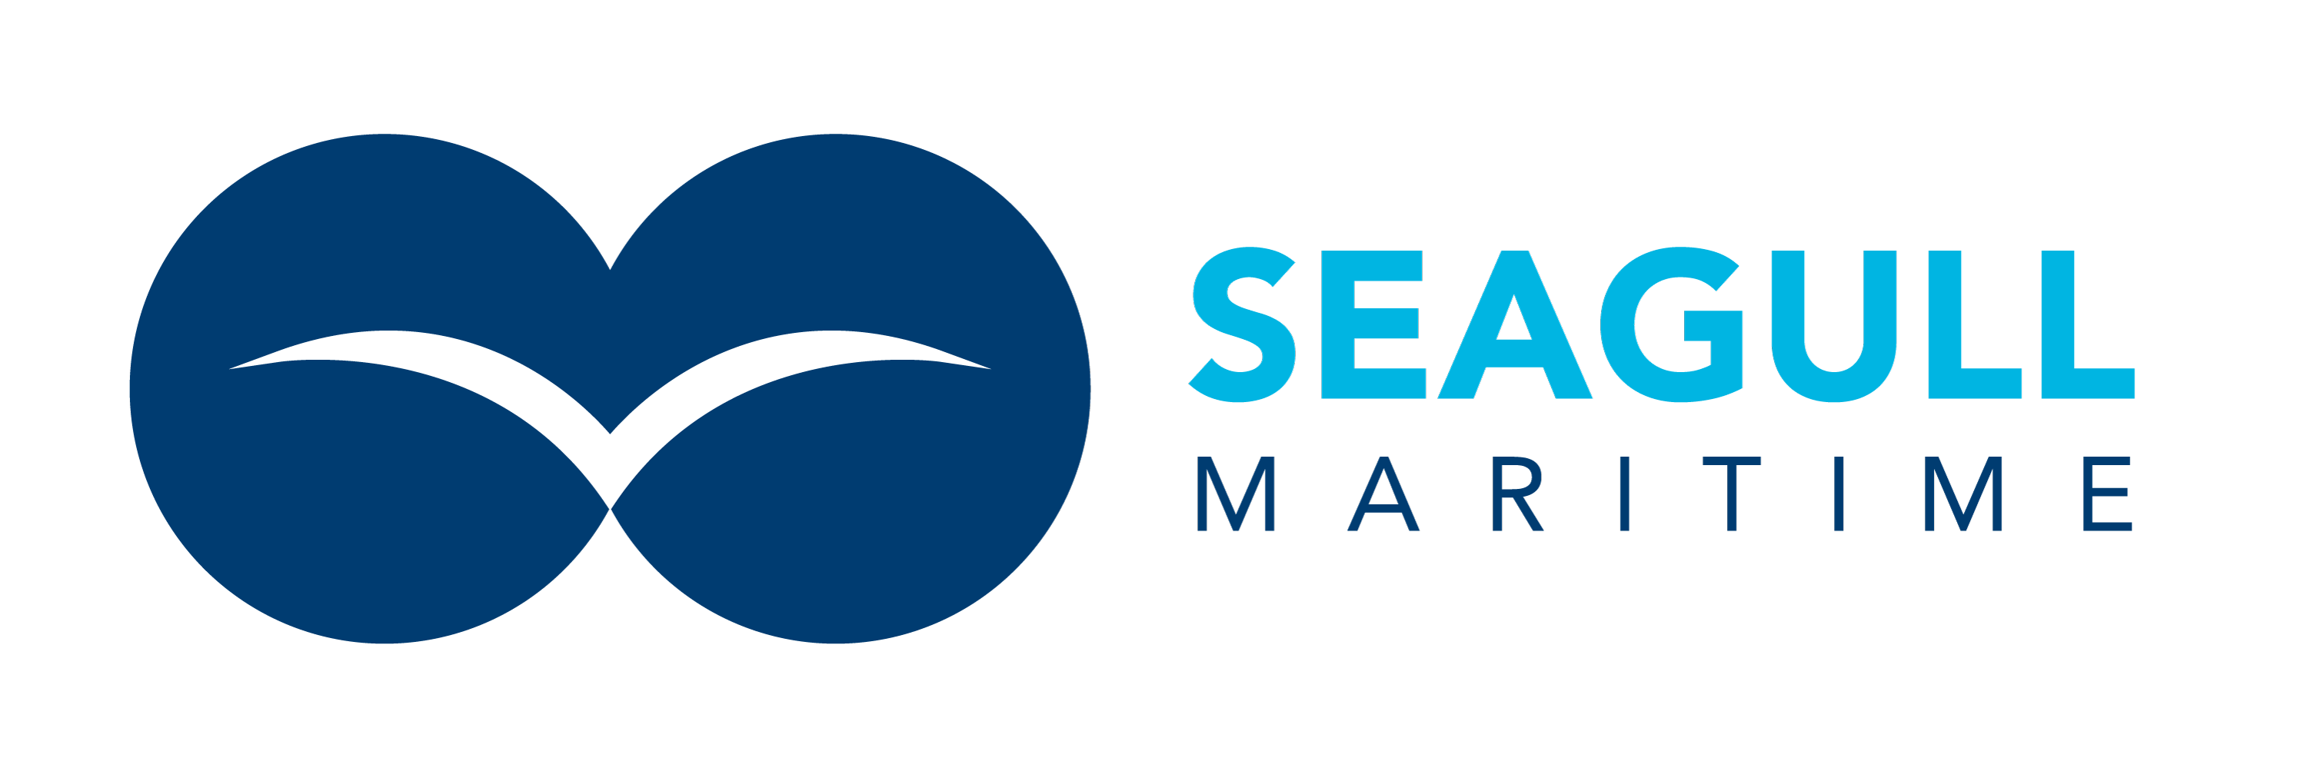
TRAINING & DRILL REPORT
OVERVIEW
Company Name: | Seagull Maritime Ltd
Location: | Piraeus Office, Greece (with remote participants via Google Meet)
Exercise Type: | Tabletop Exercise
Exercise Date: | 27/03/2026
Duration: | 1.5 hours
Supervisor/Facilitator | Darren Watts, Group Compliance Director (Dubai, remote)
Participants | Christoforos Antzoulatos, WAF Operations Director (Piraeus, in-person)  Eugene Lukshin, Compliance Administrator (remote)  Olga Zuck, Chief Commercial Officer (Ukraine, remote)  Dima Trebukh, Senior Operations Manager (remote)  Pavel Shparber, CEO (Israel, remote)  Poppy, Legal / Acting Office Manager (Piraeus, in-person)
PURPOSE & OBJECTIVES
The purpose of the tabletop exercise was to evaluate the effectiveness of the company Incident & Crisis Management Plan (SM/INT/PRO/006) and the Emergency Preparedness and Response Procedure in response to a fire emergency at a company office location.
Exercise Objectives
• Validate the organisation’s ability to identify, assess, and escalate a fire incident at a shore-based location
• Test crisis management roles, responsibilities, and decision-making across distributed locations
• Evaluate communication processes between Greece, Dubai, and remote team members
• Identify gaps, weaknesses, and improvement actions within emergency response arrangements
Participants were expected to propose and simulate their believed actions in the event of a real incident. This was the first IRT exercise conducted under the new management system.
SCOPE
• Crisis Management Team activation and coordination
• Internal and external communications (including client notification)
• Operational continuity (tasking management, vessel tracking)
• Staff welfare and accountability
• Coordination between Piraeus office, Dubai (GCD), and remote staff
Live system failure and actual physical evacuation were excluded from this exercise.
SCENARIO OVERVIEW & ASSUMPTIONS
At 10:30 local time on a working day, a fire breaks out in the electrical distribution room on the ground floor of the Piraeus office building. The fire alarm activates and all occupants evacuate. Smoke damage affects the first-floor offices where Seagull Maritime operates. No fatalities occur, but one member of staff (building tenant, not Seagull) is treated for minor smoke inhalation. The Seagull office is closed pending inspection.
The incident disrupts:
• All Greece-based office work activities including commercial and WAF operations coordination
• Physical access to equipment, files, and IT hardware left in the office
• Face-to-face client meetings scheduled for the following week
We will assume:
• Greek emergency services responded and the fire is contained within 40 minutes
• All Seagull staff evacuated safely and are uninjured
• Google Workspace and 1Clearview remain accessible online
• Chris has his mobile phone; other equipment is inside the building
PARTICIPANTS & ROLES
Role | Name | Responsibilities
Incident Commander | Christoforos Antzoulatos | On-site command, evacuation confirmation, local liaison
Crisis Coordinator | Darren Watts | Overall coordination, procedure activation, external reporting
Operations Lead | Dima Trebukh | Operational continuity, vessel tasking handover
Commercial Lead | Olga Zuck | Client communications, commercial impact assessment
Compliance Support | Eugene Lukshin | Incident documentation, regulatory notifications
CEO / Exercise Lead | Pavel Shparber | Strategic oversight, ownership decisions, external stakeholder liaison
Office Manager (Acting) | Poppy | Staff welfare, building management liaison, local logistics
EXERCISE TIMELINE
Phase One – Incident Detection / Initial Response
Scenario | 10:30 – Fire alarm activates in building. Smoke visible on ground floor.
Expected Response | Evacuation, emergency services called, initial notification to GCD
Discussion Outcomes | Chris confirmed evacuation procedure — staff to assembly point across the street (CA)  Chris called Greek fire service 199 and confirmed building evacuation (CA)  Initial confusion on who to notify first — Chris called Darren directly rather than following the notification chain in the IMP. Darren noted this should go CEO then GCD, but accepted that in practice calling the GCD first was reasonable given the compliance reporting requirement (CA/DW)  Eugene was unsure if there was a regulatory notification requirement for a building fire — Darren confirmed no maritime regulatory notification needed for a shore incident but insurers should be notified (EL/DW)
Phase Two – Crisis Management Team Activation
Scenario | 11:10 – Fire contained. Building closed. All Seagull staff confirmed safe outside.
Expected Response | CMT activation, Google Meet convened, comms to remote staff and management
Discussion Outcomes | Darren activated Google Meet call with all participants (DW)  Dima confirmed all vessel taskings are tracked in 1Clearview and accessible remotely — no immediate operational risk (DT)  Olga raised concern about client meeting scheduled Monday with a potential new IOR client — proposed rescheduling to video call. Darren agreed (OZ/DW)  Chris noted he did not have a printed emergency contact list — all contacts were on his laptop inside the building. Darren flagged this as a gap requiring action (CA/DW)  Pavel joined the Google Meet within 15 minutes of being notified. Asked for immediate confirmation of staff headcount and whether any clients were affected (PS)  Poppy confirmed she had spoken to building management and obtained the fire service contact details. Had already begun a staff headcount from the assembly point (Poppy)
Phase Three – Business Impact and Decision Making
Scenario | 11:30 – Building management confirms office will be closed for minimum 48 hours pending inspection.
Expected Response | Operational handover, client communications, resource allocation
Discussion Outcomes | Dima proposed splitting IOR operations monitoring between himself and the duty TLs for 48 hours — Darren approved, asked Dima to confirm shift coverage in writing (DT/DW)  Olga to email all scheduled clients advising of temporary office closure with alternative contact details (OZ)  Chris to recover laptops and critical equipment once fire service clears the building (CA)  Eugene asked whether an NCR needed to be raised — Darren confirmed no NCR required as this is an external event, but an incident record should be logged on the Safety App (EL/DW)  Poppy coordinated with building management for an estimated timeline on re-entry. Confirmed water damage was limited to ground floor only (Poppy)  Pavel asked whether alternative office space was needed — Darren recommended work-from-home for 48 hours first, office space search only if closure extends beyond one week (PS/DW)  Dima initially suggested diverting ops emails to his personal email — Darren corrected this, directing all comms to stay within company Google Workspace accounts for audit trail and data protection (DT/DW)
Phase Four – Recovery and Close
Scenario | 12:00 – All staff confirmed safe and accounted for. Remote working arrangements in place.
Expected Response | Recovery confirmation, lessons learned, stand-down
Discussion Outcomes | All staff confirmed able to work remotely using Google Workspace and 1Clearview (DT)  Olga confirmed all client communications sent (OZ)  Darren confirmed insurance broker to be notified by email as precautionary measure (DW)  Pavel confirmed he was satisfied with the response and authorised the stand-down (PS)  Poppy to prepare a building re-entry checklist for when fire service clears access (Poppy)  CMT stood down. Normal operations to continue remotely pending building clearance (DW)
PERFORMANCE REVIEW
Objective | Result | Comments
Safe Evacuation | Achieved | Chris demonstrated clear understanding of building evacuation
CMT Activation | Achieved | Google Meet convened within 30 minutes
Understanding of Roles | Achieved | All participants engaged and understood their responsibilities
Communication Effectiveness | Partially Achieved | Good internal comms; notification chain to CEO/ownership was slower than expected
Operational Continuity | Achieved | 1Clearview and Google Workspace enabled seamless remote transition
STRENGTHS IDENTIFIED
• Good engagement from all participants despite being the first exercise of this type
• Strong understanding of remote working capabilities and technology available
• Chris demonstrated calm, practical approach to on-site incident management
• Dima showed strong operational awareness in proposing shift coverage solutions
GAPS OR WEAKNESSES IDENTIFIED
• No printed emergency contact list available at the Greece office — all contacts stored digitally on devices left inside the building
• Notification chain to CEO/ownership not clearly understood by all participants — Chris bypassed the chain and called GCD directly
• Eugene uncertain on regulatory reporting requirements for shore-based incidents
• Dima’s initial suggestion to use personal email for ops comms indicates a data protection awareness gap
IMPROVEMENT ACTIONS
# | Action | Owner | Target Date
1 | Print and post emergency contact list at Greece office (laminated, near exit) | Chris Antzoulatos | 04/04/2026
2 | Circulate IMP notification chain to all staff as a one-page reference | Darren Watts | 04/04/2026
3 | Brief Eugene on regulatory vs. insurance notification requirements | Darren Watts | 11/04/2026
4 | Include data protection reminder in next staff awareness bulletin | Darren Watts | 30/04/2026
EXERCISE EVALUATION
The tabletop exercise demonstrated that Seagull Maritime has a reasonable level of incident response capability for a shore-based emergency. The distributed nature of the team (Greece, Dubai, Ukraine) means that remote working arrangements are already well-established, which is a significant advantage in a business continuity scenario.
Core response and recovery arrangements were effective. Several practical gaps were identified, particularly around physical emergency preparedness at the Greece office and clarity on the notification chain. These are manageable and improvement actions have been assigned.
This was the first formal IRT exercise conducted under the new management system. Future exercises should include a maritime-specific scenario to test the full operational response chain including PCASP coordination, vessel masters, and client liaison.
EXERCISE SIGN OFF
Supervisor | 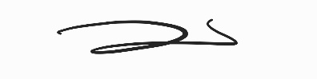
Name / Role | Darren Watts, Group Compliance Director
Date | 27/03/2026

