INSTRUCTIONS
Please read the instructions carefully before doing the questions.
- You can use materials in your computer, notebook and text book.
- You are NOT allowed to use any device to share data with others.
Beside the above conditions, students must follow the following requirements:
1. The work must complete by using Visual Studio 2022++
2. The Framework must be .NET 8.0
3. THIS PART IS VERY IMPORTANT, PLEASE READ IT CAREFULLY AND FOLLOW THE INSTRUCTIONS.
- You are given a database script (.sql file) in Zip file. Execute the script before doing questions.
- You must use the given solution.
- You are not allowed to add any more libraries via NuGet Package Manager into given solution.
- Submission Guideline:
Submit your work for each question separately. For each question, please:
- Publish your project using the command:
dotnet publish -c Release -o ./[QuestionNumber_StudentAccount]
Example:
dotnet publish -c Release -o ./Q1_trungnthe123432
- Submit the root folder of the project into the PEA_Client application.
- If the root folder of the project is too large, you may delete the following subfolders to reduce its size before submitting: /bin, /obj
Just one of above requirements is violated, your work will be considered as invalid.
Question 1:

You are provided with a database as following diagram:
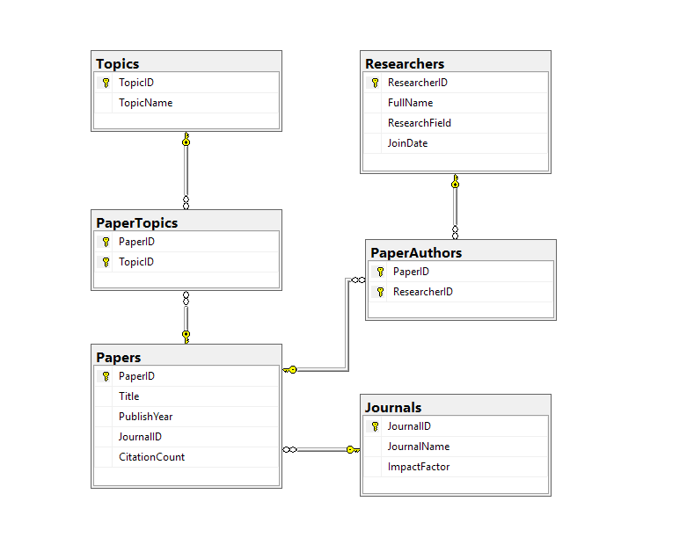
Ensure that the database connection string is adjustable through appsettings.json (otherwise your post will get 0 point) as pattern:

{
"ConnectionStrings":
{
"MyCnn": ""
}
}
Your task is to implement the following APIs using .NET 8 and Entity Framework Core:
Method | URL | Description
GET | /api/journals | Retrieve all journals with paper statistics.
GET | /api/filter-papers | Advanced search for papers with author/topic details.
POST | /api/papers | Add a new paper to the system.
DELETE | /api/papers/{paperId} | Remove a paper and its associated data.

1. GET /api/journals
Retrieve a list of all journals.
- Support response in JSON and XML.
- Return: journalId, journalName, impactFactor, and paperCount (Total papers published in this journal).
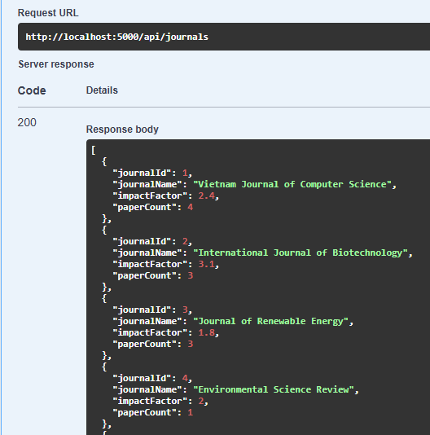
2. GET /api/filter-papers
Retrieve a list of papers with advanced author/topic statistics.
- Filtering Logic:
topic: Filter papers that are tagged with this topic name (case-insensitive).
minCitations: Return only papers whose CitationCount is greater than or equal to this value.
- Response Fields:
paperId, title, publishYear, citationCount.
journalName: Name of the journal this paper was published in.
leadAuthor: The FullName of the researcher with the smallest ResearcherID among this paper's authors. If no authors exist, return "No Author".
topicList: List of TopicName associated with this paper.
- Sorting: Sort results by CitationCount descending by default.
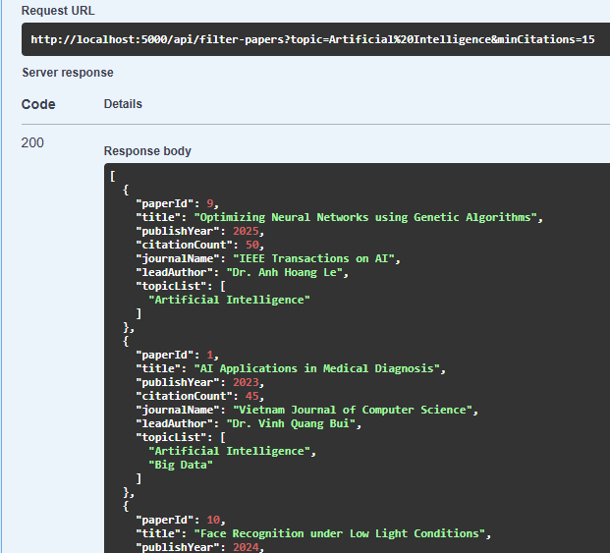
- Error handling: Return 400 Bad Request if minCitations is negative.
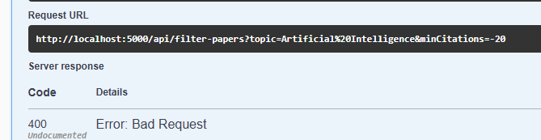

3. POST /api/papers
Accept RoomNumber-equivalent fields title, publishYear, and journalId from the request body.
- Return: The complete created object (including empty navigation properties like paperAuthors as [], paperTopics as [], journal as null).
- Error handling: If title already exists, return 400 Bad Request with message "Paper title already exists".
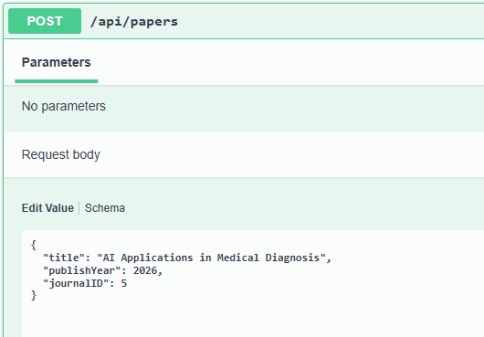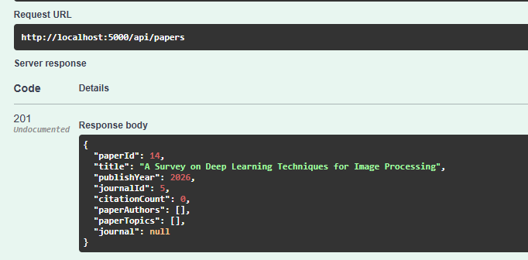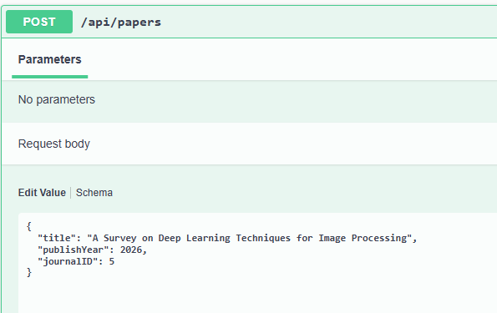

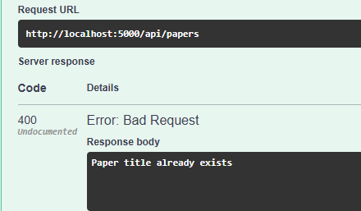

4. DELETE /api/papers/{paperId}
Delete the paper with the specified paperId.
- Return: 204 No Content if successful.
- Error handling:
If the paper has any records in PaperAuthors, return 400 Bad Request error with message "Cannot delete paper with assigned authors".
If the paperId does not exist, return a 404 Not Found error.
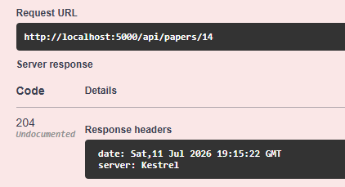
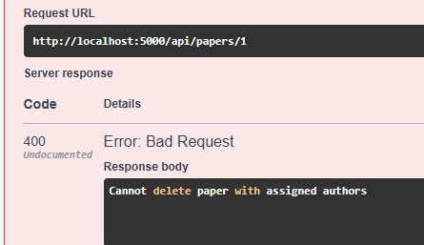
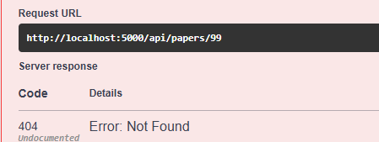
Question 2:

In this question, you are asked to write an MVC/Razor Pages application. The application fetch data by calling pre-existing RESTful API hosted at GivenAPIBaseUrl. The API are provided in a separate project named GivenAPIs, which students must run locally to start the API server.
1. Important Notes
- Students MUST use HttpClient to call the API.
- The GivenAPIBaseUrl must be written in appsettings.json
{
"GivenAPIBaseUrl": "http://localhost:5100"
}
- Students must use explicit string concatenation for API endpoints (e.g., baseUrl + "/endpoint").
- All input and output elements in the HTML source must have an 'id' attribute to ensure accessibility and traceability.

2. Provided APIs
- GET /api/researchers/search?name={name}&field={field} : Returns researchers matching the optional name (contains) and field (contains) filters. With no filter, returns all 5 seeded researchers.
- GET /api/researchers/{researcherId} : Returns the researcher's detail plus the list of papers they authored (paperId, title, publishYear).
3. Requirements
3.1. Researcher List Page
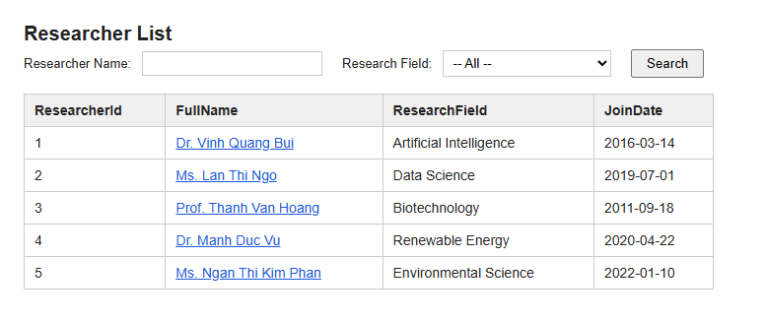
URL : /Researcher
Search Area :
- A text input for Researcher Name (id: ip_researcherName).
- A dropdown (select) for Research Field (id: ip_researchField).
- Submitting the search (e.g. pressing Enter or a Search button) issues a GET to the same page with the corresponding name / field query params.
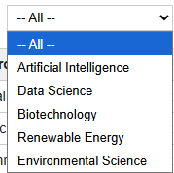

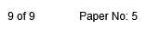
Data Table :
- A <table> whose <tbody> contains one <tr> per researcher returned by the API.
- With no filter, exactly 5 rows must be rendered (one per seeded researcher). When filtering by name, the matching row's text must include the filter value.
- Each row must link to that researcher's detail page, e.g. <a href="/Researcher/1">...</a>.
3.2. Researcher Detail Page
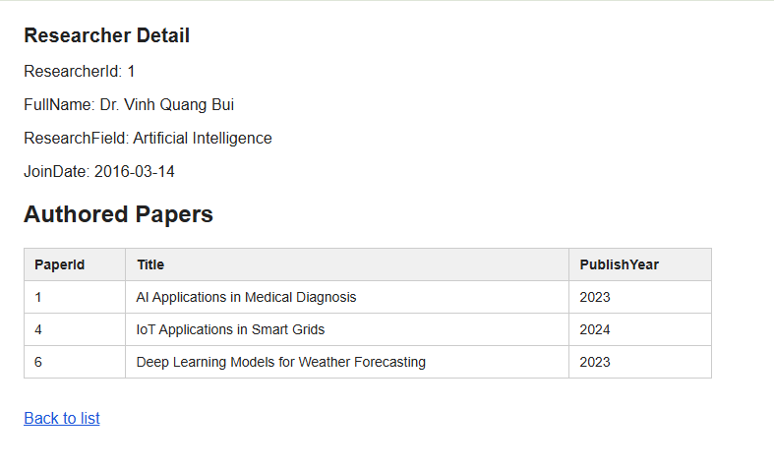
URL : /Researcher/{researcherId}
Display basic information :
- An element with id span_{researcherId} (e.g. id="span_1") whose text content includes the ResearcherId.
Display Papers Table :
- A <table> whose <tbody> lists the researcher's authored papers (one <tr> per paper, showing paperId, title, publishYear).
4. Summary of Required URLs
Function | URL
List researchers, filter by name / field | /Researcher
View researcher detail and authored papers | /Researcher/{researcherId}

