ST3189 Coursework

Machine Learning Coursework



Presented to: University of London, SIM Global Education
Course : Machine Learning (ST3189)

Prepared by: Darren Alexander

Lecturer: Eng Hock Gui
3 April 2026

Table of Contents
1. Background 3
2. Research Question 3
3. Exploratory Data Analysis (EDA) 3
3.1 Gender Distribution Analysis 3
3.2 Location Distribution Analysis 4
3.3 Payment Method Distribution 4
3.4 Seasonal Distribution analysis 5
3.5 Correlation Analysis 6
4. Unsupervised Learning 6
4.1 Customer Segmentation 6
4.2 Determining the Number of Clusters 7
4.3 Cluster Characteristics 7
4.4 Cluster Evaluation 8
5. Classification Modelling 8
5.1 Model Performance 9
5.2 ROC Curve Analysis 9
6. Regression Modelling 10
6.1 Model Performance 10
6.2 Learning Curve Analysis 11
Model Comparison 12
Conclusion 12

1. Background
Nowadays understanding how consumers shop has become increasingly important. Businesses are no longer relying only one factor, but instead use data to better understand what customers want, how they behave, and what influences their decisions. The dataset used in this study provides information about consumer shopping behaviour, including what people buy and how often they purchase. This allows us to explore patterns in a practical way and see how different types of customers behave. For example, some groups of consumers may prefer certain product categories, while others may shop more frequently. Another important aspect of this dataset is its diversity. It includes a wide range of customers and shopping activities, which makes it useful for identifying patterns between groups. By analysing this data, we can group similar customers together, understand what affects their spending, and make predictions about their behaviour

2. Research Question
This study uses consumer shopping data to better understand how customers behave. By analysing both demographic information and transaction details, the aim is to identify meaningful patterns in shopping behaviour and explore what factors influence these patterns. There are 3 research questions that want to be addressed in this analysis:
- What types of customer groups can be identified based on their shopping behaviour, demographics, and payment preferences?
- To what extent can a customer’s spending (purchase amount) be predicted using their demographic and behavioural information?
- Are there any clear patterns in purchasing behaviour over time, such as seasonal or regional differences?

3. Exploratory Data Analysis (EDA)
Exploratory Data Analysis (EDA) is an important step of data analysis where involves examining and summarising the dataset to better understand its structure and patterns before applying more advanced methods.

3.1 Gender Distribution Analysis
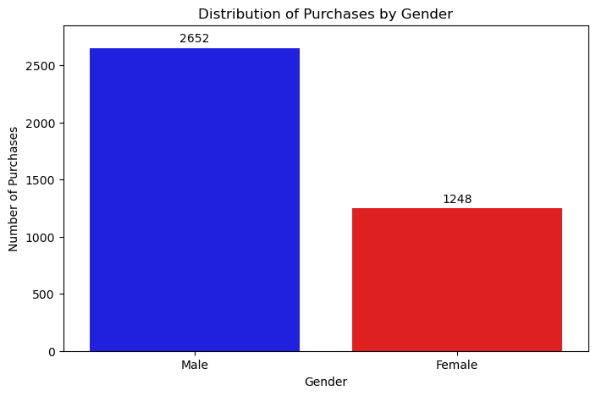
Figure 3.1: Distribution of Purchases by Gender
The first analysis shows the distribution of purchases across different genders. As shown in the chart, male customers account for a larger number of purchases (2652) compared to female customers (1248). This indicates that within this dataset, male customers are more active in terms of purchasing frequency. One possible explanation could be that male customers tend to make purchases more often than female customers.

3.2 Location Distribution Analysis
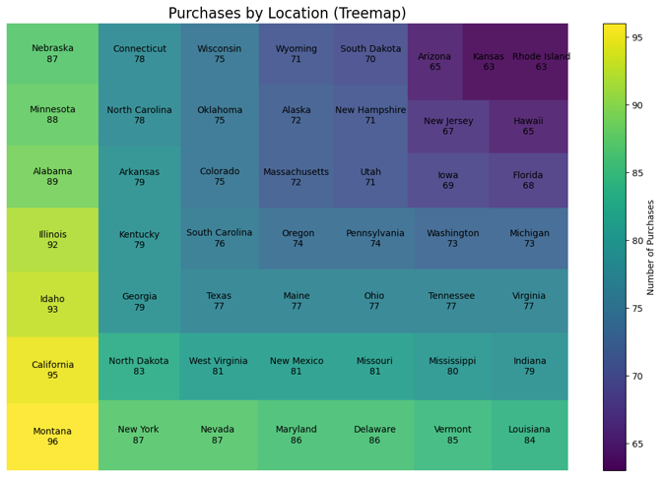
Figure 3.2: Treemap of Purchases by Location
The treemap visualisation illustrates how the number of purchases is distributed across different locations. Each box represents a state, where both the size and colour intensity indicate the number of purchases. Larger and brighter boxes correspond to higher purchase counts, while smaller and darker boxes represent lower levels of activity. From the chart, it can be seen that states such as Montana (96), California (95), and Idaho (93) have the highest number of purchases. On the other hand, states such as Rhode Island (63), Kansas (63), and Arizona (65) have the lowest number of purchases counts, suggesting less activity in those regions. Overall, the distribution of purchases across locations appears to be relatively balanced. However, there are still noticeable differences between high and low purchase regions.

3.3 Payment Method Distribution
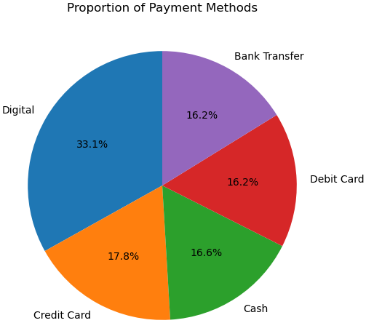
Figure 3.3: Proportion of Payment Methods
The pie chart presents the distribution of different payment methods used by customers. From the chart, digital payment methods amount for the largest share at approximately 33.1%, indicating that they are the most commonly used option among customers. This suggests a strong preference for convenient and technology-based payment solutions. Credit card payments follow at around (17.8%), while cash (16.6%), debit card (16.2%), and bank transfer (16.2%) are used at relatively similar levels. Overall, beside digital payments, the remaining payment methods are evenly distributed. This indicates that customers still rely on a mix of traditional and modern payment options rather than shifting entirely to one method.

3.4 Seasonal Distribution analysis
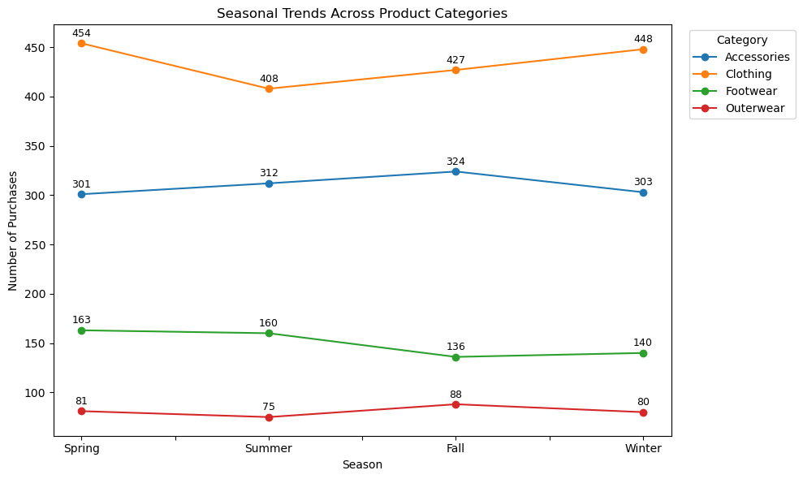
Figure 3.4: Seasonal Trends Across Product Categories
The line chart illustrates how the number of purchases varies across different product categories throughout the four seasons: Spring, Summer, Fall, and Winter. From the chart, clothing consistently amounts the highest number of purchases across all seasons, with its highest at 454 purchases. Although there is a slight drop in Summer (408), purchases increase again in Fall (427) and Winter (448). On the other hand, accessories show a relatively stable pattern with purchases ranging from 301 to 324. In addition, There is also a gradual increase from Spring to Fall, followed by a slight decline in Winter. In contrast, footwear demonstrates a decline from Spring (163) to Fall (136), before slightly increasing again in Winter (140). Lastly, outerwear has the lowest number of purchases overall but shows some seasonal fluctuation. Purchases decrease in Summer (75), increase in Fall (88), and slightly drop again in Winter (80).. Overall, the results suggest that while some categories such as clothing and accessories maintain strong demand throughout the year, others like footwear and outerwear show clearer seasonal variation.

3.5 Correlation Analysis
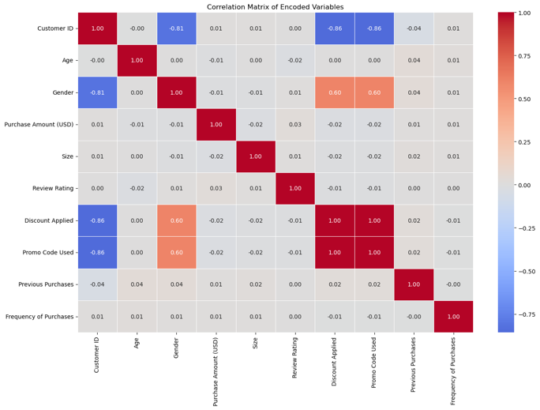
Figure 3.5: Heatmap of Correlation Matrix
The heatmap above illustrates the strength of relationships between different variables, with correlation values ranging from -1 to 1. Values closer to 1 indicate a strong positive relationship, while values closer to -1 indicate a strong negative relationship. Values near zero suggest little to no relationship between variables. From the heatmap, most variables exhibit very weak correlations with one another, as many values are close to zero. This suggests that there are no strong linear relationships among the majority of features in the dataset. For example, variables such as age, purchase amount, and review rating appear to have minimal influence on each other. However, a strong positive relationship (1) can be observed between “Discount Applied” and “Promo Code Used”. This indicates that these two variables behave very similarly. In addition, there is a moderate positive relationship (around 0.60) between gender and both “Discount Applied” and “Promo Code Used”. This suggest that certain groups are more likely to use discounts or promotional codes. Some strong negative correlations are also present, particularly between “Customer ID” and variables such as gender and promotional usage. However, since customer ID is merely an identifier, these relationships are not practically significant and can be ignored in the interpretation.

4. Unsupervised Learning

4.1 Customer Segmentation
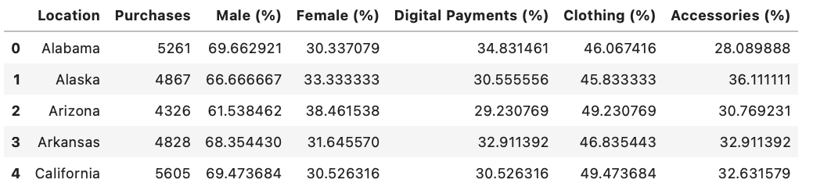
Figure 4.1: First 5 Row of The Grouped Data
To better understand patterns in consumer behaviour, clustering analysis was applied. This allows us to identify different types of customer segments without pre-defined labels. Before applying the clustering method, the data was first prepared by grouping detailed product categories into broader groups such as Clothing, Footwear, and Accessories. Payment methods were also simplified by combining similar options whereas payments such as Venmo and PayPal were grouped into Digital payments.

4.2 Determining the Number of Clusters
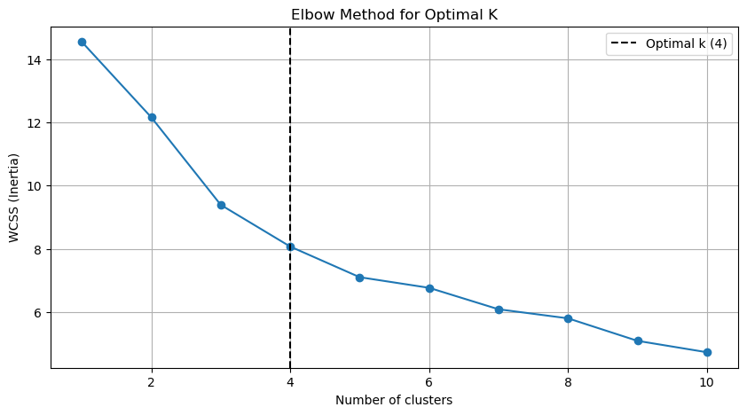
Figure 4.2: Elbow Method Graph
The Elbow Method was used to identify the optimal number of clusters. From the graph, a clear “elbow point” appears at K = 4, indicating that dividing the data into four clusters provides a good balance between simplicity and explanatory power.

4.3 Cluster Characteristics
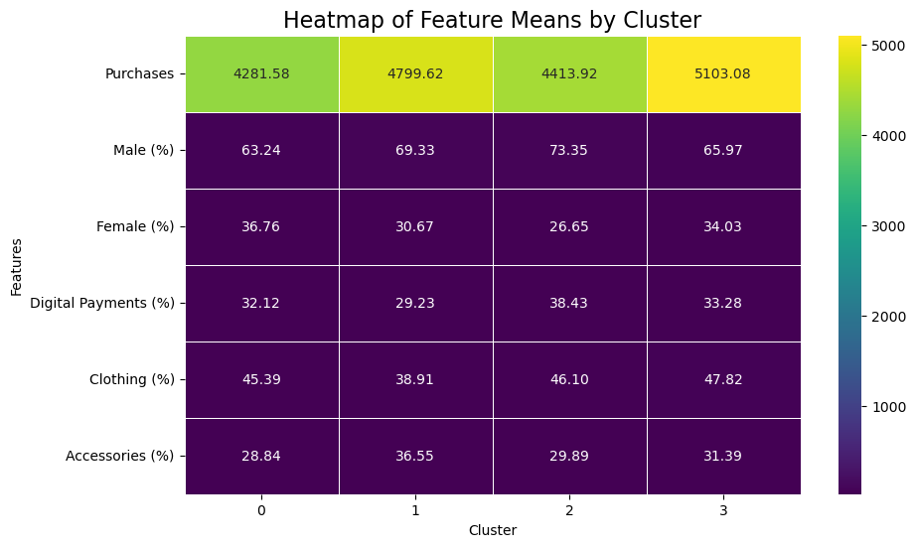
Figure 4.3: Heatmap of Means by Cluster
After applying K-Means clustering with four clusters, the average characteristics of each cluster were analysed using a heatmap. Firstly, cluster 0 shows lower overall purchases (4281.58) with a moderate proportion of digital payments and balanced gender distribution. While, cluster 1 has higher purchases (4799.62) and a higher proportion of accessories purchases (36.55%). It also has a relatively lower percentage of female customers compared to other clusters. For cluster 2, it shows the highest proportion of male customers (73.35%) and the highest use of digital payments (38.43%). Lastly, cluster 3 has the highest number of purchases overall (5103.08) and strong demand for clothing (47.82%). This cluster represents the most active group. In conclusion, these results suggest that different groups of locations shows different purchasing patterns, particularly in terms of gender, payment preferences, and product categories.

4.4 Cluster Evaluation
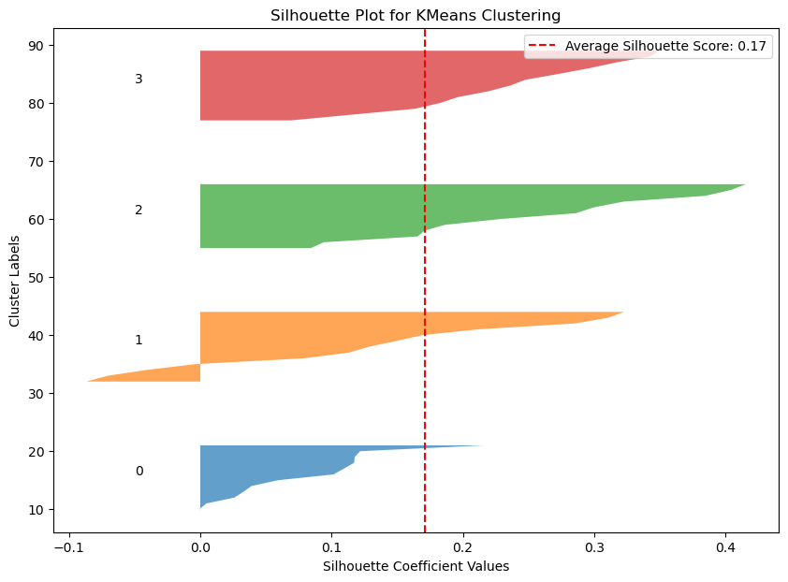
Figure 4.4: Silhouette Plot
To assess the quality of the clustering, a silhouette analysis was conducted. The average silhouette score is approximately 0.17, which indicates that the clusters are not very strongly separated but still show some meaningful structure. Some overlap between clusters is present, suggesting that customer behaviour across regions may not be sharply distinct. Overall, the clustering analysis reveals that consumer behaviour can be grouped into several distinct segments, although the differences between groups are moderate rather than extreme.

5. Classification Modelling
Classification model was used to predict whether a customer’s purchase amount is above or below the median value. This converts the problem into a binary classification task, where:
- Class 1: Purchase amount above median
- Class 0: Purchase amount below or equal to median
Before performing the classification analysis, several preprocessing steps were done to ensure the data was suitable. Firstly, categorical variables such as gender, discount usage, and promo code usage were encoded into numerical values. Secondly, ordinal encoding was applied to variables with inherent order, such as payment method, purchase frequency, and season. Next, clothing size was converted into numerical values based on its natural ordering (S to XL). Lastly, interaction features were created to capture more complex relationships between variables. For this analysis, multiple classification algorithms were implemented and compared which are Decision Tree, Random Forest, AdaBoost, K-Nearest Neighbours (KNN), Support Vector Machine (SVM). This approach ensures a comprehensive comparison between different types of models.

5.1 Model Performance
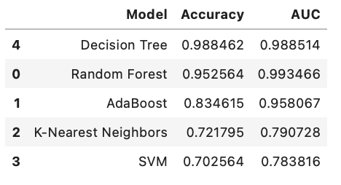
Figure 5.1: Model Accuracy and AUC
The performance of each model was evaluated using accuracy and Area Under the ROC Curve (AUC). The results show that Decision Tree achieved the highest performance with an accuracy of approximately 98.8% and AUC of 0.989, indicating excellent classification ability. While, Random Forest also performed very well, with an accuracy of 95.2% and AUC of approximately 0.993, suggesting strong predictive capability. For, AdaBoost it showed good performance with an accuracy of 83.4% and AUC of around 0.958, though slightly lower than tree-based models. However, K-Nearest Neighbours and SVM performed comparatively worse, with K-Nearest Neighbours accuracy of 72.1% and AUC of 0.79 and SVM accuracy of 70.3% and AUC of 0.783.

5.2 ROC Curve Analysis
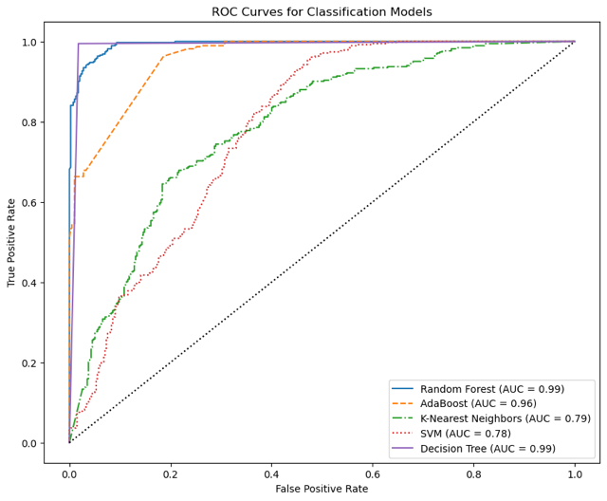
Figure 5.2: ROC Curve
The ROC curves further confirm the performance differences between models. The curves for Decision Tree and Random Forest are closest to the top-left corner, indicating high true positive rates and low false positive rates. In contrast, KNN and SVM show weaker performance with curves closer to the diagonal line. Overall, the results demonstrate that tree-based models, particularly Decision Tree and Random Forest, are the most effective for this classification task. These models are better suited to capturing non-linear relationships and interactions within the dataset.

6. Regression Modelling
Regression techniques here were applied to predict the continuous target variable, namely the Purchase Amount (USD). Unlike the classification task, which categorised purchases into binary classes, this analysis aims to estimate the actual value of customer purchases.
Before regression modelling were conducted, there are several preprocessing steps that need to be taken. Firstly, categorical variables such as gender, payment method, and purchase frequency were encoded into numerical value. Secondly, clothing size was converted into ordered numerical values. Lastly, interaction features were created to capture more complex relationships which are, interaction between promo code usage and discount application, interaction between promo code usage and previous purchases and average purchase amount per customer. For this analysis, five regression models were implemented and were to be compared to one another. Those models are Linear Regression, Random Forest Regressor, AdaBoost Regressor, Support Vector Regression (SVR), and Decision Tree Regressor.

6.1 Model Performance
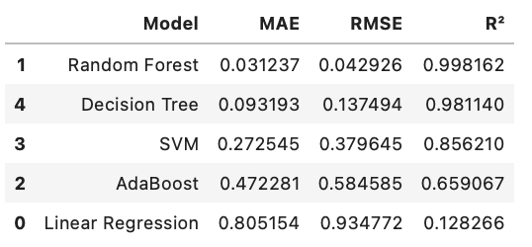
Figure 6.1: Model MAE, RMSE, and R²
To evaluate the performance of the regression models, three key metrics were used: Mean Absolute Error (MAE), Root Mean Squared Error (RMSE), and the coefficient of determination (R²). Among all models, Random Forest achieved the best performance, with the lowest error values (MAE ≈ 0.031, RMSE ≈ 0.043) and an almost perfect R² of 0.998, indicating excellent predictive accuracy. The Decision Tree model also performed strongly, with relatively low errors (MAE ≈ 0.093, RMSE ≈ 0.137) and a high R² of 0.981. The Support Vector Machine (SVM) showed moderate performance, with higher error values (MAE ≈ 0.273, RMSE ≈ 0.380) and an R² of 0.856. In contrast, AdaBoost produced weaker results, with considerably higher errors (MAE ≈ 0.472, RMSE ≈ 0.585) and a lower R² of 0.659, indicating limited predictive capability for this dataset. Finally, Linear Regression performed the worst, with the highest error values (MAE ≈ 0.805, RMSE ≈ 0.935) and a very low R² of 0.128, suggesting that it fails to capture the relationship between the predictors and the target variable.

6.2 Learning Curve Analysis
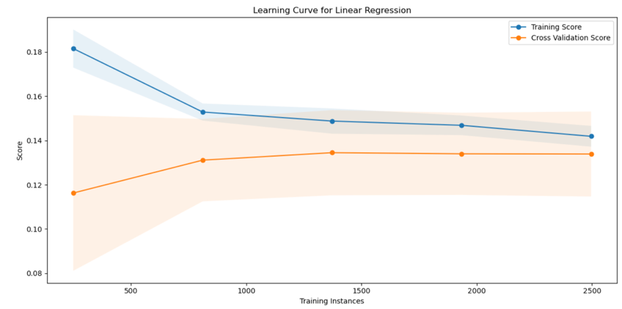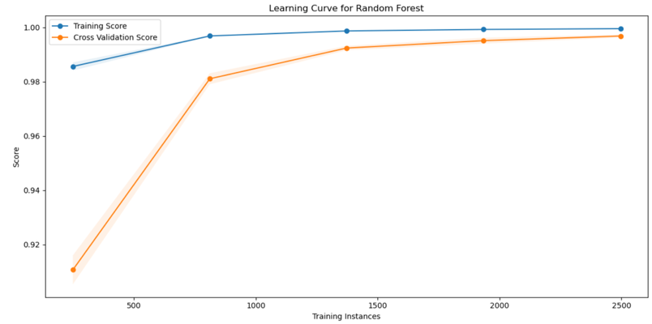
Figure 6.1: Learning Curve for Linear Regression Figure 6.2: Learning Curve for Random Forest

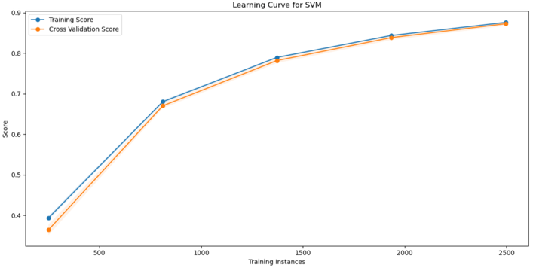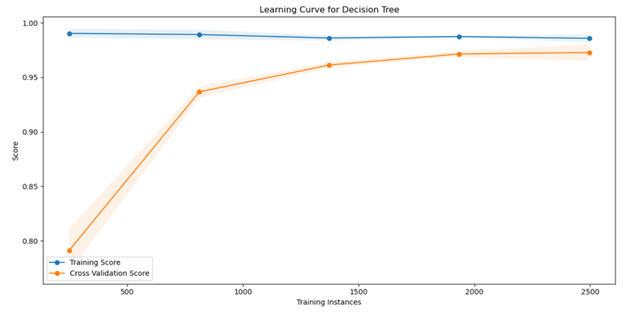
Figure 6.3: Learning Curve for SVM Figure 6.4: Learning Curve for Decision Tree

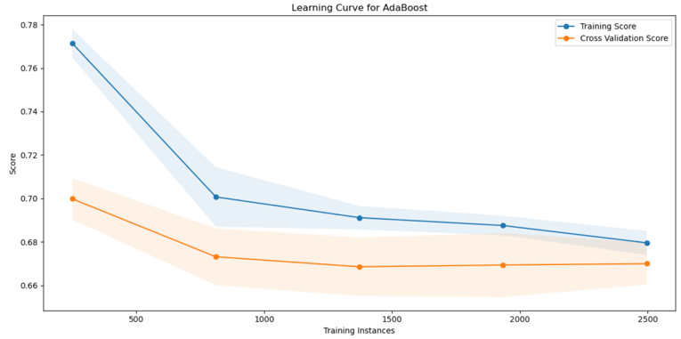
Figure 6.5: Learning Curve for AdaBoost
From learning curves graph it illustrates the behaviour and generalisation of each five models. Firstly, Random Forest and Decision Tree show very high training and validation scores, with minimal gap between them, indicating strong performance but also a potential risk of overfitting due to near-perfect accuracy. Secondly, Linear Regression exhibits low and relatively flat performance, suggesting underfitting and inability to capture underlying patterns. Thirdly, AdaBoost shows declining performance as training size increases, indicating instability and possible bias in the model. Lastly, SVM demonstrates steady improvement as more data is added, suggesting it benefits from larger datasets and may generalise better with further tuning.

Model Comparison
Unsupervised learning, classification, and regression each served different purposes in this study and produced different levels of usefulness. The unsupervised learning approach helped identify groups of locations with similar shopping characteristics, which was useful for customer segmentation and pattern discovery. Its main strength is that it can reveal hidden structures in the data without requiring a target variable. However, its weakness is that the clustering results were not very strongly separated, as reflected by the relatively low silhouette score, meaning the groups were only moderately distinct. In contrast, the classification models produced much stronger predictive results, with Decision Tree and Random Forest achieving the highest accuracy and AUC values. This shows that classification was effective in distinguishing whether purchase amounts were above or below the median. Its strength lies in strong predictive performance, especially for tree-based models, but a possible weakness is that the very high scores may suggest overfitting. Similarly, the regression models performed very well when predicting the actual purchase amount, with Random Forest again giving the best results, followed by Decision Tree. This indicates that regression was highly effective for estimating continuous outcomes. Its main strength is its ability to provide precise predictions, but like classification, the extremely high performance of the best models may reduce confidence in how well they would generalise to new data. Overall, unsupervised learning was more useful for exploration and segmentation, while classification and regression were stronger for prediction, with tree-based methods clearly outperforming the other models.

Conclusion
In conclusion, this coursework applied exploratory data analysis, clustering, classification, and regression techniques to gain a deeper understanding of customer shopping behaviour and develop predictive insights. The results showed that tree-based models, particularly Random Forest, consistently outperformed other methods, indicating that the dataset contains complex and non-linear relationships. While clustering provided useful insights into customer segments, the supervised models were more effective in predicting purchasing behaviour and spending levels.
Overall, the project highlights the practical value of machine learning in analysing real-world data and supporting better decision-making, such as improving customer targeting, marketing strategies, and sales forecasting. At the same time, some limitations, such as moderate cluster separation and the possibility of overfitting in high-performing models, suggest that results should be interpreted with care.
In the long term, this project provides a strong foundation for future work by developing key skills in data preparation, feature engineering, model selection, and evaluation. These skills are highly transferable and can be applied to a wide range of real-world problems, making this project valuable not only for understanding the current dataset but also for future applications in data science and business analytics.

