ST2195 Coursework

Programming Coursework



Presented to: University of London, SIM Global Education
Course : Programming for Data Science (ST2195)

Prepared by: Darren Alexander

Lecturer: Chee Ming Leong
3 April 2025
Table of Contents
Part 2 3
Data Cleaning 3
Question 2a. (What are the best times and days of the week to minimise delays each year?) 3
Question 2b. (Evaluate whether older planes suffer more delays on a year-to-year basis) 4
Question 2c. (For each year, fit a logistic model for the probability of diverted US flights using as many features as possible from given attributes. Visualize the coefficients across years.) 7

Part 2
Before answering the part 2 questions, I will do an initiation of the notebook first. This process requires us to import relevant library packages for analysis as well as reading the given datasets. Unfortunately, due to my device condition that cannot run a big dataset, I will only select 10000 data from each year instead of 5 million data each year.

Data Cleaning
Before addressing the questions, I began with a series of preparation steps. First, I imported all the necessary library packages for data analysis in both R Studio and Jupyter Notebook. I then imported the five consecutive years datasets, which included the yearly flight data from 2004 to 2008 (.csv.bz2 files), as well as the supporting datasets: airports.csv, plane-data.csv, and carriers.csv. In the data cleaning phase, I examined the structure of each dataset and observed that some years had different data types for certain columns compare to any other years. To address this, I used loops to convert some columns from float to integer data types. Additionally, I filled any missing values in numerical columns with 0 to ensure consistency and prevent issues in subsequent analysis. After completing the cleaning process, I merged the datasets from all five years into a single, big dataset. With this preparation completed, I proceeded to answer the questions outlined in the coursework.

Question 2a. (What are the best times and days of the week to minimise delays each year?)
Question Part 2a instruct us to use the given attributes from the datasets to show the best time and days of the week in minimizing the delays each year. The attributes that are going to be use are: DayOfWeek as the attribute that holds which day the flight happened, CRSDepTime as the attribute that holds the scheduled departure time, and any attributes that show how that specific flight run into delay.
Additionally, as the main focus is to minimize delays, I will also use DepDelay as the attribute that holds the amount of minutes that specific flights got delayed. This is chosen due to the departure delay is most likely that makes the passenger complains and remember the specific delay. Besides that, I will also make a new attribute in determining whether a flight got delayed or not, considering no matter how big or small it is. This attribute is called Delayed, where it is a categorical attribute that holds one if it is a delayed flights, and zero if it is not.
I will be grouping all the flights on each days and timeframes. These timeframes will divide the 24 hours into a more bounded group, consisted of: Morning (5:00 to 12:00), Afternoon (12:00 to 17:00), Evening (17:00 to 21:00), and Night (21:00 to 5:00) flights.
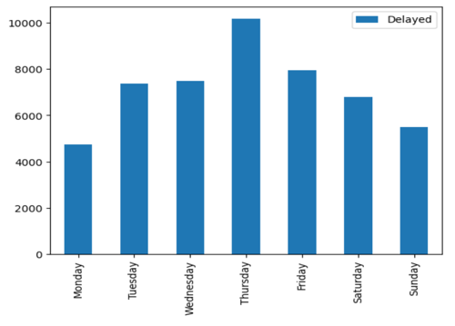
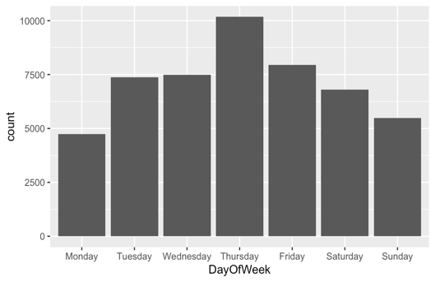
Figure 2.1: R (Amount of delays on each day) Figure 2.2: Python (Amount of delays on each day)
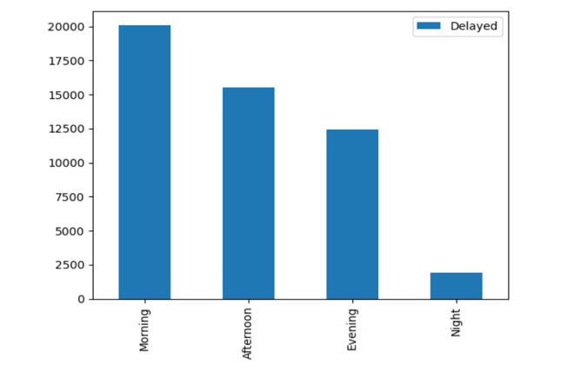
From the output bar graph above, it shows that since Monday to Sunday the amount of flights delayed increase steadily until Thursday, eventually decreasing consistently until Sunday. Additionally, as the main target is to find the best days of the week in minimizing the delays, the illustration indicates that on Monday amount of delayed flights is at its lowest compare to any other days.
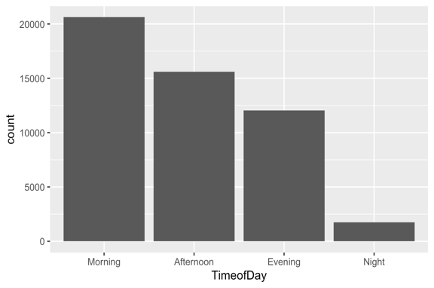
Figure 2.3: R (Amount of delays in each timeframes) Figure 2.4: Python (Amount of delays in each timeframes)
The graph above shows that the delay happens less as the day goes by, with night flights has nearly 1/8 the morning delays.
In conclusion, to answer question Part 2a, the best time and days of the week in minimizing the delays will be choosing the night flight around 21.00 to 05.00 on Monday.

Question 2b. (Evaluate whether older planes suffer more delays on a year-to-year basis)
Question Part 2b instruct us to evaluate on aircraft/plane's age and see if they receive more delay than the newer aircrafts. However, due to the data about aircraft age lies on a different datasets, we need to join them first. In the next step, I will use the categorical Delayed attribute to determine whether a flight experienced a delay. Additionally, I will group the data by aircraft age using the groupby function on the dfAge_Delayed dataframe. The graph below displays the number of delays associated with each aircraft age, rather than the sum of all delays.
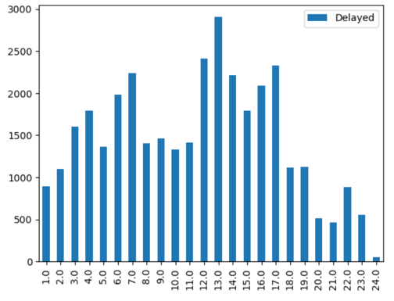
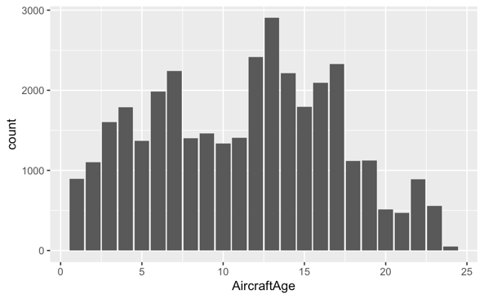
Figure 2.5: R (Count of delays per age) Figure 2.6: Python (Count of delays per age)
Due to every age have more than one amount of delay, we couldn't apply the Spearman Correlation. Hence, we will try to use the Point-Biserial Correlation. However, to apply the use of Point-Biseral Correlation, first we need to fulfil few assumptions. Each assumptions will be solve in the line below.
First Assumption: Does the two variables follow a normal distribution?
In answering the first assumption, I will be conducting the Shapiro-Wilk normality test using stats.shapiro() to test normality of the two variables.
Formulating the hypothesis below:
$H_{0}$: The data are normally distributed
$H_{1}$: The data are not normally distributed
I will also set a significance level of 5% and reject the null hypothesis if the p-value of the test is less than 0.05
However, due to the p-value of aircraft age shows a number of 6.51697296607512e-61 and the p-value of delayed departure shows a number of 7.8332400869064e-123, we can conclude that both p-values are much lower than the significance level of 5%. Hence, both attributes does not follow a normal distribution. This means I cannot use the Point-Biserial Correlation to directly answer the question. However, I can still try to look for their correlation further using a simple visualization, where as I will check if both variable have similar spread (variance).
In this process, I will also try to search for the mean and standard deviation for each group in reiterating the same variance shown on the boxplot on R Studio and Jupyter Notebook. Eventually, I found the value of mean and standard deviation for each group:
- The mean and standard deviation for aircraft age with no delay is 11.195093671813023 and 5.372623676200539
- The mean and standard deviation for aircraft age with delay is 11.362107743386527 and 5.934753992860909.
From this result, we can conclude that both the aircraft age and the delays have a small and similar variance. In addition, I can proceed to calculate the Point-Biserial Correlation to determine whether they both attributes are related or not.
After calculating the Point-Biserial Correlation, the results show that it has a coefficient of 1.47% and p-value of 0.006008 which is so small, indicating that aircraft age and the delay of an aircraft is not correlated. Despite that, we will try to look further for correlation using a simple visualization. Below are the regression line graph of the total number of delays per age and mean delays per age.
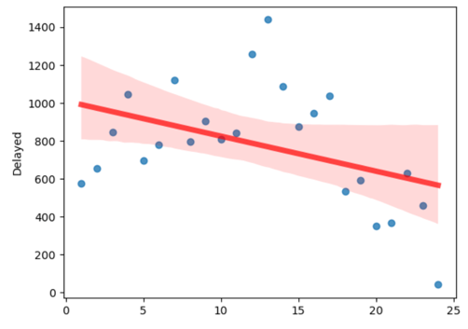
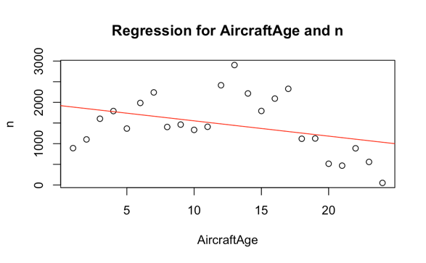
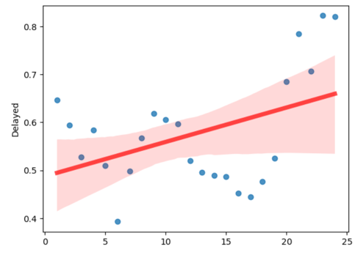
Figure 2.7: R (Sum of delay per age) Figure 2.8: Python (Sum of delay per age)
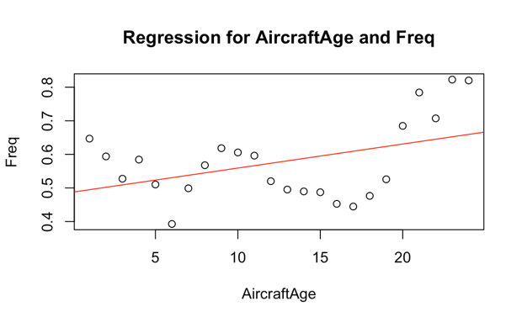
Figure 2.9: R (Mean of delay per age) Figure 2.10: Python (Mean of delay per age)

From both regression line graph above, it shows that the average number of delay happen more often on older aircrafts compare to new aircrafts. However, if we look at the total number of delay flight for each age, it can be seen that on number of delay flight in older aircrafts is much lower than newer aircrafts.
This can mean two things:
- The older planes indeed suffer more delay in average numbers, but as flights using older plane will be less in numbers, the actual total delay of older planes will be fewer considering that most flights will be using a newer aircrafts.
- Aircraft's age cannot be said to be directly correlated with flight's delay, as there is much factor beside aircraft age and number of flight delay that need to be consider in making an accurate analysis.
In conclusion to answering Part 2b question, older planes cannot be truly said that they suffer more delays on a year-to-year basis. Conducting an oversampling could not exactly evaluate that older planes suffer more delay as it is a fact that flight with older planes with happen less frequently. Additionally, cutting the age of the counted aircrafts to below age of 20 is not possible. As based on this reference, aircraft is stated as old when they reach the age of 20 or above.
Reference for aircraft age: <https://insijets.com/blog/does-the-age-of-an-aircraft-affect-its-safety>

Question 2c. (For each year, fit a logistic model for the probability of diverted US flights using as many features as possible from given attributes. Visualize the coefficients across years.)
Question Part 2c instruct us to visualize the coefficients of a logistic regression model using few given attributes from the question. These attributes are: departure date, the scheduled departure and arrival times, the coordinates and distance between departure and planned arrival airports, and the carrier.
To answer this question, we will fit a logistic regression using the properties (predicted and predictors) given by the question. Before starting to answer the question, the first step we need to do is to do data preparation, as the required attributes (predictors) are in a difference datasets.
In this question, the predicted attributes are the diverted data in diverted column. Whereas the predictors attributes are DayofMonth as the flight's date, CRSDepTime and CRSArrTime as the scheduled and arrival time, Distance as the flight's distance, UniqueCarrier as the name of the flight's airline name, Origin and Dest as the flight origin and destination with their airport's coordinates.
Additional data cleaning steps:
- Discard/drop the replicated column/attributes to make the dataframe cleaner
- As logistics regression requires all predictors to be numerical, hence, all the categorical data have to be change. In doing this process, we will create dummy variables. The attributes that will be change into dummies are UniqueCarrier, Origin, and Dest

After the data preparation is complete, we can start to look for the logistic regression. In that process, I will make sure that I have enough iteration and data, as well as the data used for model is balanced enough through oversampling.
The results of the logistic regression are Accuracy: 0.9493450948944132; Precision: 0.936278342455043; and Recall: 0.9639119935605044
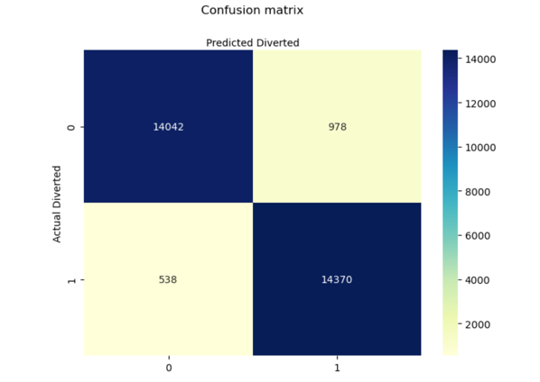
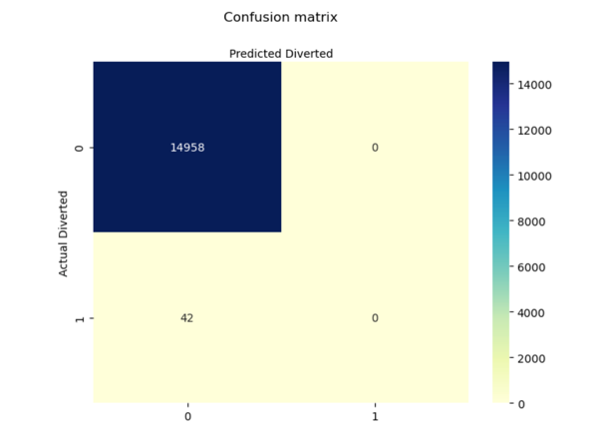
Figure 2.11: Python (Before Oversampling) Figure 2.12: Python (After Oversampling)

From the results of the number and model above, it shows that all of the metrics score exceeded 0.9 and the matrix has a good proportion of diverted and non-diverted flights, indicating that the model is a good model to predict diverted flights with the given attributes.
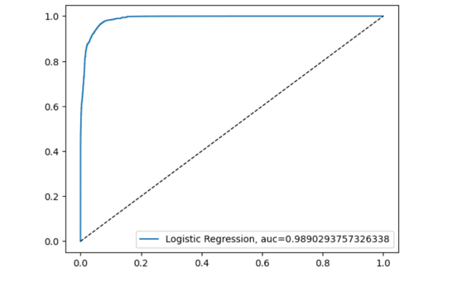
For the final step, we will use ROC Curve to further evaluate the model. For a random classifier, it has an area under the curve of 0.5, while AUC for a perfect classifier is equal to 1.
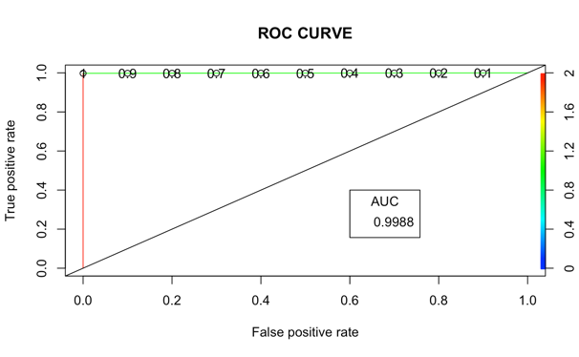
Figure 2.12: R (ROC Curve) Figure 2.13: Python (ROC Curve)
In conclusion to answering question Part 2c, the output of the model's ROC Curve above shows that it has a very good value. Although the iteration is still not enough, we can still get enough data that makes a balanced confusion matrix. Based on the accuracy, precision, and recall, the model does a good job in predicting the diverted flights.

