Business Analytics Report on Global Superstore



Prepared by: Darren Alexander
Prepared for: University of London

Word Count: 1500

Business analytics, applied modelling and prediction (ST2187)

Executive Summary
Global Superstore is a multinational retail company operating across multiple markets, including Africa, APAC, Canada, EMEA, the EU, LATAM, and the US. The company specializes in three primary product categories: Technology, Office Supplies, and Furnitures, which are further segmented into various sub-categories such as Chairs, Copiers, Labels, Bookcases, and Fasteners.
This report provides data-driven insights and strategic recommendations for senior management, based on an in-depth analysis of Global Superstore's dataset using Tableau Desktop. The primary focus of this report is the APAC market, with a detailed examination of its top three performing countries. The analysis will incorporate metrics such as sales, profit, shipping costs, discount rates, order quantities, product categories, sub-categories, and shipping details. These variables will be leveraged to identify critical insights that can assist senior management in making informed, efficient, and strategic business decisions. Ultimately, the goal of this report is to provide actionable insights that will support senior management in optimizing sales and profit growth, improving operational efficiency, and identifying opportunities for market expansion.

Table of Contents
Executive Summary 1
Dashboard 1 – (Overall Global Sales and Profit of Superstore) 3
Dashboard 2 – (APAC Market Profit and Sales Performance) 4
Dashboard 3 – (Profitable and Least Profitable Countries in APAC Market) 5
Dashboard 4 – (Shipping Cost % of Sales and Discount Rate Effect) 7
Dashboard 5 – (Forecast Analysis) 8
Recommendations 10

Dashboard 1 – (Overall Global Sales and Profit of Superstore)
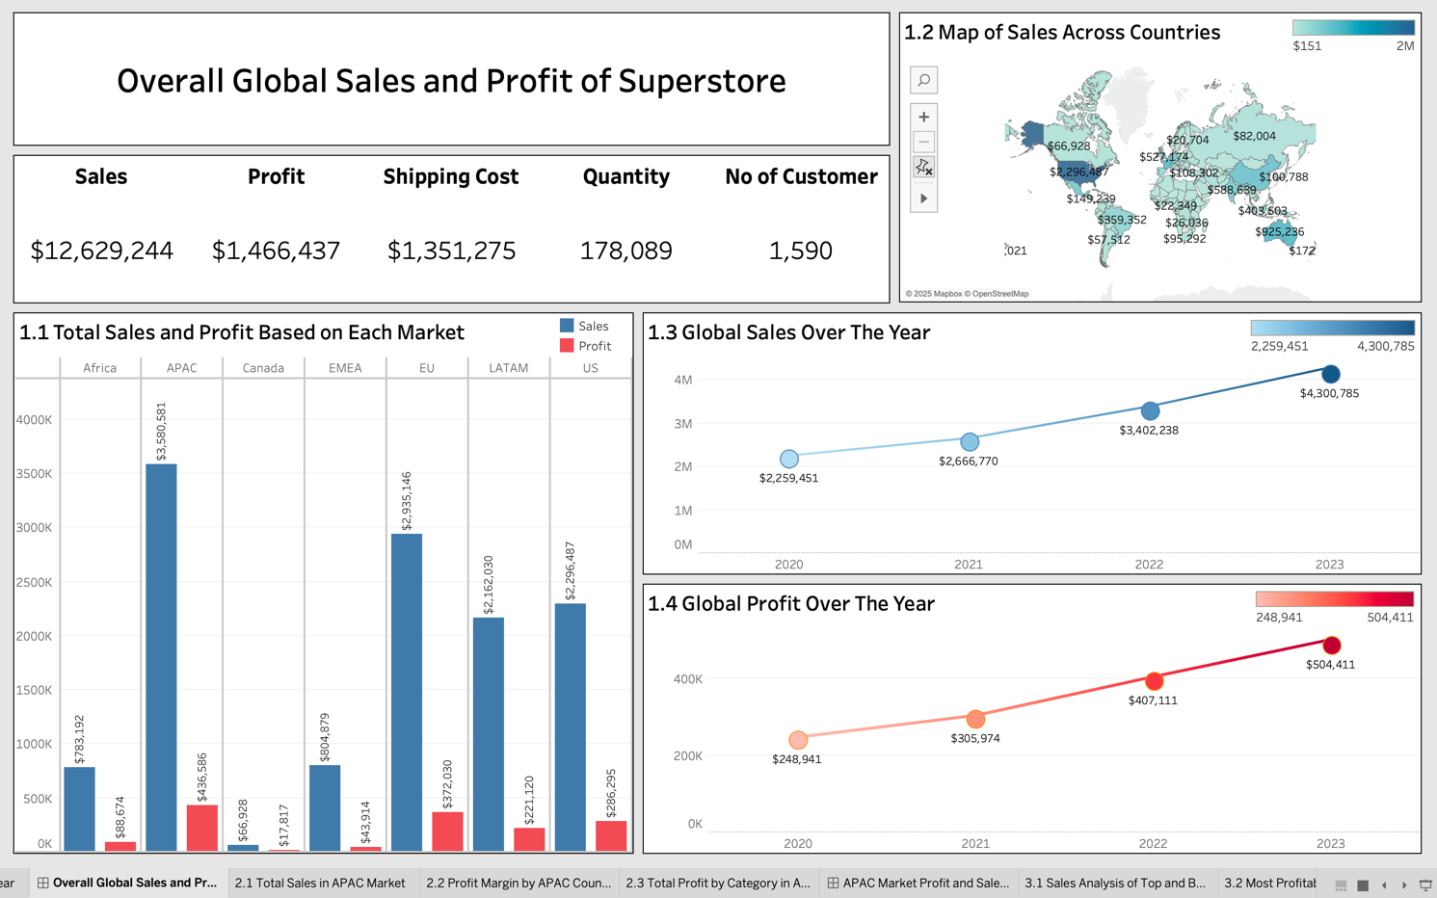
- The “Overall Global Sales and Profit of Superstore” dashboard provides insights into global sales, profits, and trends over the year. Additionally, it includes Key Performance Indicators (KPIs) such as sales, profit, shipping cost, quantity, and the number of customers across all regions. The total global sales amounted to approximately $12.6 million, with a profit of around $1.4 million. The total shipping cost was approximately $1.3 million, while the total quantity sold reached 178,089 units. Lastly, the global customer base for the superstore totalled 1,590.
- Figure 1.1 presents a bar chart illustrating the sales and profit performance across different markets. The APAC region led in total sales, reaching $3.5 million. However, its profit margin remained lower compared to the US, which generated the highest profit at $286,295 while maintaining a balanced sales-to-profit ratio. Additionally, markets such as Africa, Canada, and EMEA exhibited lower sales and profitability compared to other regions, with sales remaining below $1 million and profits below $100,000 in their respective markets.
- Figure 1.2 features a blue map that visualizes total sales contributions by country. The United States recorded the highest sales, totalling $2.2 million. In contrast, Equatorial Guinea had the lowest sales, generating only $157.
- Figures 1.3 and 1.4 illustrate the yearly trend of global sales and profit. In 2020, sales and profit were recorded at $2.26 million and $248,941, respectively. Then, over a three-year period, both revenue and profitability demonstrated steady growth, with sales nearly doubling to $4.3 million and profit increasing to $504,411.

Dashboard 2 – (APAC Market Profit and Sales Performance)
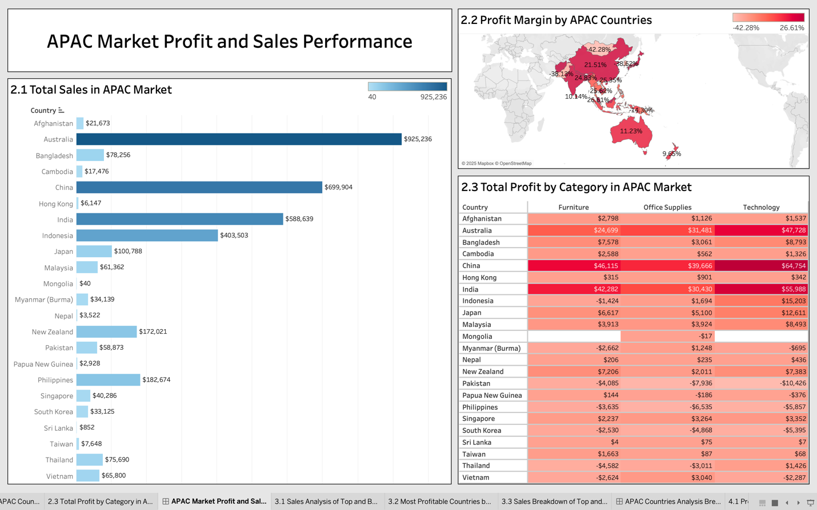
- Figure 2.1 presents a bar chart depicting the sales performance of each country in the APAC Market. Australia, China, and India recorded the highest total sales, with Australia earning at $925,236, followed by China at $699,904, and India around $588,639. In contrast, Mongolia, Sri Lanka, and Papua New Guinea are the countries that contributed the least number of sales, with Mongolia only contributed $40, followed by Sri Lanka at $852, and lastly Papua New Guinea at $2,928.
- Figure 2.2 features a heatmap illustrating profit margins of various APAC countries. Malaysia, Hongkong, and Cambodia experienced the highest profit margins, with Malaysia totaling about 26.61%, followed by Hongkong at 25.62%, and Cambodia at 25.35%. Conversely, countries such as Mongolia, South Korea, and Pakistan faced high loss with profit margins ranging from -38% to -42% in each respective country.
- Figure 2.3 presents a table displaying the total profit earned by every APAC country across three product categories: Technology, Office Supplies, and Furnitures. The data indicates that Australia, China, and India led all categories ranging from $24,699 to $64,754. Among the three, Technology emerged as the most profitable sector with total of $204,410, while Furnitures and Office Supplies only contributed about $126,823 and $105,353, respectively. However, countries such as Pakistan, Philippines, and South Korea, reported a loss ranging from $2,530 to $10,426 in each product category.

Dashboard 3 – (Profitable and Least Profitable Countries in APAC Market)
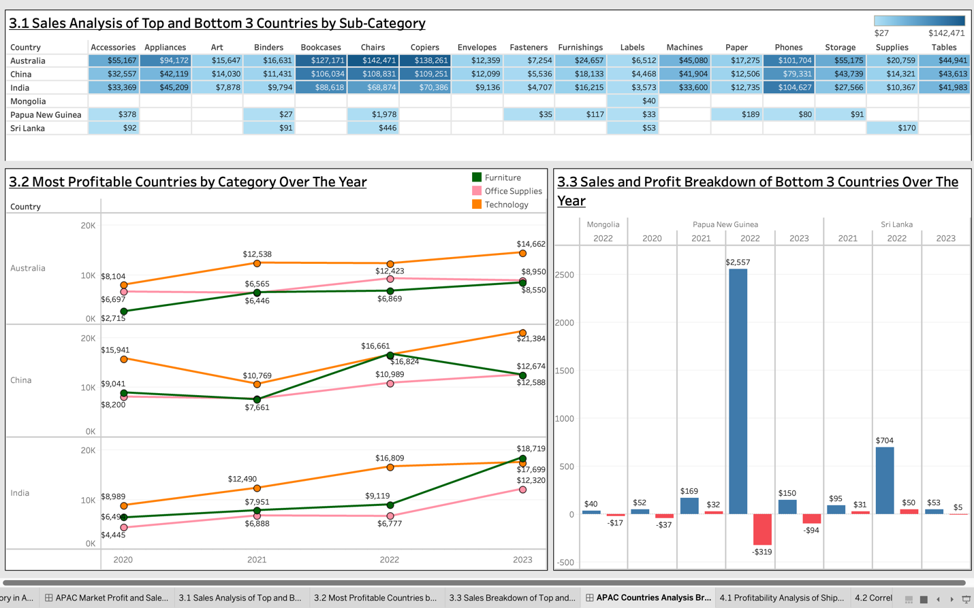
- Figure 3.1 presents a table displaying sale performance of most and least profitable countries by sub-category. Among the top performing countries, sales contributed mostly through Bookcases, Chairs, and Copiers, with Australia leading all segments ranging from $127,171 to $138,261. In contrast, sub-categories such as Labels, Fasteners, and Envelopes contributed the least total sales in whole segments, with labels reaching maximum sales at $6,512, followed by fasteners at $7,524, and envelopes at $12,359. For the least performing countries, sales remained significantly lower across all sub-categories, with the highest recorded sales at only $1,978.
- Figure 3.2 illustrates profitability yearly trends among the three top performing countries. In Australia, Technology profits grew steadily from $8,104 in 2020 to $14,662 in 2023. Office Supplies saw moderate yet stable growth, while Furniture experienced steady increases. Similarly, China saw massive increase in Technology profits, increasing from $15,941 in 2020 to $21,384 in 2023. Additionally, furniture showed drastic fluctuation to $12,674 in 2023. Lastly, Office Supplies in China remained stable but showed slower growth compared to Technology. Lastly, India saw its highest growth in Furniture, increasing from $6,494 in 2020 to $18,719 in 2023. Moreover, Office Supplies in India also experienced high growth in Office Supplies, increasing from $4,445 in 2020 to $12,320 in 2023. While India also experienced growth in Technology, it was not as aggressive as the other sectors.
- Figure 3.3 presents a bar chart analysing sales and profit trend of the least profitable countries. Mongolia recorded minimal sales and profits, with data appearing only in 2022 at $40 and -$17, respectively. In contrast, Papua New Guinea experienced high increase in sales from $52 in 2020 to $2,557 in 2022, before declining to $150 in 2023. Similarly, Sri Lanka showed signs of improvement in 2022, recording a sales increase of $704. However, like Papua New Guinea, sales declined in 2023, dropping to just 53$.

Dashboard 4 – (Shipping Cost % of Sales and Discount Rate Effect)
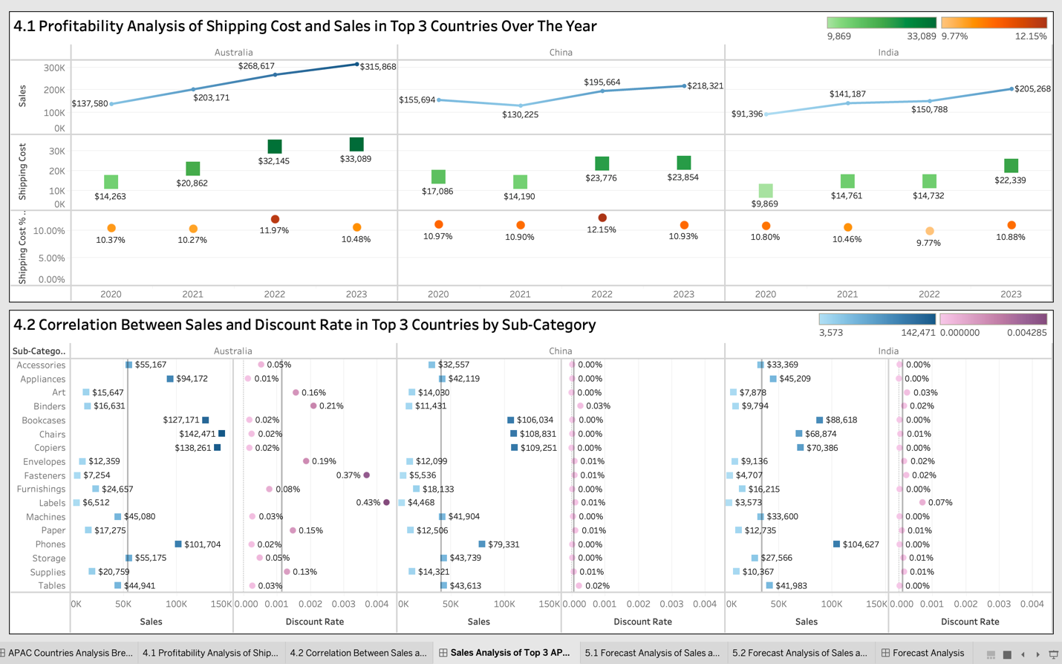
- Figure 4.1 presents a graph illustrating sales, shipping cost, and the shipping cost percentage relative to sales in top three performing countries. Australia consistently led in total sales, increasing from $137,580 in 2020 to $315,868 in 2023. Shipping costs also grew steadily, reaching $33,089 in 2023, yet the shipping cost-to-sales ratio remained stable between 10.27% and 11.97%. In contrast, China experienced a temporary declined in sales, dropping from $155,694 in 2020 to $130,225 in 2021 before recovering to $218,321 in 2023. Meanwhile, India demonstrated steady sales growth, increasing from $91,396 in 2020 to $205,268 in 2023, while maintaining the lowest shipping cost-to-sales ratio.
- Figure 4.2 illustrates a graph analysing correlation between sales and discount rate in the top three performing countries. In Australia, Bookcases, Chairs and Copiers were the top-selling categories, yet discounting remained minimal at 0.02% for each product. However, Fasteners and Furnishings had slightly higher discount rates, with 0.37% and 0.43%, respectively. China’s highest performing categories were Copiers at $109,251 and Chairs at $108,831, while discounting remained small. Meanwhile, India’s top-selling categories were Phones at $104,627 and Bookcases at $88,618, with the highest discount rate observed at just 0.07%.

Dashboard 5 – (Forecast Analysis)
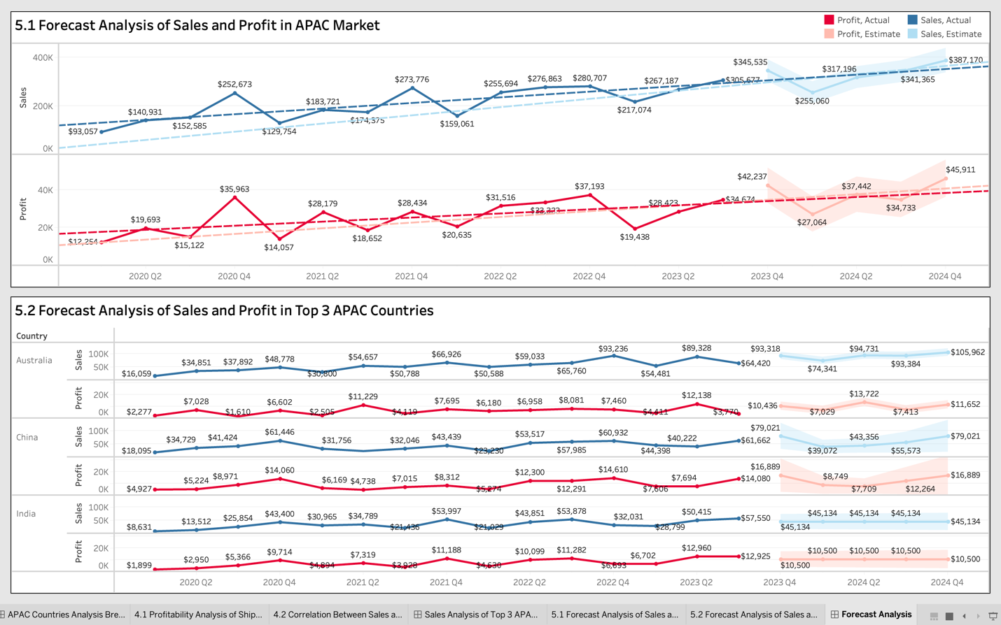
- Figure 5.1 presents a trend analysis of sales and profit growth, along with forecasted data for the APAC market over the years. Sales have demonstrated significant growth, increasing from $93,057 in Q1 2020 to $305,677 in Q4 2023. Furthermore, sales are projected to continue increasing, reaching $387,170 by Q4 2024. However, the forecast also indicates a temporary decline, with sales dropping from to $255,060 in Q1 2024 before recovering. Similarly, profitability has improved substantially, with profits rising from $12,254 in Q2 2020 to $42,237 in Q4 2023. However, profits are not projected to remain stable throughout the year, as they are projected to decline to $27,064 in Q1 2024, before ultimately peaking at $45,911 in Q4 2024.
- Figure 5.2 illustrates trend analysis of sales and profit growth, along with forecasted data for the top three performing countries. In Australia, sales have demonstrated consistent upward trend, with sales increasing from $16,059 in Q1 2020 to a projected $105,962 in Q4 2024. However, profitability has dropped through the years, peaking at $12,138 in Q2 2023 before experiencing a temporary decline to $3,770 in Q3 2023. Additionally, projected profits are estimated to stabilize, reaching $11,652 by Q4 2024. Similarly, China has experienced steady sales and profit growth, with sales rising from $18,095 in Q1 2020 to a projected $79,021 in Q4 2024. Profitability has also improved significantly, increasing from $4,927 in Q1 2020 to an estimated $16,889 in Q4 2024. Lastly, India has shown consistent sales and profit growth, with sales increasing from $8,631 in Q1 2020 to $57,550 in Q3 2023 and profits reaching $12,925 in Q3 2023. However, both estimated sales and profit are expected to stagnate in the future, stabilizing at $45,134 and $10,500, respectively.

Recommendations
Based on insights gathered from the Tableau report analysis, several recommendations can be propose for senior management at Global Superstore to optimize performance in the APAC market and its top-performing countries: Australia, China, and India. For the whole APAC market, firstly, managers should increase investment in the Technology category, as it has generated the highest sales revenue of $204,410. Secondly, senior management should expand its productions in high-margin countries such as Malaysia with profit margins of 26.61%, followed by Hong Kong at 25.62%), and Cambodia at 25.35. While low-performing markets with negative profit margins, such as Mongolia, South Korea, and Pakistan, with each at -38% or lower profit margins should be deprioritized.
In the top performing countries: Australia, China, and India, some strategies should be implemented to increase profitability. Firstly, businesses should prioritize high-performing sub-categories such as Bookcases, Chairs, Copiers, and Phones, by increasing production. Secondly, businesses should leverage profitability through increasing shipping cost, as shipping cost remained the same over the years. Lastly, managers should offers more discounts on underperforming product segments, such as Labels and Fasteners with maximum sales of only $6,512 and $7,524, respectively. Implementing a data-driven discounting strategy will enable the company to optimize sales while maintaining overall profitability.

