ELG2136 Design Project

by

Ty Beauchamp 8141646  
Ketan Sontakke 8230773

Darren Bahadoor 8190771

Joshua Garcia 8486195

Urva Patel 8445042

Abdullah Ali 8381431

for Sawsan Abdul-majid  
March 17th, 2017

Best Solution

**Design**

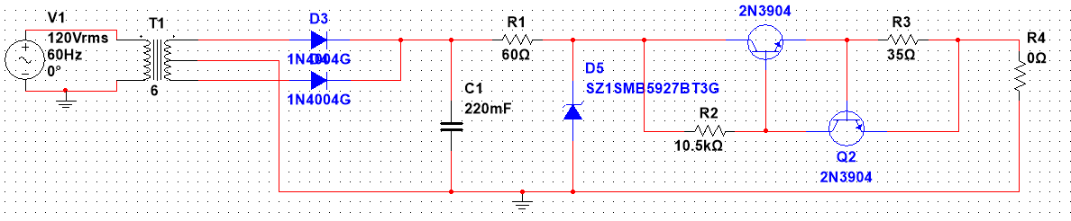  
*Figure 1 – Screen shot of the entire circuit under No Load conditions (0 Ohms).*

**Transformer**

A 6-turn center tap transformer was used to step the 120V rms AC to 10V rms AC – the voltage specified in the instructions that was going to be fed into the circuit.

**Full-Wave Rectifier**

Two diodes connected the negative and positive terminals of the transformer to a common node. This provides strictly positive sine waves with a peak voltage of about 13.4V as 0.7 volts was lost from the V peak of the 10V rms on the other side of the diodes.

**Filter**

A 220 mF capacitor was chosen to filter the voltage. Such a large capacitor creates smoother voltage as they discharge more slowly: the voltage over the capacitor is modeled by the equation v=e^(-t/RC) so a higher C value leads to a lower slope.

**Voltage Regulator**

An 11V Zener diode was chosen to regulate the voltage. Placing this diode between the ground and input terminals prevents voltage from exceeding 11V between these terminals. If the input voltage is lower than 11V, than the output voltage must therefore also be limited below 11V. Knowing the transistors lose about 0.7V and the V sensor also loses some voltage, the Zener diode was chosen slightly higher than the required output voltage (10V dc) to compensate for these loses.

**Current Limiter**

Two transistors were chosen to limit the current. The base current of first transistor was calculated by (output current / gain). This current had to dissipate about 0.7V in the first, large resistor – or the same voltage drop in the transistor. The resistor value was then calculated using these equations. The second, small resistor had to dissipate about 0.7V – or the same voltage drop in the second transistor at the total output current (0.02A). This signals the second transistor to start conducting (and stealing Ib from the first transistor) if the output current becomes too high and the voltage across this resistor becomes too high. This resistor was calculated to be (0.7/0.02 = 35 Ohms).

**Calculations**

R before Zener:

To calculated the resistance before the Zener we used ohm’s law. V=I*R where V = Vzener, I = 0.454545 (from 5 Watt max) this equation ensures current through the Zener diode isn’t too high. Solving for R, R = 60 ohms.

V max = V Zener:

Max voltage is equal to the Zener voltage. If the voltage exceeds the Zener voltage, the Zener diode short circuits, preventing it from regulating a higher voltage.

R sensor:

Using the equation V=I*R where V = 0.7, I = 20mA, R sensor = 35 ohms.

R large:

The minimum voltage for a transistor to operate is 0.7 volts. 0.7 = Ib * R where Ib is the current into the base. B = 2*20mA/Gain of transistor. β = 150. This value was calculated to be 10.5k Ohms.

The capacitor discharge equation models the voltage in the circuit as v=e^(-t/RC).

**Simulation**

|  |  |  |
| --- | --- | --- |
| **Load (Ohms)** | **Voltage (V)** | **Current (mA)** |
| 0 | 0 | 19.477 |
| 100 | 1.907 | 19.073 |
| 500 | 7.638 | 15.431 |
| 1k | 8.459 | 8.459 |
| 2k | 8.882 | 4.441 |
| 50k | 9.406 | 0.188 |
| 500k | 9.485 | 0.020 |

*Table 1 – MultiSim Simulation results for the circuit in figure 1 under various loads.  
**A 10V Zener diode had to be used as no 11V Zener diode was available. Voltages are therefore higher*

**Components**

|  |  |
| --- | --- |
| **Component** | **Part Number** |
| Diode | 1N4004G |
| Zener diode | 1N5348 |
| Capacitor | **-** |
| Resistors | SZ1SMB5927BT3G |
| Transistors | 2N3904 |

*Table 2 – Table listing the part numbers of each unique component used.*

Alternate Solution

**Design**

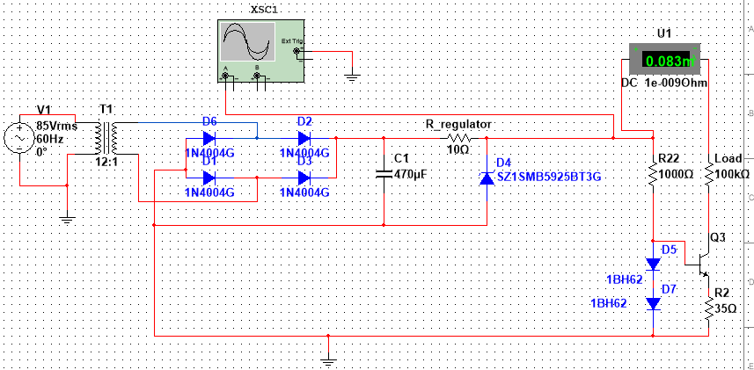

*Figure 2 - Second solution with one transistor and two diodes. Figure depicts high load conditions (100k Ohms).*

**Current Limiter**

This solution uses a single transistor and two diodes as the main method to limit current. The alternate solution was worse than the best solution since it is less efficient and only allows 8.3 volts at best. It is also power inefficient as a higher resistor is needed (1000 Ohms) to ensure current does not surpass 20mA. When the current coming out of the emitter is greater than 20 mA the voltage drop is greater than 0.7 volts. In total the voltage will be greater than 1.4 volts and the current will pass through the diodes instead which have a voltage drop of 0.7+0.7=1.4.

**Comparison to First Solution**

The main difference between this solution and the best solution is the lack of a second transistor. With a second transistor, if the voltage across the sense resistor is high enough, this causes the second transistor to turn on and divert some current to ground. Since this design is lacking a second transistor, more current is sent to the load, sometimes exceeding 20mA. This makes the current limiter not very effective. From a design standpoint, two transistors were chosen opposed to only one because it performs the same function as this solution but outputting a higher voltage (averaging 9.5 volts) while reducing space, thereby reducing cost. This solution also does not maintain a current under 20mA under all tested load conditions.