CS 255 System Design Document
DriverPass System Design
Darren Sweely

UML Diagrams

UML Use Case Diagram
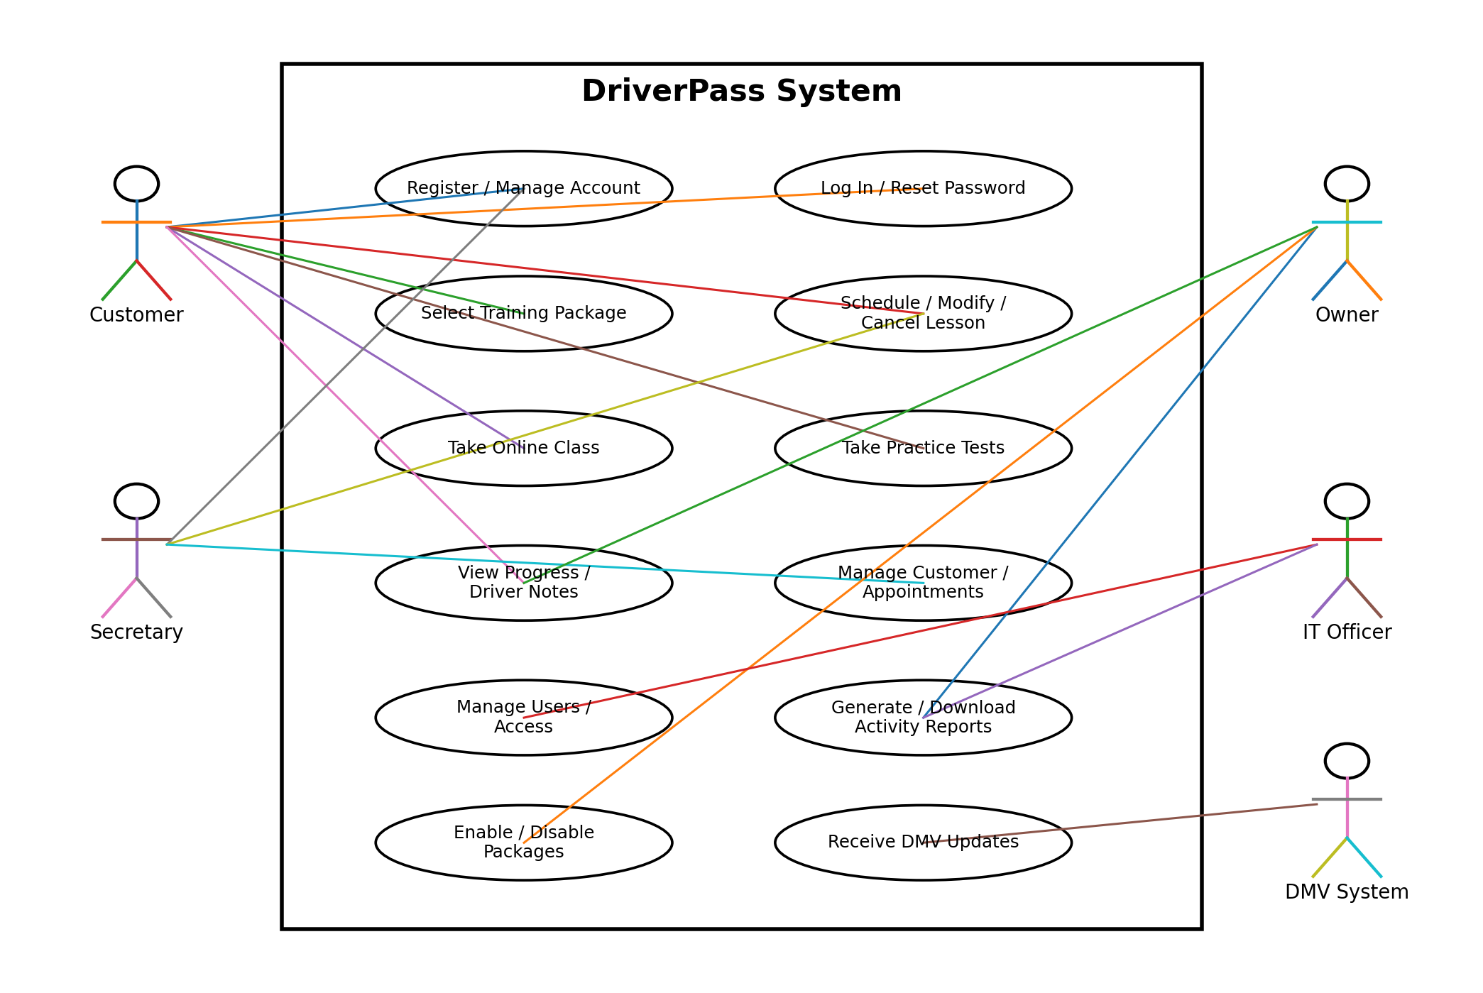
The use case diagram identifies the primary DriverPass users and the system functions available to each user.

UML Activity Diagram 1 - Schedule Driving Lesson
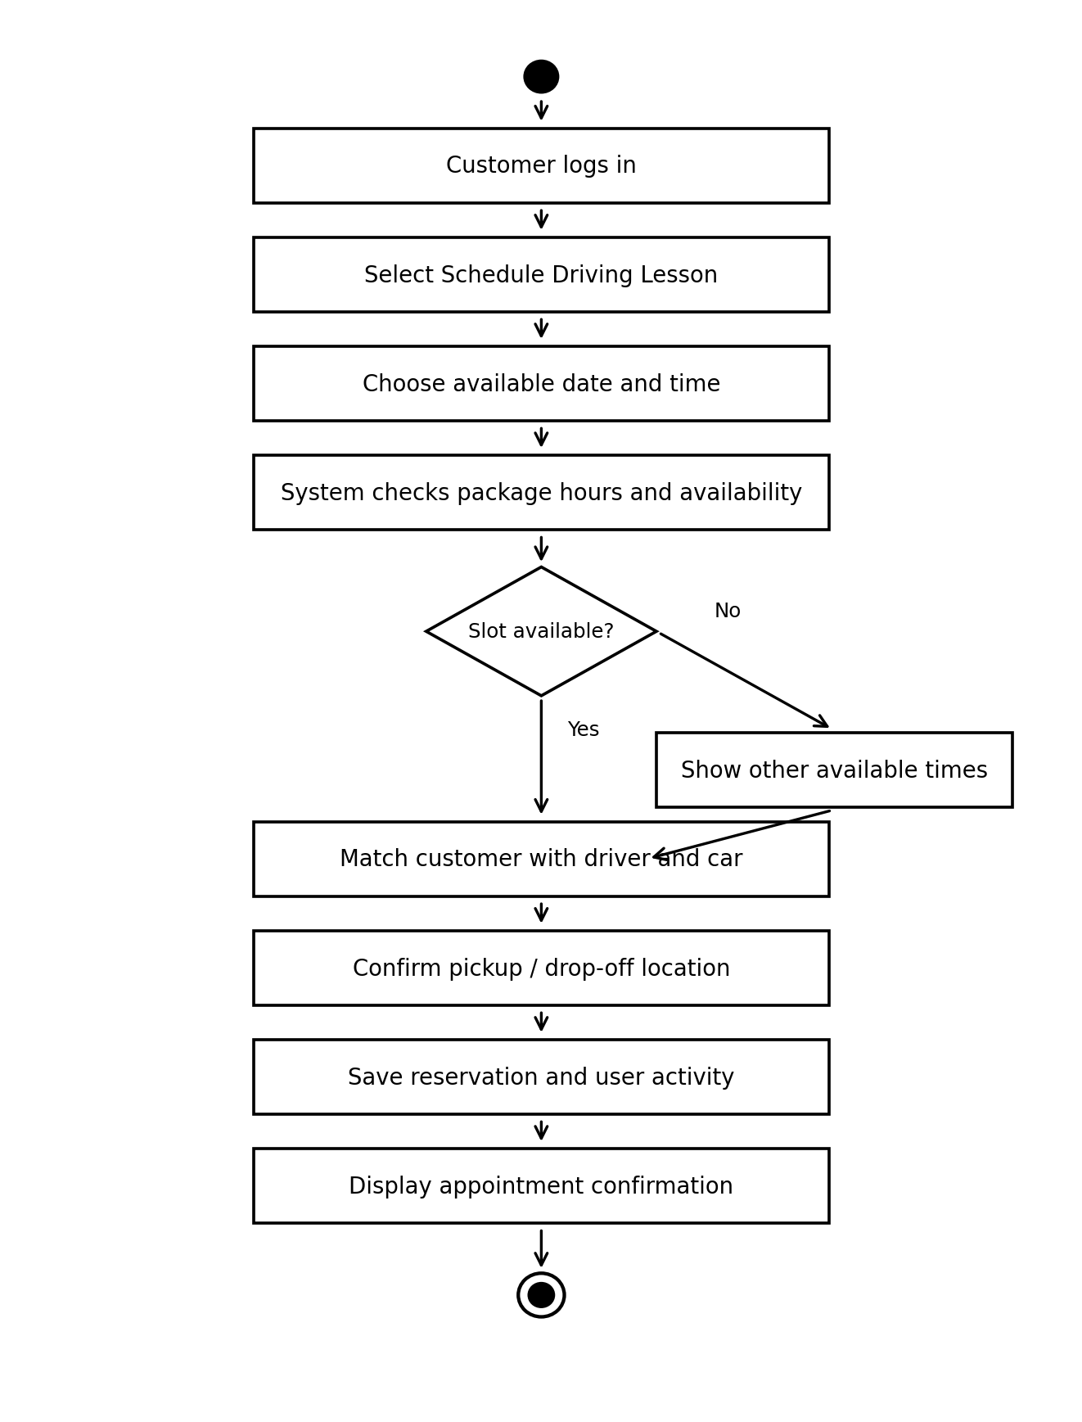
This activity diagram shows the steps required for a customer to schedule a two-hour driving lesson, including availability checks and assignment of a driver and vehicle.

UML Activity Diagram 2 - Take Practice Test
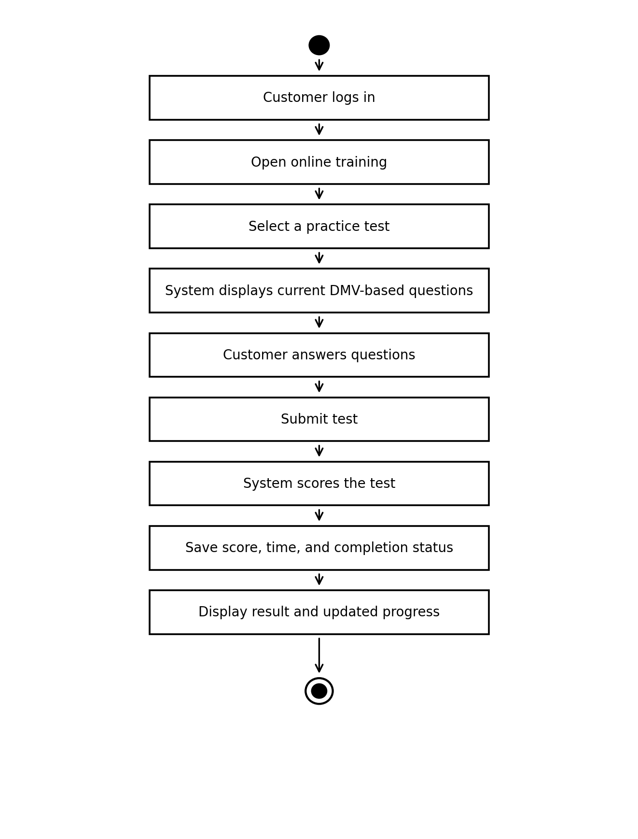
This activity diagram shows how a customer selects, completes, and receives results for an online practice test.

UML Sequence Diagram - Schedule Driving Lesson
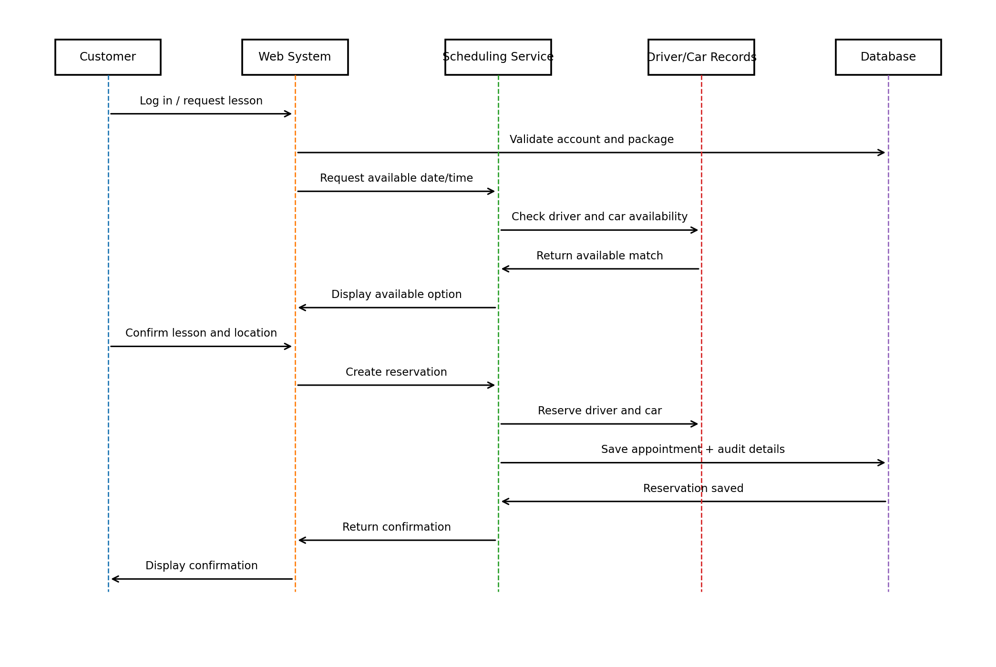
This sequence diagram shows the order of interactions required to schedule a lesson and save the reservation.

UML Class Diagram
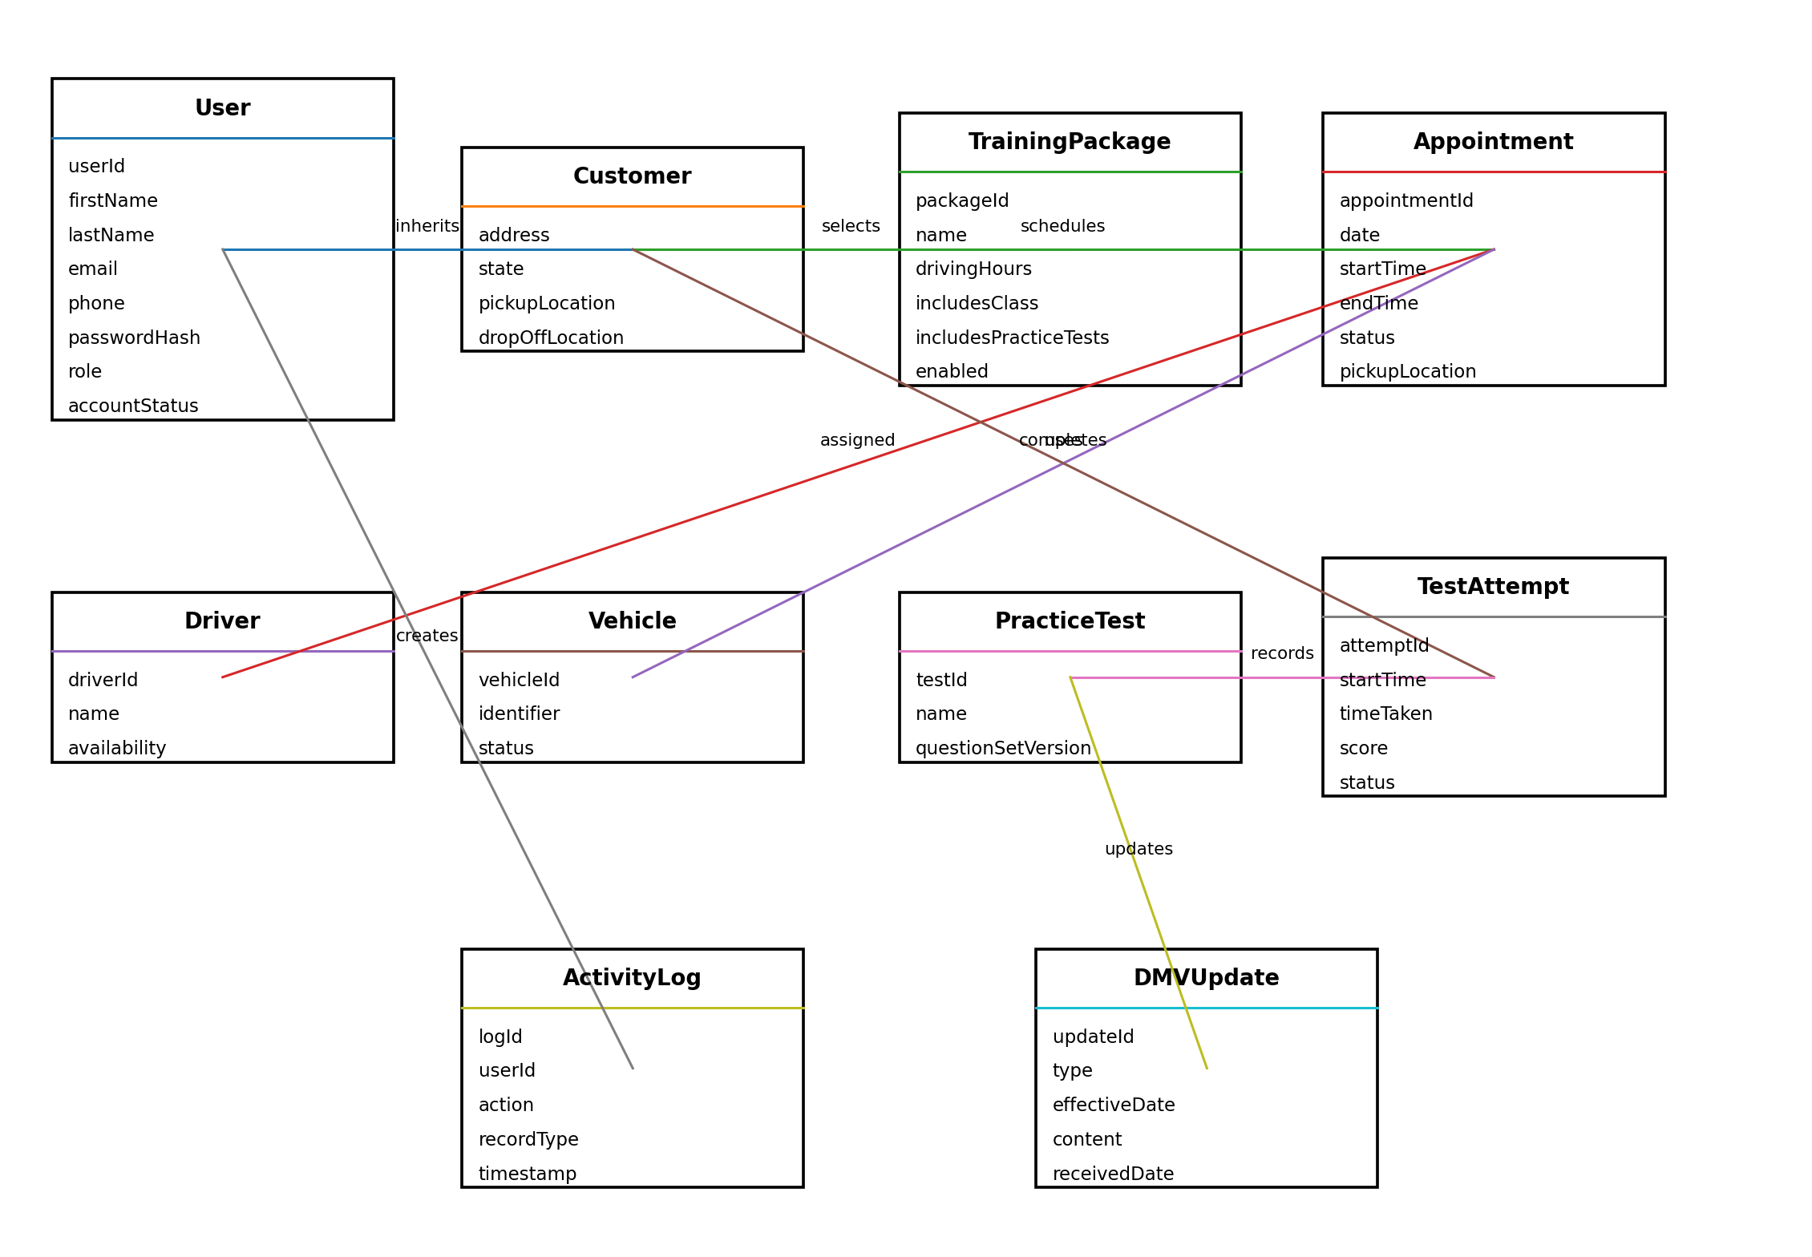
The class diagram identifies the major data objects and attributes required to support DriverPass.

Technical Requirements
Hardware: DriverPass employees need standard internet-connected desktop or laptop computers, while customers should be able to use common computers, tablets, and mobile devices. No dedicated on-site application server is required because DriverPass requested a web-based cloud solution.
Software: The system requires a browser-based interface, server-side application services, and a relational database for accounts, appointments, training packages, test progress, driver and vehicle assignments, and activity records. Reports should be downloadable in a format that can be opened in Microsoft Excel.
Security: The system must use authenticated accounts and role-based access so customers, the secretary, the owner, and the IT officer receive only the permissions needed for their responsibilities. Password reset is required, and the IT officer must be able to reset or block accounts. Sensitive data should be protected while transmitted and stored.
Infrastructure: The application should be hosted in a cloud environment that provides centralized storage, backup, availability, and security management. Users can access information from supported devices anywhere they have internet access, but changes to live data require an online connection to avoid conflicting copies.
Integration and Data: The system must receive DMV updates for new rules, policies, and sample questions and notify DriverPass when new information is available. Appointment records must connect a customer with a date, time, driver, and vehicle. The system must also record who created, changed, or canceled a reservation.
Maintainability and Flexibility: DriverPass must be able to manage user accounts and disable existing training packages without changing program code. Larger changes, such as adding new package structures or major modules, can be handled in future development releases.

