Symbols

* ℝ = real numbers, ℤ = integers, ℕ=natural numbers (0, 1, 2, …), ℚ = rational numbers, P = irrational numbers
* Compounded Statements: ~ ∧ V ≡ ≢ ≠ /\ \/
* Conditionals: ⇒ ⇔
* Quantifiers: ∃ ∀ ∴ ∵ ∤ |
* Sets: ⊆ ∪ ∅ ∩ ⧵ ∈ 𝒫 ⊕(exclusive or)
* Functions: (f o g)(x)=f(g(x)) ⌊ x ⌋ ⌈ x ⌉ ≤ ≥ < >

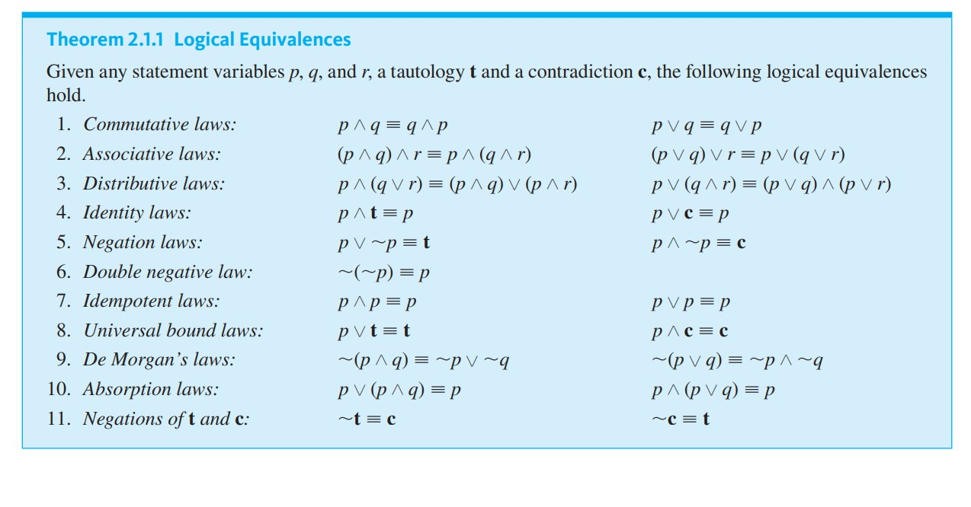

12. Implication law: p -> q ≡ ~p V q

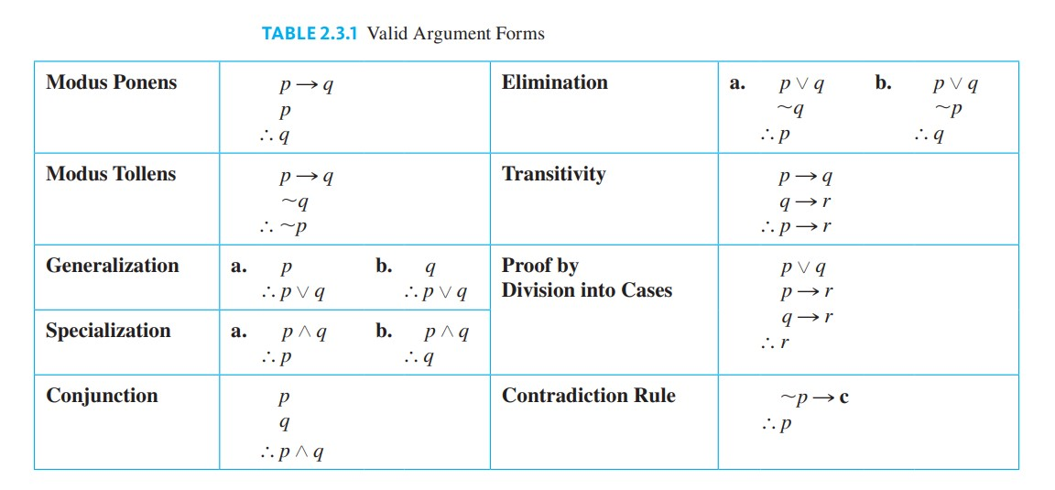

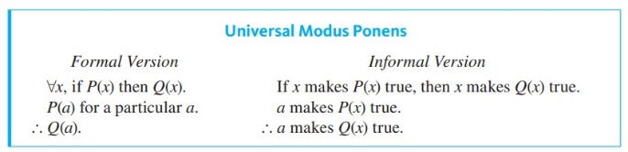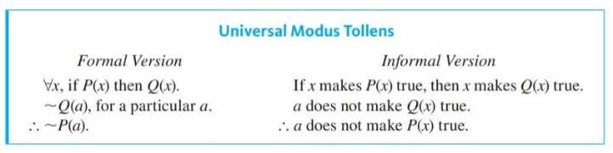



|  |  |
| --- | --- |
| Theorem (Extra stuff) | Text |
| Zero Product Property (a ≠ 0, b ≠ 0, ab ≠ 0) | If neither of two real numbers is zero, then their product is also not zero. |
| Theorem 4.7.1 ( is irrational) | is irrational |
| Proposition 4.6.4 (𝑛2 is even -> n is even) | For all integers 𝑛, if 𝑛2 is even then 𝑛 is even. |
| Theorem 4.2.1 (ℤ ⊆ ℚ) | Every integer is a rational number. |
| Theorem 4.2.2 (ℚ + ℚ = ℚ)  Corollary 4.2.3(ℚ x 2 = ℚ) | The sum of any two rational numbers is rational.  The double of a rational number is rational. |
| Theorem 4.3.1 (A Positive Divisor of a Positive Integer) | For all positive integers 𝑎 and 𝑏, if 𝑎 | 𝑏, then 𝑎 ≤ 𝑏. |
| Theorem 4.3.2 (Divisors of 1) | The only divisors of 1 are 1 and -1. |
| Theorem 4.3.3 (Transitivity of Divisibility) | For all integers 𝑎, 𝑏 and 𝑐, if 𝑎 | 𝑏 and 𝑏 | 𝑐, then 𝑎 | 𝑐. |
| Theorem 4.6.1 (No greatest Integer exists) | There is no greatest integer. |
| Theorem 4.6.2 (No number can be both odd and even) | No number can be both odd and even |
| Theorem 4.1.1 (Sum of any 2 even integers is even)  Theorem 4.1.2 (Sum of any even and odd integer is odd)  Lemma #1, Tutorial 1 (odd*odd = odd) | Sum of any 2 even integers is even  Sum of any even and odd integer is odd  The product of any 2 odd integers is an odd integer |
| Theorem 6.2.18 (bijective f: A -> B iff has an inverse) | bijective <-> injective and surjective |
| Tutorial 2 proof | 1. (∀𝑥 ∈ 𝐷 𝑃(𝑥)) ∧ (∀𝑥 ∈ 𝐷 𝑄(𝑥)) <-> ∀𝑥 ∈ 𝐷 (𝑃(𝑥) ∧ 𝑄(𝑥))  2. (∃𝑥 ∈ 𝐷 𝑃(𝑥)) ∧ (∃𝑥 ∈ 𝐷 𝑄(𝑥)) ≢ ∃𝑥 ∈ 𝐷 (𝑃(𝑥) ∧ 𝑄(𝑥))    Let P(x) be “x is a cs student”, Q(x) be “x is a math student”  A: for all x students, a student is either a cs or math student vs all students are either cs students or all students are math students |
| Tutorial 3 proof | 1. A ⊆ B if and only if A ∪ B = B  2. A ⊕ B = (A / B) ∪ (B / A) ≡ (A ∪ B) \ (B ∩ A) |
| Fundamental theorem of Arithmetic | Every positive integer >=2 has a unique factorization into product of prime numbers |
| Proposition 8.1.10 (Divisor is at most the number) | If d | n and n ≠ 0, then |d| ≤ |n| |
| Lemma 8.4.11 (same gcd for x, y and r for x mod y = r) | If x, y, r ∈ Z such that x mod y = r, then gcd(x, y) = gcd(y, r) |
| Lemma 8.1.9 (if 2 positive numbers can divide each other to give an integer, then the permutation w negatives can too) | Let d, n ∈ Z. If d | n, then −d | n and d | −n and −d | −n |
| Proposition 8.1.12 (Transitivity of divisibility) | Let a, b, c ∈ Z. If a | b and b | c, then a | c. |
| Lemma 8.1.14 (Division under Closure) | Let a, b, d, m, n ∈ Z. If d | m and d | n, then d | (am + bn). |
| Lemma 8.6.2 (Mod equivalences) | a ≡ b (mod n)  a = nk + b for some k∈ Z  n | (a-b) |
| Lemma 8.6.5 (reflexivity, symmetry, transitivity) | a ≡ a (mod n)  If a ≡ b (mod n), then b ≡ a (mod n)  If a ≡ b (mod n) and b ≡ c (mod n), then a ≡ c (mod n) |

|  |  |
| --- | --- |
| Operation | Definition |
| ⊆ | ∀z (z ∈ A ⇒ z ∈ B)  (trick is to use with def of “or” for ∪ questions) |
| Even Integer | iff n = 2k, k ∈ ℤ |
| Odd Integer | iff n = 2k + 1, k ∈ ℤ |
| Closure Property of Integers | Closure under +, -, and × |
| Equality (Sets) | (A⊆B) and (B⊆A) |
| ∃! (There exist a unique) | [Need to show any a∈A leads to a unique b∈B]  1. (Existence) show a∈A, f(a)∈B, (a, f(a)) ∈S. So (a, b) ∈S for some b∈B  2. (Uniqueness) b∈B s.t. (a, b) ∈S, b=f(a) [justify], unique b∈B s.t. (a, b) ∈S |
| p only if q | ~q -> ~p ≡ p -> q |
| r is a sufficient condition for s | r -> s |
| r is a necessary condition for s | ~r -> ~s ≡ s -> r |
| r necessary and sufficient condition for s (AKA iff) | r <-> s ≡ (r -> s) ∧ (s -> r) |
| For universal instantiations, ~ ∀ ≡ ∃ | ~ [∀x … P(x) -> Q(x)] ≡ ∃x [P(x) ∧ ~Q(x)] by implication law |
|  |  |

|  |  |
| --- | --- |
| Word Play | Logical Equivalence |
| There is no x y | ∀y (y -> ~x)  [replace x and y accordingly based on predicates] |
| All P(x) and all Q(x) | ∀x(P(x) ∧ Q(x)) |
| Every P(x) Q(x, y) R(x, y) | ∀x(P(x) -> ∀y (Q(x, y) -> R(x, y) ) )  Or  ∀x[P(x) -> ∃y(Q(x, y) ∧ R(x, y) ) ]  [be careful of biconditionals] |
| Every P(x) also Q(x) | ∀x(P(x) -> Q(x)) |
| No P(x) did Q(x) | ∀x(P(x) -> ~Q(x)) |
| Some P(x) also Q(x) but some P(x) did not Q(x) | [∃x(P(x) ∧ Q(x))] ∧ [∃y(P(y) ∧ ~Q(y))] |

|  |  |
| --- | --- |
| Proof | Method |
| Contrapositive | Suppose negation of conclusion, work towards negation of hypothesis |
| Contradiction | Suppose negation of given premise is false (ie assumption), work on the false situation, it will eventually lead to a contradiction on a given truth |
| Exhaustion | Show all cases for elements in the given set leads to a true conclusion |
| Construction | Use general terms that can encompass all cases (eg k ∈ ℤ) as specified by the question |

|  |  |  |
| --- | --- | --- |
| Errors | Symbolically | Argument |
| Inverse | ~p -> ~q | p -> q  ~p  ∴ ~q |
| Converse | q -> p | p -> q  q  ∴ p |

